Assignment – 11:
Problem Statement: Build Scaling plans in AWS that balance load on different EC2 instances.
Steps:
- The GitHub account is signed in and the repository visibility is checked from the Settings section. It is ensured that the repository is set to Public. 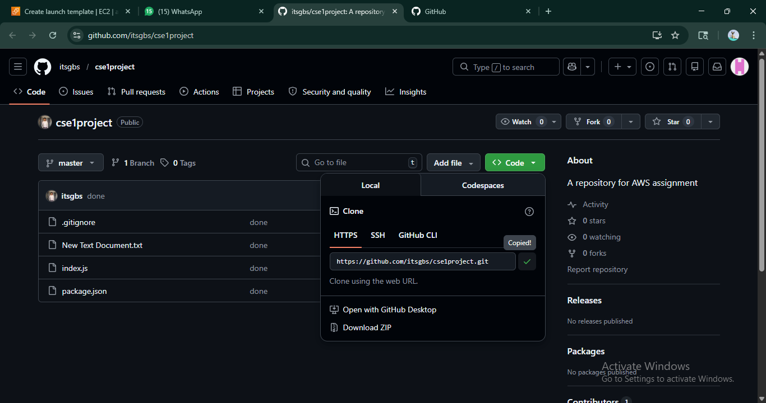
- The AWS console is opened in another tab and the account is signed in. The EC2 dashboard is accessed.
- From the left navigation panel, the Launch Templates section is opened and a new launch template is created by providing a suitable name and description. The Provide Guidance option is enabled. 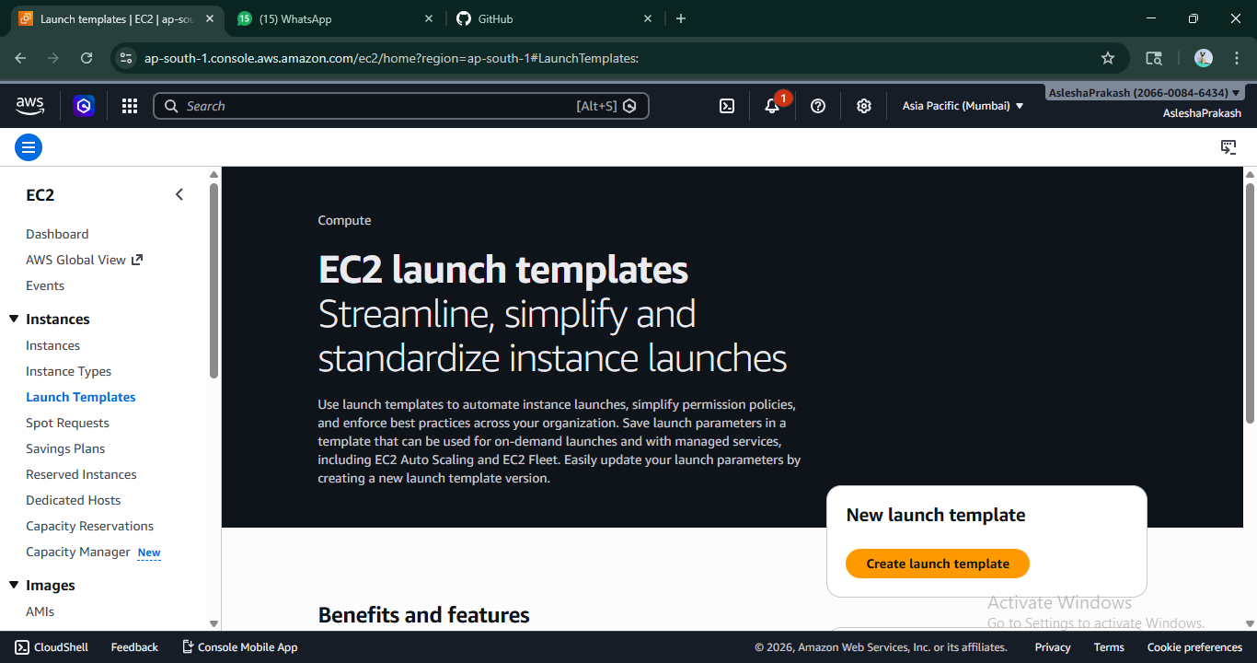
- The Ubuntu operating system and t2.micro instance type are selected. An existing key pair and security group are chosen. 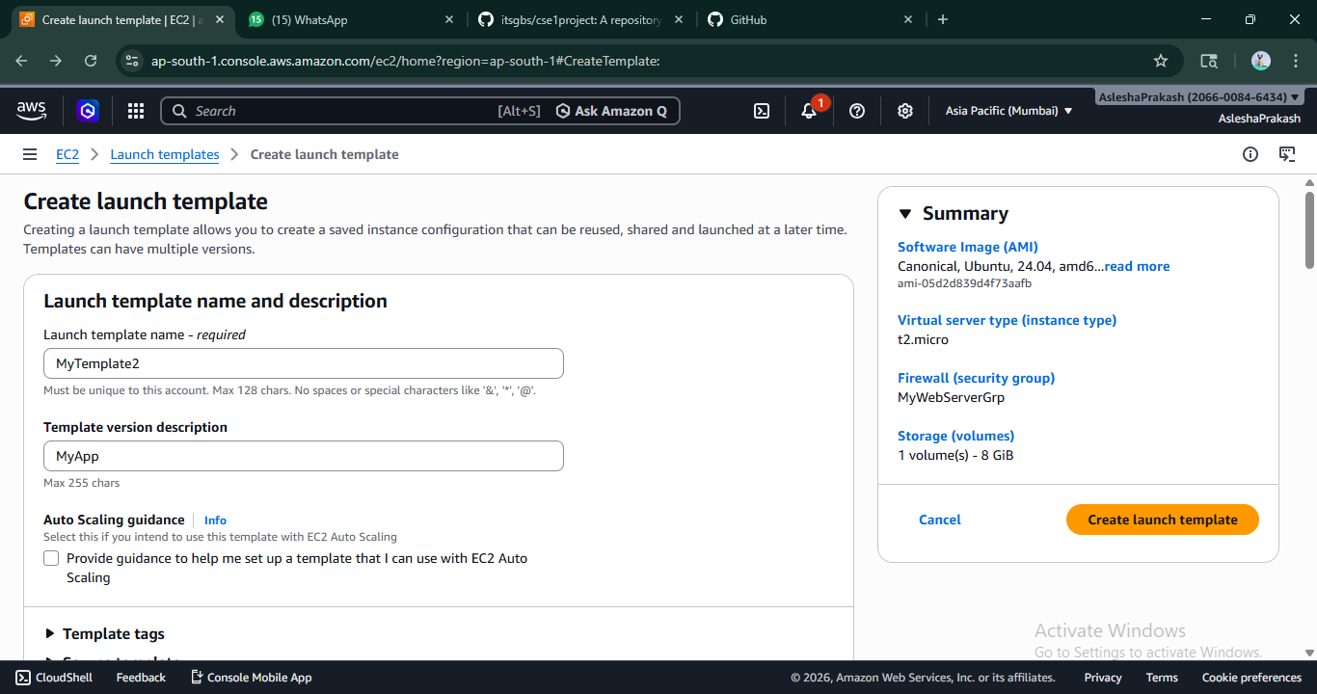
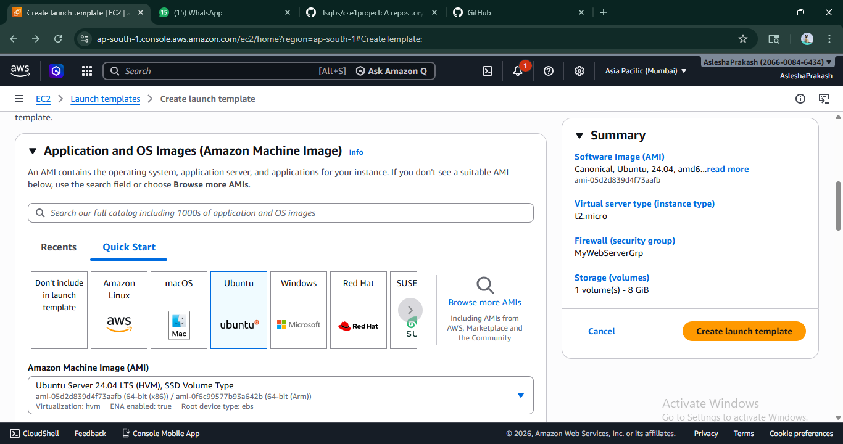
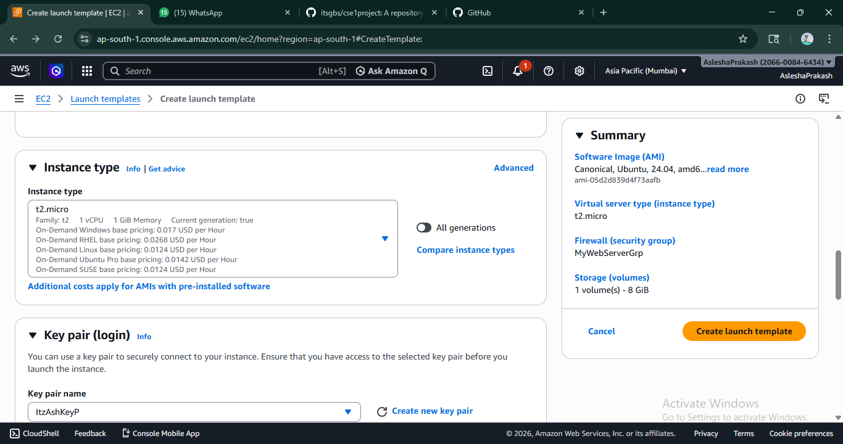
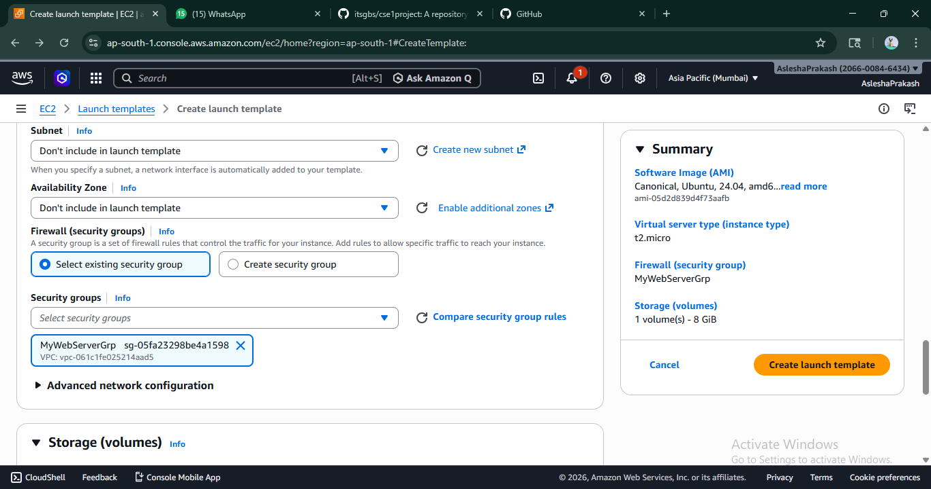
- In the Advanced Details section, user data is provided to automate setup during instance launch:
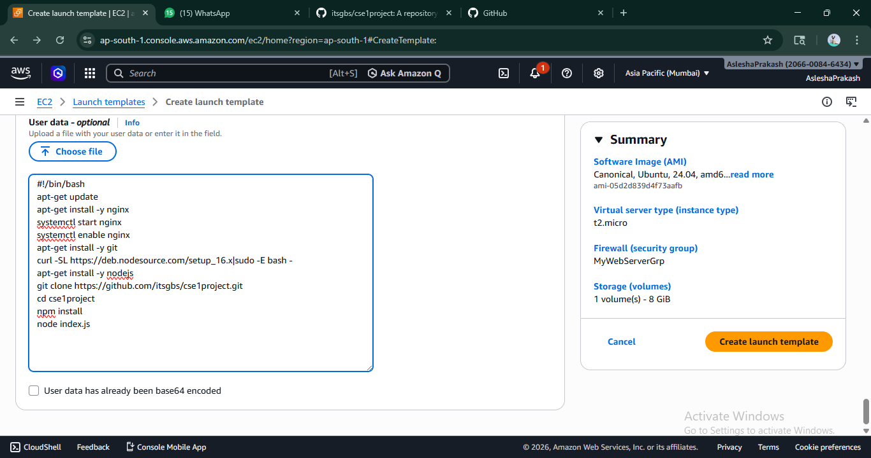
- The launch template is created successfully.
- The Auto Scaling Groups section is opened and a new Auto Scaling Group is created by selecting the previously created launch template and choosing the latest version.
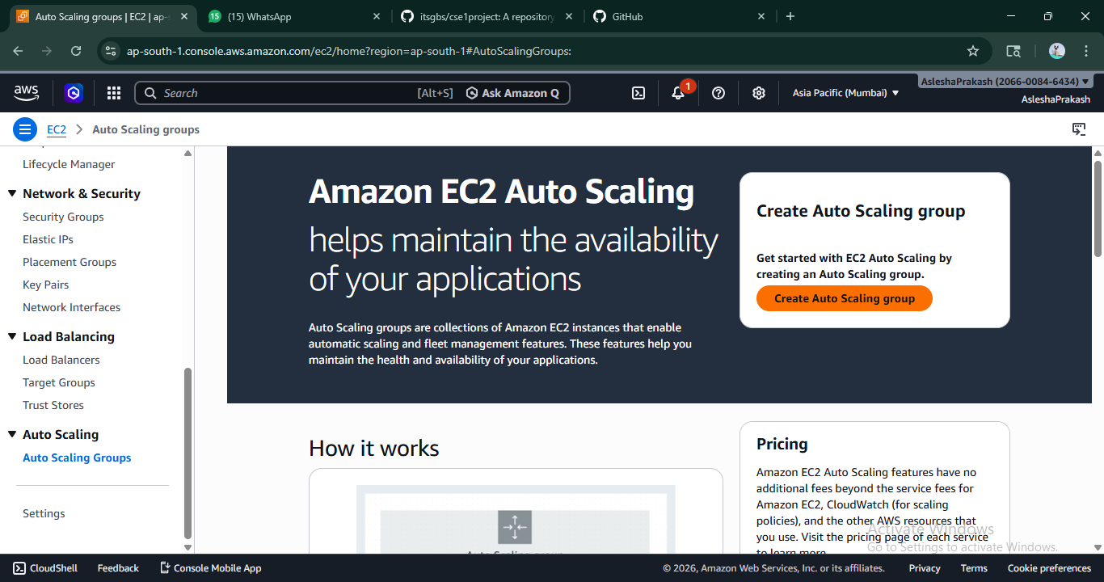

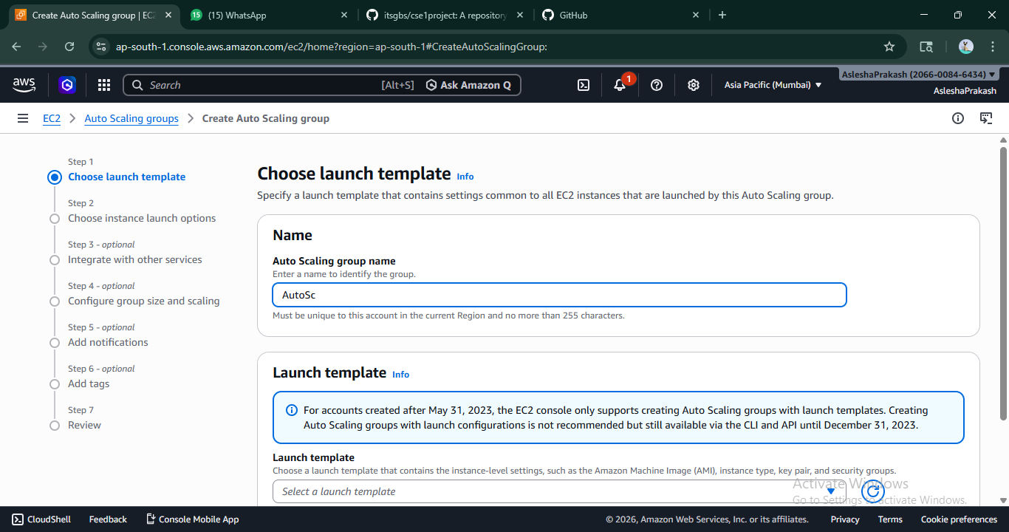
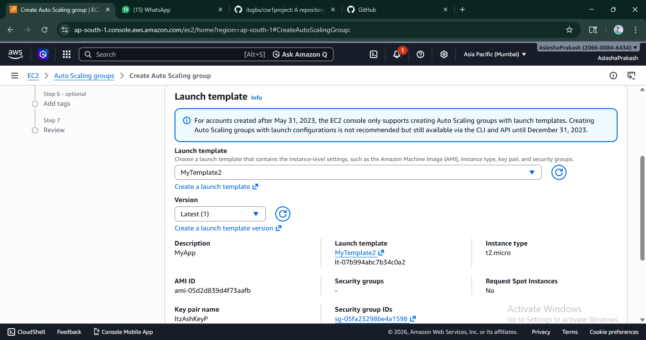
- Under network settings, all available Availability Zones and Subnets are selected to ensure high availability.
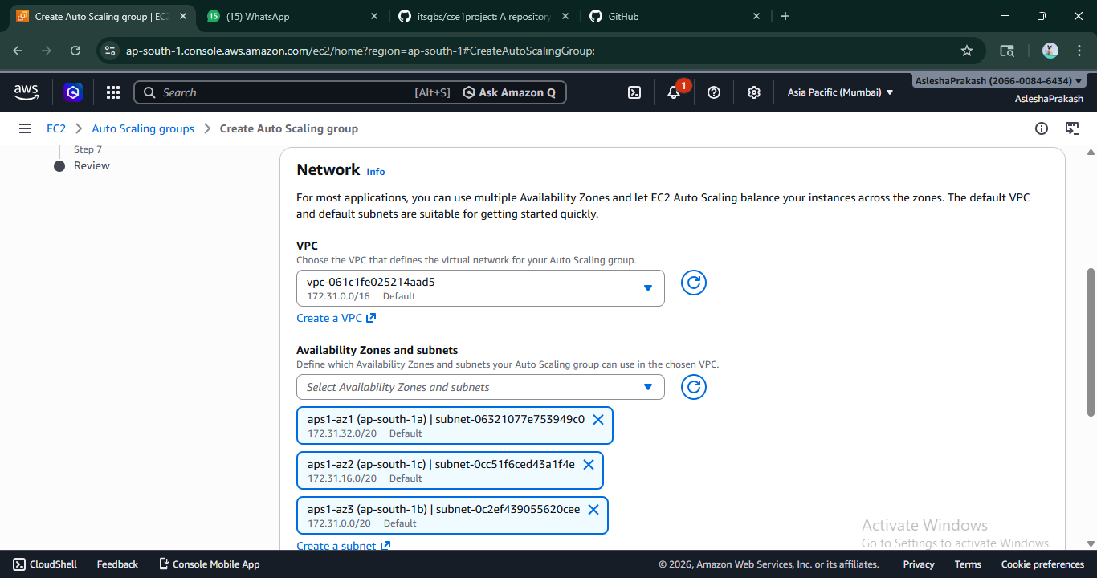
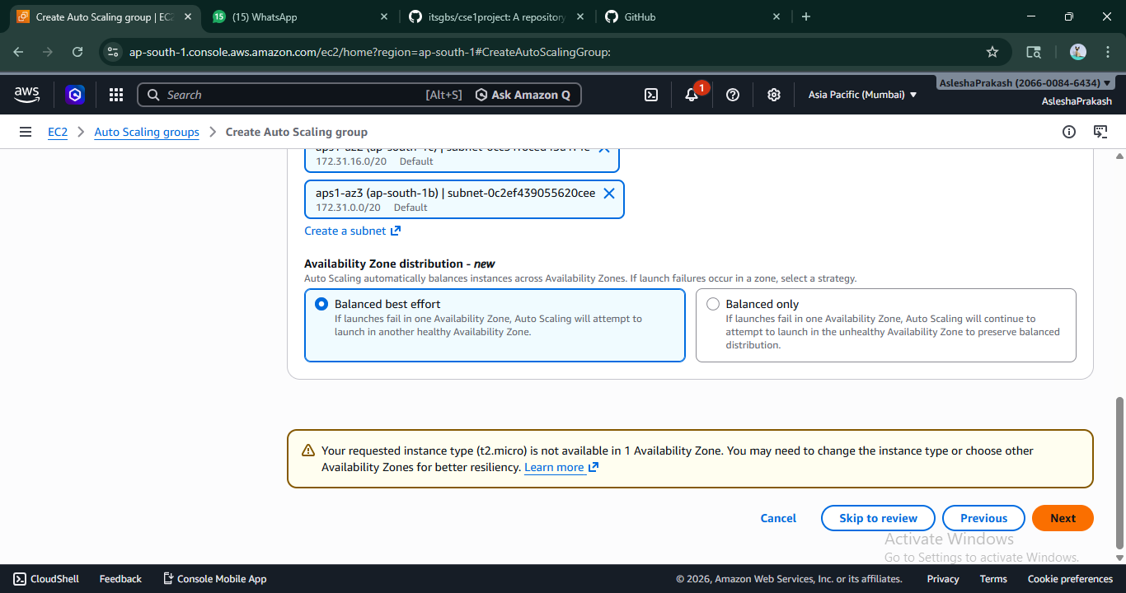
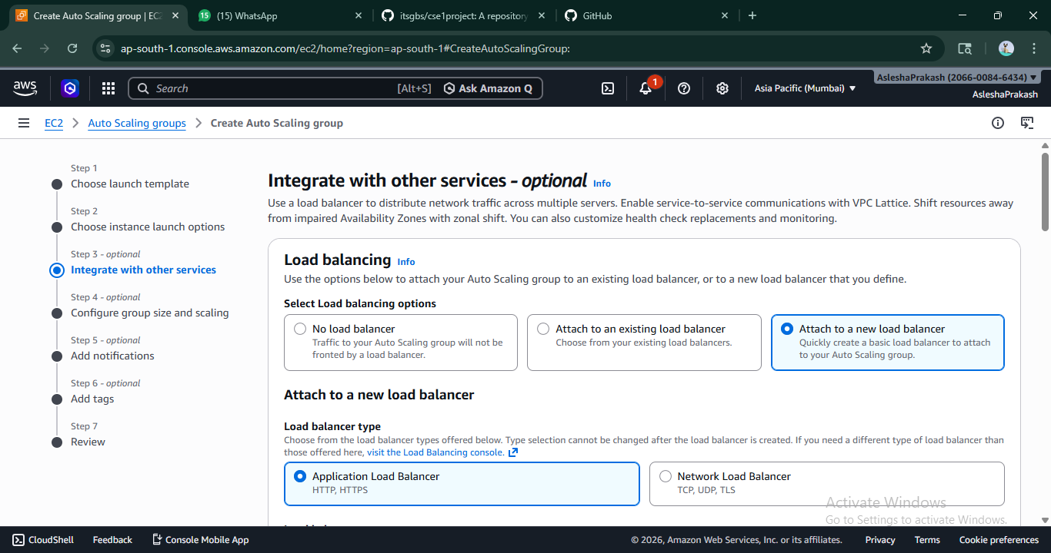

- A new Load Balancer is attached by selecting the Internet-facing option. A target group is created, and the required port number (e.g., 4000) is specified.
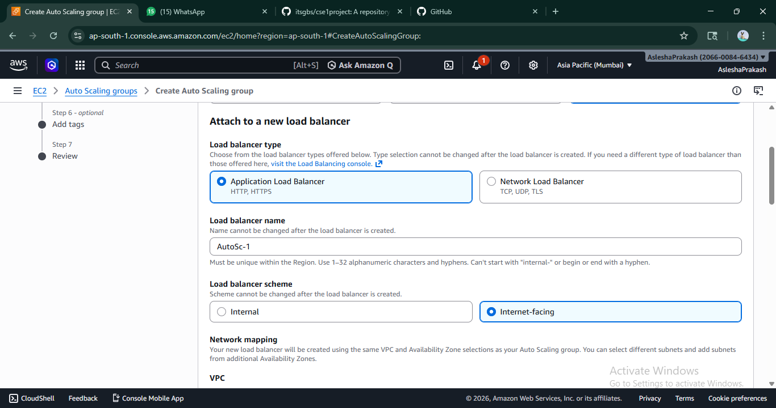
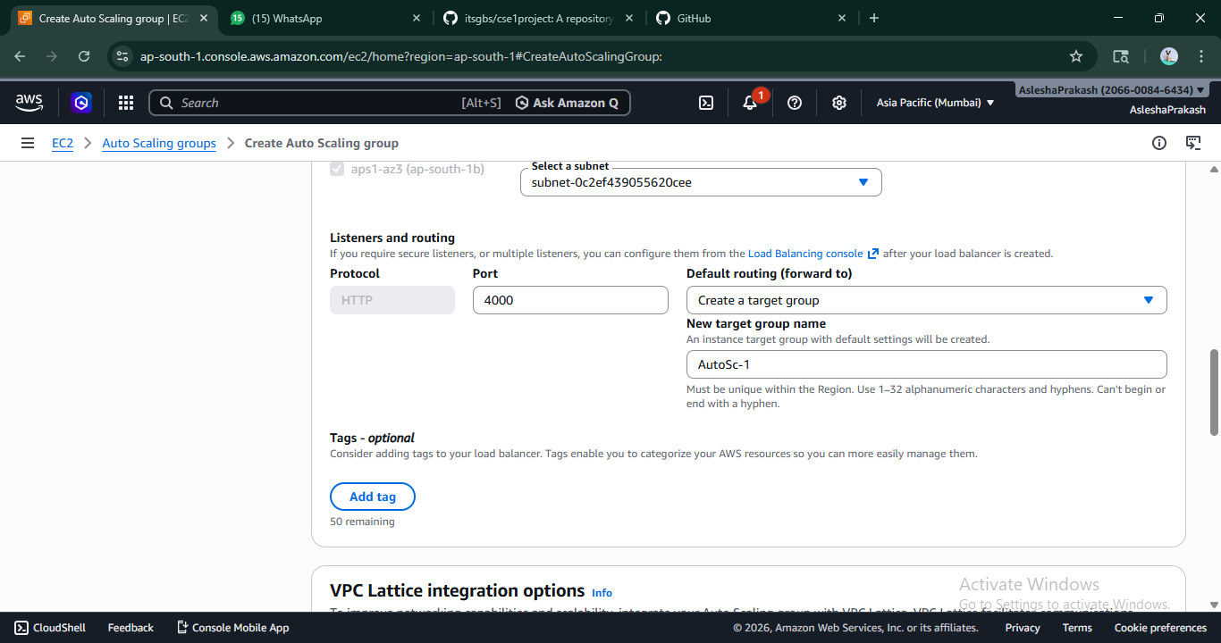
- The group size is configured as:
  - Desired Capacity = 2 , Minimum Capacity = 2 , Maximum Capacity = 3
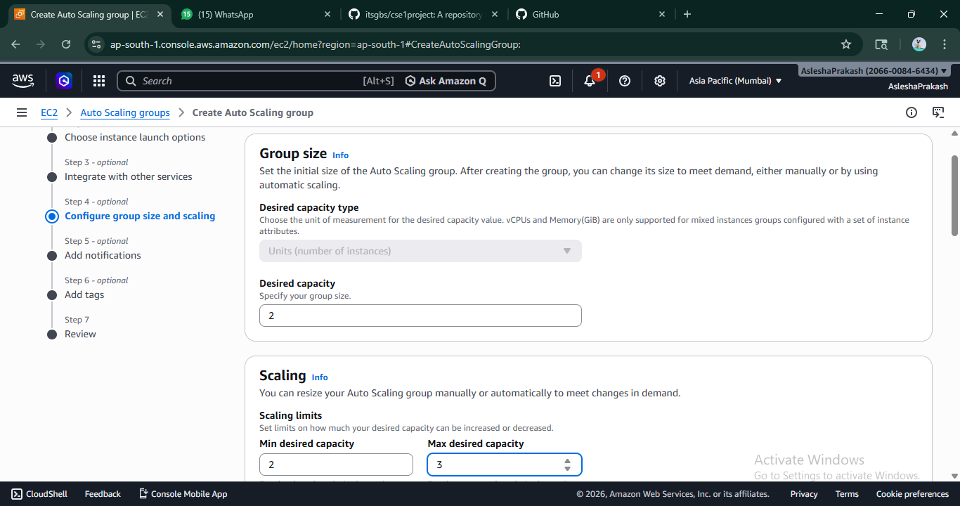
- A Target Tracking Scaling Policy is selected with:
  - Metric Type: Average CPU Utilization
  - Target Value: 20%
  - Warm-up Time: 300 seconds
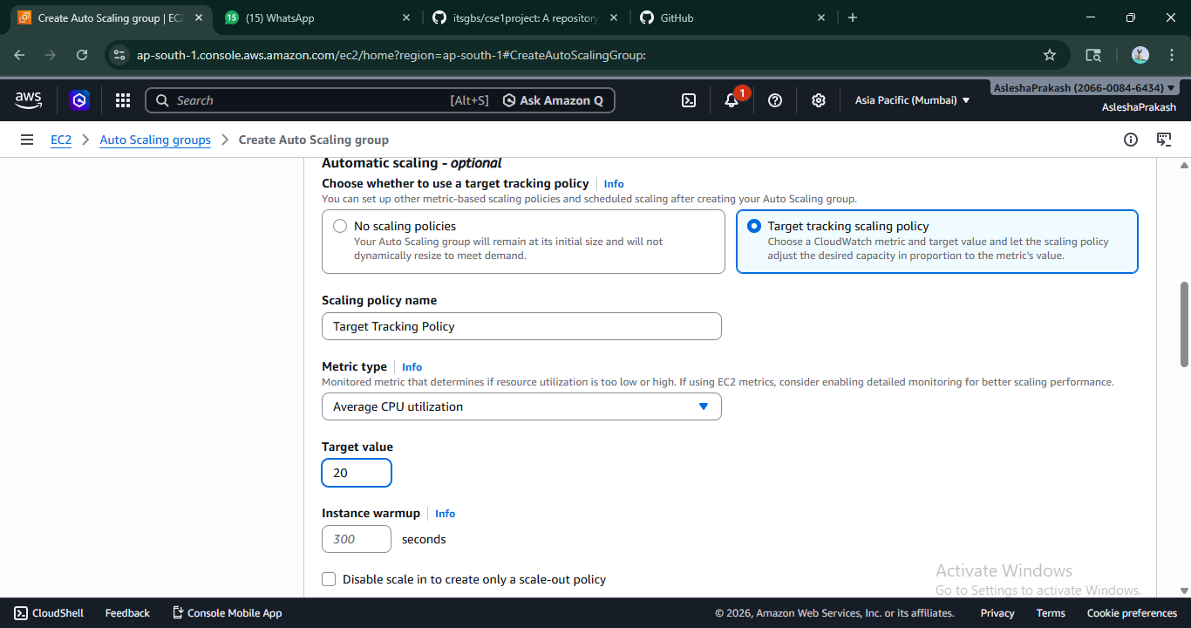
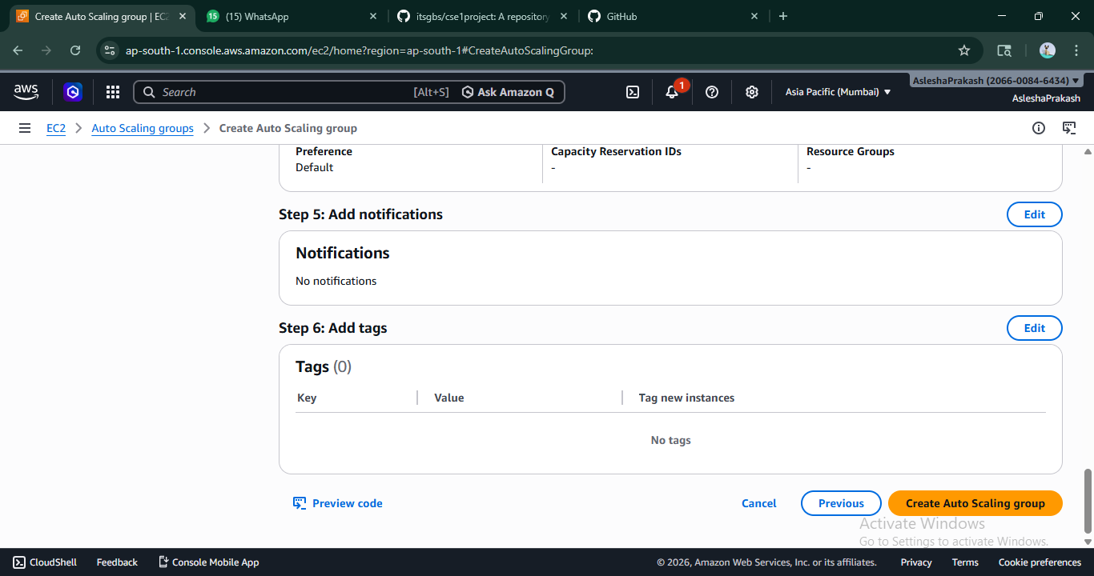
- The remaining settings are kept as default, and the Auto Scaling Group is created successfully.
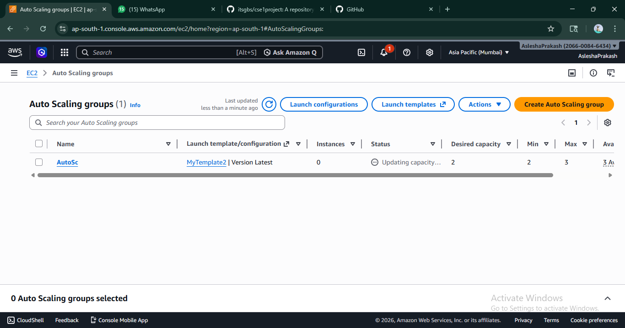
- The EC2 Instances section is opened, and the public IPv4 DNS of an instance is copied and accessed in a browser.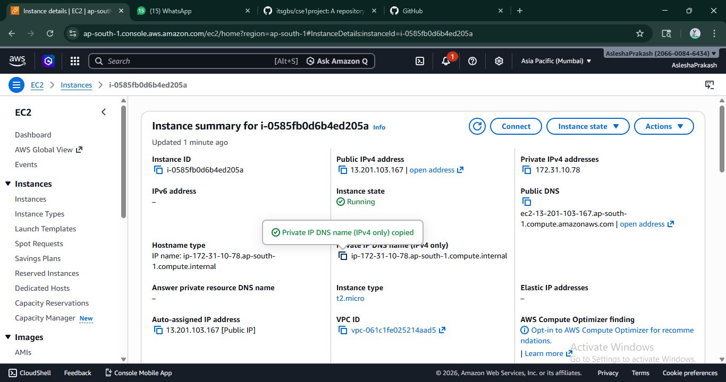
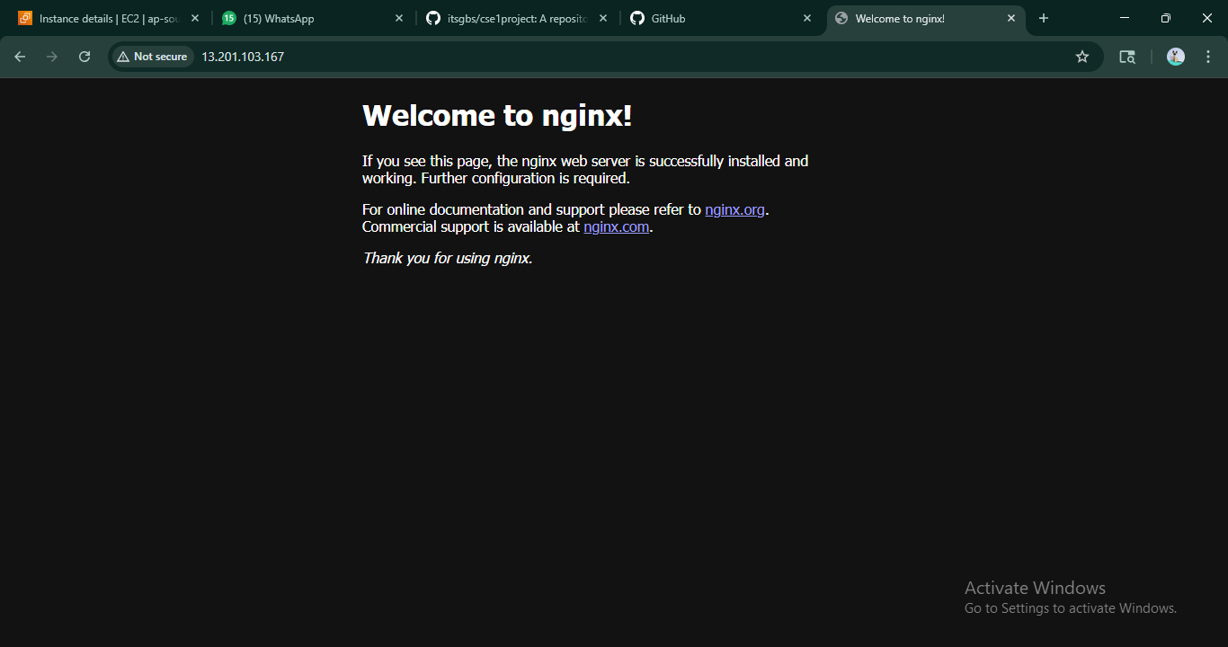
- The application is observed to be running successfully.
- The EC2 Instances page is opened and the running instances are selected. The instances are terminated using the Instance State → Terminate option. The page is refreshed periodically, and it is observed that the instances are terminated.
- After some time, new instances are automatically launched by the Auto Scaling Group.
- A filter (Instance state = running) is applied to view active instances.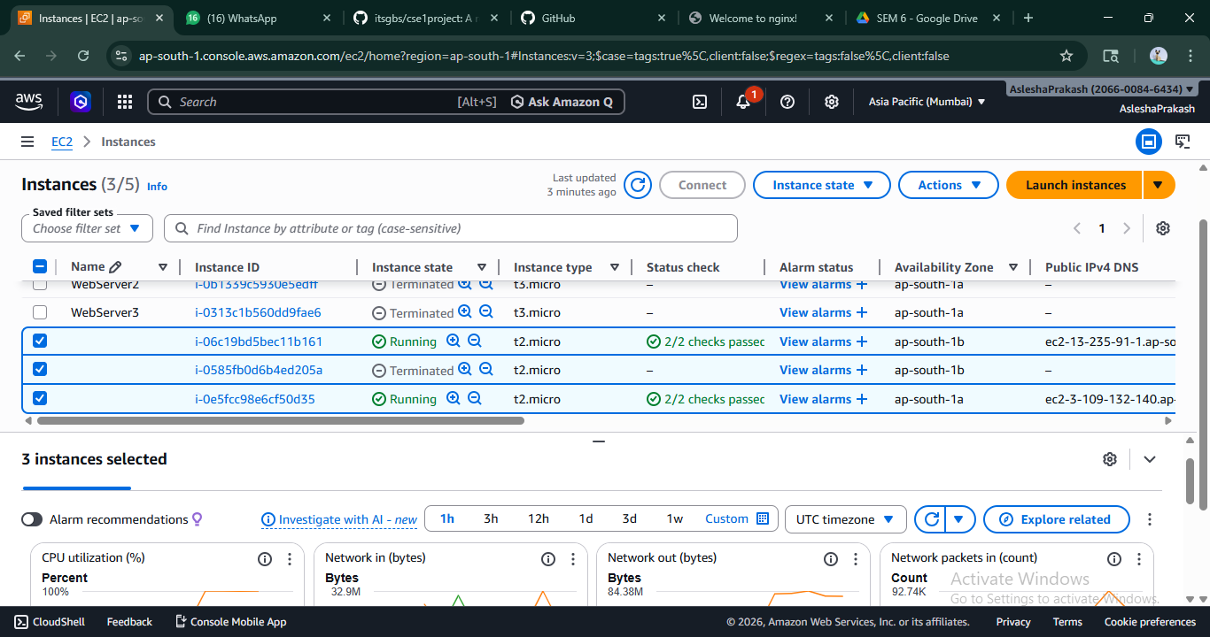
- The public IPv4 DNS of the new instance is accessed in a browser along with the port number, and the application is observed to be running successfully.
- CPU utilization is increased by executing scripts on the running instances.
- The instances are accessed using SSH (Bitvise or browser terminal), and a script file is created and executed:
nano infil.sh
chmod +x infil.sh
./infil.sh
- The script runs continuously, increasing CPU utilization.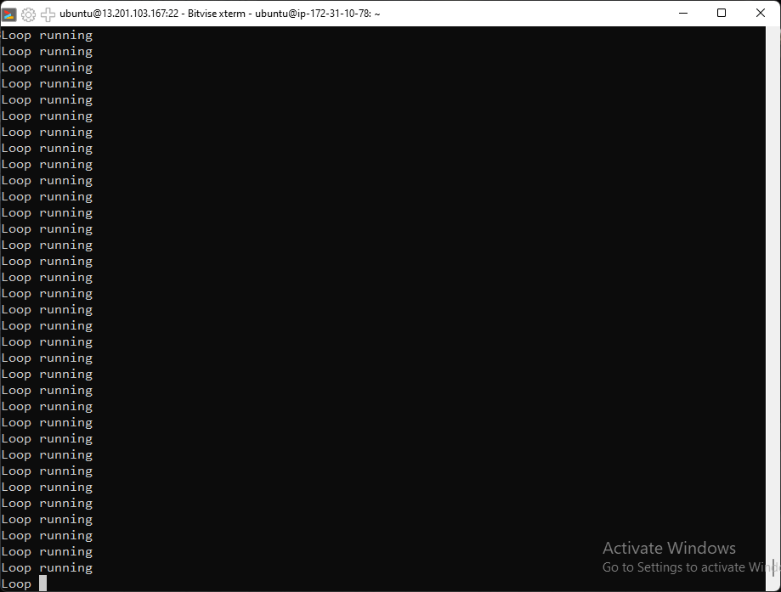
- When CPU usage exceeds the defined threshold (50%), additional instances are automatically created by the Auto Scaling Group.

- It is observed that the number of instances increases up to the maximum limit.

