ASSIGNMENT 10: Deploy and run the project in AWS without using the port.

1: Go to the EC2 dashboard.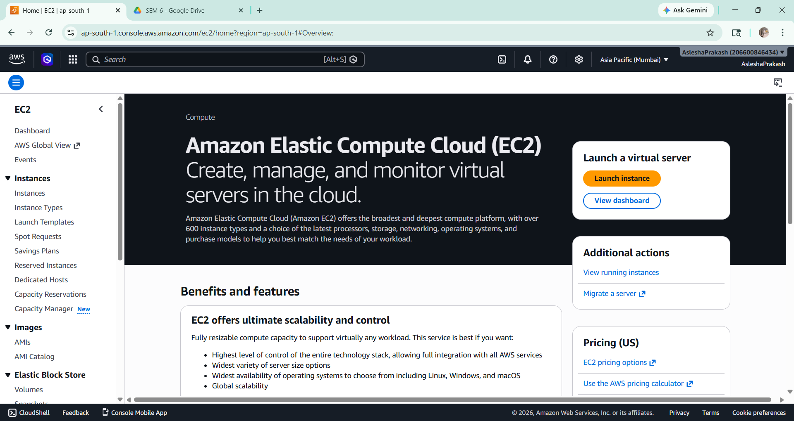

- Click on Launch Instance.

- Give the name of the instance and select UBUNTU as the OS. 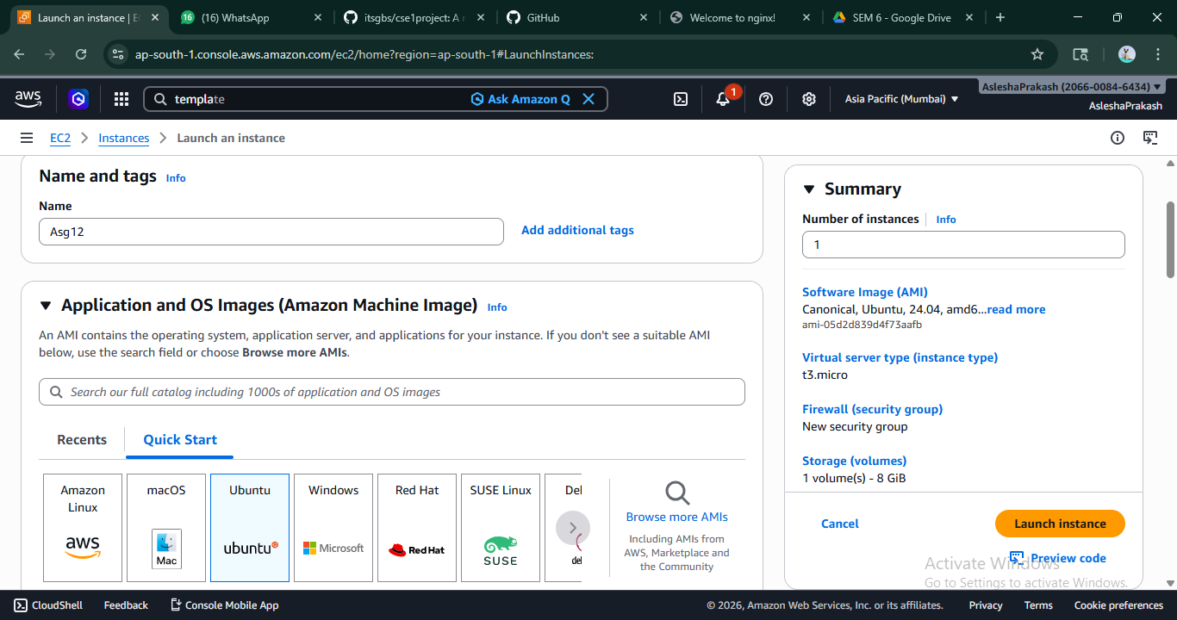

- Select the keypair and select existing security group. (If not created then create the both).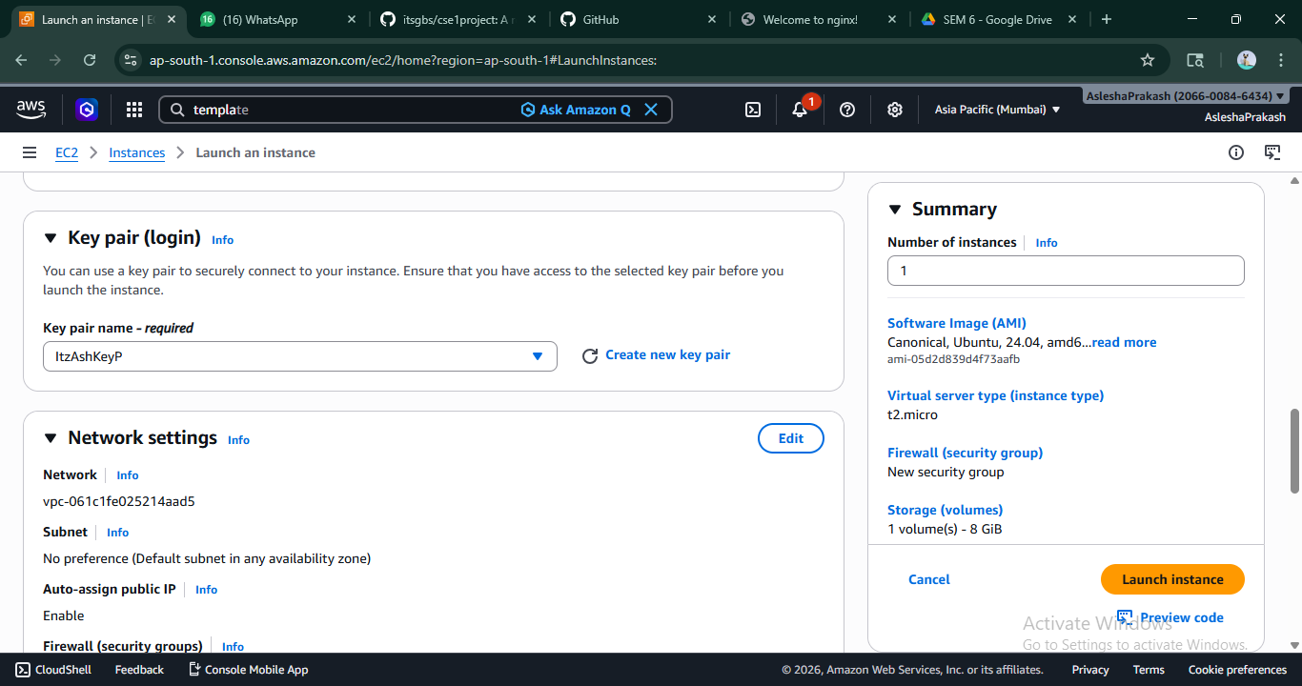

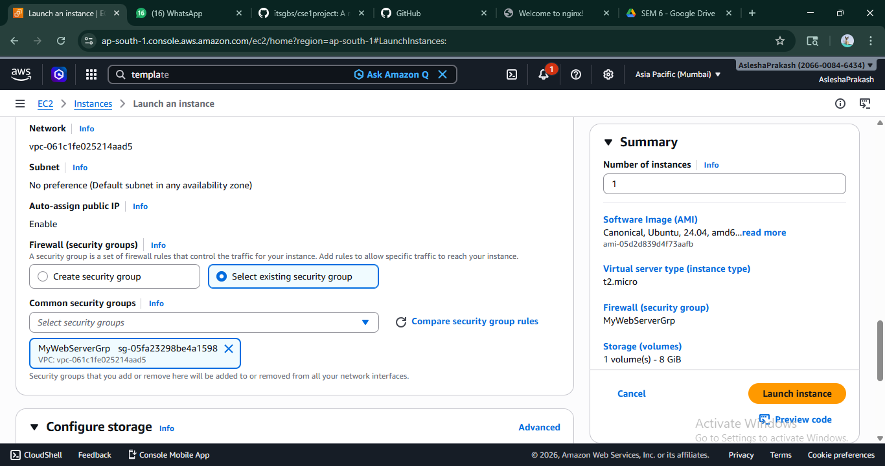

- In the Advanced settings scroll down and write the code shown in the picture. Then click on “Launch Instance”.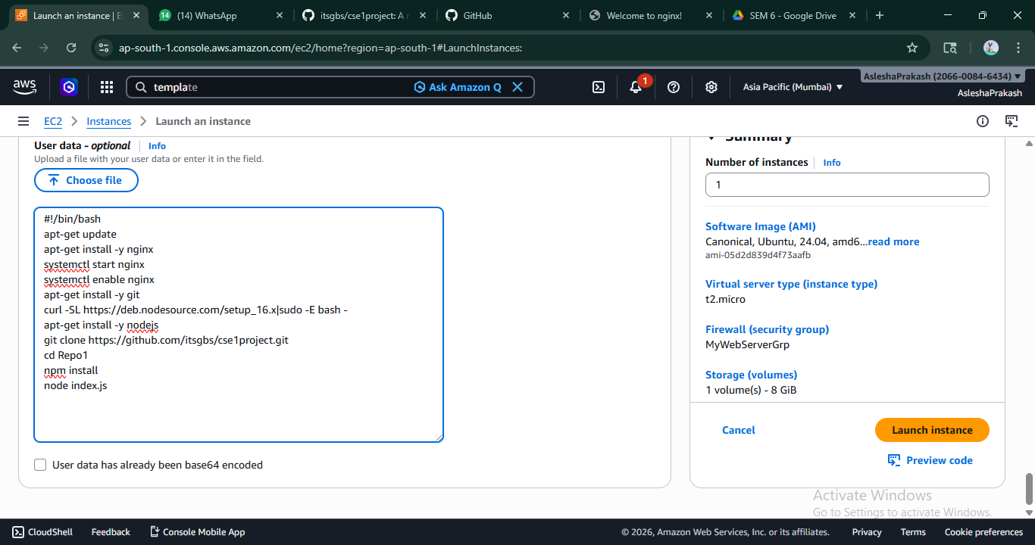

- The instance is created successfully.

- Copy paste the Public IPv4 address of the created instance.

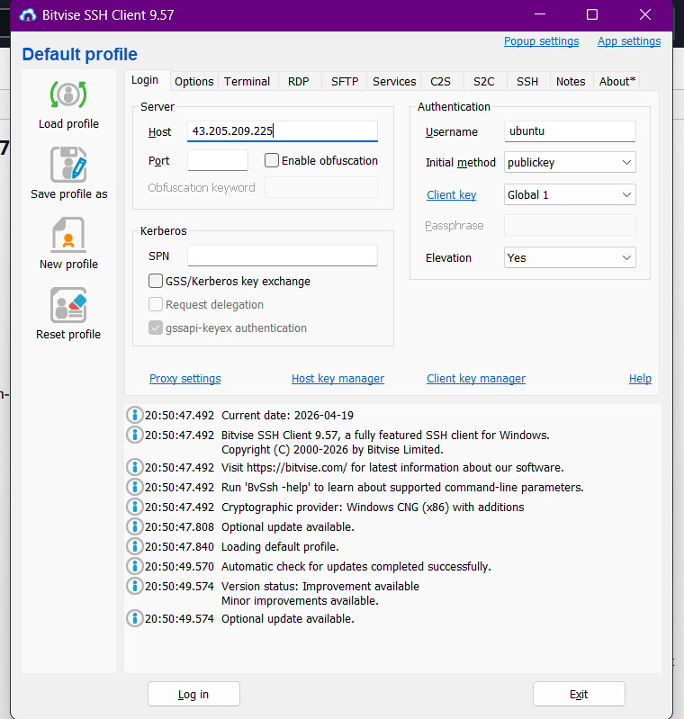
- Open the Bitvise SSH client and paste the ipv4 address here. Under Authentication select username as “ubuntu”, initial method as “public key” , client key as “Global 1” and in client key manager import the keypair selected while creating the instance. Then click on “Log in” then Accept and Save.

- Paste the copied ipv4 address on the new tab. Add 4000 (the port number) at the last of the address to see the content of the index.js file.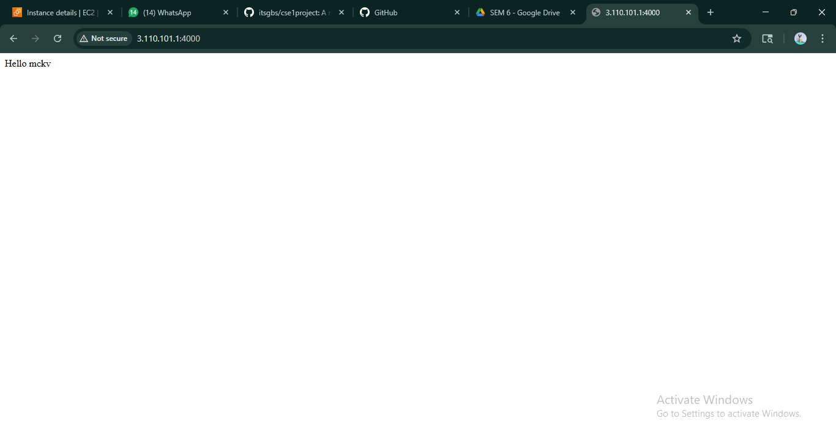

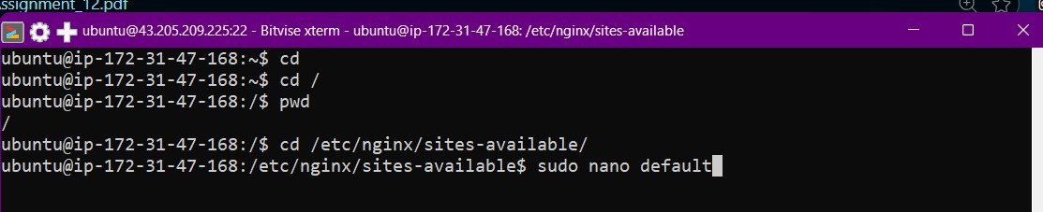
- Go to the new terminal window from Bitvise SSH client and write the commands shown in the picture.

- Uncomment the code shown in the picture.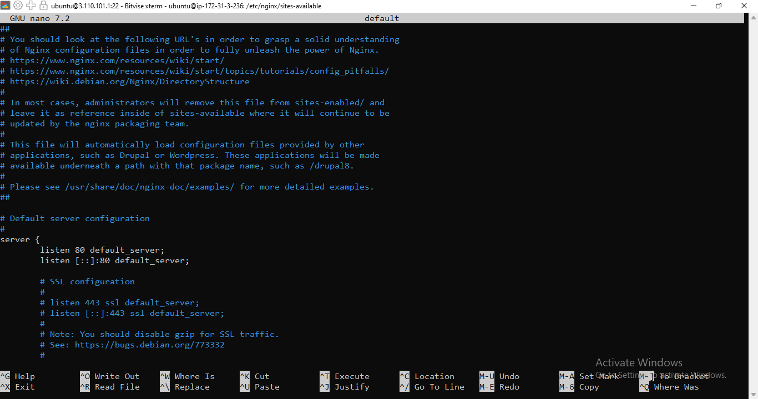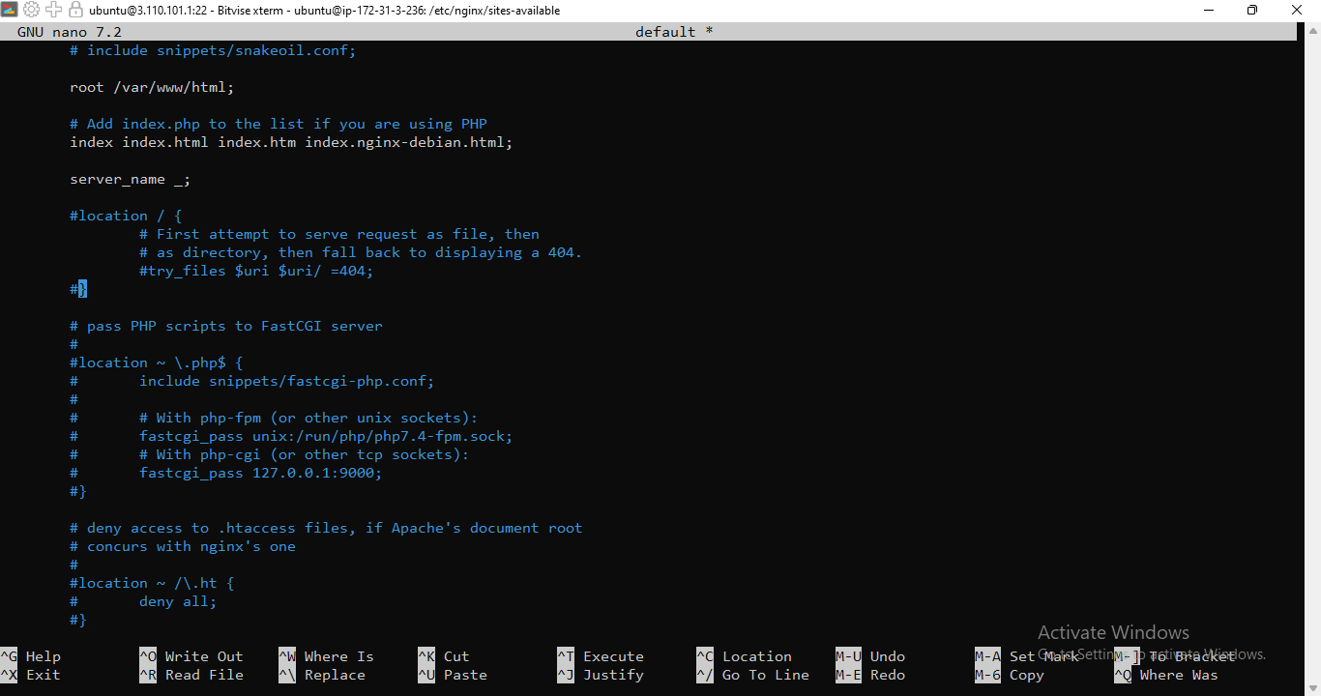

- Add the following code instead. Then Ctrl + X → Y → Enter. You will come back to bash terminal. 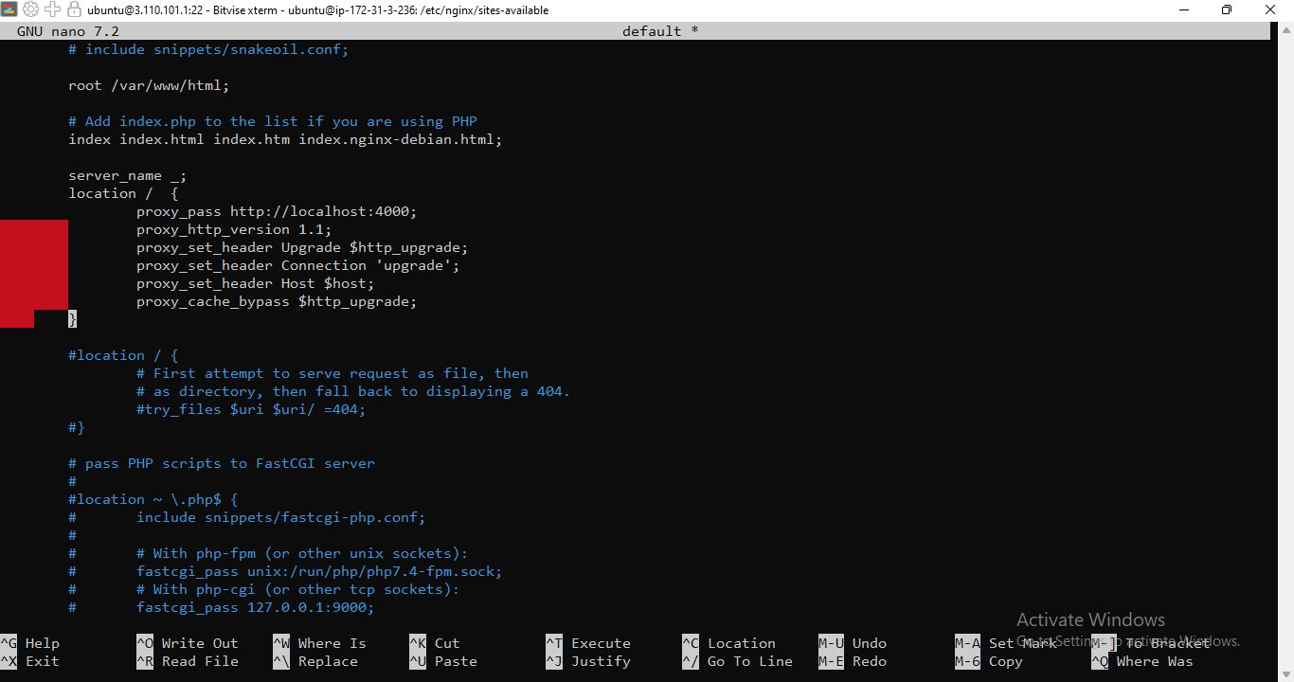

- Write the code → sudo systemctl restart nginx. Go back to the created instance in AWS and refresh it.

- Copy paste the ipv4 address again in the new tab without adding the port number 4000 to it. 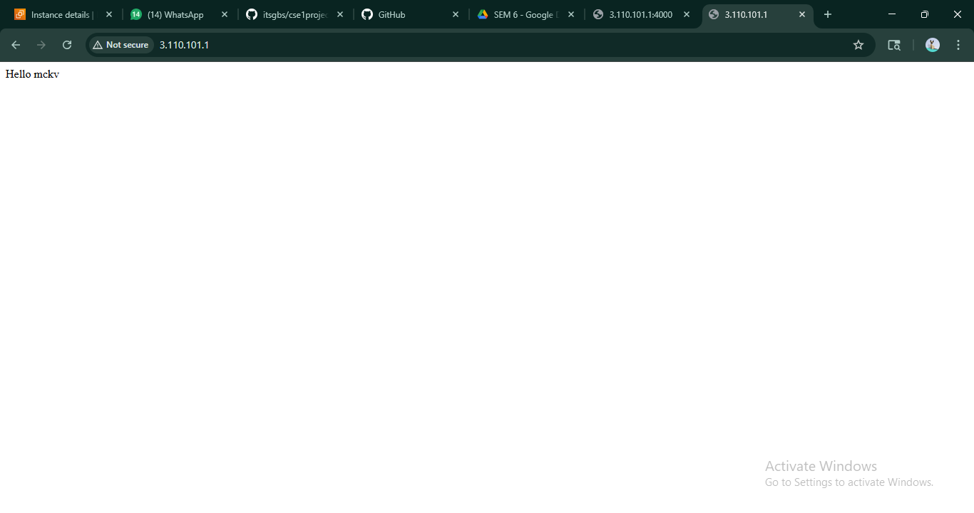
Seeing the output we can conclude that our project is successfully deployed and run in AWS without the help of port number.

