Assignment – 15:
Problem Statement: Create a Serverless computing service.
Steps:
- The AWS console is signed in and the Lambda service is searched and opened.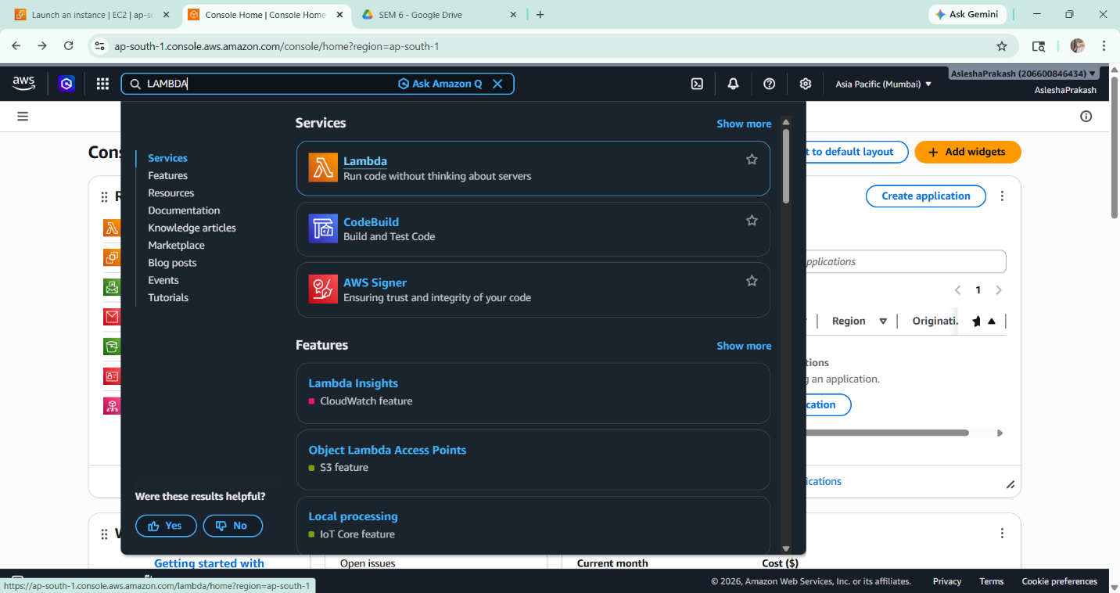

- The Create Function option is selected, and the Author from scratch option is chosen.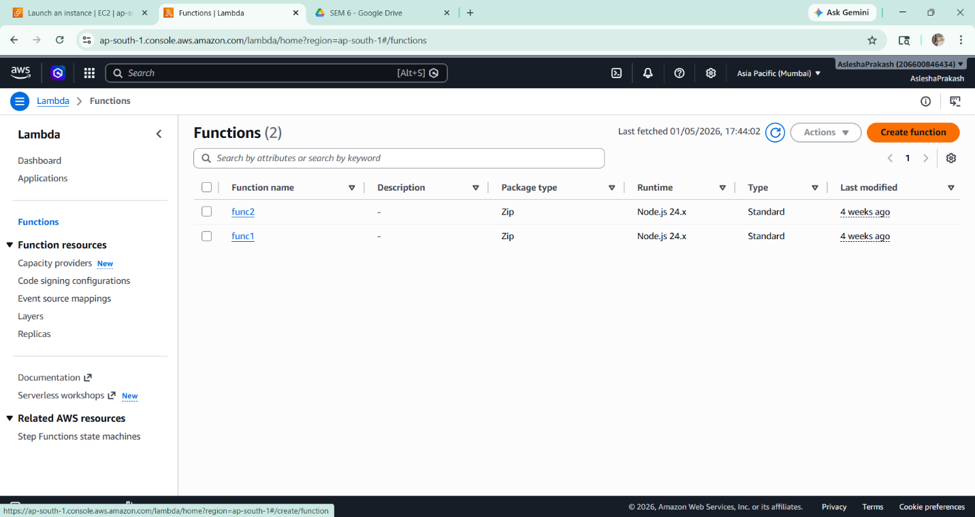

- A suitable function name is provided, and Node.js is selected as the runtime. The remaining settings are kept as default, and the function is created.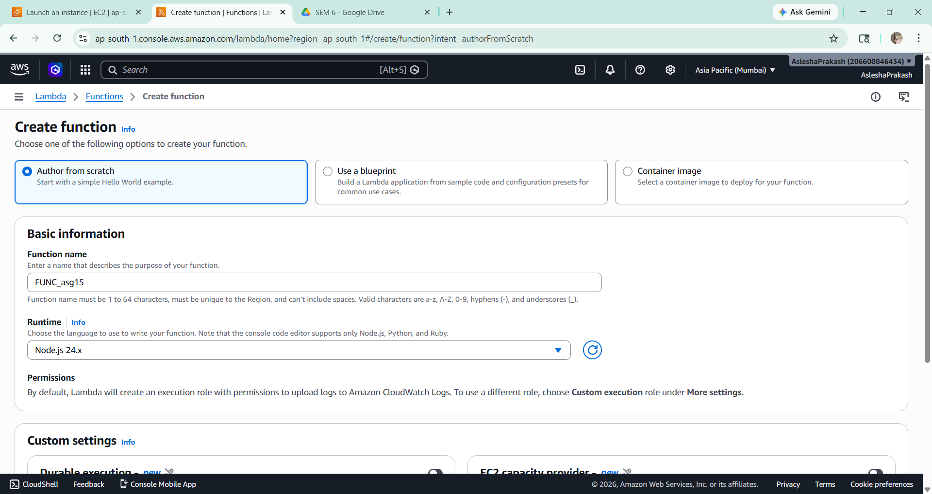

- The code section of the created function is accessed, and the required string/message in the code is modified.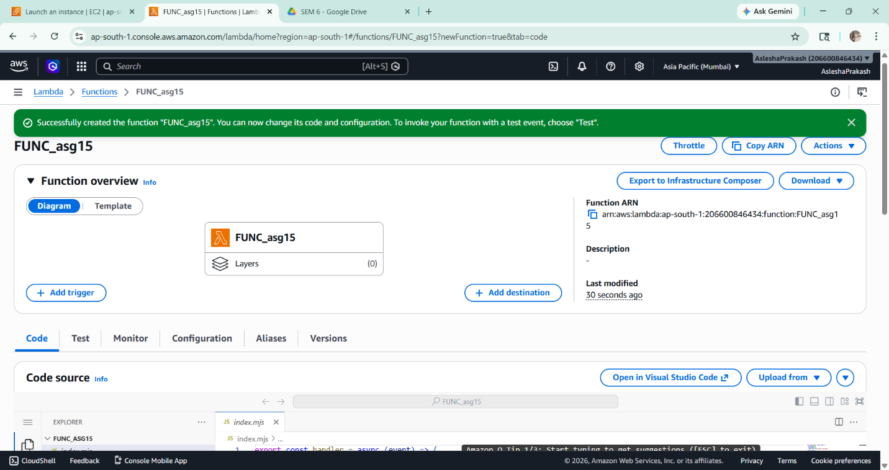

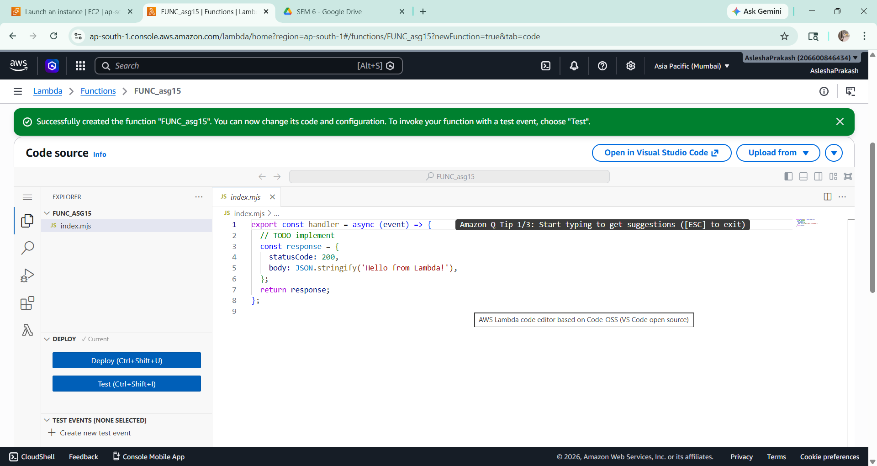
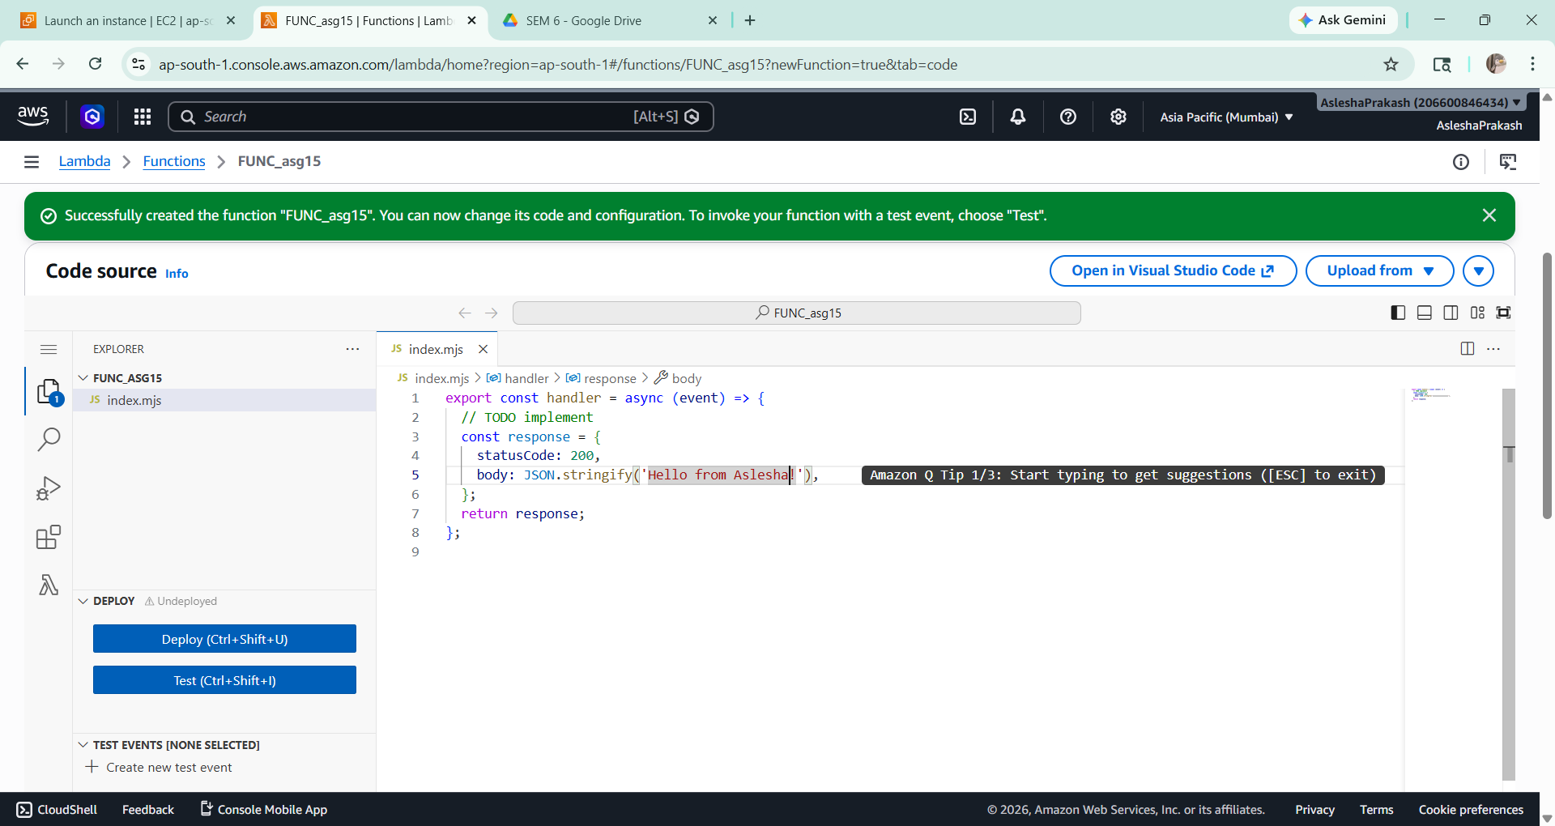

- The changes are saved using the Save option.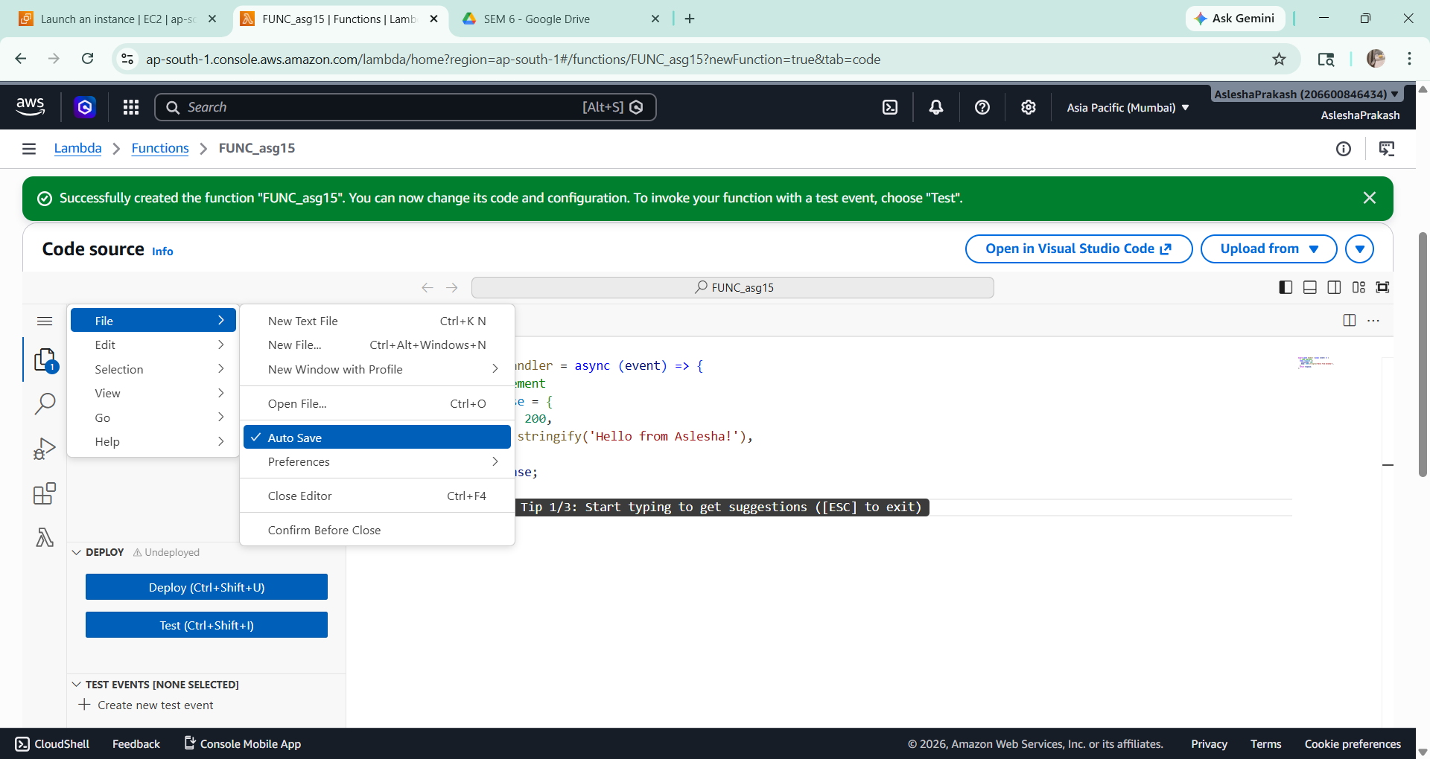

- The function is tested by clicking on the Test button. A new test event is created, named, and saved.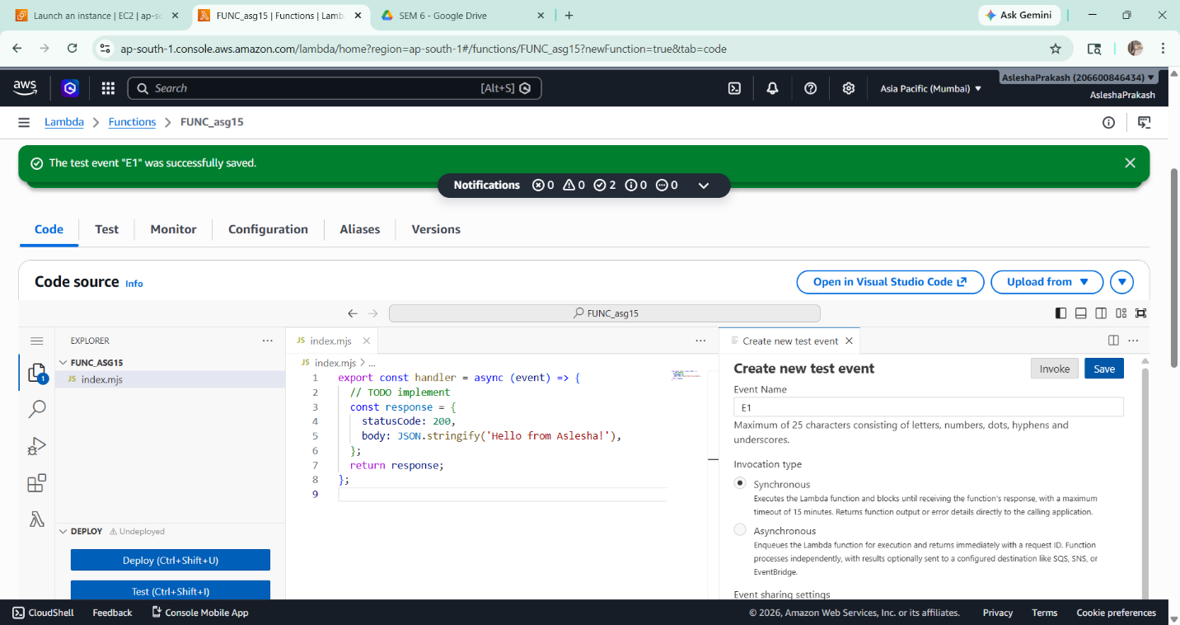

- The function is deployed using the Deploy button, and successful deployment is confirmed. 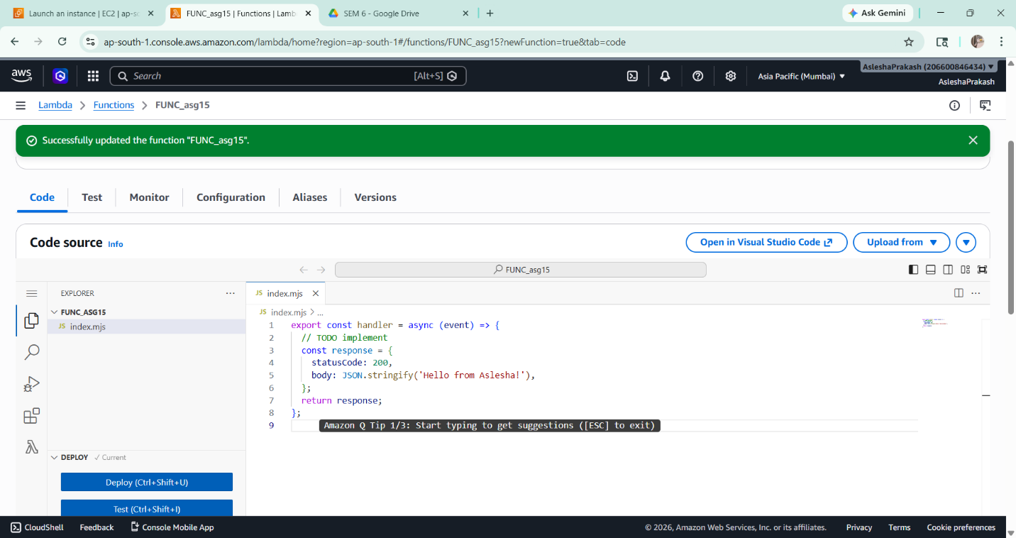

- The Configuration tab is opened, and the Function URL option is selected from the left panel. 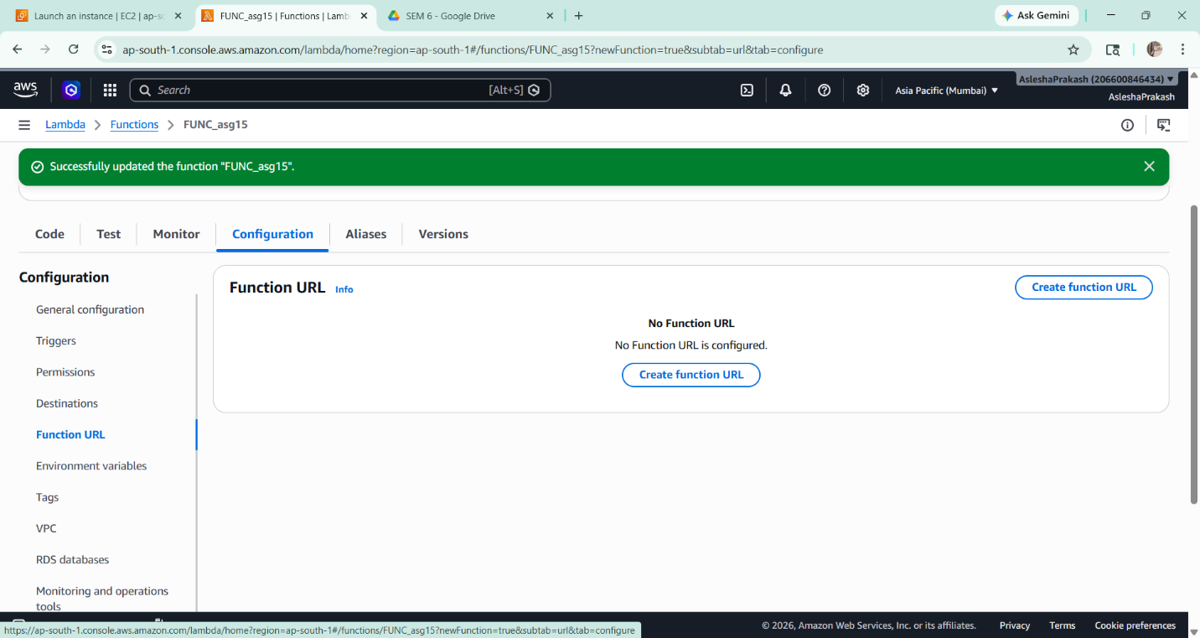

- A new function URL is created by selecting the NONE authentication type and saving the settings.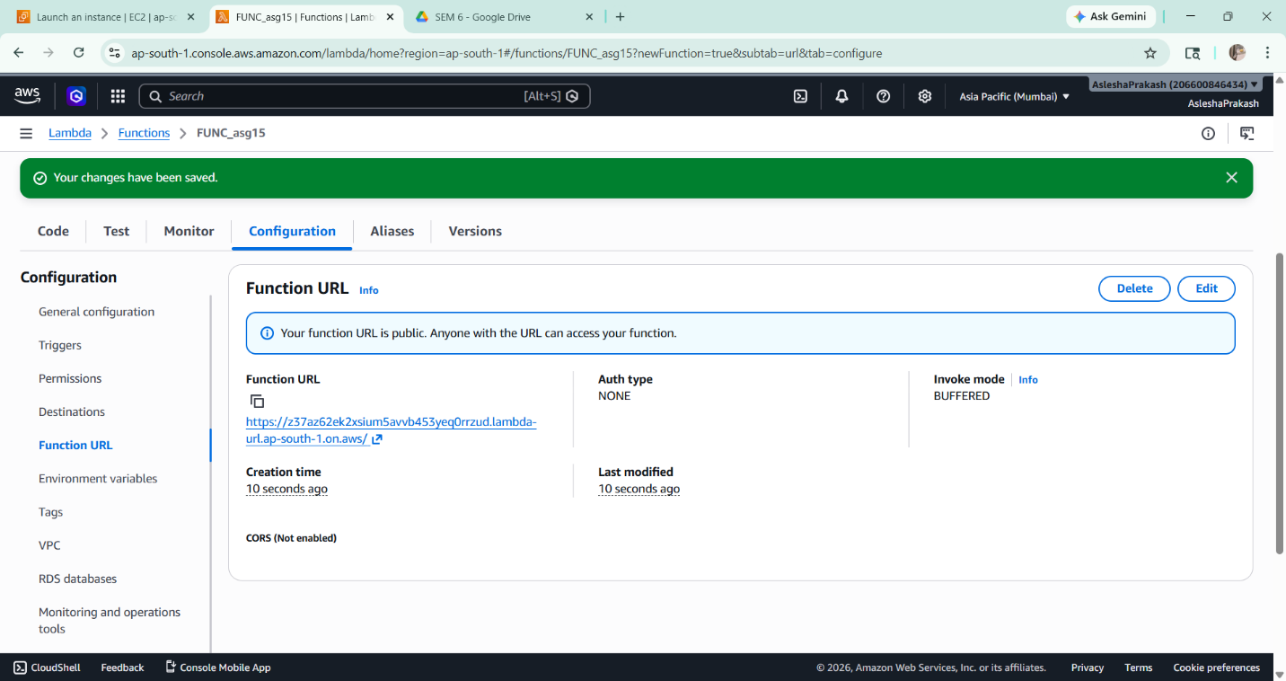

- The generated Function URL is copied and opened in a browser, where the output of the function is displayed successfully.
