NAME- BRISHTI DHARA(CSE/23/90)
Assignment No. 10
Problem Definition: - Deploy a project from GitHub to EC2 by creating a new security group and user data.
Step: 1. Sign up for an AWS account, search for ‘EC2’ then click on it.
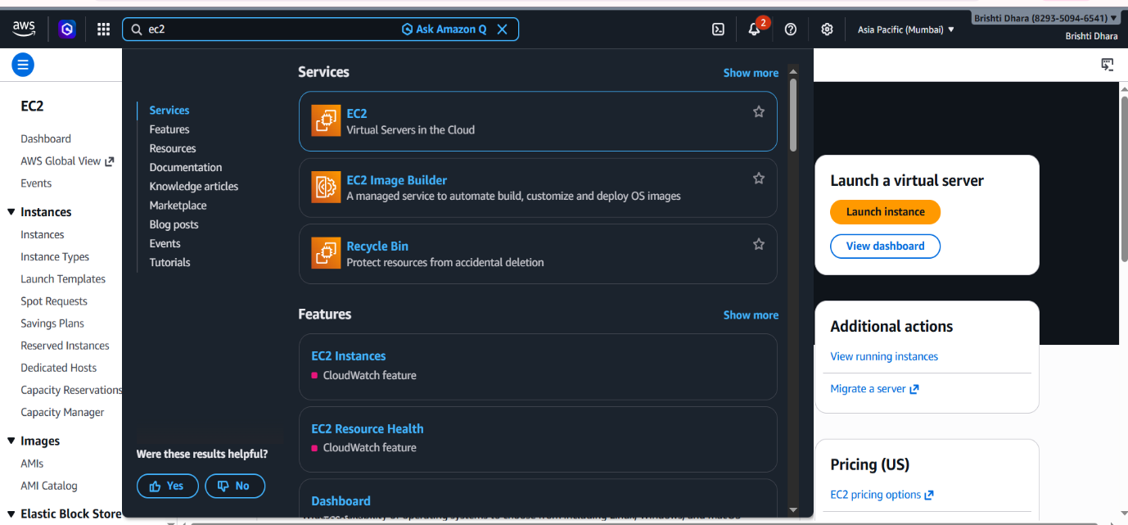

STEP 2.Click on ‘Security Groups’ and then ‘Create security group’..

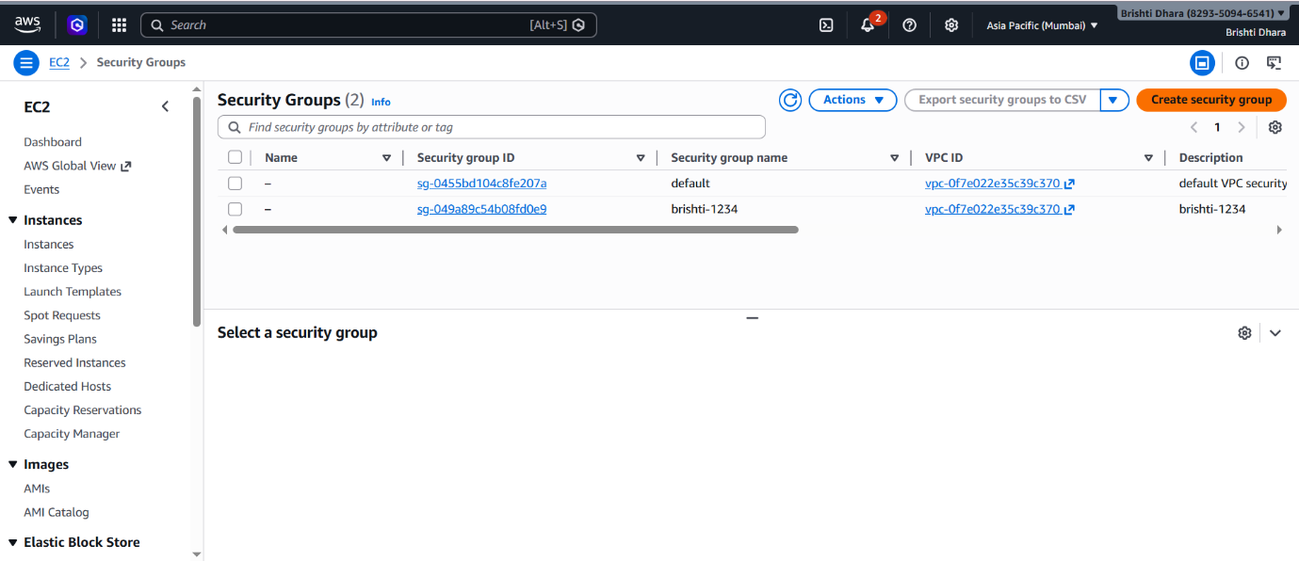

STEP 3. Add Basic details and then in ‘Inbound rules’ go to ‘Add rule’.
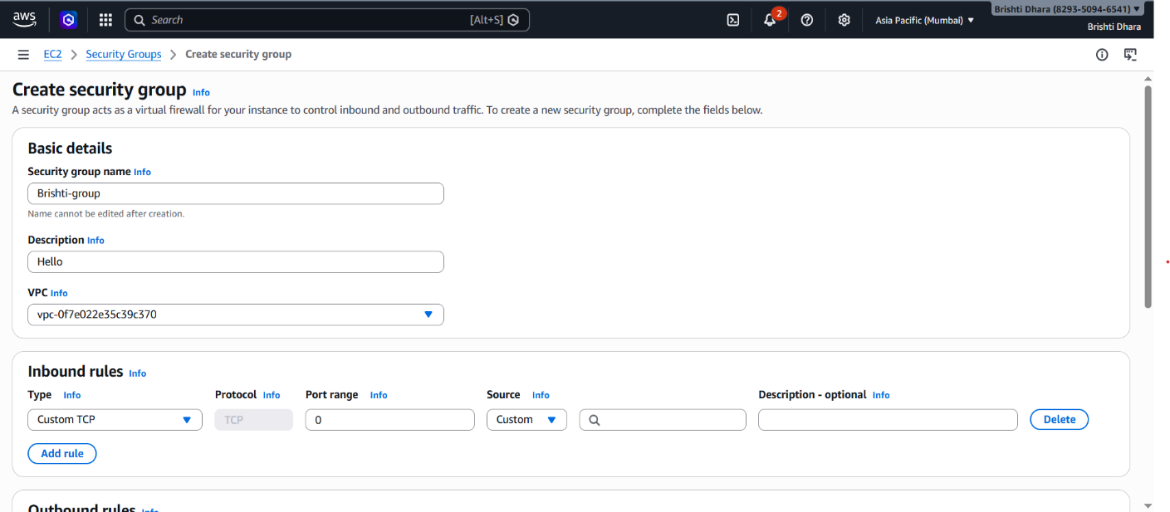

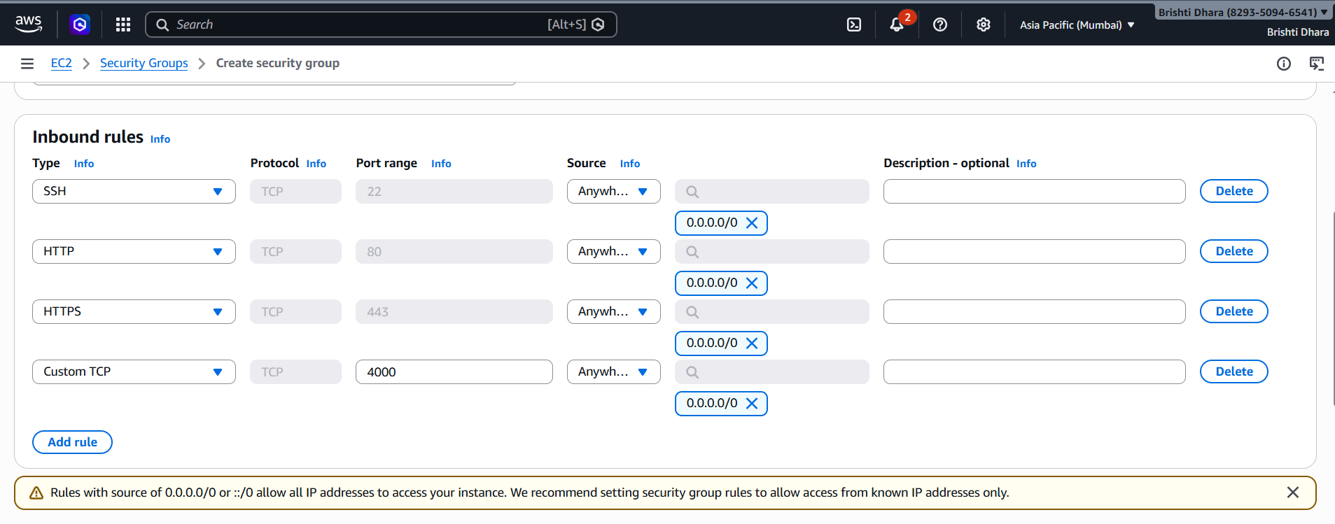
STEP 4. Add all the necessary rules like SSH, HTTP and HTTPS from anywhere;
along with a Custom TCP rule allowing traffic on port 4000 from anywhere.

STEP 5. Then finally ‘Create security group’.
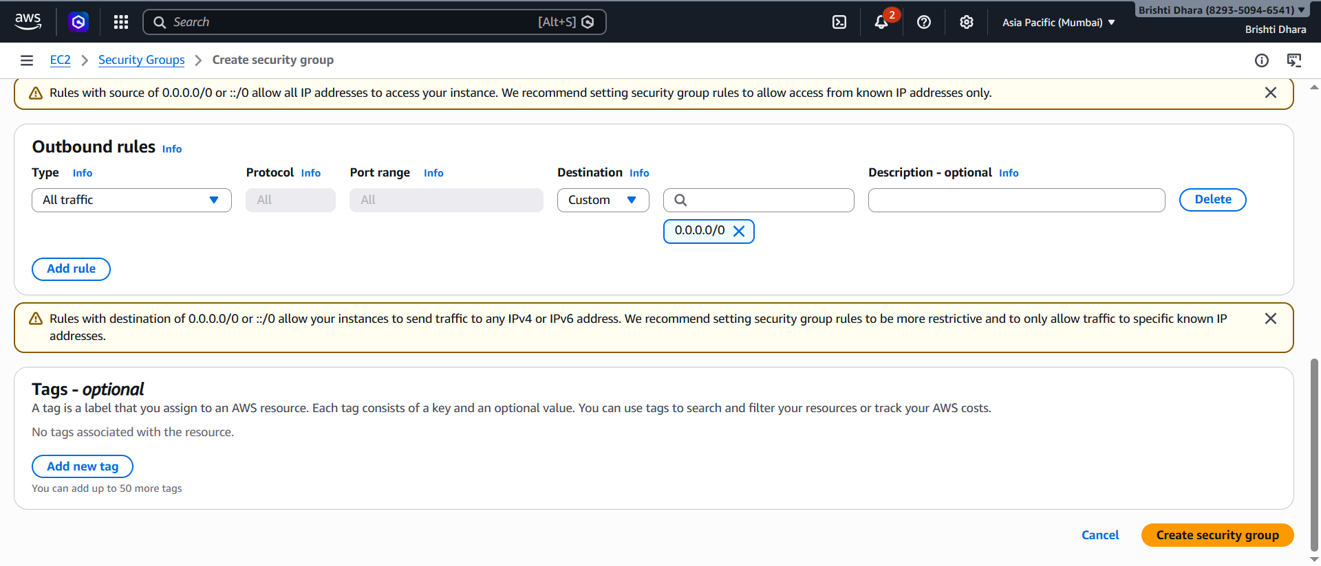

STEP 6. After the security group is created, go to ‘EC2 Dashboard’.
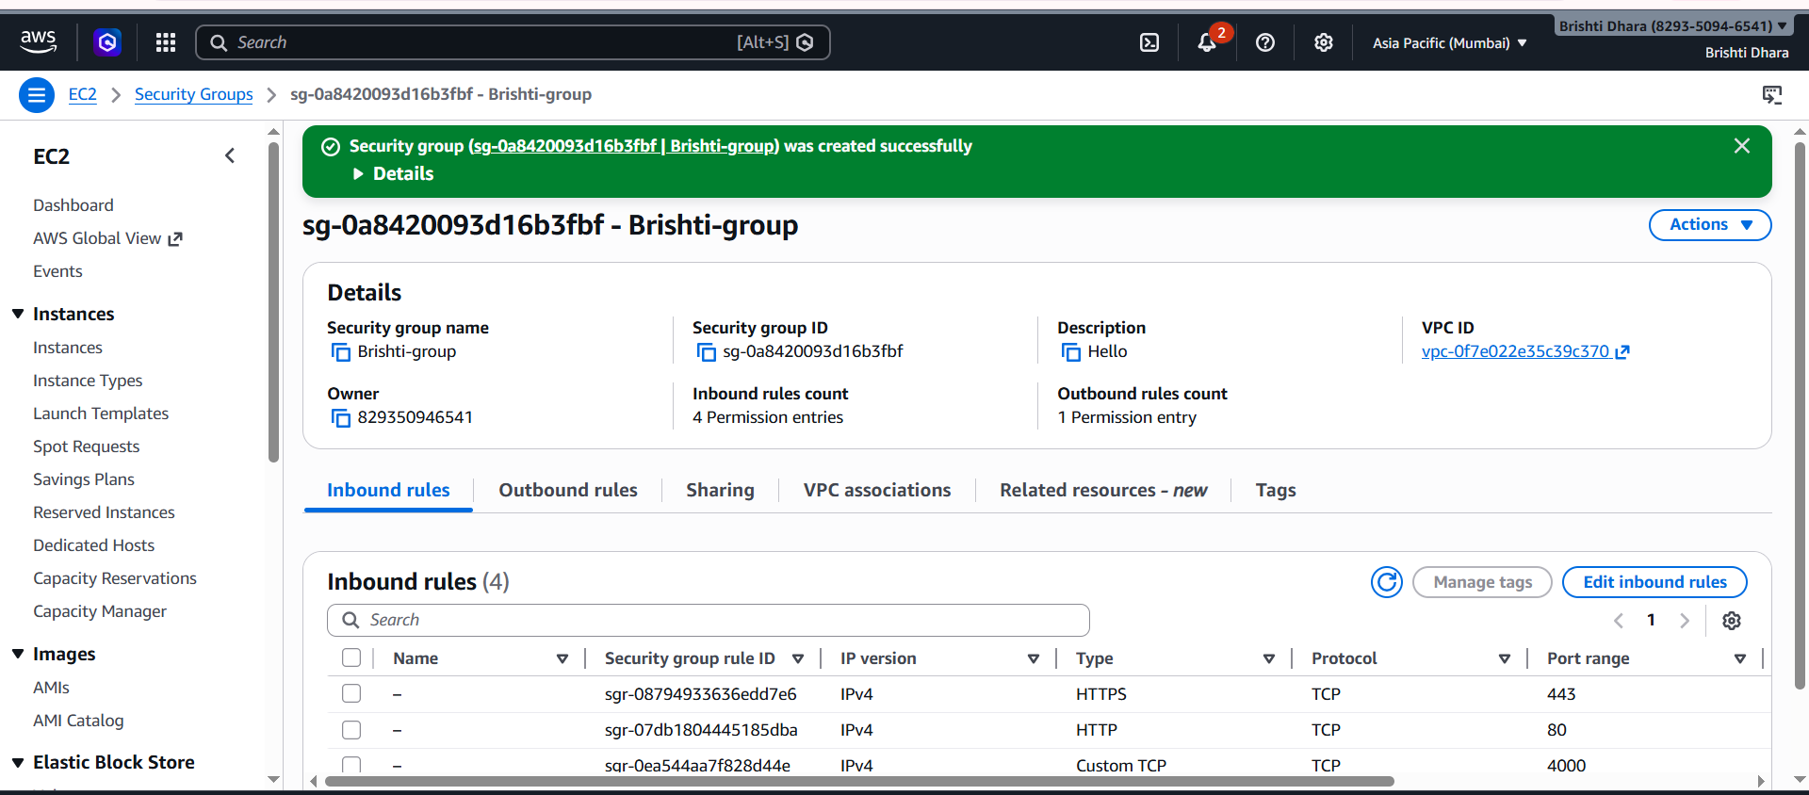

STEP 7. Click on ‘Launch instance’.

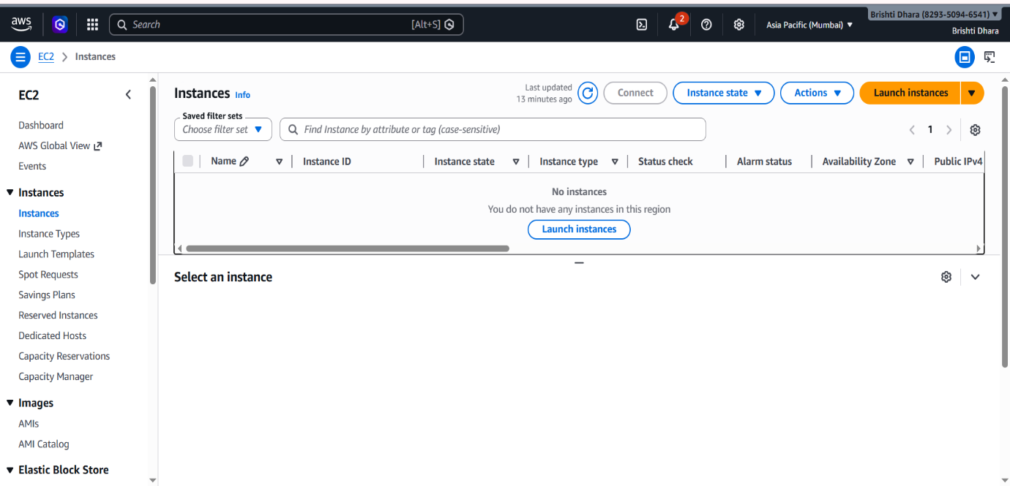

STEP 8. Fill up the required details-> ‘Name’ and under ‘Application and OS Images’ select ‘ubuntu’.

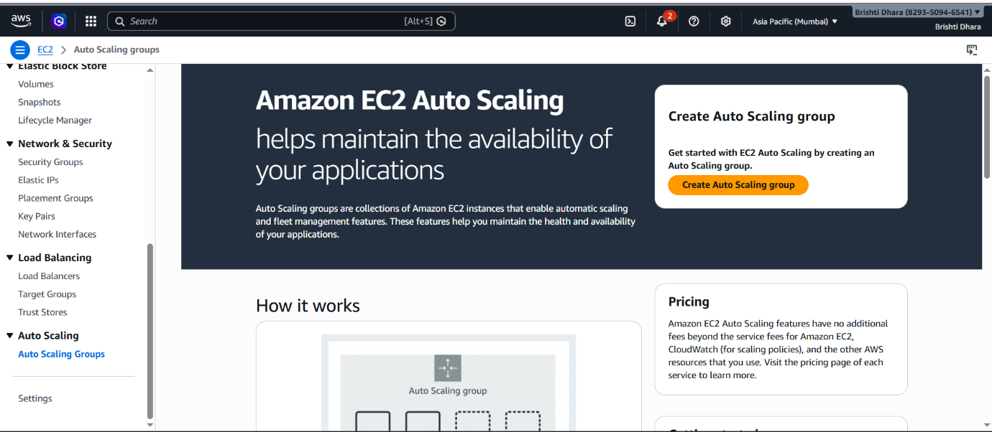

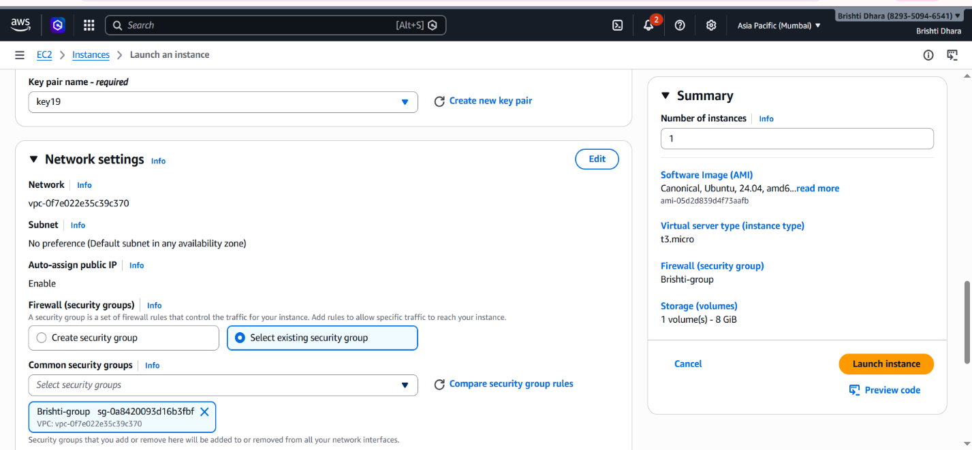
STEP 9. In ‘Key pair (login)’, click on ‘Create new key pair’, give ‘key pair name’ and create it. For ‘Network Settings’ from ‘Select existing security group’ choose the security group you just created.

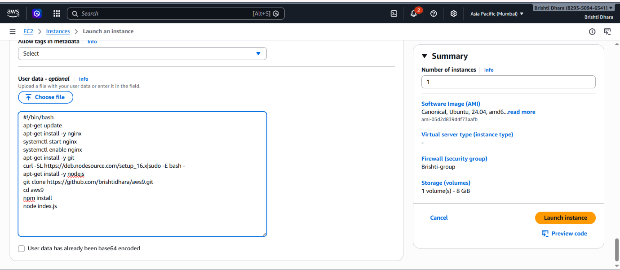
STEP 10. Scroll Down and Click on ‘Advanced details’. In ‘Advanced details’ go to the last, in advanced data put the following bash script. Then click on ‘Launch instance’.

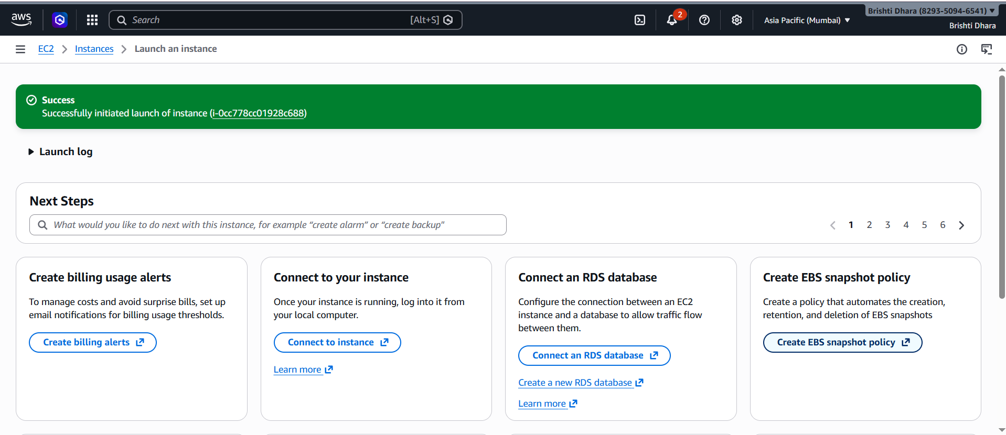
STEP 11. ‘Brishti1’ instance is created successfully.

Step 12. Go to the newly created instance and click on the Connect button.
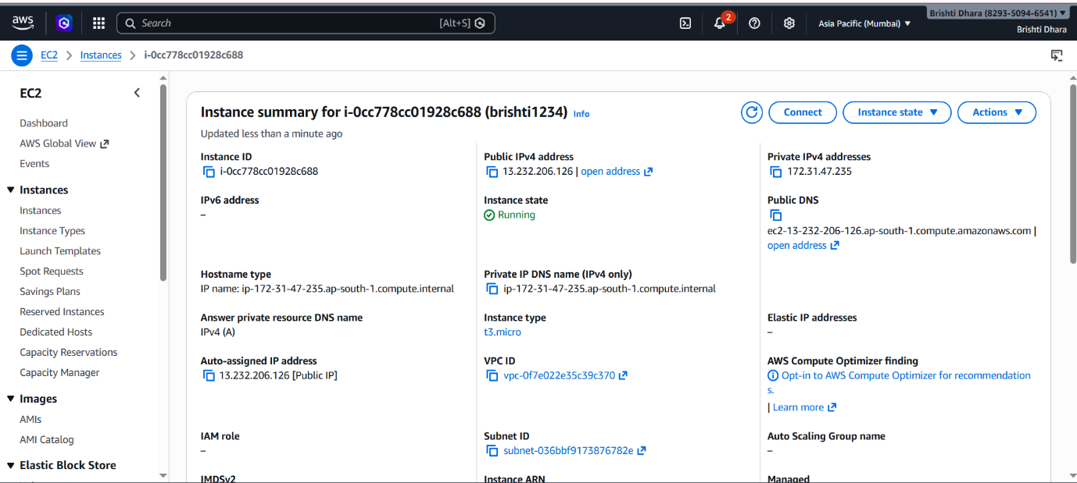

Step 13.Inside this page, click on the Connect button.
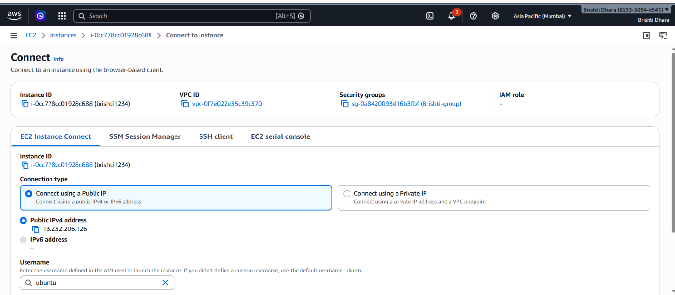

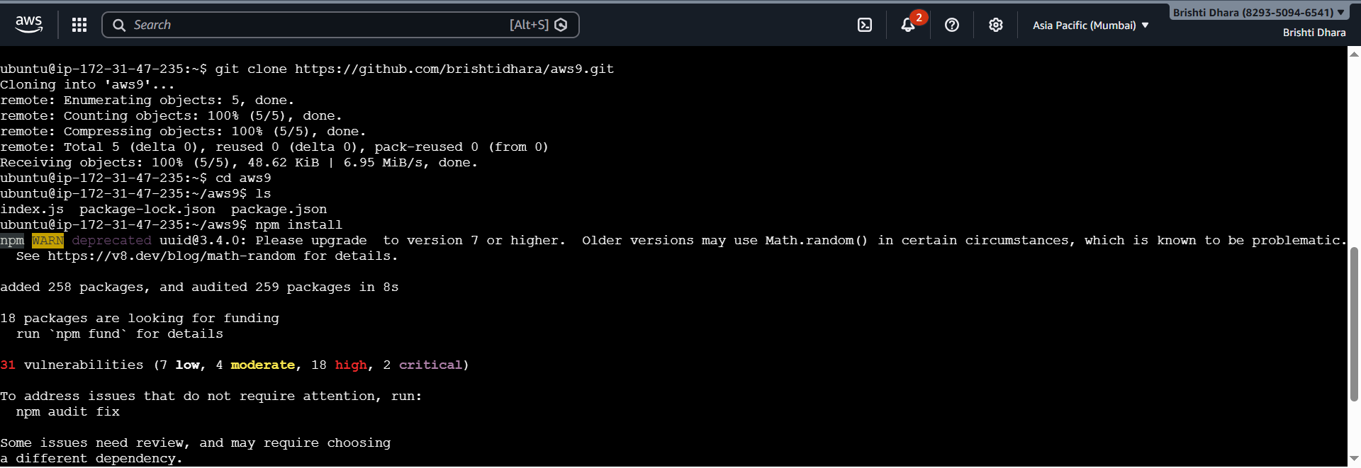
14. A new tab will be opened with a terminal. Enter the command git clone https://github.com/brishtidhara/aws9.git to clone the repo containing the project. Then go to the cloned folder and Enter command ls to check the files present.

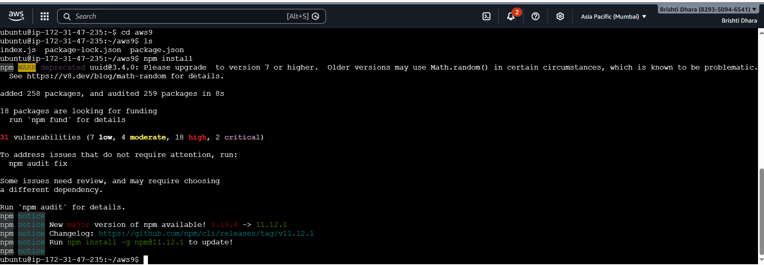

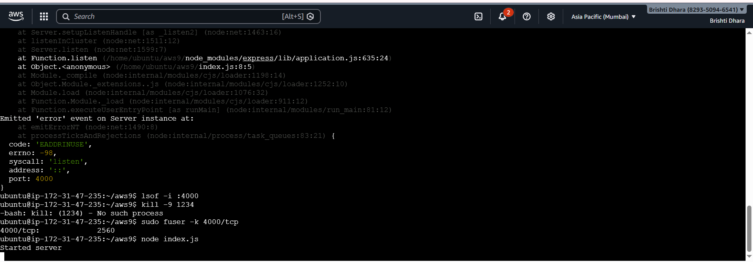
Step 15.Enter the command npm install to install the dependencies, node index.js to start the server.

Step 16. We can put the public IPv4 address on the URL address bar a new tab to open the website.


