NAME-BRISHTI DHARA(CSE/23/90)
ASSIGNMENT: 11
PROBLEM STATEMENT: Build scaling plans in aws that balance the load on different EC2 instances.
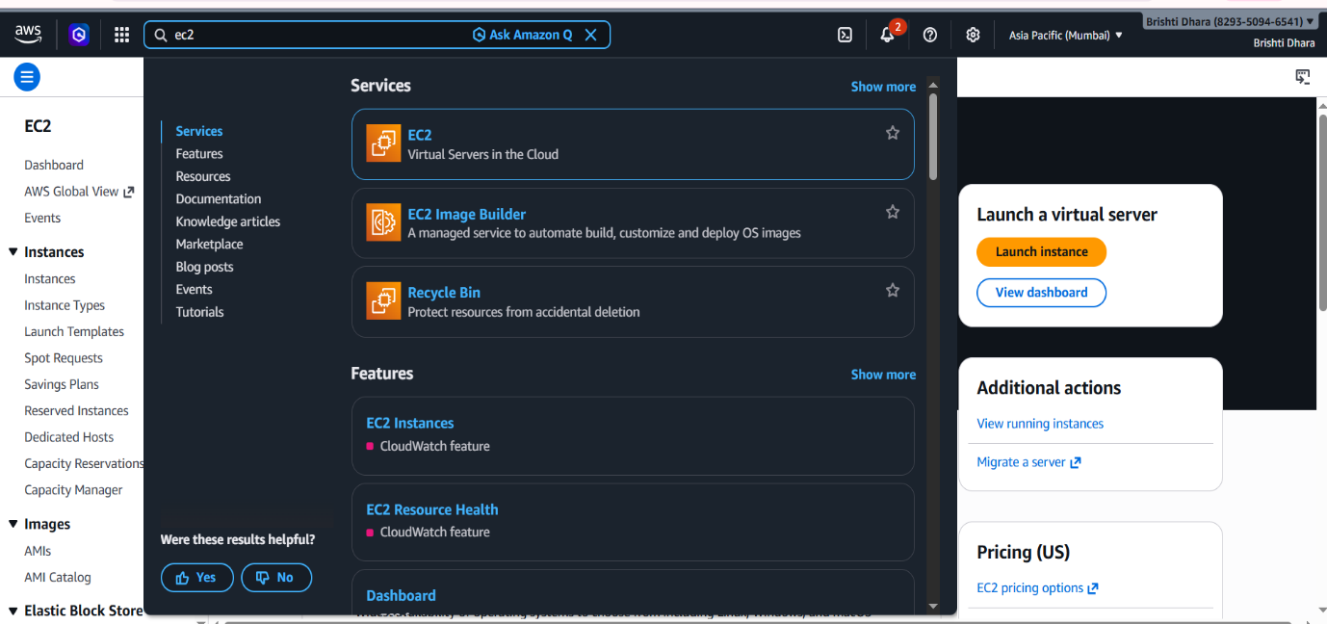
Step1: Sign up for an AWS account, search for ‘EC2’ then click on it

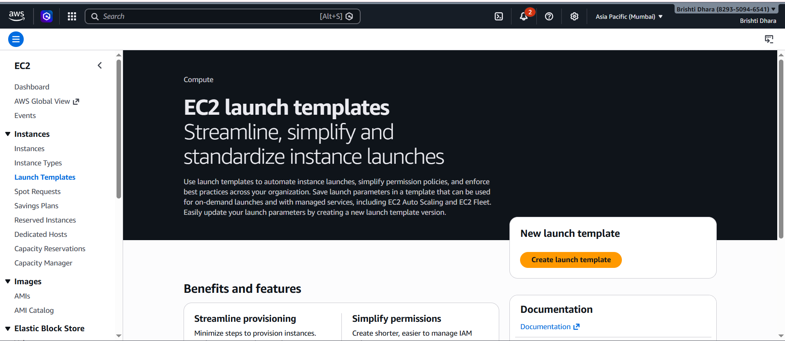
Step2: Click on ‘Launch Templates’ & then ‘Create launch template’

STEP 3: In ‘Launch templet name and description’ give a name and description to your launch templet and select the check box for ‘Provide guidance to help me set up a template that I can use with EC2 Auto Scaling’.
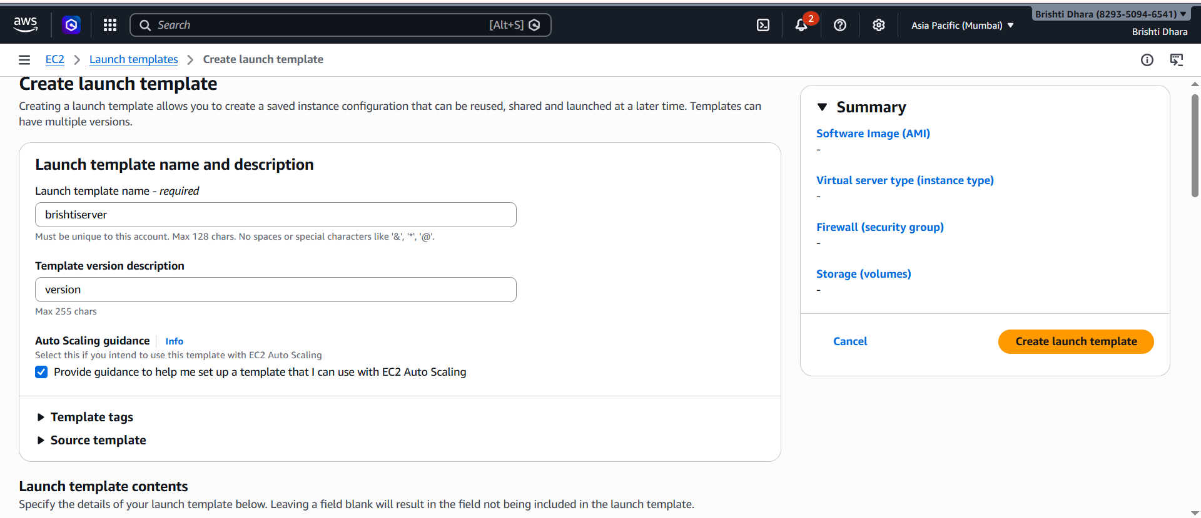

STEP 4. For OS Image select ‘ubuntu’.
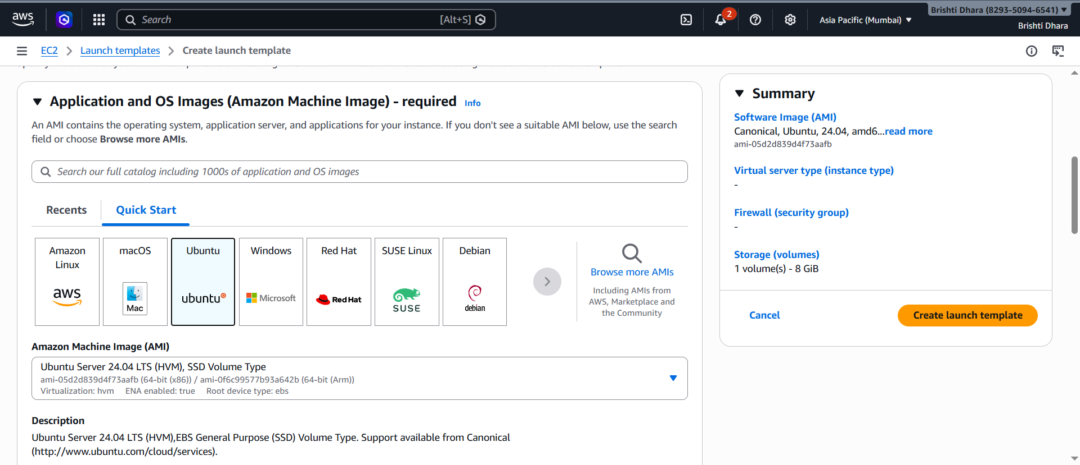

STEP 5. For instance type, select ‘t2.micro’ or any other free tire eligible instance type. For key pair, select an existing key pair or create a new key pair. For security group select an existing security group where port 4000 is open for incoming traffic.
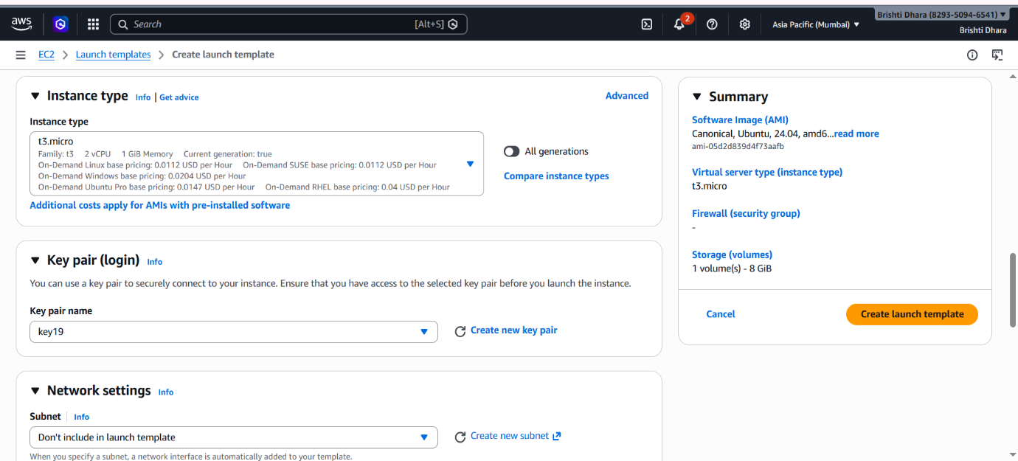

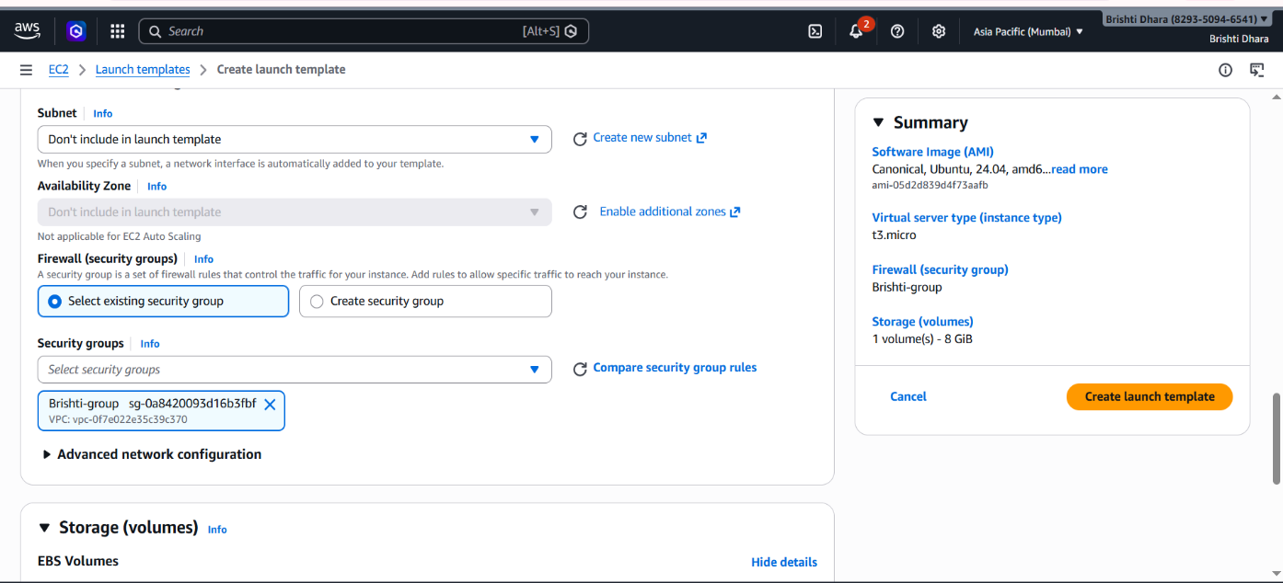

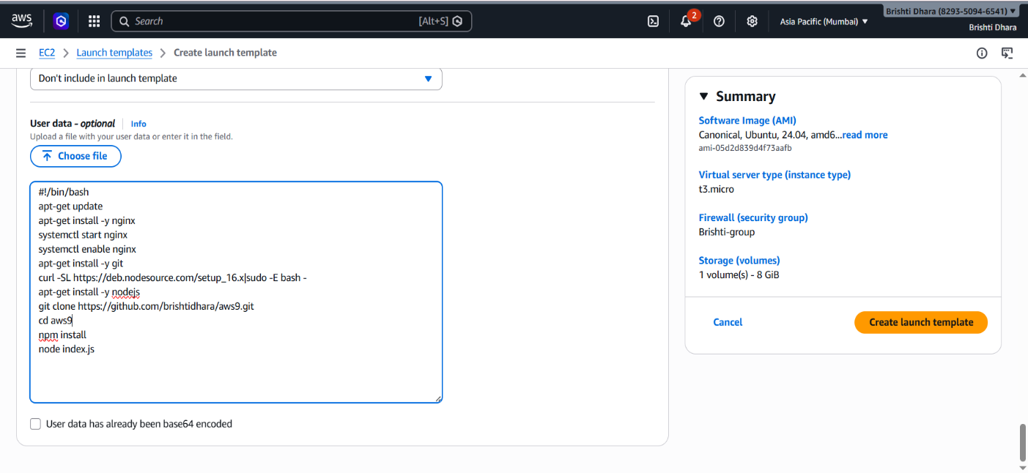
STEP 6. In Advanced details scroll down to the bottom and add the text to the user data. Then click on Create launch template.

STEP 7. Launch Templates created successfully.
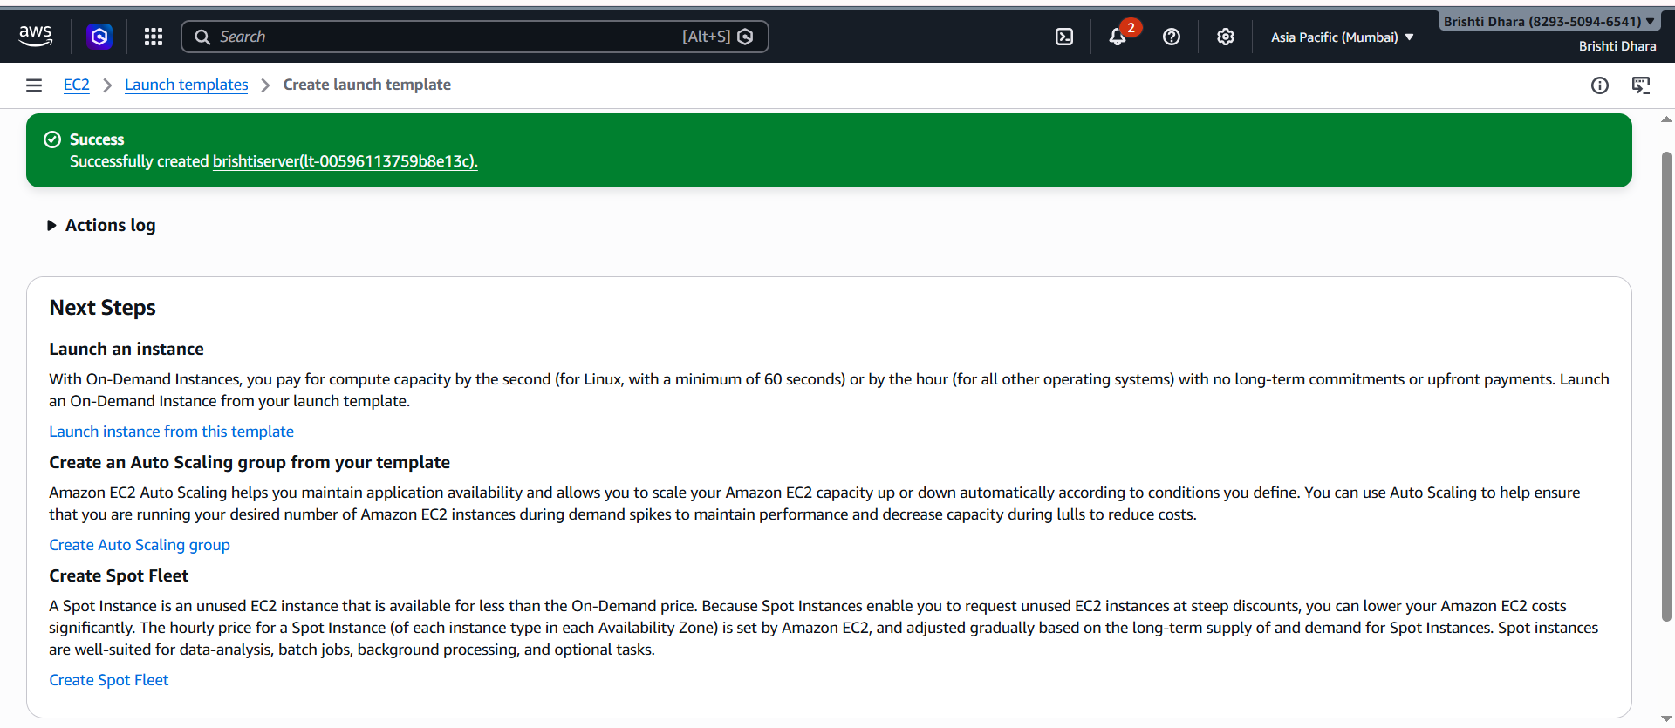

STEP 8. Scroll down and click on View launch templates -> Now go to ‘Create Auto Scaling Groups’
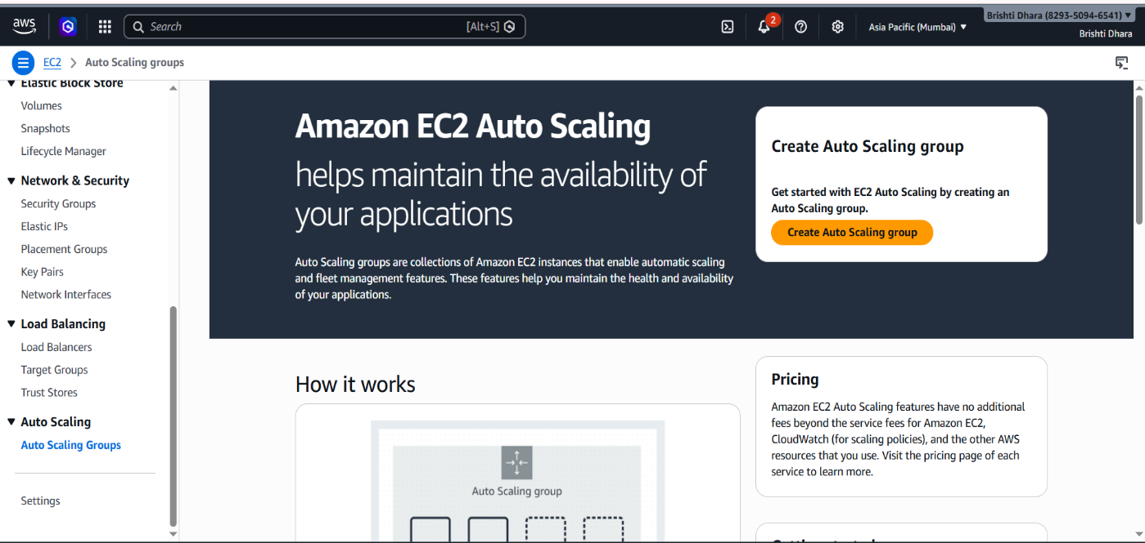

STEP 9. Add Details for the Auto Scaling Group. In Step 1, Choose launch templates- Give a name to the Auto Scaling Group and choose the Launch template you just created as the launch template. Click on Next.

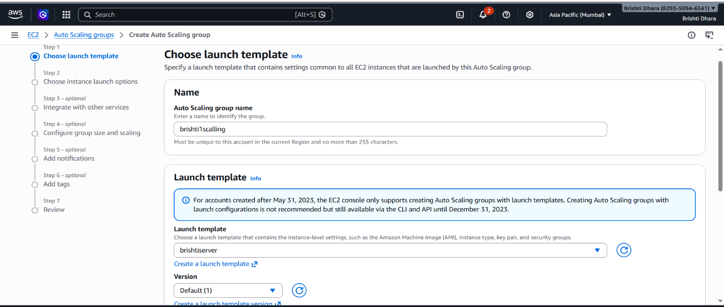

STEP 10. In Step 2, Choose instance launch options- Choose all the ‘Availability Zones’ available. Click on Next.
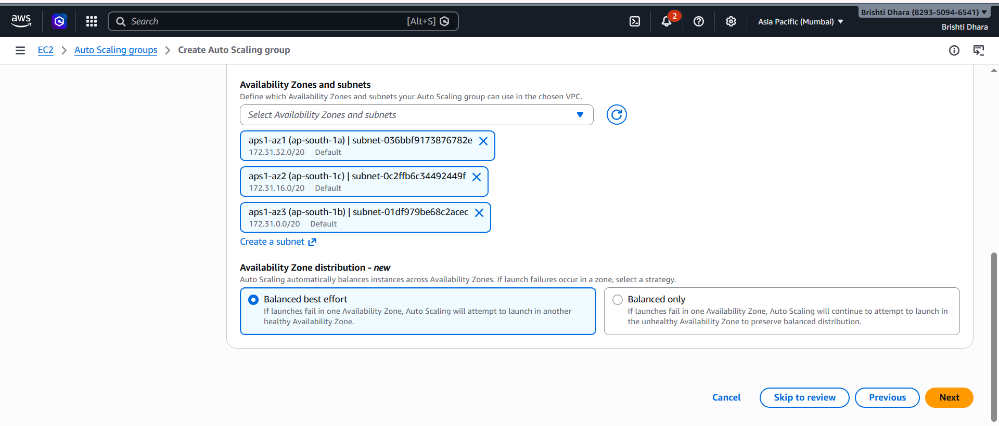

STEP 11. In Step 3, Configure advanced options- For Load balancing select ‘Attach to a new load balancer’.
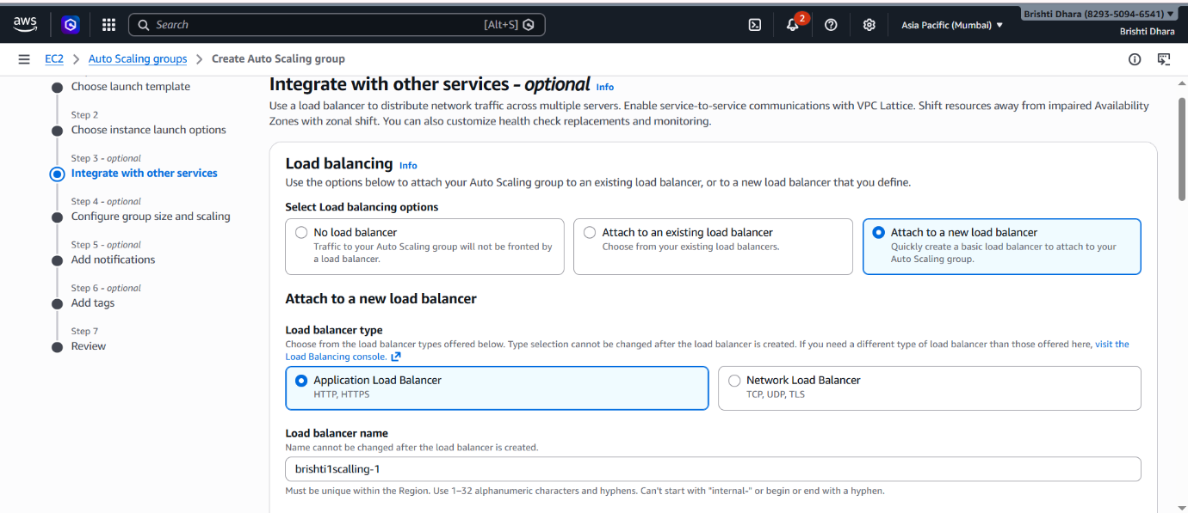

STEP 12. For new load balancer configuration select ‘Application Load Balancer’, ‘Internet-facing’ and make HTTP port from 80 to 4000 while creating a target group.
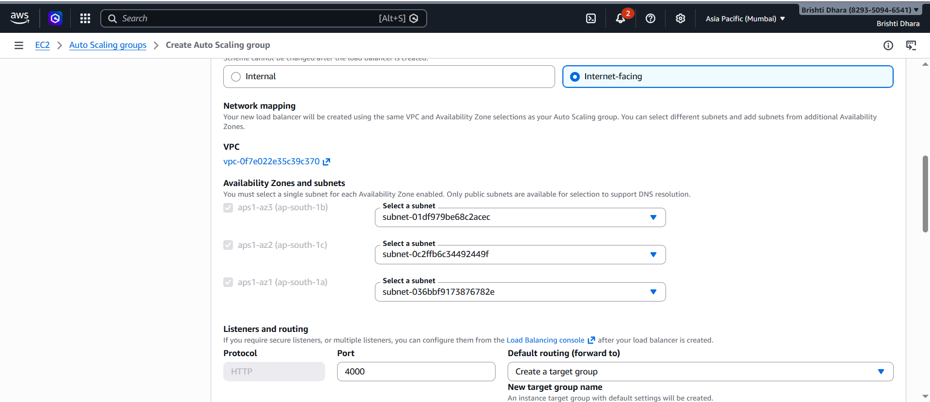

STEP 13. Health checks tick the check box for ‘Turn on Elastic Load Balancing health checks’ and make the health check grace period 200 seconds. Click on Next.

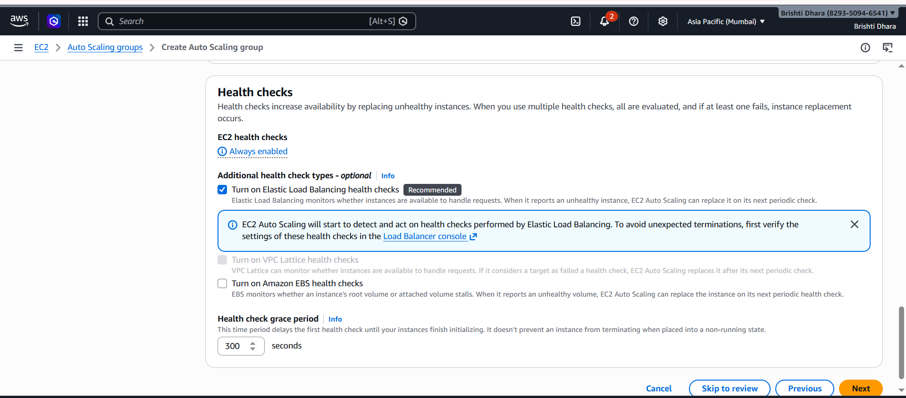

STEP 14. In Step 4, Configure group size and scaling- In Group size set Desired capacity as 2. In Scaling set Min desired capacity as 2 and Max desired capacity as 3. In Automatic scaling choose target scaling policy .Keeping everything else as default, Click on Next.
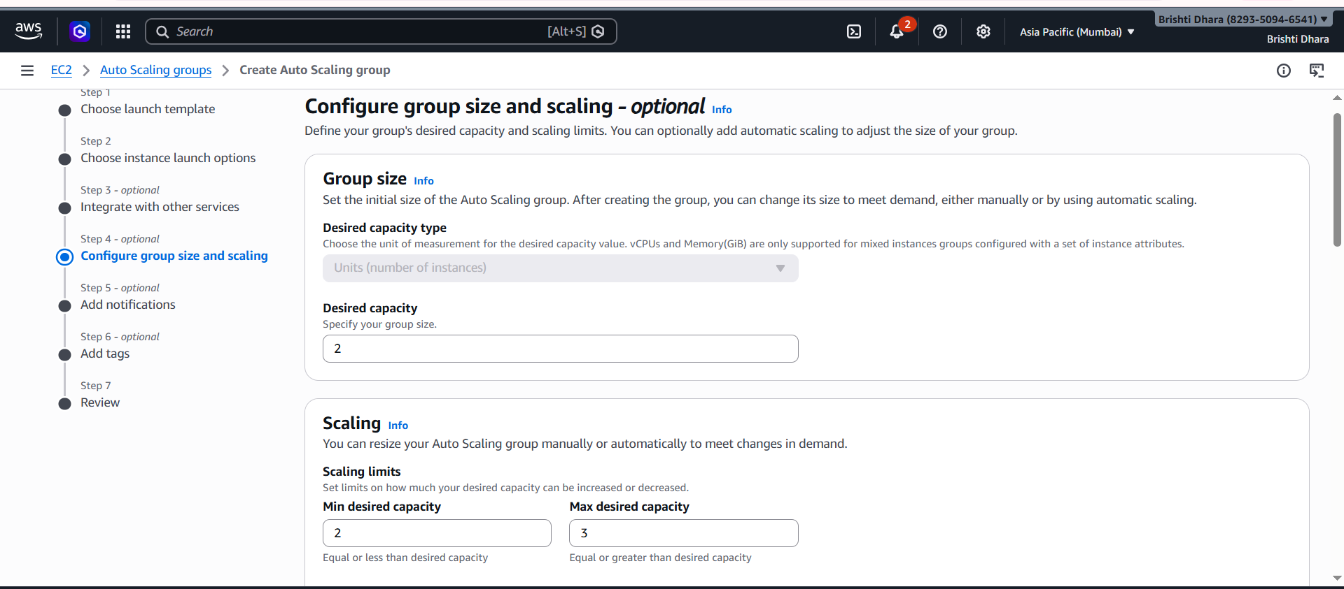

STEP 15. Skip through Step 5 and Step 6 by clicking Next. Finally In Step 7 Click on Create Auto Scaling Group.
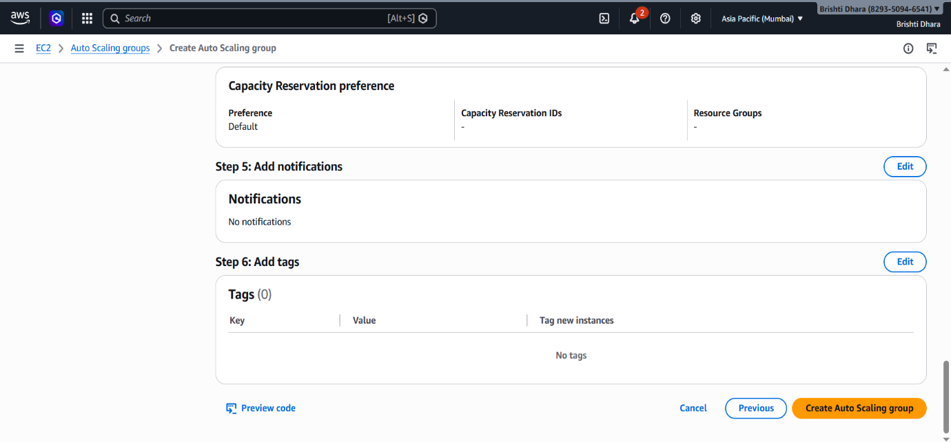

STEP 16. Auto Scaling Group is created successfully.
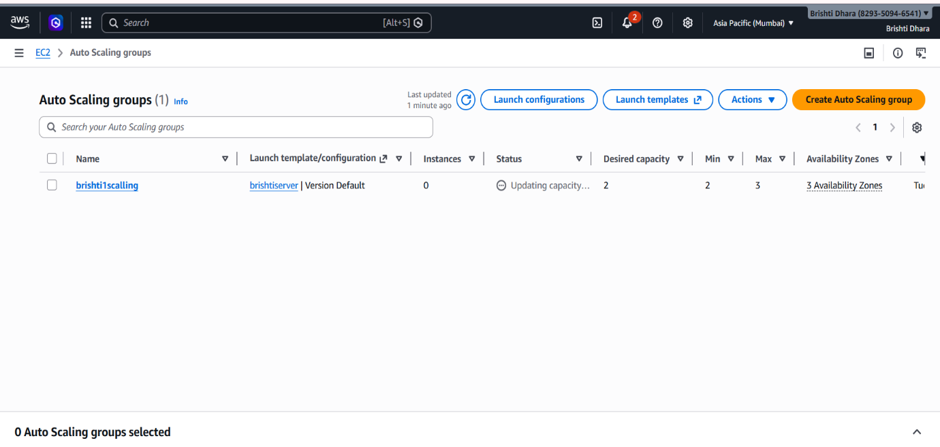

Step 17 . Now in instances we can see two instances have been created->copy IPv4 of any instance and paste it. Now paste the public ipv4 of any one instance and then add : 4000 to it.


Step 18: In Bitvise SSH Client, paste the ‘Public IPV4 address’ and click on ‘Client key Manager’. 20. In Bitvise SSH Client, paste the ‘Public IPV4 address’ and click on ‘Client key Manager’. 22. In ‘Bitvise SSH Client’, under ‘Default profile’ give the ‘Username’ as ‘ubuntu’ then select ‘Global1’ from ‘Client Key Manager’ then click on ‘Log in’ & ‘Accept and save.
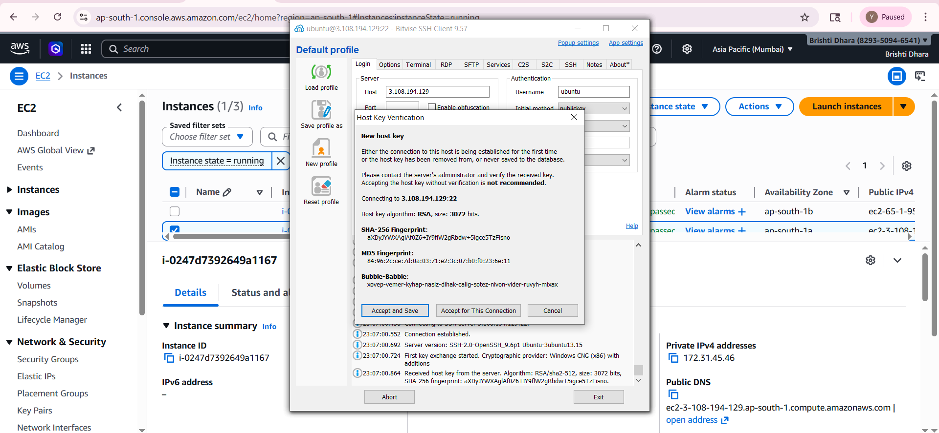

STEP 19. Click on ‘New terminal console’, to access the terminal of your instance. Inside the terminal type ‘sudo nano brishti1.sh’ to create an infinitely running bash script. In the bash script, add the following code.
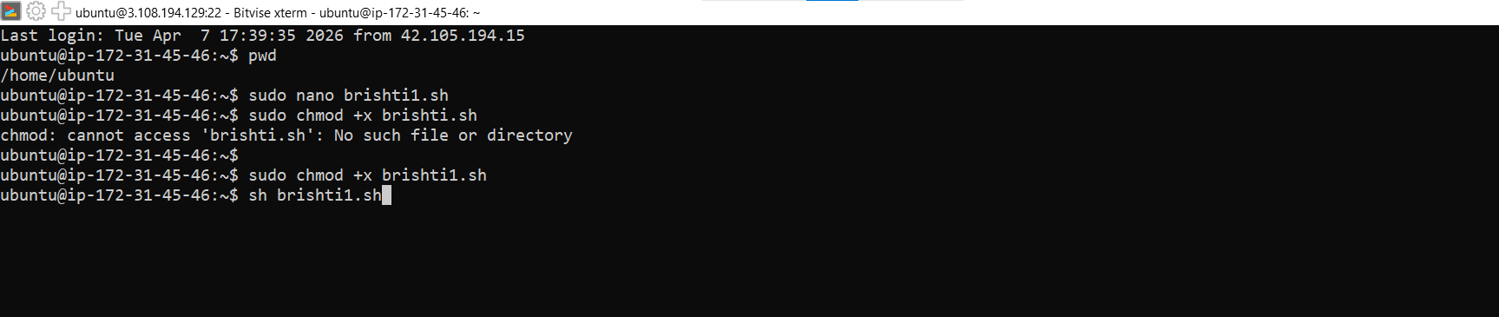

STEP 20. To make the script executable, type ‘sudo chmod +x anoushka.sh’ ->Run the script ‘sh brishti1.sh’.




STEP 21. An infinite loop starts to run, stressing the CPU of the instance.
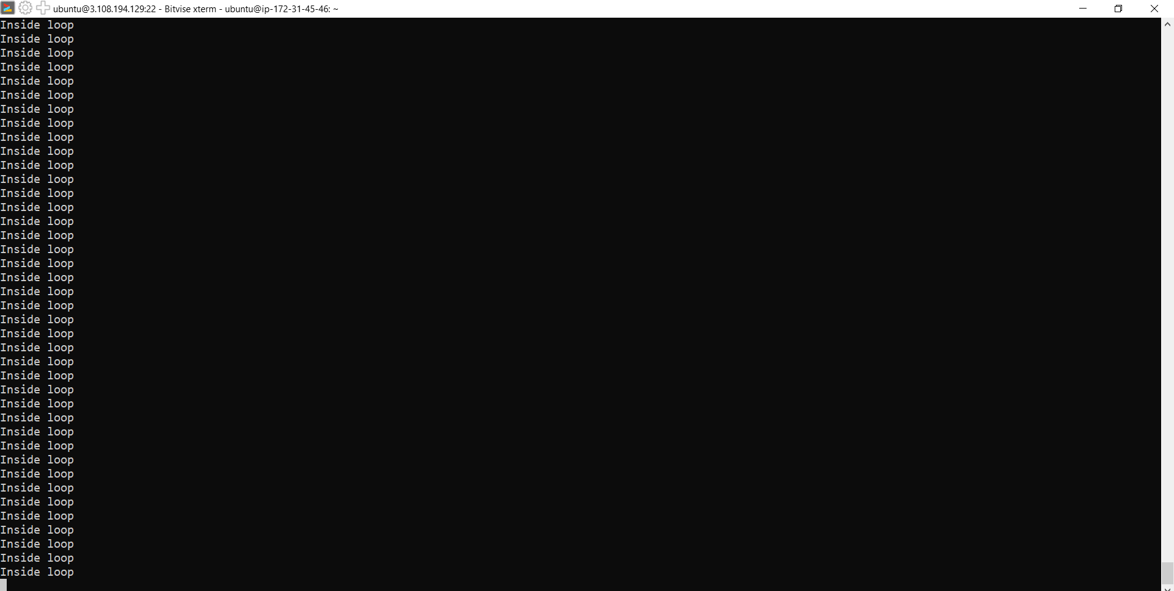

STEP 22. Selecting the two instances we can look at the CPU utilisation graph.

