NAME-BRISHTI DHARA(CSE/23/90)
Assignment No : 12
Problem Statement: Deploy and run the project in AWS without using the port.
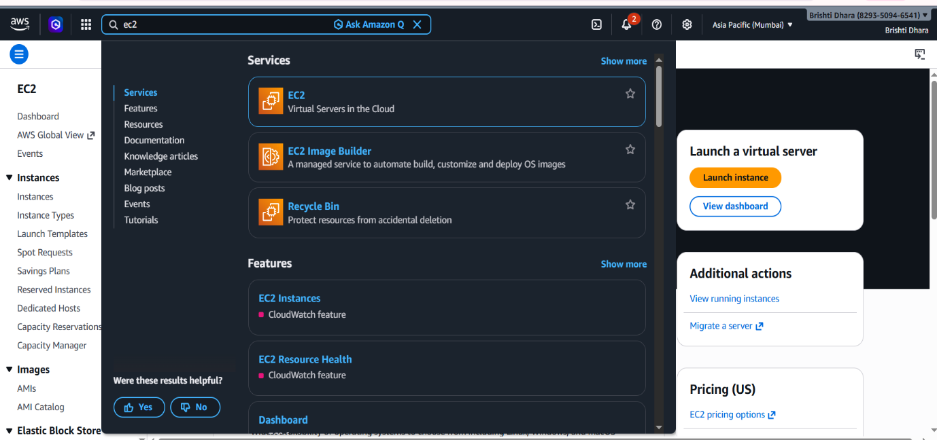
Step 1: Search EC2 in the search bar and click on it.

Step 2: In the EC2 page, click in Launch Instance button.
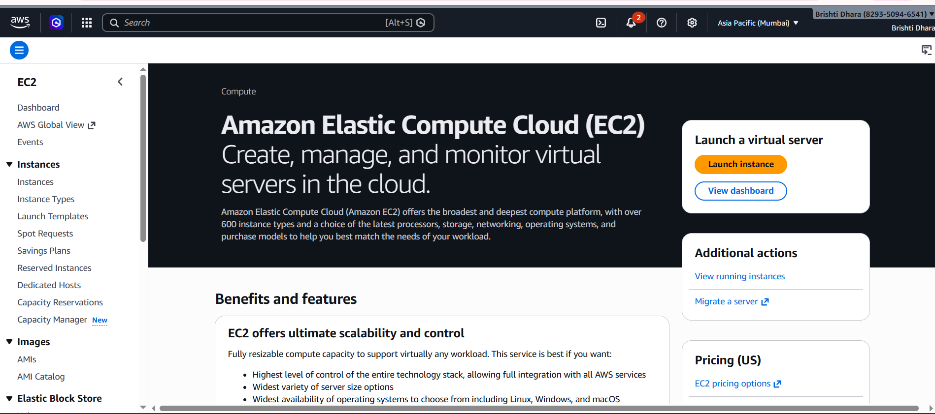

Step 3: Enter the name (server-brishti), choose ubuntu as Quick start.
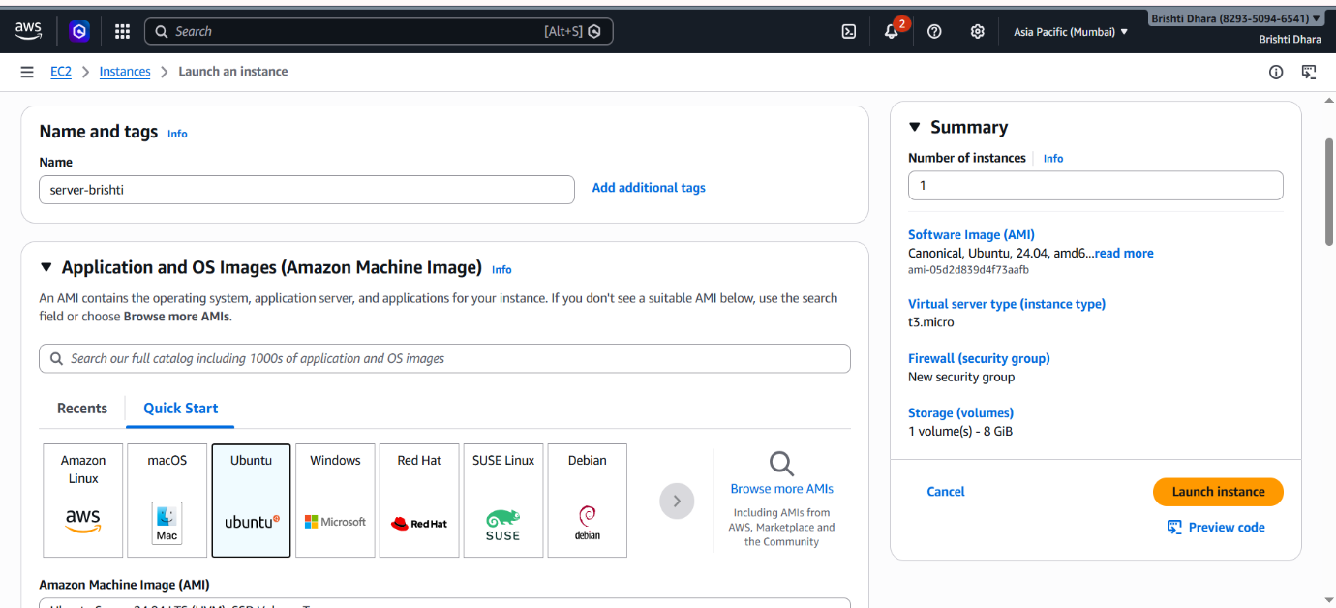

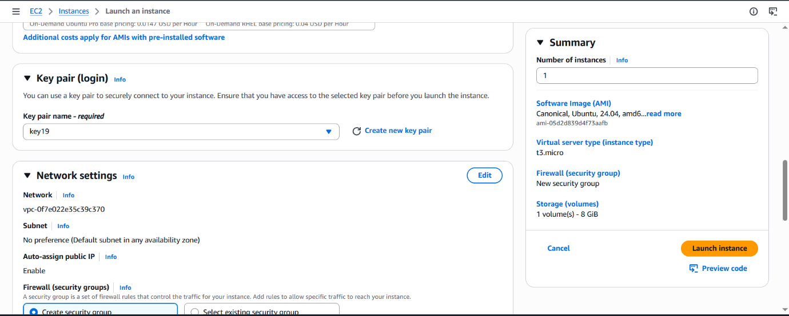
Step 4: Choose a key pair name from the existing. Choose Select existing security group and choose on of the existing groups in this case Brishti group.

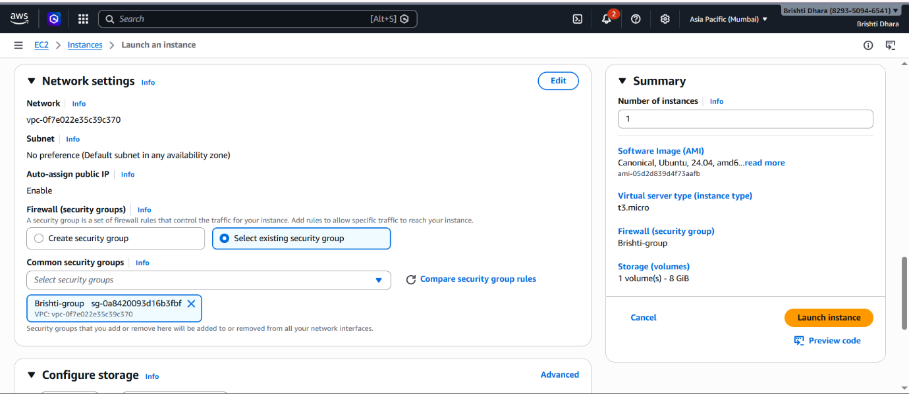

Step 5: In the user data field enter the following script and click on Launch Instance button.
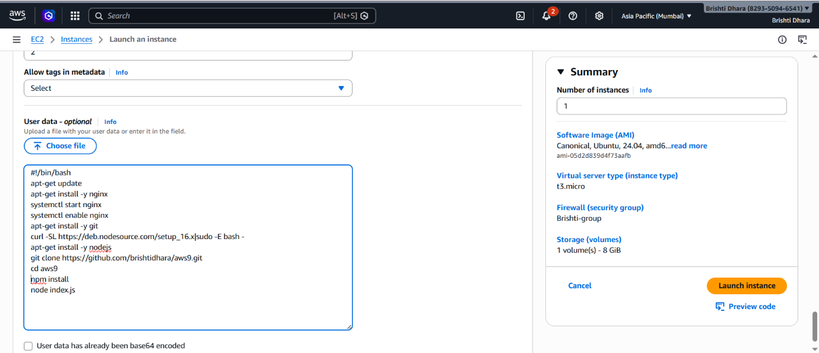

Step 6: A new Instance will be successfully created.
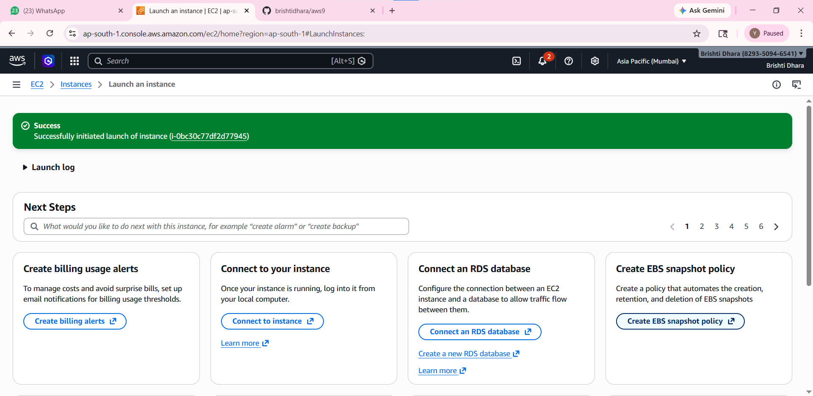

Step 7: We can see the instance is running by going to the IPv4 link and with :4000 port.

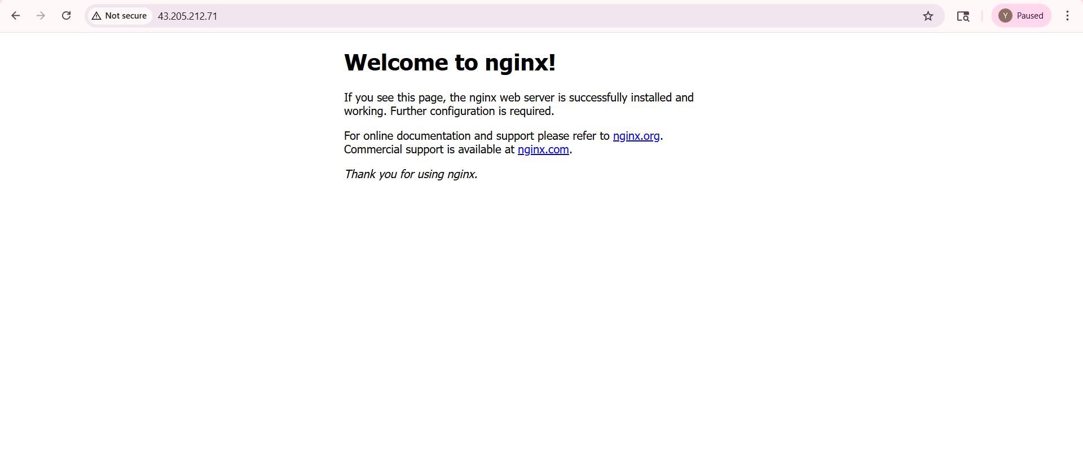

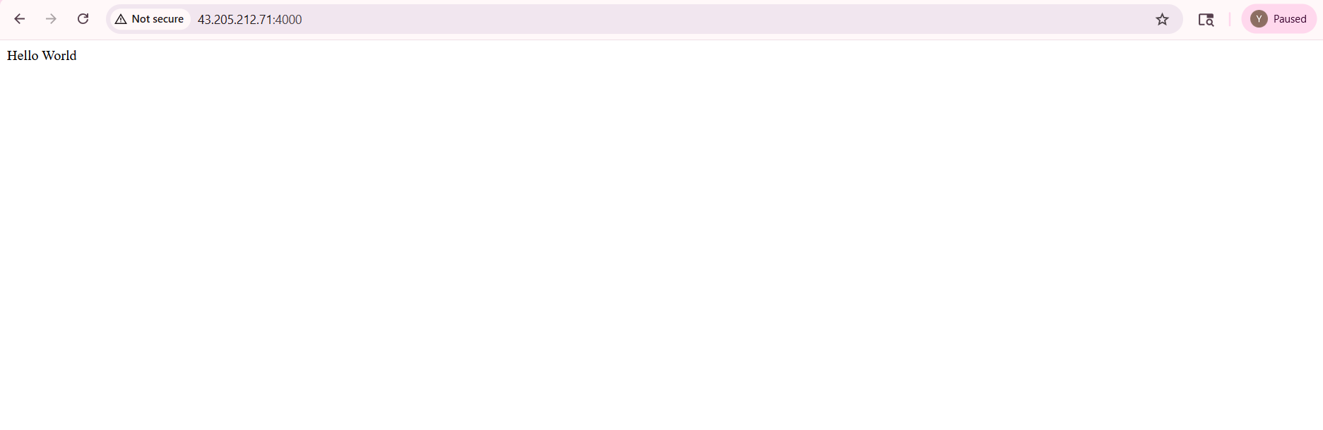

Step 8: Open bitwise, and enter the Host, Username as ubuntu, initial method as public key and click on the Log in button. It will be successfully connected. Click on the New terminal console button to open a new console.

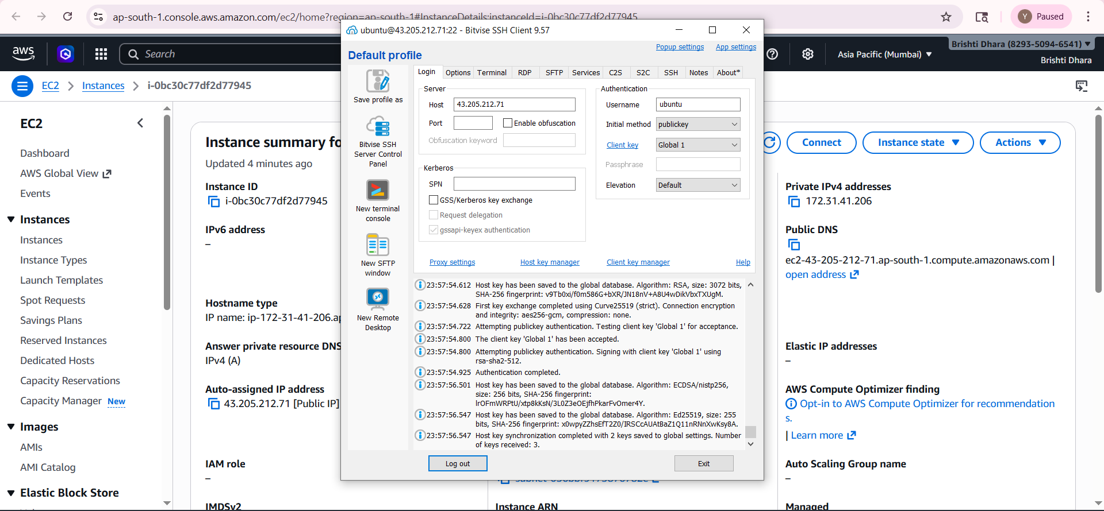

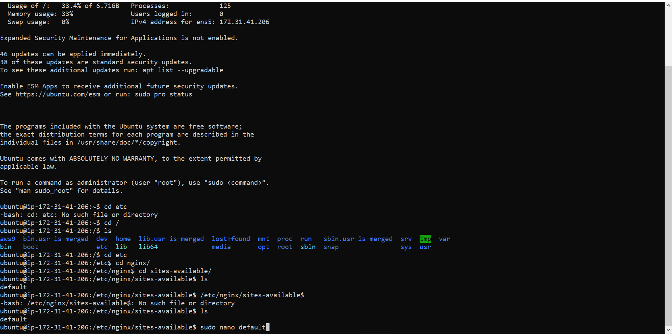
Step 9: In the terminal, enter the commands cd / to go to the root, ls to view the files, then cd etc, cd nginx/, cd sites-available/ to go to the required directory.

Step 10: Enter the command sudo nano default to edit the default file.


Step 11: In the file edit the location / {} and write the following.
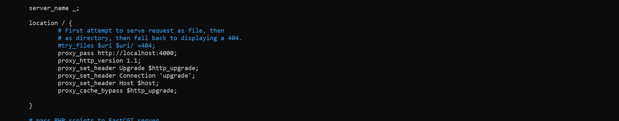

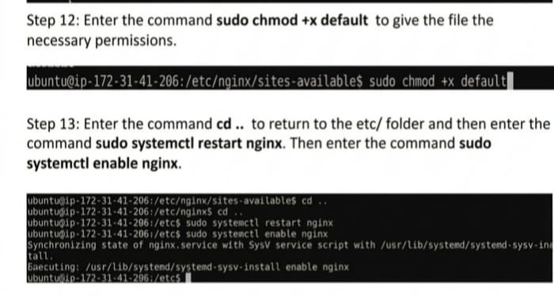

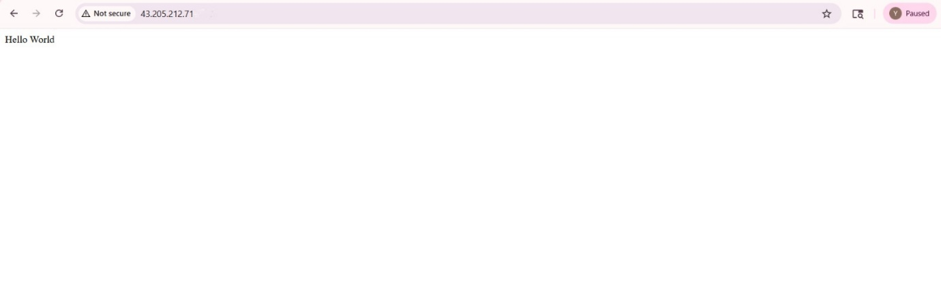
Step 14: The project will be deployed and run without a port.

