NAME-BRISHTI DHARA (CSE/23/90)
Assign9(Problem Definition): - Deploy a project from GitHub to EC2.
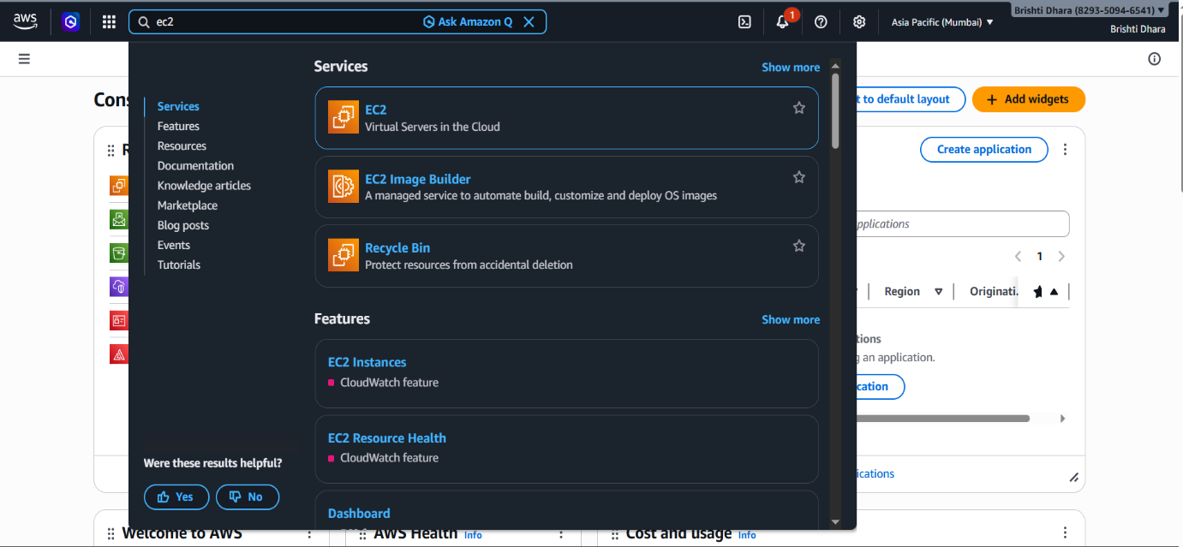
Step-1: Sign up for an AWS account, search for ‘EC2’ then click on it.

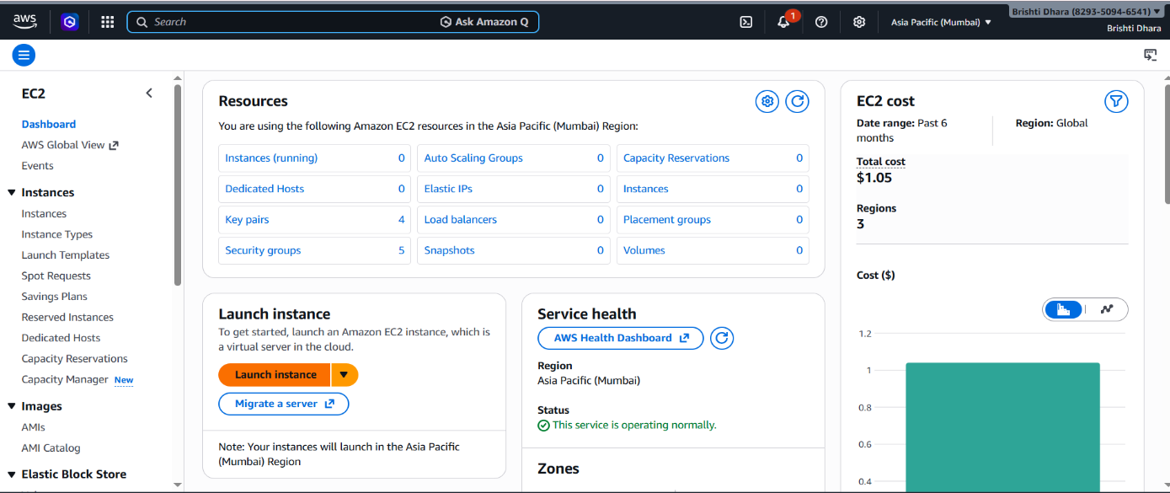
Step-2: Click on ‘Launch instance’.

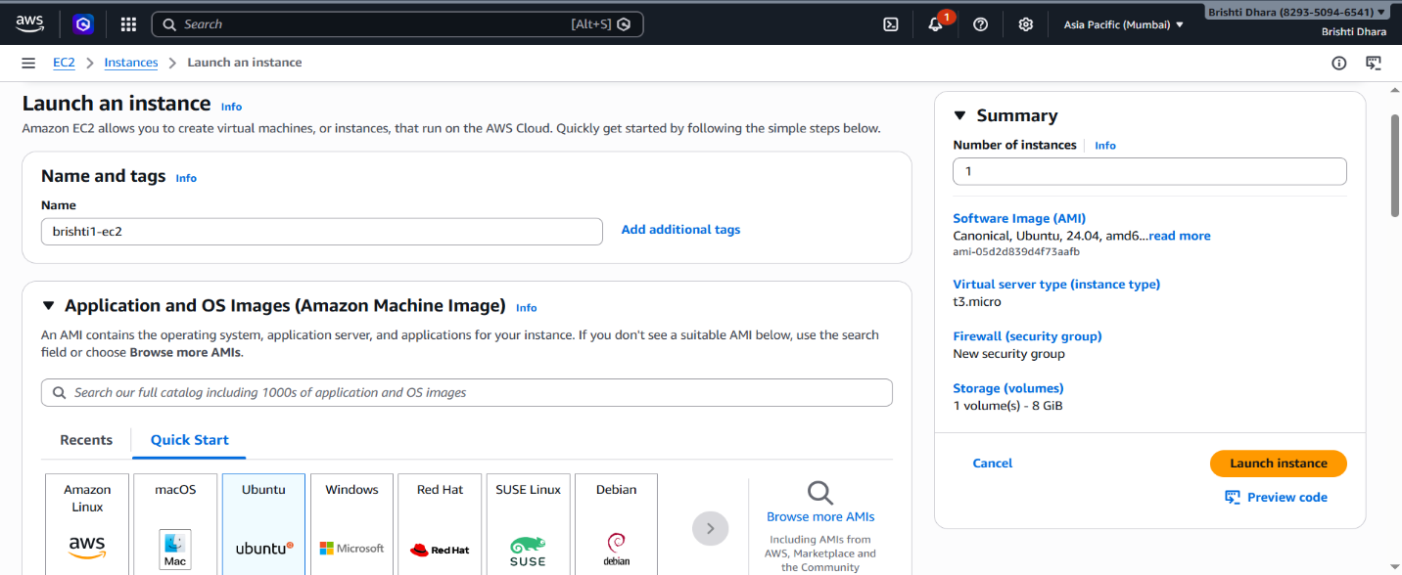
step-3: Fill up the required details-> ‘Name’ and under ‘Application and OS Images’ select ‘ubuntu’.

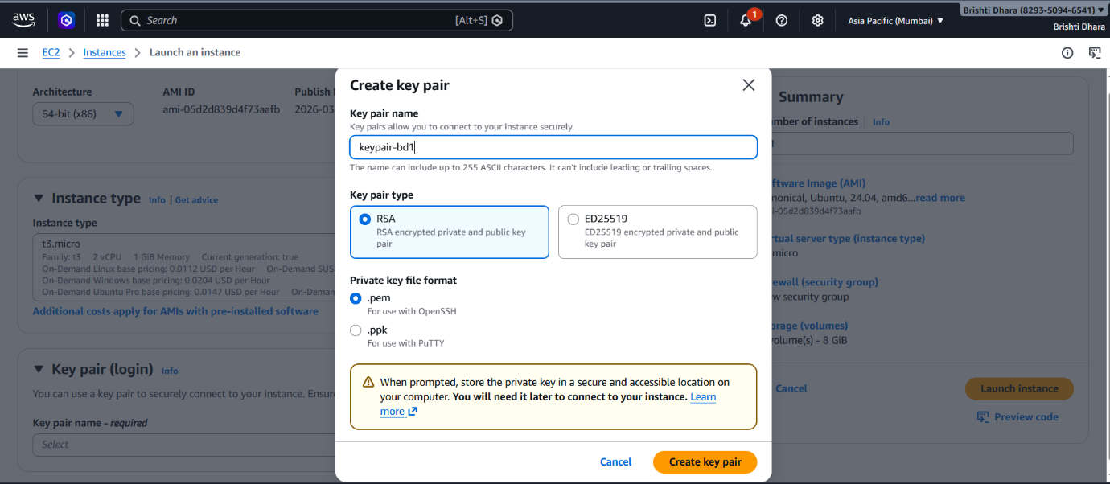
Step-4: In ‘Key pair (login)’, click on ‘Create new key pair’, give ‘key pair name’ and create it. Under ‘Network Settings’ tick on all checkboxes. Then Launch instance.

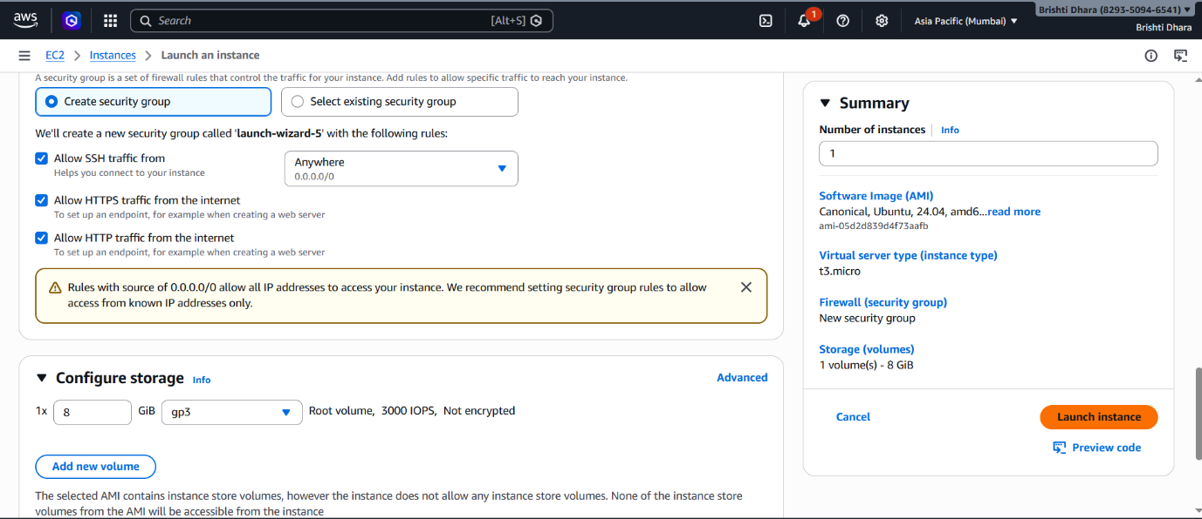

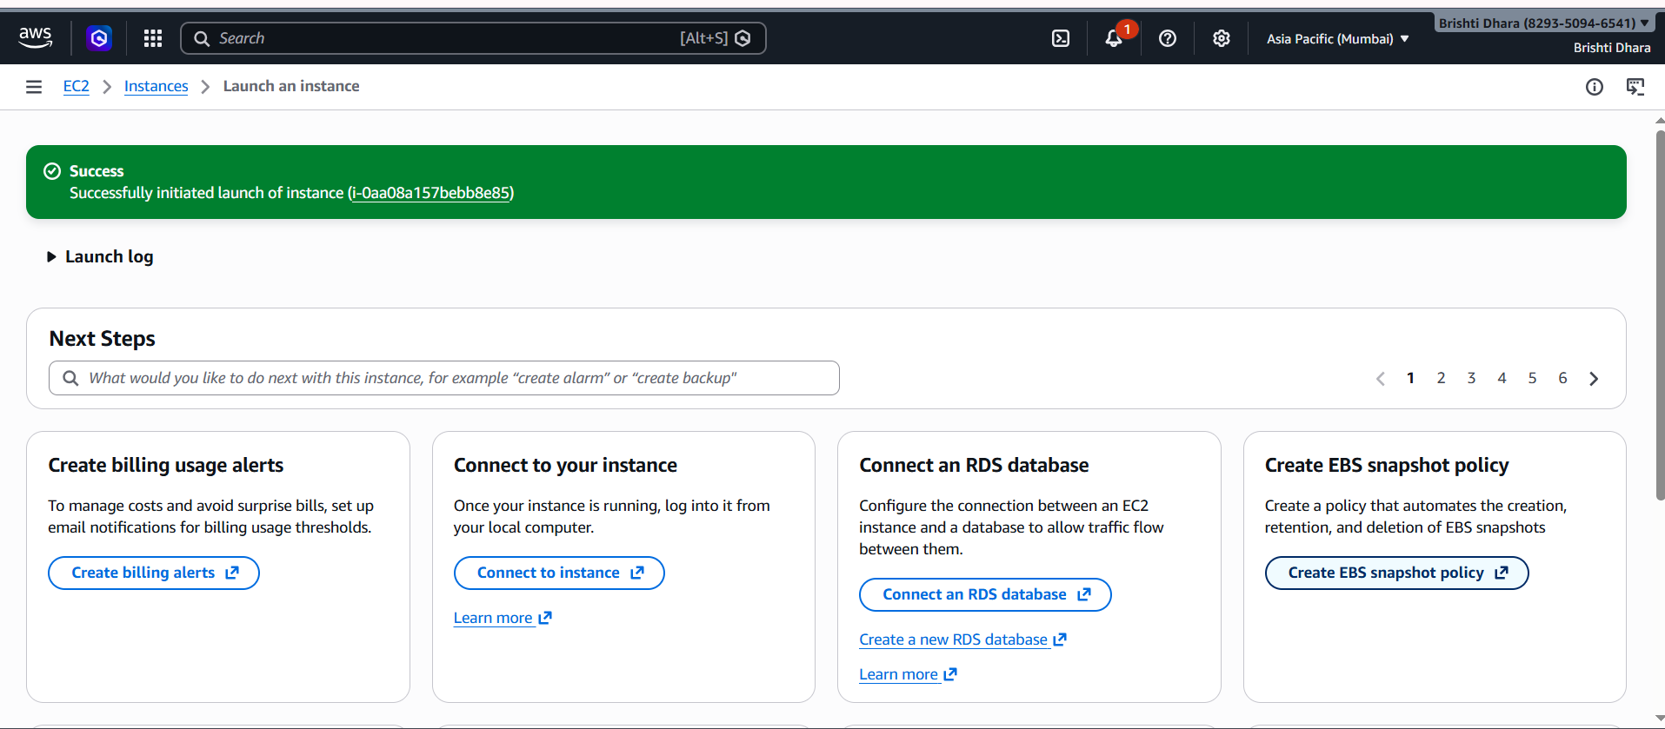
STEP-5:‘keypair-bd1’ instance is created successfully.
-5: ‘Anoushka-0001’ instance is created successfully.
Step-6: Click on ‘Public IPV4 address’ & copy it then open ‘Bitvise SSH Client’. In Bitvise SSH Client, paste the ‘Public IPV4 address’ & click on ‘Client key Manager’.
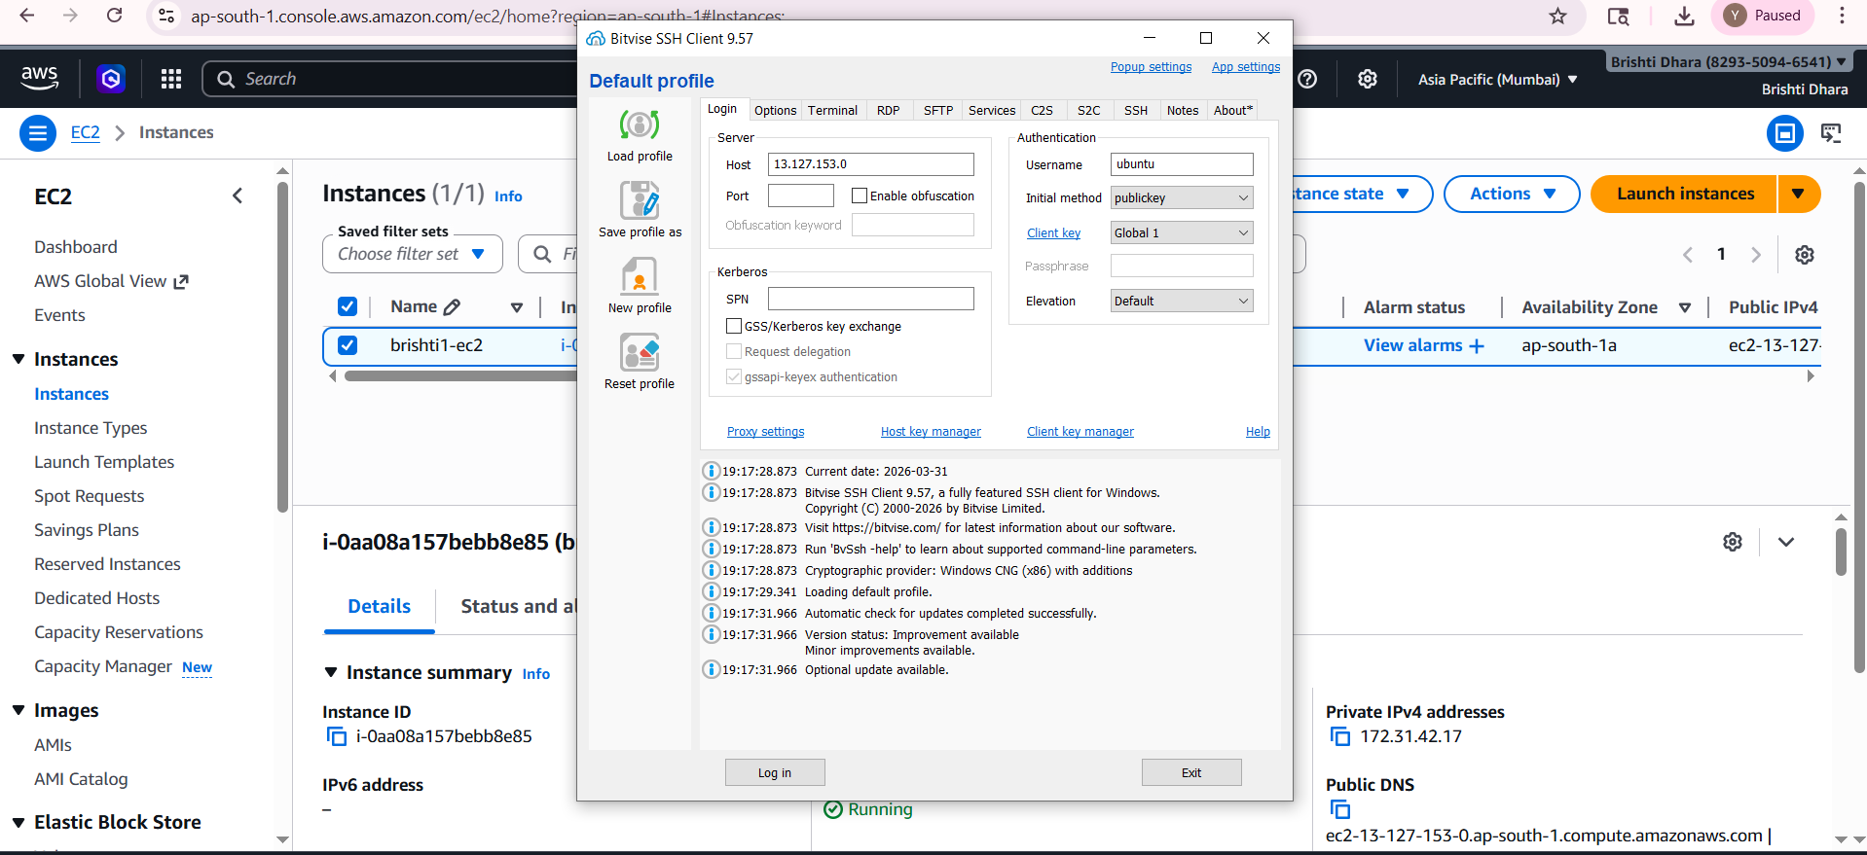

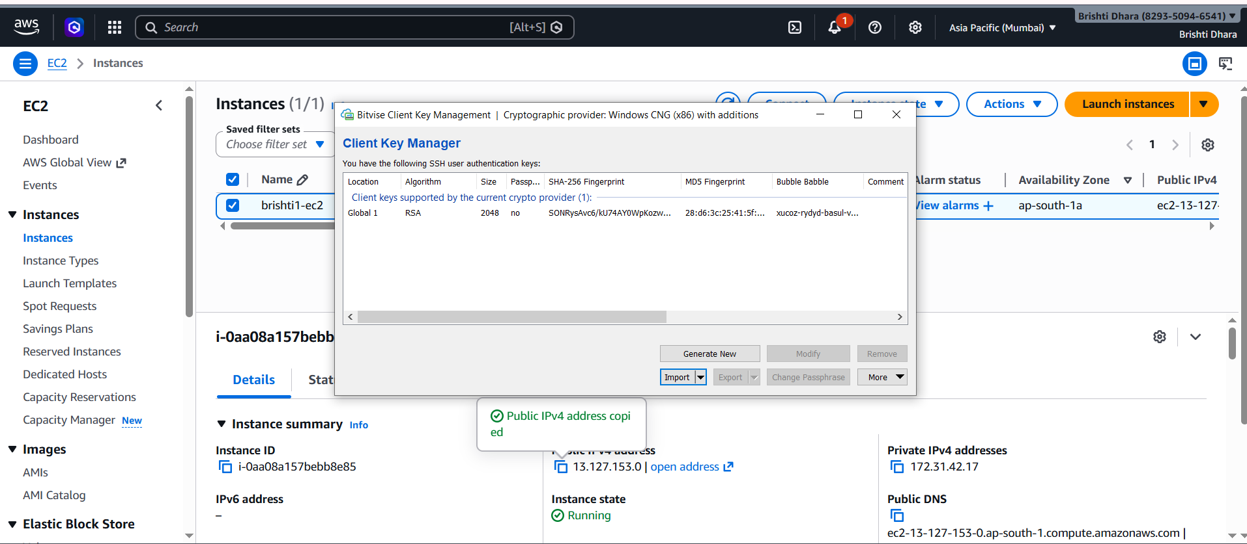
Step-7: Under ‘Client key manager’, if there is any existing key then remove it and click on ‘Import’, select the created key ‘keypair-bd1.pem’ then again click on ‘Import’ and then the key is successfully imported.
Step-8:In ‘Bitvise SSH Client’, under ‘Default profile’ give the ‘Username’ as ‘ubuntu’ then select Global1 from ‘Client Key Manager’ then click on ‘Log in’ & ‘Accept and save’.
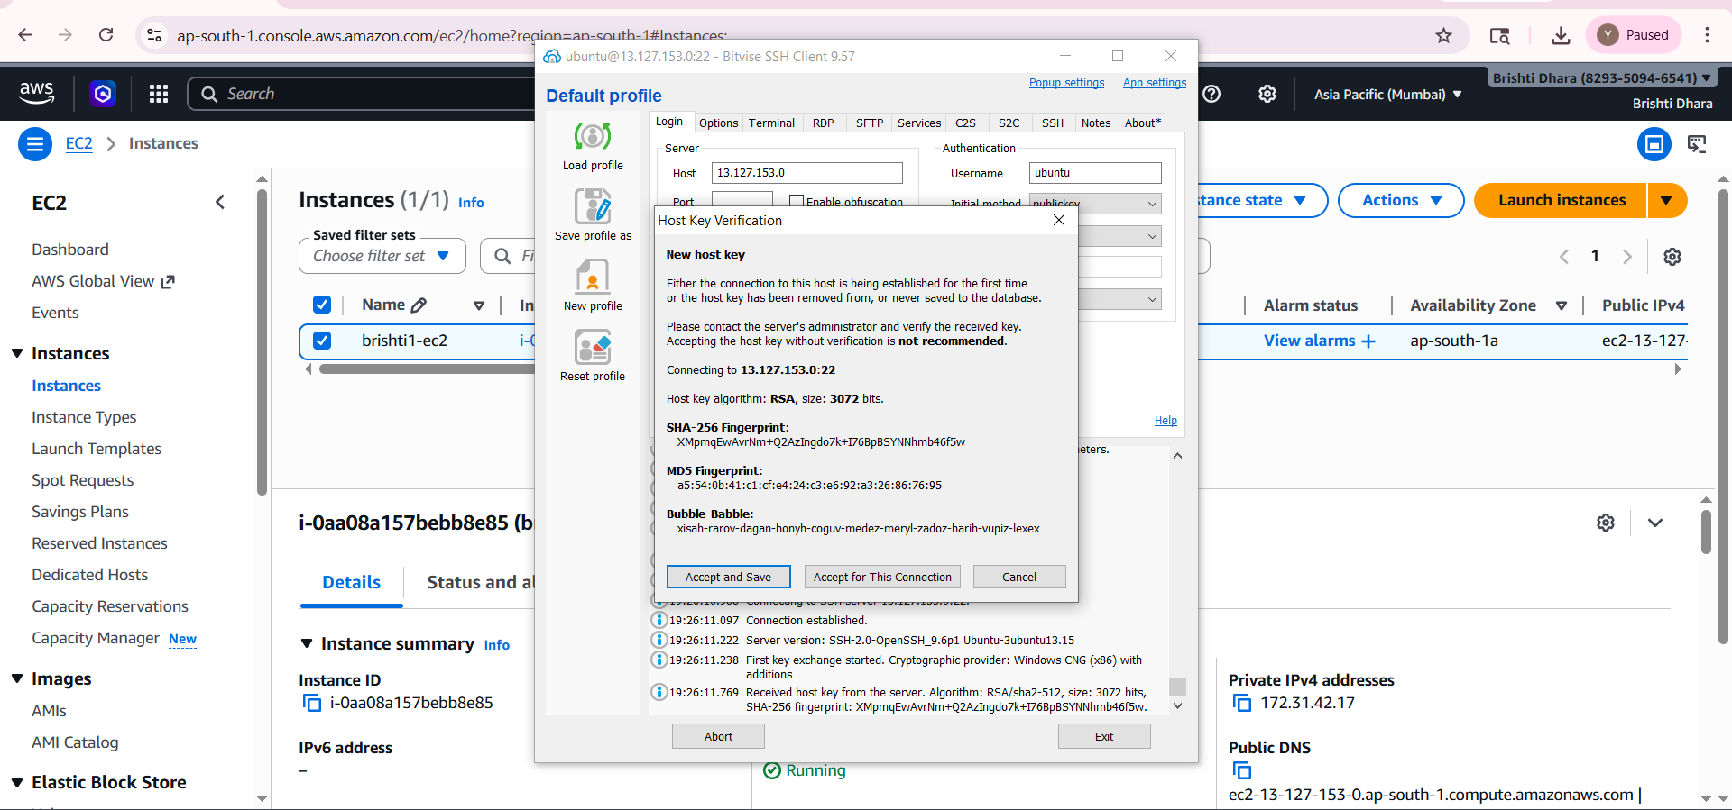

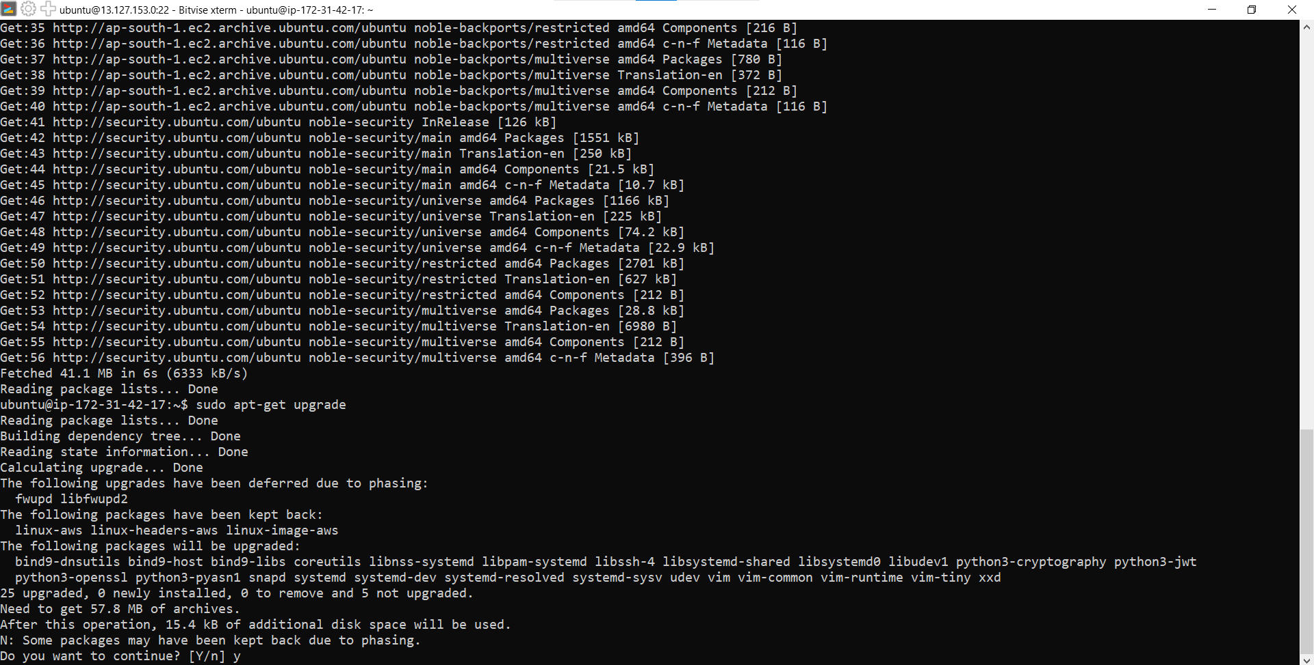
Step:9-In ‘Bitvise SSH client’, under ‘Default profile’ click on ‘New terminal console’ and there run ‘sudo apt-get update’, ‘sudo apt-get upgrade’
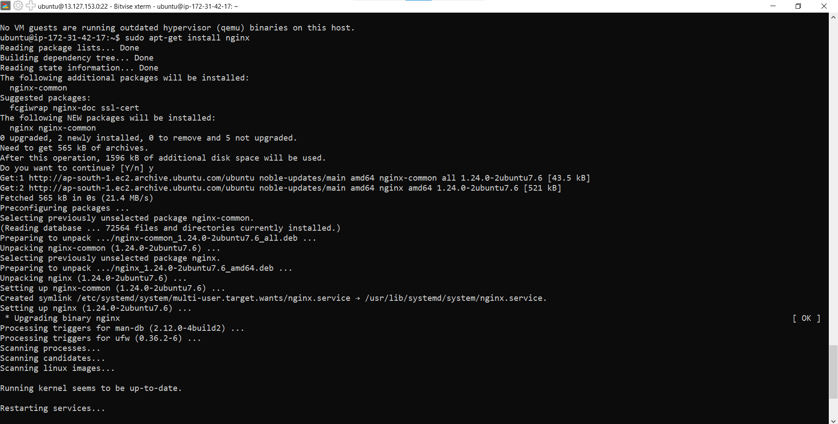
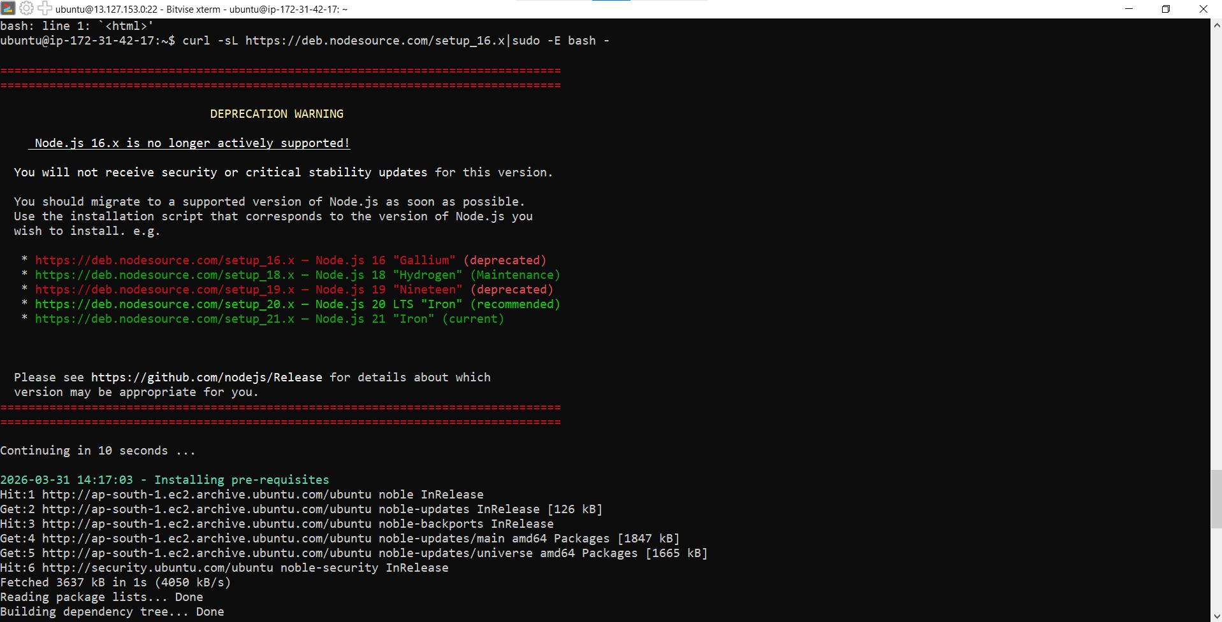
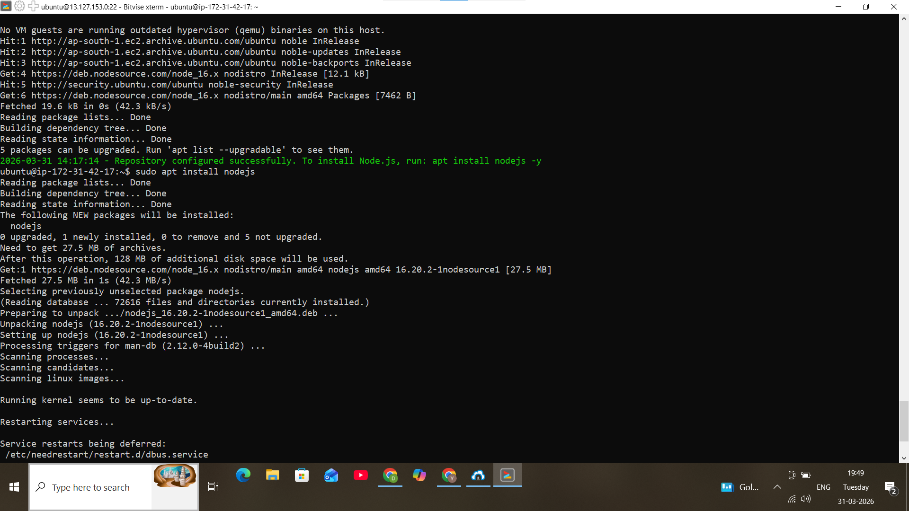
Step10:-In terminal console, type the following commands. ->’sudo apt-get install nginx’, ‘nginx -v’, ‘curl -sL https://deb.nodesource.com/setup_16.x | sudo - E bash -’, ‘sudo apt install nodejs’
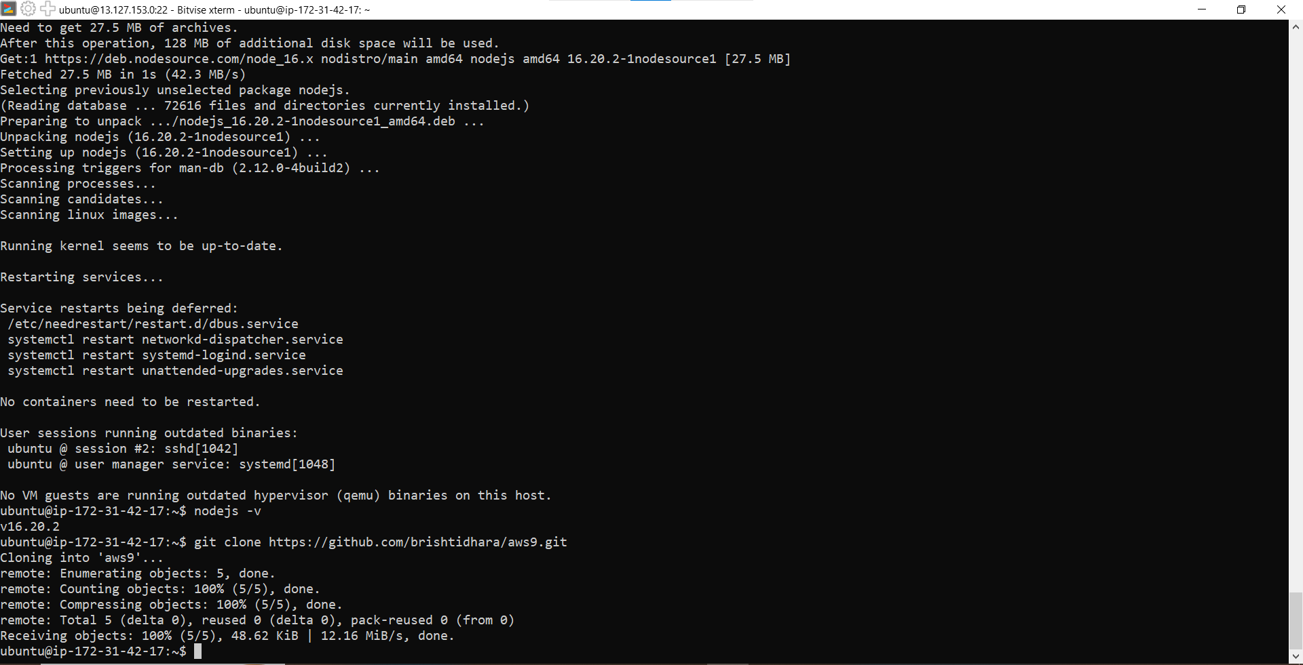
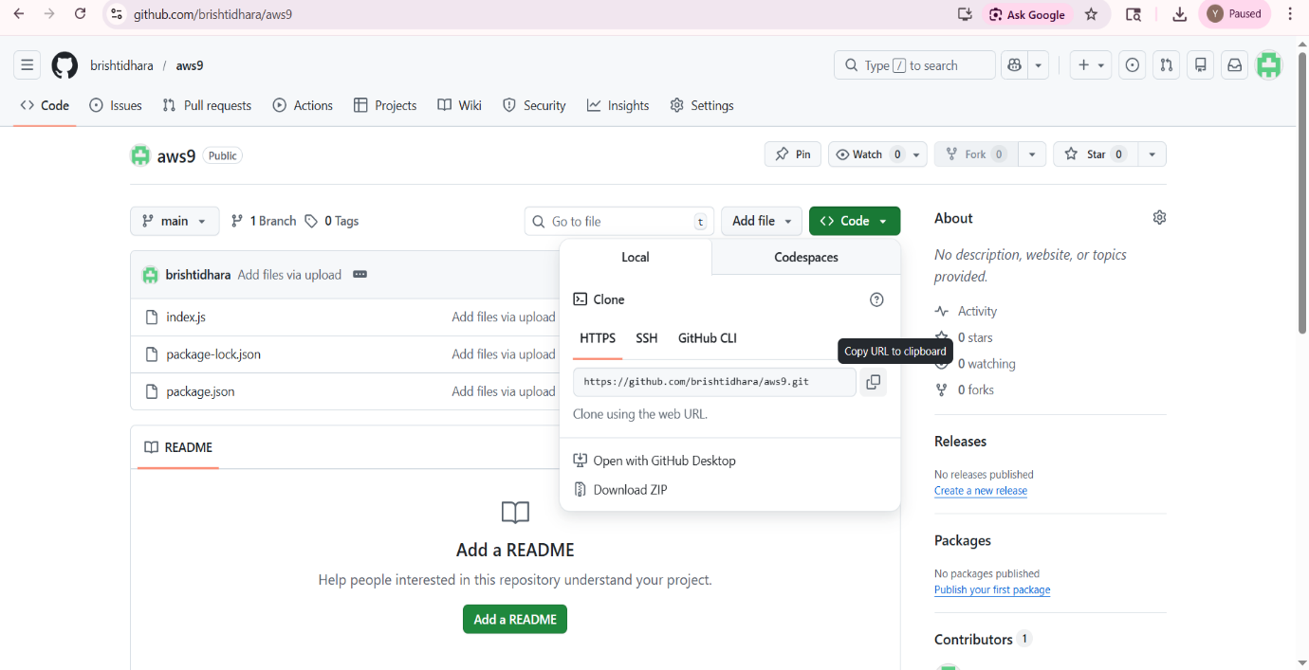
Step:11- Now open Github and copy the HTTPS Link from the repository ‘aws9’ and then run the commands ‘nodejs -v’, ‘git clone https://github.com/brishtidhara/aws9.git’.

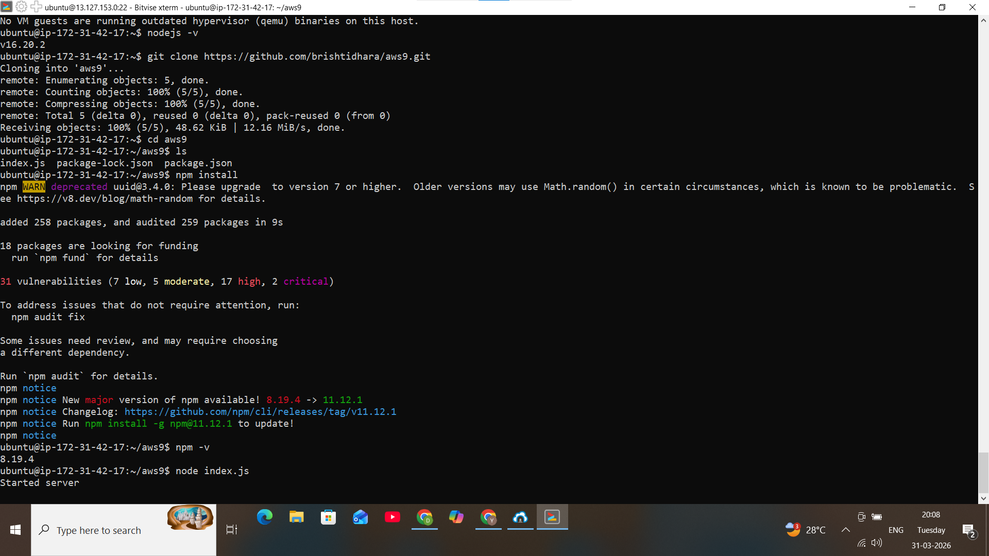
Step:12- Now in the console, type also these following commands in sequential order
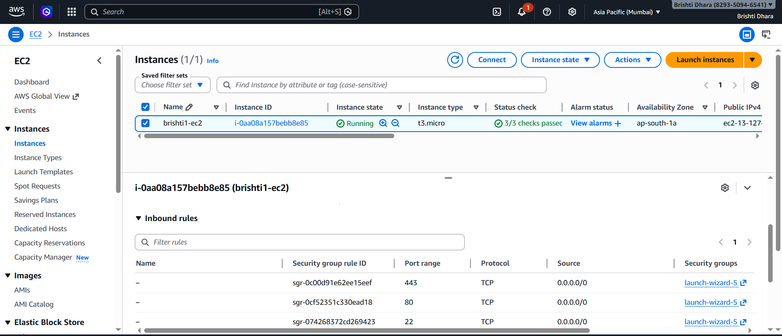
Step:14- Now click on ‘Instance ID’. Then go to ‘Security’ and click on link
under ‘Security groups’ to get the edit option.

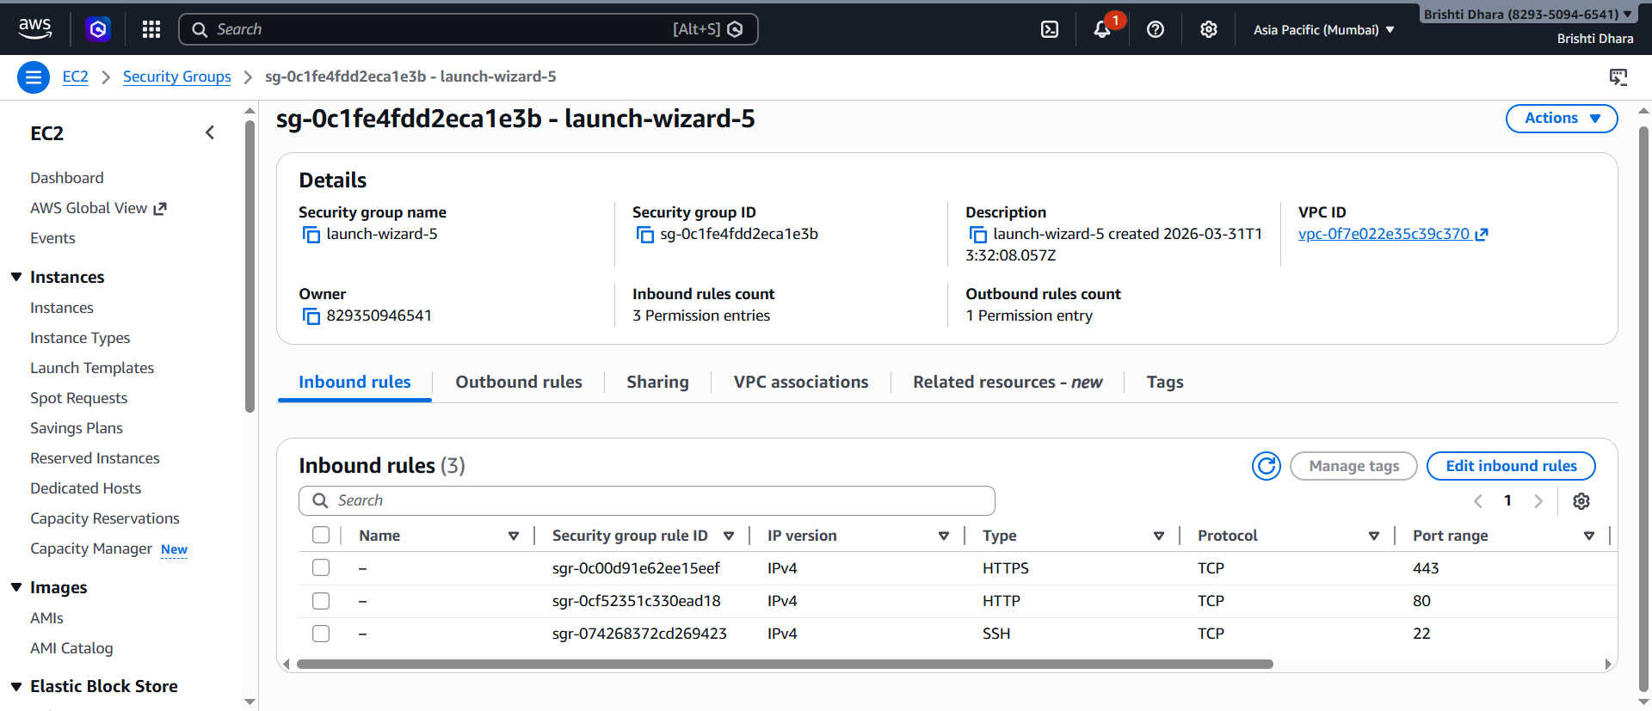
Step-14: Then in ‘Inbound rules’, click on ‘Edit inbound rules’.

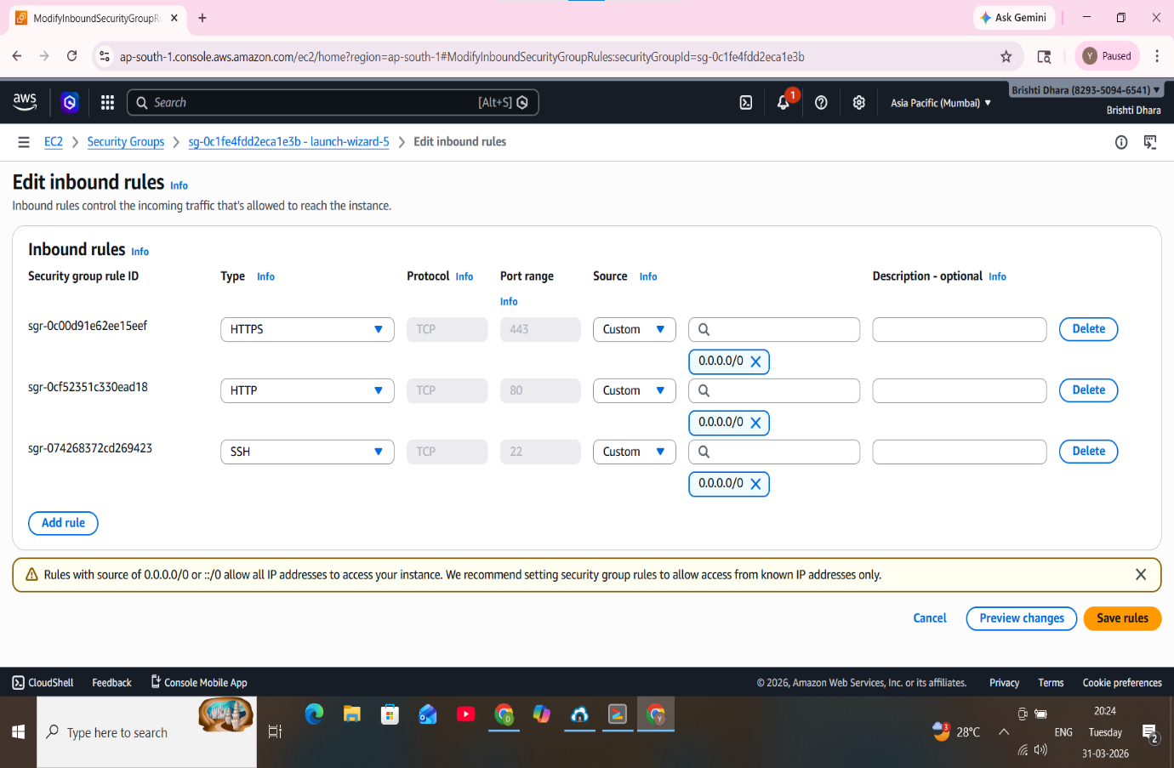
Step15:-Click on ‘Add rule’.

Step16:-Set the ‘Port range’ to ‘4000’, in ‘Source’ set ‘0.0.0.0/0’ & click on ‘Save rules’.

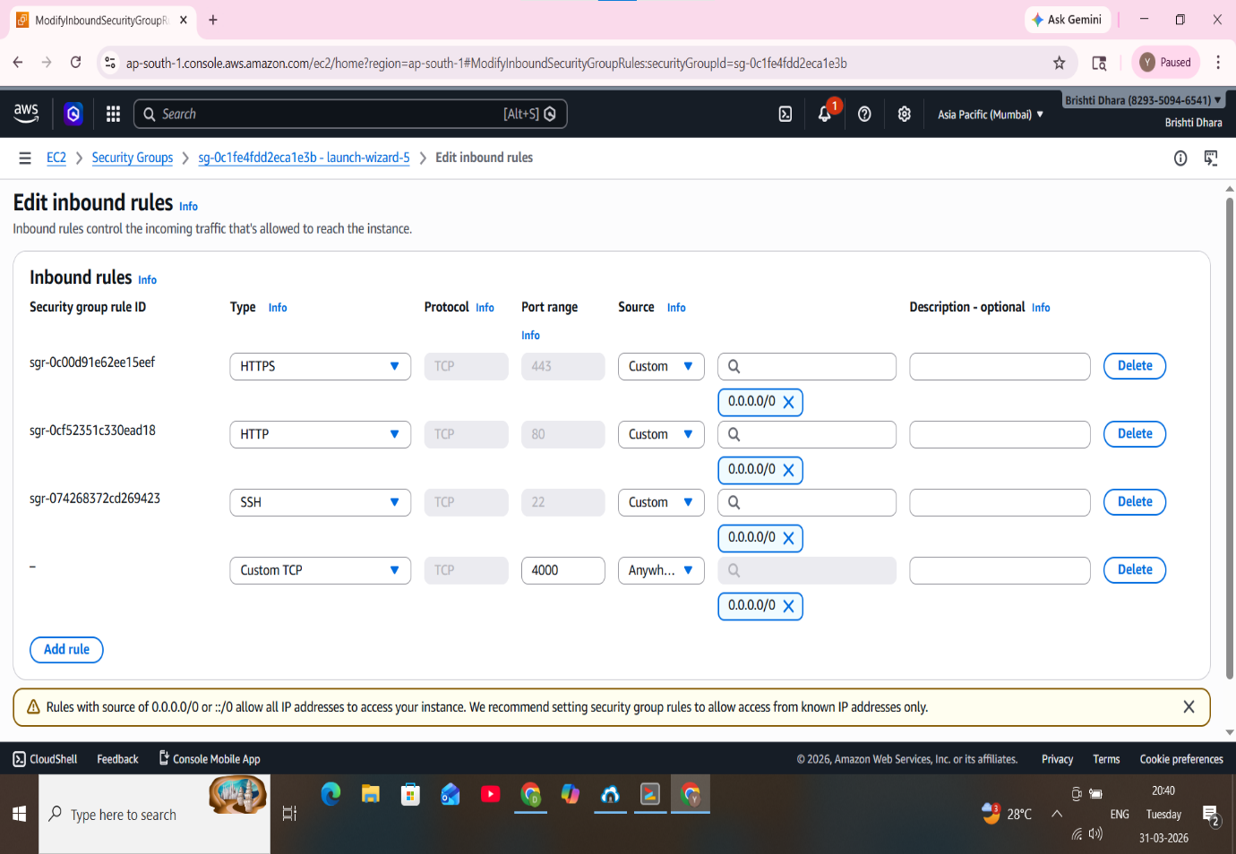

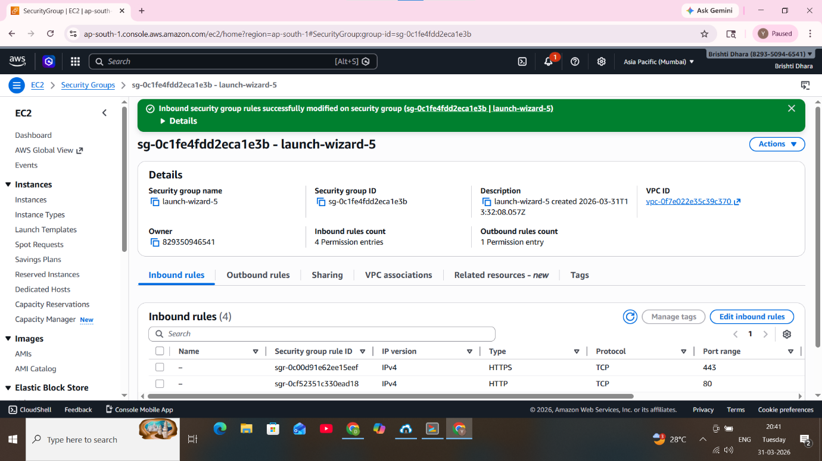
Step-17: Rule has been successfully saved.


Step18:- Now copy the ‘Public IPv4 address’ & paste it on a new tab. Add ‘:4000’ at the end and then press enter. The project has been successfully deployed from GitHub to EC2.

