Abstract

Introduction

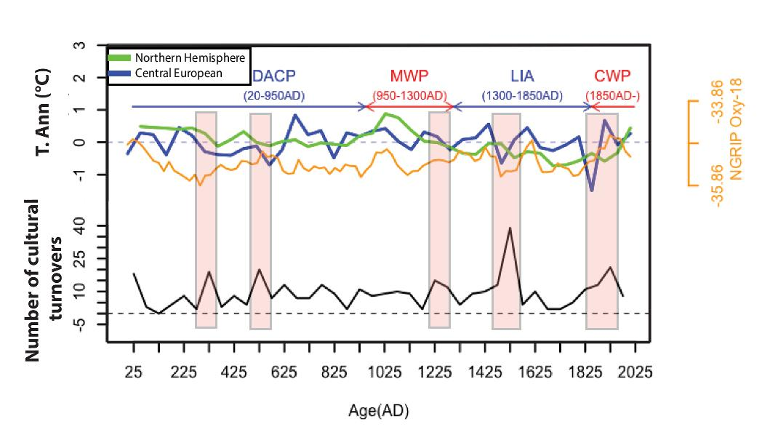

Table 1 All the 50 year periods which experienced high cultural turnover

|  |  |
| --- | --- |
| **Year** | **Cultural Turnover** |
| 1525 | 39 |
| 1925 | 21 |
| 525 | 20 |
| 325 | 19 |
| 25 | 18 |
| 1225 | 15 |

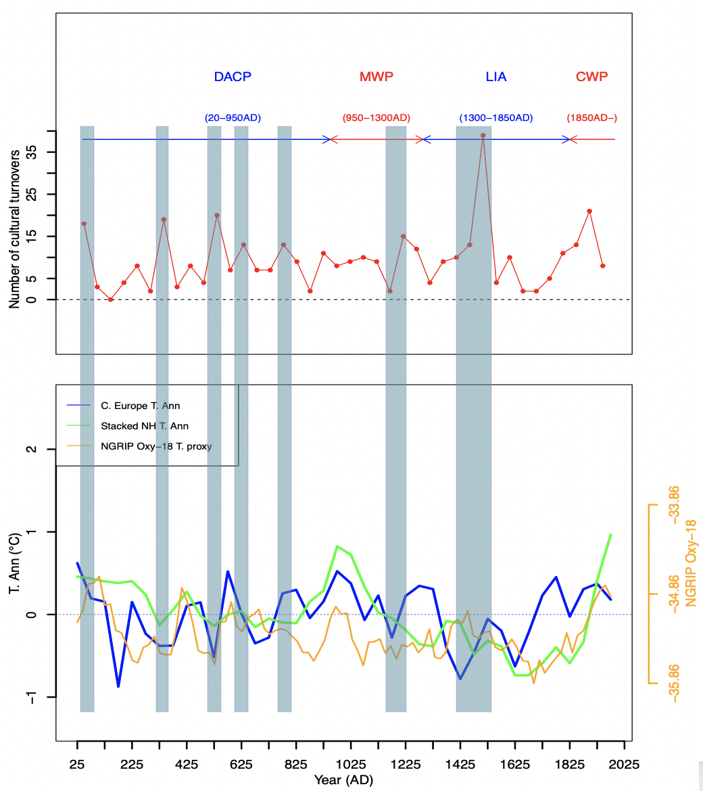

**Correlation with Cultural Turnover**

|  |  |  |  |  |  |
| --- | --- | --- | --- | --- | --- |
|  | **0-500AD** | **0-1000AD** | **0-1500AD** | **0-1900AD** | **0-2000AD** |
| **NH Temp Annomaly** | -0.22 | -0.29 | -0.25 | -0.13 | -0.08 |
| **CE Temp Annomaly** | -0.33 | -0.27 | -0.20 | 0.01 | 0.02 |
| **NGRIP Oxy 18** | -0.35 | -0.36 | -0.30 | -0.07 | 0.04 |

**Lagged Correlation with Cultural Turnover**

|  |  |  |  |  |  |  |  |  |  |  |
| --- | --- | --- | --- | --- | --- | --- | --- | --- | --- | --- |
| **Lag** | **50.00** | **100.00** | **150.00** | **200.00** | **250.00** | **300.00** | **350.00** | **400.00** | **450.00** | **500.00** |
| **NH Temp Annomaly** | 0.04 | -0.10 | -0.16 | -0.19 | -0.17 | -0.21 | -0.08 | 0.13 | 0.37 | 0.07 |
| **CE Temp** | 0.07 | 0.00 | -0.36 | -0.05 | 0.06 | -0.13 | 0.42 | -0.07 | -0.27 | 0.08 |
| **NGRIP Oxy 18** | 0.16 | 0.16 | -0.08 | -0.30 | -0.09 | -0.10 | 0.05 | 0.32 | 0.19 | -0.04 |

**Data and Methods**

The goal of our project is to find relationship between global cultural turnover and representative global temperature for last 2000 years. We know that temperature fluctuates and varies a lot region by region. But a global temperature for the entire earth can be measured by taking average of regional temperatures and can tell us whether the earth was going through a warmer or a colder phase. An averaged northern hemispheric temperature can give us idea about generally cooler or warmer environment in northern hemisphere where the majority of civilization has evolved due to habitable land and resources for human societies. Christiansen and Ljungqvist have reconstructed a northern hemisphere mean temperature series. They have considered 40 different proxies from all across the world each of which had annual or decadal sample resolution for partial or full period of last 2000 years.

(Bün) Büntgen et al. [53]: tree-rings, extracted from over thousand ring width series of central Europe, temperature anomaly [oC], -499 to 2003 BC/AD, 1 year time resolution

(McK) McKay and Kaufman [54]: stack of different temperature proxies [°C], extracted from 59 single records, ~20% of them covering the whole period, 1 to 2000 AD, 1 year time resolution, Arctic 60o- 90o N.

<https://en.wikipedia.org/wiki/List_of_conflicts_in_Europe>

<https://en.wikipedia.org/wiki/List_of_conflicts_in_Asia>

Correlation between each temperature curve and event

**Results**

In our data and experiment, we have identified that cultural turnover is more likely to happen in a globally cool environment. Climate cooling is a forcing factor behind dynastic transition. The six major turnover periods (Table 1) when we have seen the rise of societal change have been cooler periods. The red boxes in Figure 1 indicate five of those climate cooling period when we can see the spikes in our event graph.

Most regions of the world has experienced cooler climate during Little Ice Age. Although the beginning and the severity of the cold may have differed across the continents, the global average temperature was very low. The northern hemisphere temperature (green curve in Figure 1) shows that afer 1250 AD, the temperature started to fall down 0 degree celcius and it kept the general downward trend (with one exception-still below 0 degree) during 16th and 17th century up until 1800 AD. And we can clearly see how the severe cold has impacted in the changes of dynasties as 39 cultural turnover occurred during that mid-period 1525 (total turnover count of 1500-1550) marks the middle of the “Little Ice Age”.

The period 1900-1950 (marked by year 1925 in Figure 1 and Table 1) has also experienced high turnover as this is the period when the first world war and second war have taken place. This aligns with a short span of decline in the northern hemispheric temperature curve. (Geopolitics needs to be more discussed- temperature is definitely not the primary cause).

The period 500-550 has experienced almost equal (20) cultural turnover event. The NH temp green curve shows that the temperature declined below zero degree around that time from a relatively high temperature in the recent past. The Central European temperature curve show much more sharp decline in temperature.

**Conclusion**