**Periodicity in foraminifer and nannofossil evolution induced by climate change**

Abdullah Khan Zehadyb, James G. Ogga,b,*,

*aState Key Laboratory of Biogeology and Environmental Geology, School of Earth Sciences, China University of Geosciences, Wuhan 430074, Hubei, P.R. China*

*bDepartment of Earth, Atmospheric and Planetary Sciences, Purdue University, 550 Stadium Mall Drive, West Lafayette, Indiana, 47907-2051, USA*

*cResearch School of Earth Sciences, Australian National University, Acton, ACT, Australia*

E-mail addresses: [*azehady@purdue.edu*](mailto:azehady@purdue.edu)(A. K. Zehady), *jogg@purdue.edu* (J. Ogg),

*Keywords*: Planktonic foraminifer, Calcareous Nannofossil, Stratigraphic range, Biostratigraphy, Earth History, Past Climate

**Highlights**

Speciation and extinction events from Lineage and morphospecies tree during Cenozoic.

Speciation and extinction events of Calcerous nannofossils during Cenozoic.

Detection of Astronomical cycles (1.3 – 2.4 myr)

Correlation with climate proxy data.

Similarity/dissimilarity in foraminifer and nannofossil evolution over time.

Relationship between global climate and evolution of marine organisms

**Abstract**

**1. Introduction**

Forams and nanofossils are recognized as significant markers. Evolution of foraminifer and nannofossils show similar trends. We can see cyclic patterns in their turnover timeseries. The cycles (around 2 myr) has been found in many segments of geologic time in different sources.

**2. Dataset**

**1.** Which dataset?

**2.** Source of data

**3.** Why is this dataset used? What’s the significance of it? Why not something else?

**4.** Descriptive statistics of the dataset – lifespan (mean, min, max)

**5.** Astronomically tuned timescale?

6.

We wanted to focus on the macroevolutionary trend in the early Cenozoic era. To study evolutionary trends over millions of years, it is required to have access to a group of organisms which was prevalent throughout the entire time. Planktonic foraminifer lies in the base of the food pyramid and has been widely available across different marine environment throughout the whole Phanerozoic. Aze et al have looked into multiple studies of foraminifer fossil records and compiled a dataset of evolutionary ranges of foraminifer fossils for the whole Cenozoic. The grouping mechanism of the organisms relied mainly on the morphological characteristics and further grouped by ecological information. Genetic similarity or dissimilarity between organisms were not considered as it is difficult to obtain ancient DNA. The dataset provides two main evolutionary tree: one represents the lineage tree and the other is more elaborative morphospecies tree. We decided to use the morphospecies tree to perform our macroevolutionary analysis as our primary concern is the rate of change in the speciation, extinction and turnover which can be benefitted if we have more data points per million years. Every morphospecies in the tree has a first and last appearance datum which creates the evolutionary range. There are 340 unique morphospecies under 48 unique genera of 10 families: "Globigerinidae", "Globorotaliidae", "Catapsydracidae", "Bittnerulidae”, "Pulleniatinidae", "Globoquadrinidae", "Hedbergellidae", "Truncorotaloididae", "Hantkeninidae", "Eoglobigerinidae".  Mean species lifespan for the morphospecies is 7.26 Myr, where as 50% of the morphospecies (median lifespan) has lifespan less than 5.53 Myr. Globoquadrinidae family has the maximum mean life span (14.19 Myr) whereas the short-lived

family is Eoglobigerinidae with mean life span 1.83 Myr for only 3 morphospecies. The greatest number of morphospecies, total 110 species, are under the family Globigerinidae. The family Globoquadrinidae has the maximum mean life span of 14.19. And the longest living species is the “Catapsydrax unicavus” which lived 38.02 Myr (FAD=5.55Myr, LAD=17.54 Myr)

Table 1: Planktonic Foraminifer statistics by family

|  |  |  |  |  |
| --- | --- | --- | --- | --- |
|  | |  |  |  |
| **Family** | **# of Species** | **Mean Lifespan** | **Start of Lifespan** | **End of Lifespan** |
| Eoglobigerinidae | 3 | 1.83 | 66.04 | 62.29 |
| Pulleniatinidae | 6 | 2.70 | 6.61 | 0.00 |
| Globorotaliidae | 52 | 3.80 | 22.44 | 0.00 |
| Hantkeninidae | 16 | 4.12 | 47.41 | 33.90 |
| Bittnerulidae | 13 | 4.52 | 18.26 | 0.00 |
| Hedbergellidae | 28 | 5.52 | 70.92 | 30.22 |
| Truncorotaloididae | 69 | 5.86 | 66.02 | 30.28 |
| Globigerinidae | 110 | 9.81 | 66.03 | 0.00 |
| Catapsydracidae | 28 | 9.97 | 65.96 | 0.00 |
| Globoquadrinidae | 14 | 14.19 | 38.98 | 22.92 |

BP Gulf of Mexico paper has created a standard framework to detect the biozonation using nannofossils. For some genera, the family name is missing and the class or phylum name was used. And in some case “-“ is used. The nannofossils in our study are under the following families: "-", "Calcidiscaceae", "Ceratolithaceae", "Coccolithaceae", "Discoasteraceae", "Helicosphaeraceae", "Noelaerhabdaceae", "Pontosphaeraceae", "Sphenolithaceae".

Table 2: Number of species and Lifespan of Nannofossils by Family/Class/Phylum

|  |  |  |  |  |
| --- | --- | --- | --- | --- |
|  | | | |  |
| **Family** | **# of Species** | **Mean Lifespan** | **Start of Lifespan** | **End of Lifespan** |
| Ceratolithaceae | 25 | 3.43 | 26.84 | 0.00 |
| Discoasteraceae | 95 | 4.37 | 55.86 | 1.90 |
| Sphenolithaceae | 42 | 9.13 | 61.61 | 3.53 |
| Calcidiscaceae | 3 | 9.33 | 17.14 | 1.61 |
| Noelaerhabdaceae | 31 | 10.73 | 53.70 | 0.00 |
| Helicosphaeraceae | 35 | 11.31 | 50.00 | 4.98 |
| Coccolithaceae | 6 | 13.93 | 65.40 | 10.80 |
| Sphenolithaceae | 42 | 9.126095238 | 61.61 | 3.531 |

The evolutionary first appearance and last appearance ages are calibrated to the high precision astronomically tuned timescale provided in the Geologic TimeScaleCreator software. The astronomical solution provided by Laskar et al, 2004 has been used to create the timescale of Cenozoic era which has been later significantly enhanced to ensure high precision. The high frequency cyclostratigraphy data from International Ocean Drilling Program (IODP) Legs are also used to ensure the accuracy of Cenozoic timescale.

Median life span for nannos is 2.83 Myr.

Lineage and Morphospecies evolutionary tree from Fordham and Zehady et al(2018). Phylogenetic tree data and graphs provided by Aze & others. Calcerous nannofossil data from BP gulf of Mexico paper.

Oxygen-18 isotope data (Cramer 2009)

**3. Methods**

LAD and FAD forms evolutionary range of existence for each organism.

Every 1 myr bin, we have counted the number of speciation (birth of organism) and the number of extinction event.

Timeseries for speciation and extinction events from 0-35 myr.

Timeseries for oxygen-18/temperature data.

Timeseries for icesheet expansion, cold phase event data (used in mammal turnover paper , any other new paper!??)

Smoothing of timeseries using moving average/gaussian filtering for every 100 kyr.

Correlation co-efficient using pearson correlation between three timeseries.

Mean species lifetime: How many species are there in my dataset?

What is the mean species lifetime for the planktonic foraminifer fossils

What is the mean species lifetime for the nannofossil dataset?

Characteristic of fossil (investigation whether any particular foraminifer has links to dryness, humidity)

Why certain species might have died during certain cold phase? Any patterns

Which species has the longest life? Versus which species has the shortest life span…

Hidden markov model: turnover probability. -> speciation proability, extinction probability, turnover probability.

Cycle analysis using multitaper spectral analysis. Significance test with autoregression (AR) and harmonic variance ratio F-test.

For robust analysis, hidden markov model and AIC based model selection (pacing paper by Myers)

1. **Results**

Figures

1. Speciation events of planktonic foraminifer(PF)
2. Extinction events of PF
3. Turnover events of PF
4. Speciation events of calcerous nannofossils(NN)
5. Extinction events of NN
6. Turnover events of NN
7. Temperature (Oxygen-18) timeseries
8. Hidden markov model figures
9. Spectral power for frequency + period with significance level

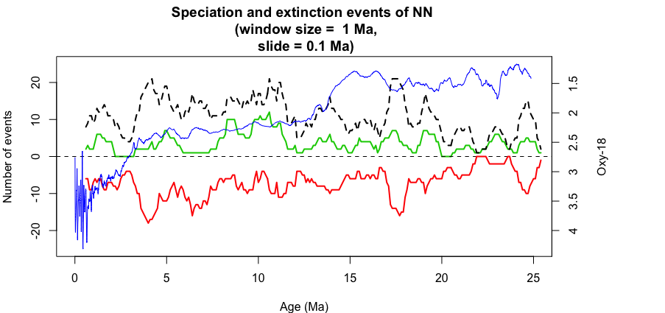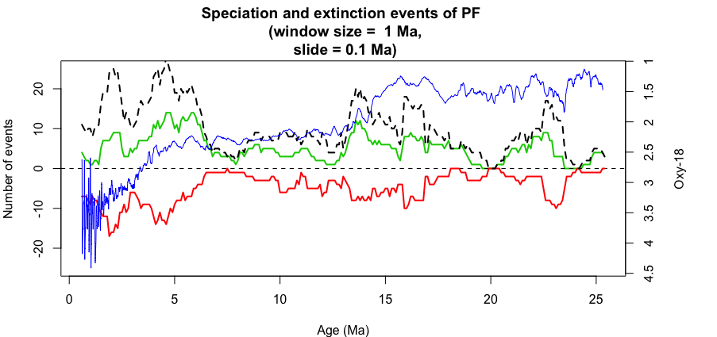

1. **Discussion**

What does the speciation + extinction of forams and nannofossil tell us about the past global climate? What caused the speciation and extinction? Can we see matches with already known major events?

﻿Milankovitch grand cycles (7) are astronomical rhythms as- sociated with the amplitude modulation of Earth’s climatic precession cycle and axial obliquity cycle. During the Late Cenozoic, the amplitude modulation of precession by eccen- tricity results in a 2.4-My cycle in addition to the well-known cycles of 405,000 and ∼100,000 y; the long-period obliquity amplitude modulation is ∼1.2 My (Fig. 1) (8, 9). These relate to

1. **Conclusions**

Contribution of the paper

**Acknowledgements**

**References**

TSCreator;

**Appendix**