Answers to questions in

Lab 1: Filtering operations

Name: Markus Brislöv___________________________________ Program: AUSY1____________________

**Instructions**: Complete the lab according to the instructions in the notes and respond to the questions stated below. Keep the answers short and focus on what is essential. Illustrate with figures only when explicitly requested.

Good luck!

___________________________________________________________________________

**Question 1**: Repeat this exercise with the coordinates p and q set to (5, 9), (9, 5), (17, 9),

(17, 121), (5, 1) and (125, 1) respectively. What do you observe?

Answers:

Depending on the given coordinates a difference in the sinewave can be observed relating to its frequency and orientation.

___________________________________________________________________________

**Question 2**: Explain how a position (p, q) in the Fourier domain will be projected as a sine wave in the spatial domain. Illustrate with a MATLAB figure.

Answers:

In the Fourier domain a point (p, q) represents two orthogonal frequencies, and . For instance, a point (10, 1) will generate a sinewave oriented vertically with and as frequencies. Frequency and coordinate relation are and because of indices starting at 1 in MATLAB.

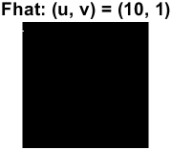 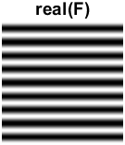

If the given point was (1, 10) the sinewave would be oriented horizontally.

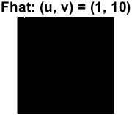 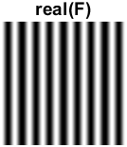

A point (10, 10) yields a sinewave oriented in 45 degrees (origin upper left corner).

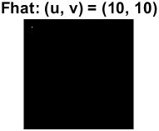 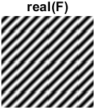

___________________________________________________________________________

**Question 3**: How large is the amplitude? Write down the expression derived from Equation (4) in the notes. Complement the code (variable amplitude) accordingly.

Answers:

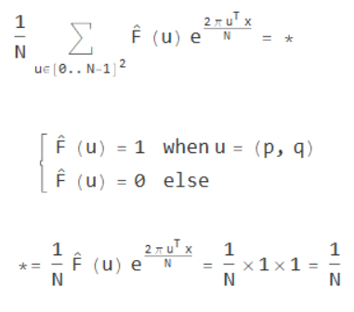

The amplitude can therefore be calculated in the code accordingly:

___________________________________________________________________________

**Question 4**: How does the direction and length of the sine wave depend on p and q? Write down the explicit expression that can be found in the lecture notes. Complement the code (variable wavelength) accordingly.

Answers:

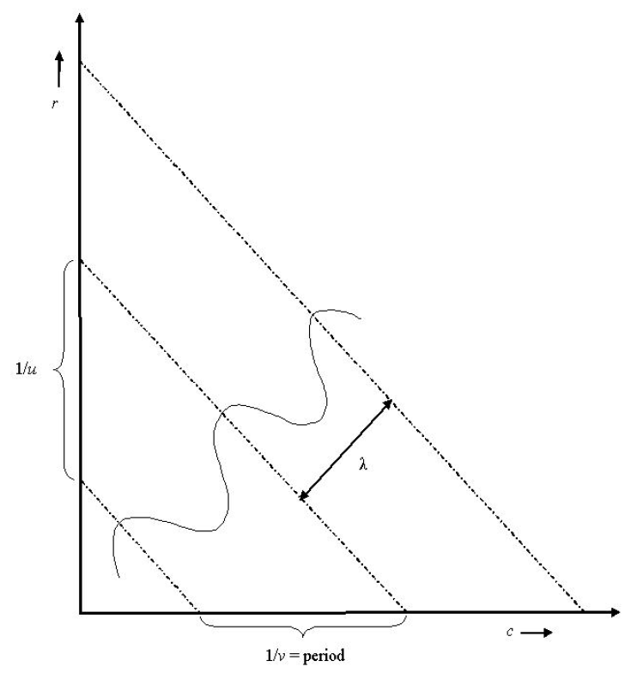

___________________________________________________________________________

**Question 5**: What happens when we pass the point in the center and either p or q exceeds half the image size? Explain and illustrate graphically with MATLAB!

Answers:

When either p or q exceeds half the image size its corresponding frequency becomes negative. The values are mirrored around (65, 65) which can be seen in the following images.

 

 

 

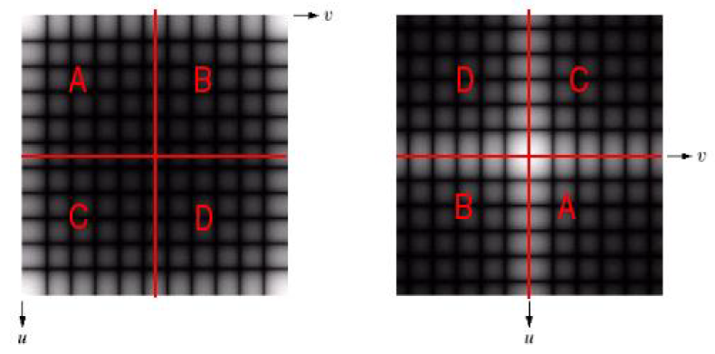

___________________________________________________________________________

**Question 6**: What is the purpose of the instructions following the question *What is done by these instructions?* in the code?

Answers:

There are two purposes, one is due to indices starting at 1 in MATLAB, which requires that the coordinates are subtracted by one if they are less than half of the image size. This allows us to get the correct frequencies.

The other is convert the coordinates, given they are above half the image size, to negative values, negative frequencies.

___________________________________________________________________________

**Question 7**: Why are these Fourier spectra concentrated to the borders of the images? Can you give a mathematical interpretation? Hint: think of the frequencies in the source image and consider the resulting image as a Fourier transform applied to a 2D function. It might be easier to analyze each dimension separately!

Answers:

From the image in the spatial domain we see that we only have changes along the vertical axis which is why we can only see frequencies along the border of the vertical axis u in the Fourier spectra.

 

Therefore, we only have nonzero values when .

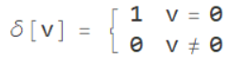

This can be used to simplify the 2D Discrete Fourier Transform.

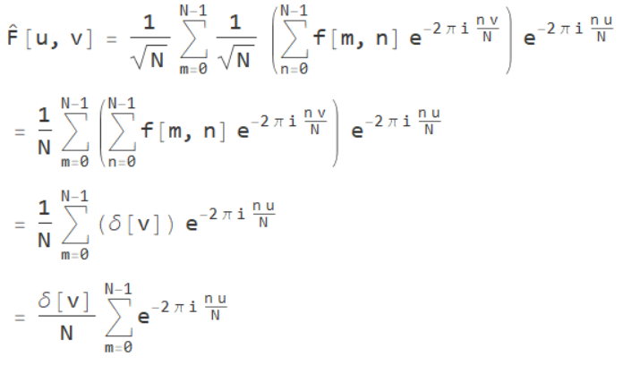

___________________________________________________________________________

**Question 8**: Why is the logarithm function applied?

Answers:

To compress the dynamic range of the image which helps with revealing features in an image where the dynamic range is to large to be displayed. It works by enhancing the lower values which can be seen in the following images.

 

 

________________________________________

___________________________________________________________________________

**Question 9**: What conclusions can be drawn regarding linearity? From your observations can you derive a mathematical expression in the general case?

Answers:

Its linear, because the multiplication and addition can either be done before or after the Fourier transform.



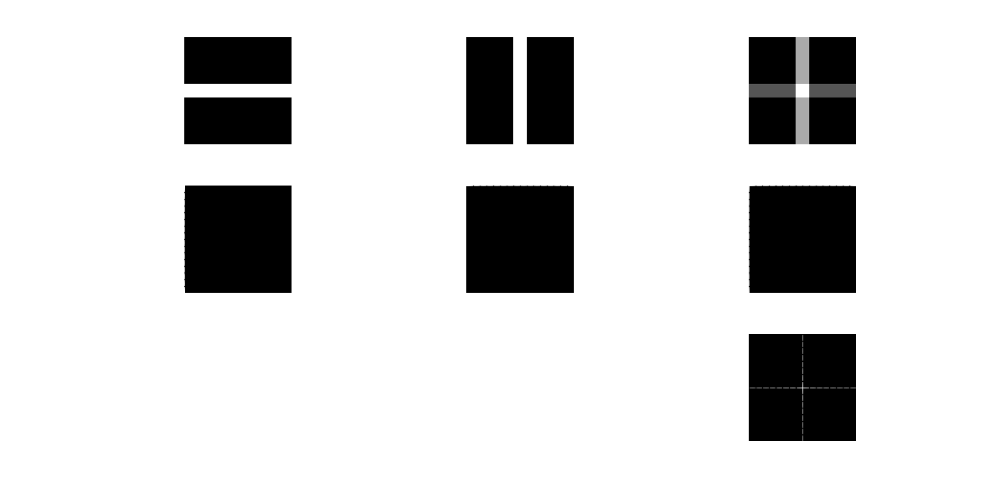

___________________________________________________________________________

**Question 10**: Are there any other ways to compute the last image? Remember what multiplication in Fourier domain equals to in the spatial domain! Perform these alternative computations in practice.

Answers:

Multiplication in the spatial domain is same as convolution in the Fourier domain.[1]



That is, the pointwise multiplication in the spatial here is the same as the convolution in the frequency domain.

 



___________________________________________________________________________

**Question 11**: What conclusions can be drawn from comparing the results with those in the previous exercise? See how the source images have changed and analyze the effects of scaling.

Answers:



Comparing the images, we can see that when something is scaled up in the spatial domain corresponds to compression in the Fourier domain. Additionally, scaling down in the spatial domain corresponds to expansion in the Fourier domain.

Conclusion: compression in spatial domain is same as expansion in Fourier domain (and vise versa).[2]

___________________________________________________________________________

**Question 12**: What can be said about possible similarities and differences? Hint: think of the frequencies and how they are affected by the rotation.

Answers:



When an image is rotated in the spatial domain its representation in the Fourier domain will rotate accordingly. Varying amounts of noise is introduced from the rotation. That is due to the constrains for discretization of a diagonal line.

___________________________________________________________________________

**Question 13**: What information is contained in the phase and in the magnitude of the Fourier transform?

Answers:



?

___________________________________________________________________________

**Question 14**: Show the impulse response and variance for the above-mentioned t-values. What are the variances of your discretized Gaussian kernel for t = 0.1, 0.3, 1.0, 10.0 and

100.0?

Answers:

___________________________________________________________________________

**Question 15**: Are the results different from or similar to the estimated variance? How does the result correspond to the ideal continuous case? Lead: think of the relation between spatial and Fourier domains for different values of t.

Answers:

___________________________________________________________________________

**Question 16**: Convolve a couple of images with Gaussian functions of different variances (like t = 1.0, 4.0, 16.0, 64.0 and 256.0) and present your results. What effects can you observe?

Answers:

___________________________________________________________________________

**Question 17**: What are the positive and negative effects for each type of filter? Describe what you observe and name the effects that you recognize. How do the results depend on the filter parameters? Illustrate with Matlab figure(s).

Answers:

___________________________________________________________________________

**Question 18**: What conclusions can you draw from comparing the results of the respective methods?

Answers:

___________________________________________________________________________

**Question 19**: What effects do you observe when subsampling the original image and the smoothed variants? Illustrate both filters with the best results found for iteration i = 4.

Answers:

___________________________________________________________________________

**Question 20**: What conclusions can you draw regarding the effects of smoothing when combined with subsampling? Hint: think in terms of frequencies and side effects.

Answers:

___________________________________________________________________________

1. Lecture 4, page 20
2. Lecture 4, page 15