Answers to questions in

Lab 2: Edge detection & Hough transform

Name: Markus Brislöv________________________________ Program: AUSY_____________________

**Instructions**: Complete the lab according to the instructions in the notes and respond to the questions stated below. Keep the answers short and focus on what is essential. Illustrate with figures only when explicitly requested.

Good luck!

___________________________________________________________________________

**Question 1**: What do you expect the results to look like and why? Compare the size of *dxtools* with the size of *tools*. Why are these sizes different?

Answers:

It’s expected that the edges will be highlighted horizontally when *deltax* is applied and vertically when *deltay* is applied.





Image *tools* is 256x256 pixels whereas *dxtools* and *dytools* are 254x254 pixels. When we convolute the image with the Sobel operator, which is a 3x3 matrix, the evaluated pixel in *tools* will be the central pixel in the Sobel matrix. Therefore, we can’t evaluate the pixels on the edges of tools as we need additional pixels along the edge, see *Figure* *1*. That means that we lose either a row or column of pixels on either side of *tools*. This behavior occurs because we used ‘valid’ in the conv2() function.

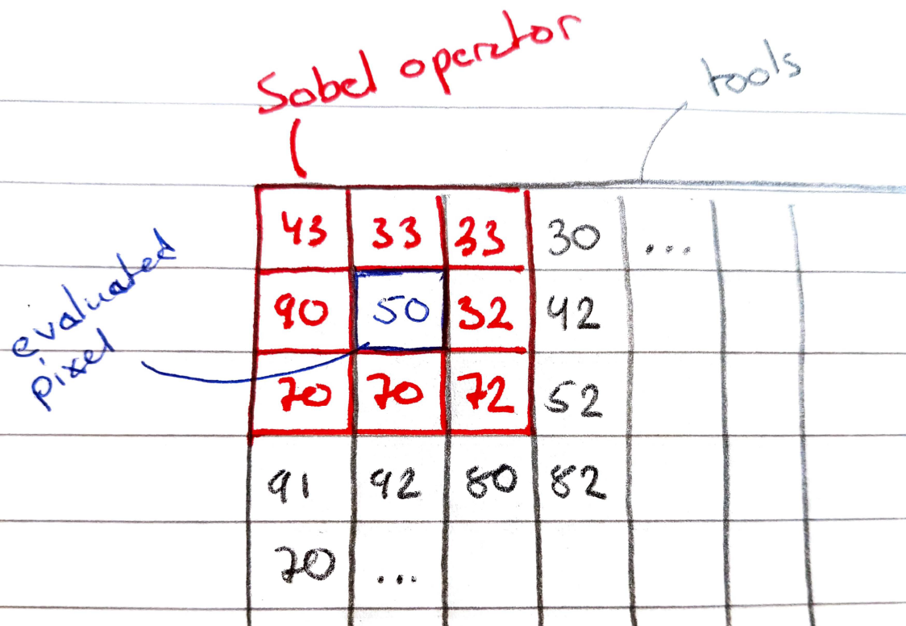

Figure . Sobel operator along the edge of tools

___________________________________________________________________________

**Question 2**: Is it easy to find a threshold that results in thin edges? Explain why or why not!

Answers:





No, because an edge might vary in magnitude and thickness along its path. Therefore, there isn’t a specific threshold value that results in thin edges without removing some edges entirely. This magnitude and thickness difference evident along the hammer where the head of the hammer is more defined compared to the handle.

___________________________________________________________________________

**Question 3**: Does smoothing the image help to find edges?

Answers:







Figure . First row is without smoothing, for the other rows gaussian blur with variance 1, 2 and 4 has been applied respectively

Yes, smoothing can be used to help reduce the amount of noise that can be interpreted as edges. The drawback is that weak edges will become less defined and fade if to much smoothing is applied while the opposite occurs for strong edges.

___________________________________________________________________________

**Question 4**: What can you observe? Provide explanation based on the generated images.

Answers:

___________________________________________________________________________

**Question 5**: Assemble the results of the experiment above into an illustrative collage with the *subplot* command. Which are your observations and conclusions?

Answers:

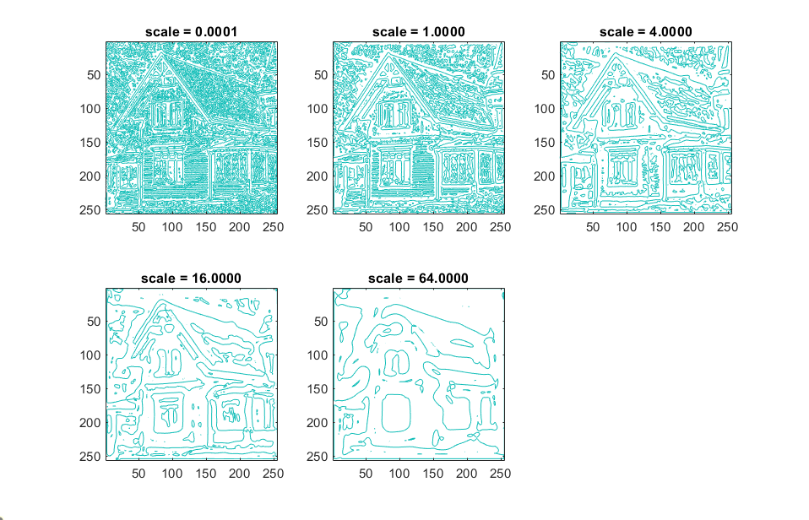

Figure . Lvvtilde



Figure . Lvvvtilde



Figure . Lvvvtilde

___________________________________________________________________________

**Question 6**: How can you use the response from *Lvv* to detect edges, and how can you improve the result by using *Lvvv*?

Answers:

___________________________________________________________________________

**Question 7**: Present your best results obtained with *extractedge* for *house* and *tools*.

Answers:

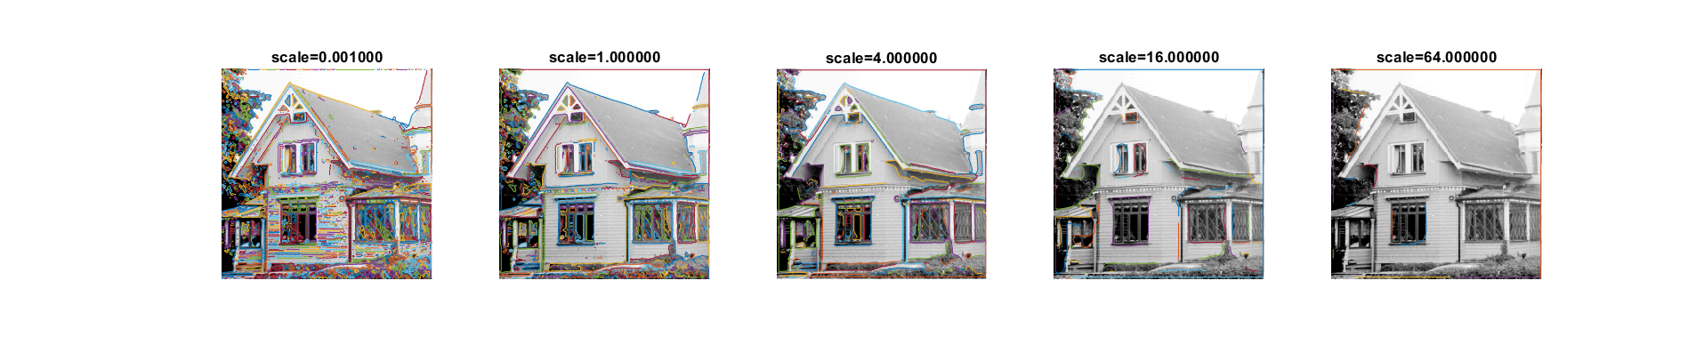

Figure . t = 2 * 10^3

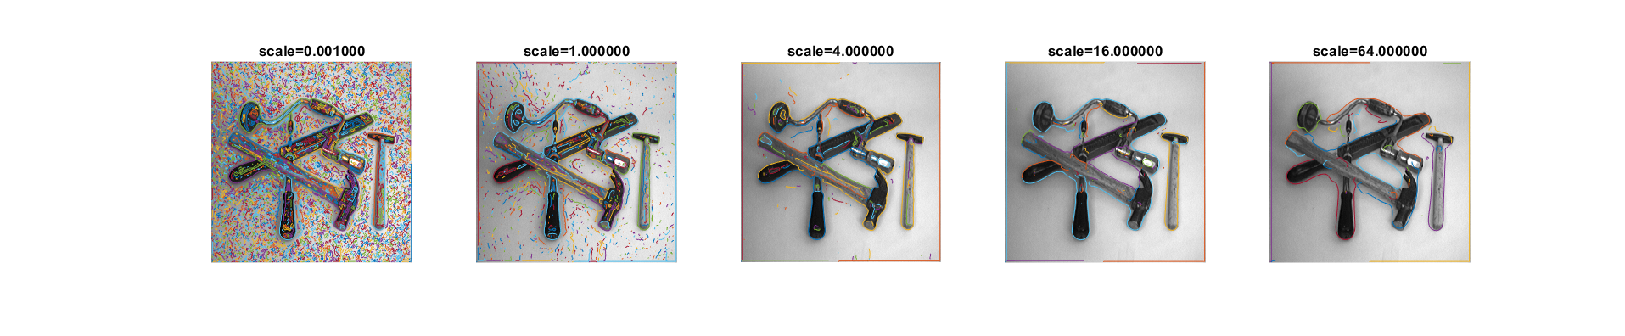

Figure . t = 100

_____________________________________________________________________________________________________

**Question 8**: Identify the correspondences between the strongest peaks in the accu-mulator and line segments in the output image. Doing so convince yourself that the implementation is correct. Summarize the results of in one or more figures.

Answers:

___________________________________________________________________________

**Question 9**: How do the results and computational time depend on the number of cells in the accumulator?

Answers:

___________________________________________________________________________

**Question 10**: How do you propose to do this? Try out a function that you would suggest and see if it improves the results. Does it?

Answers:

___________________________________________________________________________