Appendix: Search String Evolution Log
Running summary (updated each iteration):
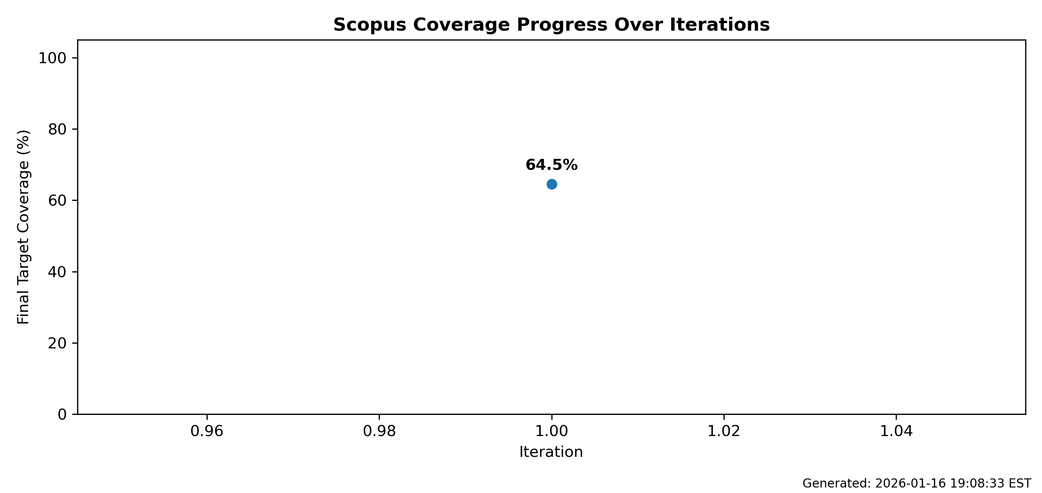

Iteration 1 — 2026-01-16 19:08:33 EST
Summary:
- Search hash: 7966816ef7dd (source: file:scripts/outputs/step1/step1_total_query.txt)
- Final target: secondary
- Final coverage: 20/31 (64.5%)
- Final missed count: 11
Search string used:
TITLE-ABS-KEY((((smallholder* OR "small holder*" OR "small-scale farmer*" OR "small-scale producer*" OR "subsistence farmer*" OR "farmers in low-income countr*" OR "small-scale farmers in low-income countr*" OR "marginal farmer*" OR "resource-poor farmer*") OR ("rural household*" OR "farm household*" OR "agricultural household*" OR "family farmer*" OR "low-income household*" OR "poor household*" OR "female-headed household*" OR "women-headed household*") OR (pastoralist* OR "agro-pastoralist*" OR "agro pastoralist*" OR herder* OR "livestock keeper*" OR "livestock farmer*" OR "livestock producer*" OR "dairy farmer*" OR "crop-livestock farmer*") OR (fisher* OR "small-scale fisher*" OR "small scale fisher*" OR fisherfolk OR "artisanal fisher*" OR "aquaculture producer*" OR "fish farmer*" OR "shrimp farmer*") OR ("agroforestry farmer*" OR "agroforestry producer*" OR "tree crop farmer*" OR "fruit grower*" OR "forest farmer*" OR silvopastoral OR "silvo-pastoral" OR "tree-livestock farmer*") OR (women OR female* OR "women farmer*" OR "female farmer*" OR youth OR "rural youth" OR "young farmer*" OR "young producer*" OR adolescent* OR "landless farmer*" OR "tenant farmer*" OR sharecropper* OR "contract farmer*" OR "Indigenous Peoples" OR "indigenous communit*" OR "tribal communit*" OR "ethnic minorit*" OR "agricultural laborer*" OR "farm worker*" OR "seasonal worker*" OR "migrant farmworker*"))) AND (((adapt* W/5 (practice* OR behav* OR decision* OR strateg* OR adjust* OR chang*) OR livelihood* OR "coping strateg*" OR "coping capacit*" OR uptake OR adoption OR participat* OR "participatory process*" OR "adaptive management" OR learning* OR "learning process*" OR "feedback loop*" OR "feedback mechanism*" OR (governance W/5 (adapt* OR climate))) OR ("adaptive capacity" OR (capacity W/3 (build* OR strengthen* OR expand* OR improv*)) OR (knowledge W/3 (adapt* OR climate OR resilience))) OR ((resilien* W/5 (outcome* OR capacity OR livelihood* OR improv* OR effect*)) OR (adapt* W/5 (outcome* OR impact* OR effect* OR capacity OR livelihood*)) OR (reduc* W/5 (risk OR "climate risk*" OR vulnerabilit* OR exposure*)) OR wellbeing OR "well-being") OR (livelihood* OR "coping strateg*" OR "coping capacit*" OR (income W/5 (stability OR variability OR loss*)) OR (yield W/5 (stability OR improved OR increased OR variability OR loss*))) OR (maladapt* OR "maladaptive outcome*" OR "maladaptive adaptation"))) AND ((((climate W/3 (change OR adapt* OR resilien* OR risk OR hazard* OR variability OR exposure* OR shock*)) OR "climate-resilient*" OR "climate-smart agriculture" OR CSA) OR ((extreme* W/3 (climate OR heat OR weather OR rainfall OR aridity)) OR heatwave* OR "heat wave*" OR "heat stress" OR frost OR "cold spell" OR "heavy rainfall" OR "intense rainfall" OR drought* OR "water scarcity" OR "water stress" OR "aridity events" OR "dry spell" OR flood* OR "storm surge" OR "coastal erosion" OR "salinity intrusion" OR "saline intrusion" OR cyclone* OR hurricane* OR typhoon* OR (wind W/3 (storm OR gust* OR intens*)) OR "weather shock*" OR disaster*))) AND (((agricultur* OR farm* OR crop* OR "farming system*" OR "food production" OR "rainfed agriculture" OR "irrigated agriculture" OR "livestock rearing" OR "animal husbandry" OR rangeland* OR fishery OR fisheries OR aquacultur* OR forestry OR agroforestry OR "tree crop*" OR silvopastoral OR "silvo-pastoral" OR "crop-livestock system" OR "mixed crop-livestock" OR "mixed farming" OR agroecolog* OR "integrated farming system*"))) AND (((indicator* OR metric* OR "measurement framework*" OR monitor* OR evaluat* OR assess* OR "impact evaluation" OR "results-based management" OR "results based management" OR "M&E" OR MEL OR effectiv* OR impact* OR (measur* W/5 (adapt* OR resilience OR outcome*)) OR index OR indices OR "data collection" OR survey* OR (participatory W/3 (monitoring OR method* OR assessment)) OR "mixed methods"))))
Suggested improvements:
Candidate terms from missed eligible titles + abstracts (filtered + eligibility-weighted)
and routed to your Step1 query blocks (so you know WHERE to add them).
BLOCK: C_concept__adaptation_actions
Where to add: inside this block's TITLE-ABS-KEY(...) OR list in step1_queries.json
Suggested terms:
extension, decisions, practices, behaviour
Paste-ready OR-snippet:
extension* OR decisions* OR practices* OR behaviour*
Rationale (weighted score; where they occur):
- extension: 40.50 (title_hits=1, abstract_hits=7)
- decisions: 18.90 (title_hits=1, abstract_hits=5)
- practices: 8.10 (title_hits=0, abstract_hits=3)
- behaviour: 8.10 (title_hits=0, abstract_hits=3)
BLOCK: C_concept__resilience_outcomes
Where to add: inside this block's TITLE-ABS-KEY(...) OR list in step1_queries.json
Suggested terms:
vulnerability
Paste-ready OR-snippet:
vulnerability*
Rationale (weighted score; where they occur):
- vulnerability: 10.80 (title_hits=0, abstract_hits=4)
BLOCK: C_concept__capacities_knowledge
Where to add: inside this block's TITLE-ABS-KEY(...) OR list in step1_queries.json
Suggested terms:
information, training
Paste-ready OR-snippet:
information* OR training*
Rationale (weighted score; where they occur):
- information: 18.00 (title_hits=0, abstract_hits=9)
- training: 10.00 (title_hits=0, abstract_hits=5)
BLOCK: C_concept__livelihood_productivity
Where to add: inside this block's TITLE-ABS-KEY(...) OR list in step1_queries.json
Suggested terms:
yields, livelihoods, profits
Paste-ready OR-snippet:
yields* OR livelihoods* OR profits*
Rationale (weighted score; where they occur):
- yields: 18.23 (title_hits=0, abstract_hits=3)
- livelihoods: 12.15 (title_hits=0, abstract_hits=2)
- profits: 9.00 (title_hits=0, abstract_hits=2)
BLOCK: C_context_climate__climate_framing
Where to add: inside this block's TITLE-ABS-KEY(...) OR list in step1_queries.json
Suggested terms:
risks
Paste-ready OR-snippet:
risks*
Rationale (weighted score; where they occur):
- risks: 22.50 (title_hits=0, abstract_hits=5)
BLOCK: C_context_agriculture__ag_systems
Where to add: inside this block's TITLE-ABS-KEY(...) OR list in step1_queries.json
Suggested terms:
irrigation
Paste-ready OR-snippet:
irrigation*
Rationale (weighted score; where they occur):
- irrigation: 12.15 (title_hits=0, abstract_hits=2)
BLOCK: P__households_poverty
Where to add: inside this block's TITLE-ABS-KEY(...) OR list in step1_queries.json
Suggested terms:
households
Paste-ready OR-snippet:
households*
Rationale (weighted score; where they occur):
- households: 42.53 (title_hits=0, abstract_hits=7)
FINAL SUMMARY (deduped across all blocks; with title/abstract hit counts):
- extension: title_hits=1, abstract_hits=7, score=40.50
- decisions: title_hits=1, abstract_hits=5, score=18.90
- practices: title_hits=0, abstract_hits=3, score=8.10
- behaviour: title_hits=0, abstract_hits=3, score=8.10
- vulnerability: title_hits=0, abstract_hits=4, score=10.80
- information: title_hits=0, abstract_hits=9, score=18.00
- training: title_hits=0, abstract_hits=5, score=10.00
- yields: title_hits=0, abstract_hits=3, score=18.23
- livelihoods: title_hits=0, abstract_hits=2, score=12.15
- profits: title_hits=0, abstract_hits=2, score=9.00
- risks: title_hits=0, abstract_hits=5, score=22.50
- irrigation: title_hits=0, abstract_hits=2, score=12.15
- households: title_hits=0, abstract_hits=7, score=42.53
FINAL OR-SNIPPET (wildcarded; paste terms into the appropriate blocks above, not necessarily into TOTAL__ALL directly):
extension* OR decisions* OR practices* OR behaviour* OR vulnerability* OR information* OR training* OR yields* OR livelihoods* OR profits* OR risks* OR irrigation* OR households*
Figure: Coverage comparison (baseline vs secondary) — Overall only
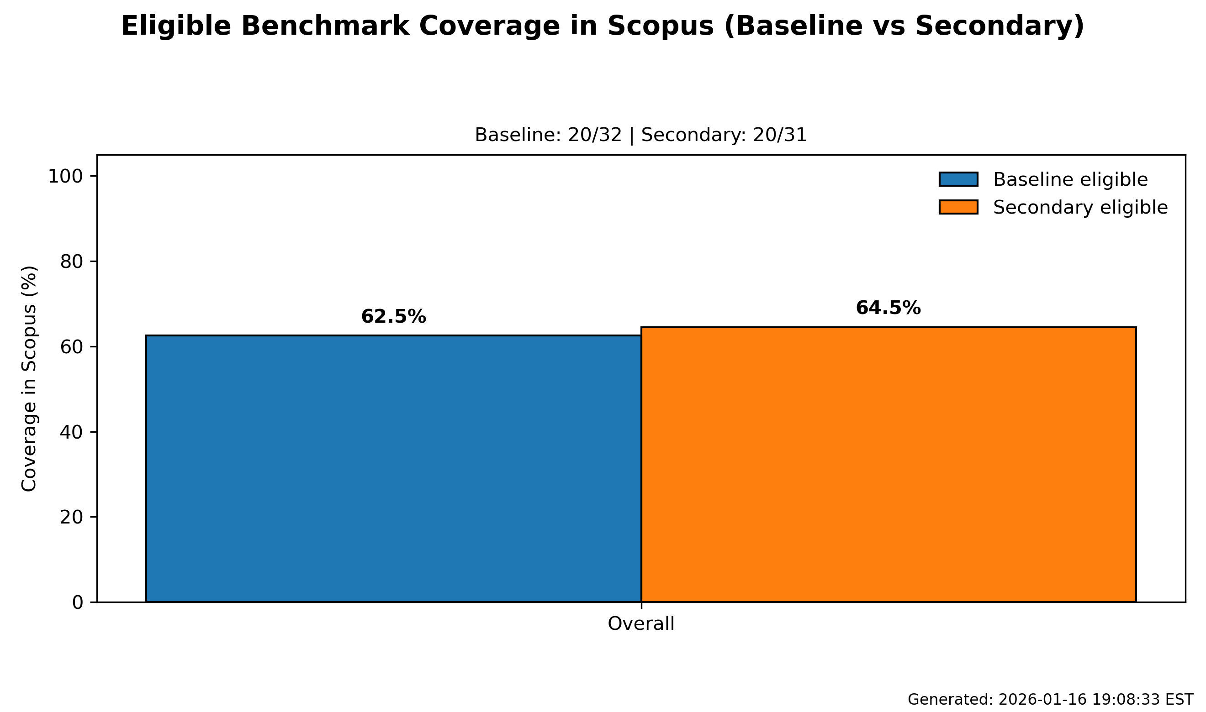

Figure: Baseline eligible retrieval (overall only)
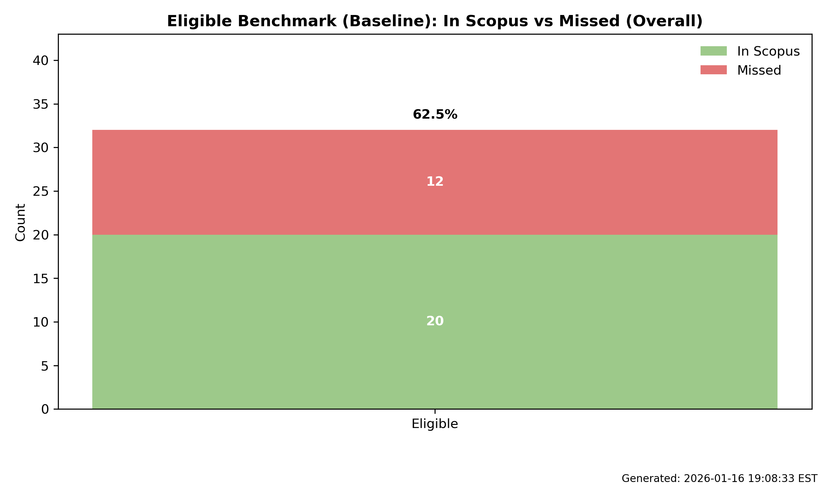

Figure: Secondary eligible retrieval (overall only)
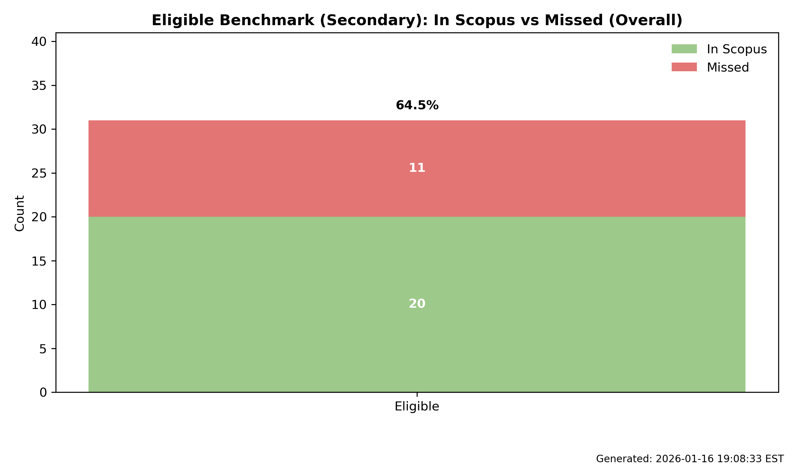

Figure: Full benchmark list retrieval (2x2 by status)
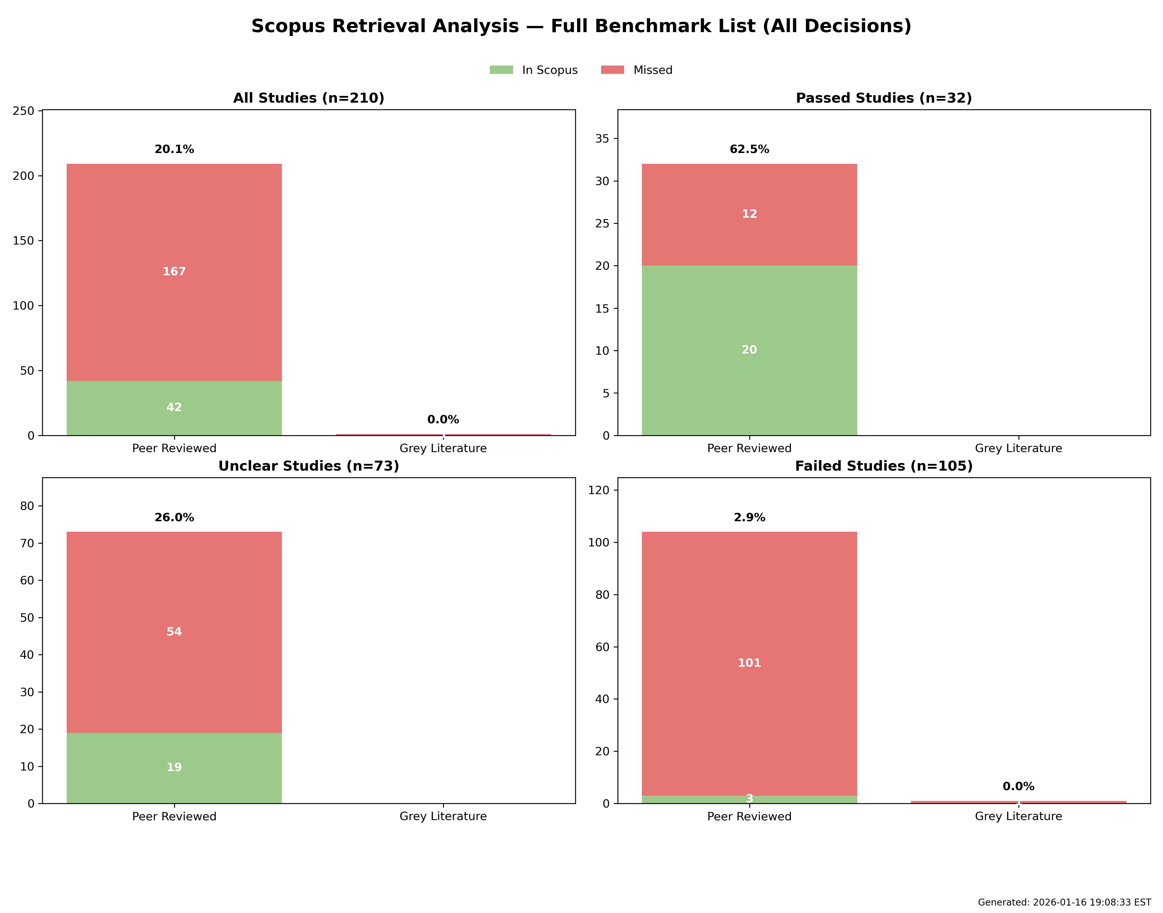

Figure: Full secondary check list retrieval (2x2 by status)
