Appendix: Computational Methodology for the Systematic Map on
Climate Adaptation Effectiveness among Smallholder Producers
Document generated: 06 April 2026
Full code repository: https://github.com/bristlepine/ilri-climate-adaptation-effectiveness
All pipeline scripts, eligibility criteria (criteria.yml), search strings (search_strings.yml), calibration outputs, and this document's source (methodology.py) are available in the repository above. The default branch is 'main'. Individual script links are provided in each section below.

Table of Contents

Note: Right-click this field in Word and select 'Update Field' to populate the table of contents.

1. Overview
This appendix provides a transparent, step-by-step account of the computational pipeline used to conduct the systematic map. The pipeline consists of sixteen sequential steps implemented in Python, each producing auditable outputs that feed into the next stage. It is fully resumable: all external API results and large language model (LLM) decisions are cached to disk so that any step can be re-run without reprocessing already-completed records.

1.1 Human Oversight and the Role of Automation
The pipeline is designed as an assistive tool, not an autonomous decision-maker. Human judgement is built in at every consequential stage. Specifically:
Search design. The search query and eligibility criteria were constructed and iteratively refined by the research team. No automated search strategy generation was used.
Calibration screening. Two independent human reviewers (Caroline Staub and Jennifer Cisse) screened each calibration sample separately in EPPI Reviewer, then reconciled disagreements into a gold standard before the LLM was assessed against it.
Criteria revision. After each calibration round, the team reviewed systematic disagreements and revised the eligibility criteria (criteria.yml) accordingly. Full-corpus screening did not proceed until performance metrics reached acceptable thresholds across three rounds.
Inclusion defaults. Where the LLM was uncertain, or where an abstract was missing, the conservative default was to include the record, not exclude it. False negatives (missed relevant studies) are treated as a more serious error than false positives.
Spot-checking. A random sample of LLM decisions was reviewed by human researchers at the title/abstract and full-text screening stages.
Data extraction. Extracted data fields were reviewed against source documents for a random sample of coded records before the coded dataset was finalised.

1.2 Database Coverage
The current pipeline was built and validated end-to-end using Scopus as the primary database, which offers the broadest interdisciplinary coverage of any single academic database and was the natural starting point for a multi-disciplinary systematic map. The Deliverable 3 protocol commits to five primary databases: Scopus, Web of Science Core Collection, CAB Abstracts, AGRIS, and Academic Search Premier, plus grey literature from approximately 20 institutional repositories. Coverage checks against Web of Science and OpenAlex are underway to identify records not captured in the Scopus corpus; those will be incorporated and the pipeline re-run before the final deliverable. The figures in this document therefore reflect a Scopus-based pilot run; they will be updated when the full multi-database corpus is assembled.

1.3 Preliminary Nature of Current Figures
Several pipeline statistics — in particular the count of records with missing abstracts and the full-text retrieval rate — reflect a preliminary run conducted under constrained API access: specifically, without an Elsevier institutional token. An application for institutional access through Cornell University is in progress. Once active, the Elsevier Abstract Retrieval API and Full-Text API will be available for the full corpus, and the enrichment and retrieval steps will be re-run. Affected figures are labelled 'preliminary' in the relevant sections. The screening pipeline design, calibration process, and eligibility criteria are not affected by this access limitation.
All LLM-assisted steps used a locally hosted model (Ollama; model: qwen2.5:14b) with temperature set to 0.0, ensuring fully deterministic and reproducible outputs. No proprietary cloud-based model API was used for screening or data extraction decisions.

Pipeline Summary Statistics
Stage | Count
Records returned by Scopus (raw) | 17,083
Records after deduplication (Step 2) | 17,021
Records with abstract after enrichment (Step 9a) | 15,707
Records still missing abstract after enrichment | 1,314
Records screened at title/abstract stage (Step 12) | 17,021
Included after title/abstract screening | 6,206
Excluded after title/abstract screening | 10,815
Full texts retrieved (Step 13) | 929
Records with no full text available | 5,277
Included after full-text screening (Step 14) | 184
Excluded after full-text screening | 130
Records coded in systematic map (Step 15) | 6,076
Coded from full text | 184
Coded from abstract only | 4,583
Abstract unavailable | 1,309

2. Computational Efficiency and the Case for Automation
Systematic reviews and evidence maps involving tens of thousands of records present a fundamental practical challenge: the volume of evidence to be processed far exceeds what a small research team can screen and code manually within a reasonable timeframe. A corpus of 17,021 records, if subjected to conventional dual independent human screening at the title/abstract stage alone, would require approximately 1,135 person-hours (assuming two minutes per record per reviewer, two reviewers). Full-text screening of the 6,206 passing records would add a further estimated 2,069 person-hours, and data extraction from the included studies a further estimated 2,532 person-hours. In aggregate, the three core screening and extraction stages would demand on the order of 5,700 person-hours of researcher time under conventional approaches, equivalent to approximately three full-time years of effort.
The pipeline described in this appendix completed the equivalent computational work in a small fraction of that time. Title/abstract screening of all 17,021 records was completed in 03:04:54 of unattended compute time. Full-text screening of 6,206 records took 03:50:05. Data extraction across 6,076 coded records took 00:13:58. Full-text retrieval (05:23:07) ran unattended overnight. The total unattended compute time for these four stages was approximately 13 hours, compared to an estimated 5,700 person-hours for manual equivalents.
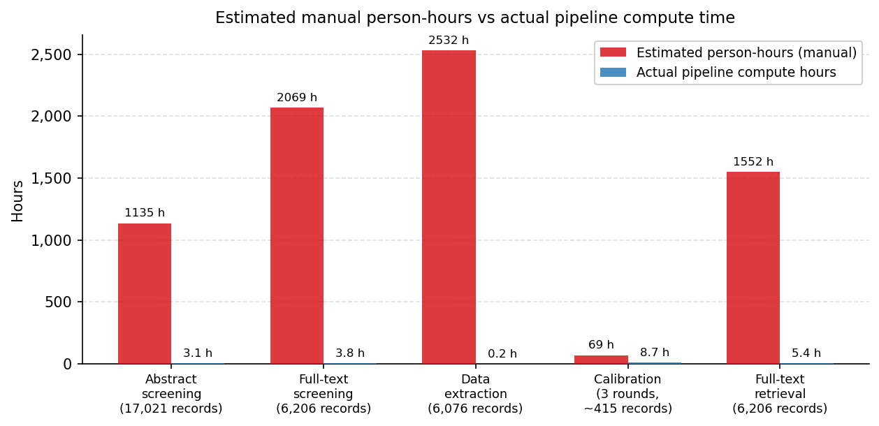
Figure 1. Estimated person-hours required for manual execution of each pipeline stage (red) versus actual unattended compute time (blue). Human estimates assume standard dual-reviewer protocols: 2 min/record for title/abstract screening, 10 min/record for full-text screening, 25 min/record for data extraction, 15 min/record for manual full-text retrieval. Calibration hours reflect LLM compute plus estimated human reconciliation time.
This efficiency gain does not come at the cost of rigour. The pipeline preserves human oversight at the stages where it matters most: search query design and iteration, criteria formulation, calibration of the LLM screener against independent human judgements, and verification of extracted data. The calibration process, described in Section 6, demonstrates that LLM agreement with reconciled human decisions reached substantial-to-almost-perfect kappa levels (k > 0.77) before full-corpus screening proceeded. Where the LLM was uncertain, the conservative default was to include rather than exclude, minimising false negatives.
A further practical consideration is reproducibility. Because all LLM decisions are made at temperature 0.0 and cached with full input-output provenance, the screening and extraction process can be re-run in its entirety and will produce identical results. This is not a property that manual screening can offer. The pipeline therefore combines the speed of automation with a level of reproducibility that exceeds conventional systematic review practice.

3. Search Strategy

3.1 Query Construction (Step 1)
Pipeline reference
Step 1: step1_scopus_query_counts.py — https://github.com/bristlepine/ilri-climate-adaptation-effectiveness/blob/main/scripts/step1_scopus_query_counts.py
Outputs: outputs/step1/ (step1_hits_plot.png, step1_queries.json, step1_total_query.txt)

The search query was structured around a Population, Concept, Context, and Methodology (PCCM) framework. Individual search elements were defined in a machine-readable YAML file (search_strings.yml), enabling version-controlled iteration. Step 1 submitted each element and their combination to the Scopus Search API to retrieve record counts, without downloading any records. A SHA-256 hash of the query was computed before each run; if unchanged, cached counts were returned without further API calls. Exponential backoff (up to six retries, maximum 60-second wait) handled transient rate limits.
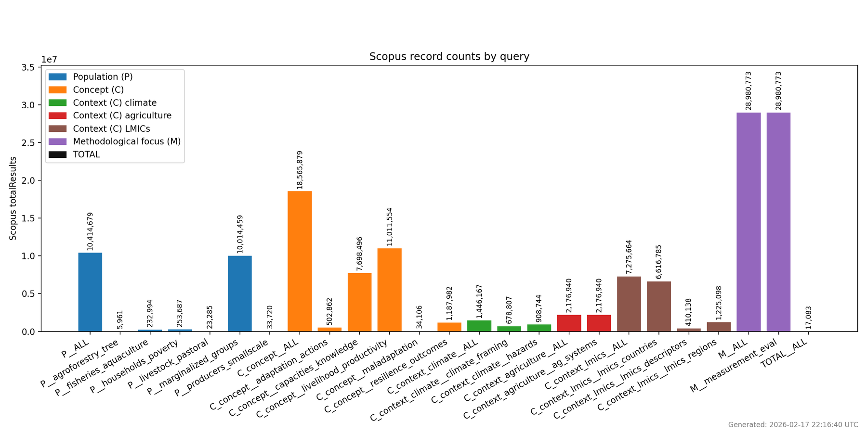
Figure 2. Record counts returned by the Scopus API for individual search string elements (P, C, M sub-groups) and the combined PCCM query. Generated by Step 1 of the pipeline.

3.2 Record Retrieval (Step 2)
Pipeline reference
Step 2: step2_scopus_retrieve_records.py — https://github.com/bristlepine/ilri-climate-adaptation-effectiveness/blob/main/scripts/step2_scopus_retrieve_records.py
Outputs: outputs/step2/ (step2_total_records.csv, .ris, .bib, .meta.json)

Step 2 retrieved all records matching the combined PCCM query. Scopus imposes a hard deep-paging limit of 5,000 records per query slice. To retrieve the full result set, the query was automatically sliced by publication year (1990-2025); where a single year still exceeded 5,000 records, further sub-slices by Scopus subject area (27 codes) or source type (7 disjoint types) were applied. Records were streamed directly to CSV as each page was received. After all slices were retrieved and deduplicated, 17,021 unique records were retained (from 17,083 reported by Scopus). Deduplication used a priority key: DOI (where present), then normalised title and year, then title alone, then EID.

3.3 Benchmark List and Coverage Analysis (Steps 3, 4, 7)
Pipeline reference
Step 3: step3_benchmark_match.py — https://github.com/bristlepine/ilri-climate-adaptation-effectiveness/blob/main/scripts/step3_benchmark_match.py
Step 4: step4_fetch_abstracts.py — https://github.com/bristlepine/ilri-climate-adaptation-effectiveness/blob/main/scripts/step4_fetch_abstracts.py
Step 7: step7_scopus_check.py — https://github.com/bristlepine/ilri-climate-adaptation-effectiveness/blob/main/scripts/step7_scopus_check.py
Outputs: outputs/step3/, outputs/step4/, outputs/step7/

A benchmark list of known key studies, compiled by the research team prior to the search, was used to validate coverage. Step 3 enriched the benchmark list with DOIs using Crossref, OpenAlex, and Semantic Scholar. Candidate matches were scored by title similarity (difflib SequenceMatcher); matches scoring 0.90 or above were accepted automatically. Step 7 compared the benchmark list against the Scopus retrieval and generated keyword suggestions from non-retrieved benchmark records to guide iterative query refinement. Human review of suggestions was required before any query modification was made.

4. Record Cleaning and Deduplication (Step 8)
Pipeline reference
Step 8: step8_clean_scopus.py — https://github.com/bristlepine/ilri-climate-adaptation-effectiveness/blob/main/scripts/step8_clean_scopus.py
Outputs: outputs/step8/ (step8_scopus_cleaned.csv, .ris, .meta.json)

Step 8 applied deterministic cleaning to the raw Scopus records: HTML unescaping, whitespace normalisation, DOI canonicalisation, and year extraction. Where a DOI was present but author list, journal name, or year was missing, Crossref was queried to repair the gap. All Crossref lookups were cached locally. The step was designed to be idempotent: on re-runs, previously cleaned records were preserved; only records new to the current Scopus pull were processed.

5. Abstract Enrichment (Steps 9 and 9a)

5.1 Automated Multi-Source Enrichment (Step 9)
Pipeline reference
Step 9: step9_enrich_abstracts.py — https://github.com/bristlepine/ilri-climate-adaptation-effectiveness/blob/main/scripts/step9_enrich_abstracts.py
Outputs: outputs/step9/ (step9_scopus_enriched.csv, step9_missing.csv, step9_summary.json)

Step 9 retrieved missing abstracts for all cleaned Scopus records using a sequential fetch chain: (1) Elsevier Abstract Retrieval API by DOI then Scopus ID; (2) Semantic Scholar; (3) OpenAlex (abstract reconstructed from the inverted-index word-position map); (4) Crossref; (5) Unpaywall; (6) landing page scrape via JSON-LD, HTML meta tags, or raw HTML. All API responses were cached with a 30-day time-to-live. Of 17,021 records, 5,839 already carried an abstract from Scopus; Step 9 enriched a further 9,752. After Step 9, 1,430 records remained without an abstract.
Note (preliminary): the 1,430 records without an abstract after Step 9 reflect an API access constraint rather than a data availability problem. The Elsevier Abstract Retrieval API requires an institutional token to return full abstract content for many records. This run was executed without institutional token access. Spot-checks of a sample of the missing records confirm their abstracts are available on the Scopus web interface. Once the Elsevier institutional token is active (application in progress through Cornell University), Step 9 will be re-run and this figure is expected to fall substantially.

5.2 RIS-Based Supplementary Enrichment (Step 9a)
Pipeline reference
Step 9a: step9a_enrich_from_ris.py — https://github.com/bristlepine/ilri-climate-adaptation-effectiveness/blob/main/scripts/step9a_enrich_from_ris.py
Inputs configured in config.py (step9a_ris_glob, step9a_iteration) | Outputs: outputs/step9a/ (step9a_scopus_enriched.csv, step9a_diff.csv, step9a_summary.json)

Following automated enrichment, EPPI Reviewer exported the full corpus as RIS files with any manually entered abstracts included. Step 9a parsed these files (five files totalling 17,011 records in iteration step9a1) and injected RIS abstracts into records still lacking one, matching by DOI, Scopus EID, or normalised title and year. It then re-attempted API enrichment for remaining gaps, bypassing Step 9 cached failures. In total Step 9a recovered 116 additional abstracts, reducing the missing count from 1,430 to 1,314. Each run is labelled with an iteration identifier and UTC timestamp for provenance. Records still lacking an abstract were retained and treated conservatively at screening.

6. Calibration and Validation (Steps 10 and 11)
This section describes the structured validation process that was conducted before any automated screening of the full corpus. It is the methodological core of the quality-assurance framework for this pipeline. Three independent calibration rounds were run, each involving dual human screening, gold-standard reconciliation, LLM performance assessment, and criteria revision. Full-corpus screening did not proceed until performance metrics reached acceptable thresholds across all three rounds.

6.1 Calibration Process
Pipeline reference
Step 10: step10_llm_calibrate.py — https://github.com/bristlepine/ilri-climate-adaptation-effectiveness/blob/main/scripts/step10_llm_calibrate.py
Step 11: step11_irr_analysis.py — https://github.com/bristlepine/ilri-climate-adaptation-effectiveness/blob/main/scripts/step11_irr_analysis.py
Criteria: criteria.yml — https://github.com/bristlepine/ilri-climate-adaptation-effectiveness/blob/main/scripts/criteria.yml
Calibration RIS inputs configured in config.py (step10_calibration_ris, step10_run_label) | Outputs: outputs/step10/, outputs/step11/

For each round, a sample was drawn from the enriched corpus. Two human reviewers (Caroline Staub and Jennifer Cisse) screened the same records independently in EPPI Reviewer, with no visibility of each other's decisions. Their decisions were then compared and disagreements discussed until a reconciled gold-standard decision was agreed for every record. Step 10 ran the LLM screener against the same sample using the current version of criteria.yml. Step 11 computed all pairwise Cohen's kappa coefficients and produced confusion matrices showing how each rater's decisions compared to the reconciled gold standard. The research team reviewed the outputs after each round and identified categories of systematic disagreement. Where the LLM was consistently wrong in a particular way (e.g. over-including vulnerability-only studies), the eligibility criteria were revised in criteria.yml before the next round was run. This process is analogous to calibration training in conventional systematic review practice, but with a documented, reproducible audit trail.

6.2 Metric Definitions and Interpretation
Two complementary sets of metrics are reported for each calibration round. They answer different questions and should be read together.
Cohen's kappa (κ) measures agreement between two raters beyond what would be expected by chance alone. It is the standard metric for inter-rater reliability in systematic review practice and is used by EPPI Reviewer, Cochrane, and the Campbell Collaboration for exactly this purpose. A kappa of 1.0 indicates perfect agreement; 0.0 indicates agreement no better than chance; negative values indicate systematic disagreement. In this pipeline, kappa is computed in two contexts: (a) between the two human reviewers, to assess human agreement; and (b) between the LLM and the reconciled gold standard, to assess LLM performance.
κ range | Interpretation | Typical implication for screening
< 0.00 | Less than chance | Systematic disagreement — criteria likely ambiguous
0.00 – 0.20 | Slight | Very poor agreement — do not proceed
0.21 – 0.40 | Fair | Poor agreement — substantial criteria revision needed
0.41 – 0.60 | Moderate | Acceptable for initial calibration; revision recommended
0.61 – 0.80 | Substantial | Good agreement — approaching deployment threshold
0.81 – 1.00 | Almost perfect | Excellent — criteria are clear and consistently applied

Thresholds from Landis and Koch (1977). The conventional minimum threshold for proceeding to full-corpus screening in systematic review practice is κ ≥ 0.60 (substantial agreement). In this pipeline, full-corpus screening was not approved until the LLM reached κ ≥ 0.67 against both human reviewers in Round 3a, and human reviewers themselves maintained κ = 0.70 inter-rater agreement at that point.
Precision, recall, and F1 are classification metrics computed from the confusion matrix of LLM decisions against the reconciled gold standard. They are reported alongside kappa because they are more familiar in the machine learning literature and provide complementary information:
Precision. Of all records the LLM decided to include, what proportion were truly relevant (i.e. also included in the gold standard)? High precision means few false positives — the LLM is not over-inclusive.
Recall. Of all records in the gold standard that should be included, what proportion did the LLM correctly identify? High recall means few false negatives — the LLM is not missing relevant studies. In systematic review practice, recall is the more critical of the two: missing a relevant study is a more serious error than including an irrelevant one. The conservative inclusion default in this pipeline (unclear → include) is specifically designed to protect recall.
F1. The harmonic mean of precision and recall, giving a single balanced score. An F1 of 1.0 is perfect; 0.0 is the worst possible. F1 penalises imbalance: a model that achieves high recall by including everything would have low precision and therefore a moderate F1.
Note: precision, recall, and F1 can only be computed for rounds in which a reconciled gold-standard column exists. Round 3a was designed to verify criteria stability rather than generate a new gold standard; for that round, only pairwise kappa between human reviewers and the LLM is available.

6.3 Calibration Results
Table 1 summarises LLM performance against the reconciled gold standard across calibration rounds.
Round | n | Human κ | LLM κ vs gold | Precision | Recall | F1
R1 (initial criteria) | 205 | 0.500 | 0.436 | 0.559 | 0.776 | 0.650
R1b (revised criteria) | 205 | 0.500 | 0.645 | 0.699 | 0.866 | 0.774
R2a (2nd revision) | 103 | 0.765 | 0.770 | 0.788 | 0.897 | 0.839
R3a (final — no gold std) | 107 | 0.703 | avg 0.682 | — | — | —

Round 1 (n = 205): The LLM's initial performance was moderate — κ = 0.436 against the gold standard, with recall = 0.776 but precision = 0.559 (F1 = 0.650). The low precision reflects over-inclusion: 41 false positives against only 15 false negatives. This is the expected failure mode for diffuse-concept topics: the model correctly identified relevant studies but also included many that were related but not eligible (e.g. vulnerability assessments without outcome measurement, or impact evaluations without adaptation framing). The human inter-rater kappa at this round was 0.500 — moderate — reflecting that the criteria themselves were not yet sufficiently precise to support consistent application even by trained human reviewers.
Round 1b (n = 205, revised criteria): After tightening the Concept and Methodology eligibility criteria to explicitly exclude vulnerability-only and impact-only studies, LLM performance improved markedly: κ = 0.645, precision = 0.699, recall = 0.866, F1 = 0.774. The number of false positives dropped from 41 to 25, while false negatives remained low at 9. LLM kappa crossed into the 'substantial agreement' band (κ ≥ 0.61) for the first time.
Round 2 / 2a (n = 103): Human inter-rater kappa improved substantially to 0.765 at Round 2, confirming that the revised criteria were now sufficiently clear for consistent human application. After a further criteria revision (Round 2a), LLM performance against the reconciled gold standard reached: κ = 0.770, precision = 0.788, recall = 0.897, F1 = 0.839. Both human reviewers reached almost-perfect agreement with the gold standard (Caroline: κ = 0.879; Jennifer: κ = 0.884).
Round 3a (n = 107): The final round was designed to verify criteria stability on a fresh sample, not to generate a new gold standard. Human inter-rater kappa was 0.703 (substantial agreement). LLM agreement with Jennifer Cisse: κ = 0.690; with Caroline Staub: κ = 0.674. Both are within the substantial agreement band and consistent with Round 2a performance. The team reviewed criteria and confirmed they were stable. Full-corpus screening was approved to proceed.
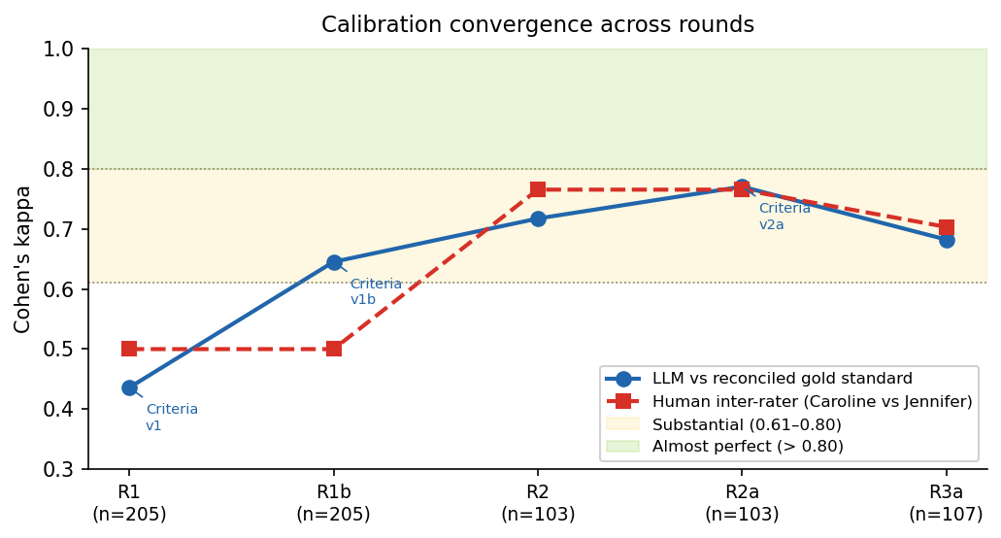
Figure 3. Cohen's kappa convergence across calibration rounds. Blue circles: LLM agreement with reconciled human gold standard (or mean LLM-human kappa for R3a where no gold standard was collected). Red squares: human inter-rater kappa. Shaded bands show the Landis and Koch (1977) interpretation thresholds. Annotated labels indicate criteria revision points between rounds.
The trajectory in Figure 3 shows a clear and systematic improvement driven by targeted criteria revisions. Round 1 LLM kappa of 0.44 (moderate) — precisely the failure mode documented in the literature for diffuse-concept topics — was identified, diagnosed, and corrected through two further rounds of calibration before full-corpus screening began. By Round 2a the LLM had reached substantial agreement (κ = 0.77, F1 = 0.84, recall = 0.90), and human reviewers were in almost-perfect agreement with the gold standard (κ > 0.87). This is the intended outcome of a structured calibration process, not an incidental finding.

6.4 Relationship to Supervised Machine-Learning Screeners
The calibration approach used here differs categorically from supervised machine-learning screeners such as those in EPPI Reviewer or Juno. Supervised ML screeners are classifiers trained from near-scratch on labelled examples and typically require 2,000–7,000 training records before reaching adequate performance. The screener used in this pipeline is a pre-trained large language model (qwen2.5:14b, 14 billion parameters trained on extensive text corpora). The approximately 415 calibration records across three rounds are not training data — they are a validation set for prompt and eligibility criteria design. The model's parameters are not updated at any point.
The relevant question is therefore not 'did the model see enough examples to learn?' but 'was it verified that the model correctly applies the eligibility criteria before full-corpus deployment?' Three iterative calibration rounds with structured reconciliation, confusion matrix analysis, and criteria revision serve exactly that purpose. The analogy in conventional systematic review practice is not classifier training — it is calibration training: verifying that a reviewer correctly understands and consistently applies the eligibility criteria before they begin independent screening. The number of records needed for that purpose (to detect systematic misapplication and verify correction) is different in kind from the number needed to fit a statistical classifier.

6.5 Round-by-round calibration figures
The following figures show the full three-panel analysis for selected calibration rounds: pairwise kappa heatmap, per-rater confusion bar chart relative to reconciled decisions, and reconciled decision distribution.
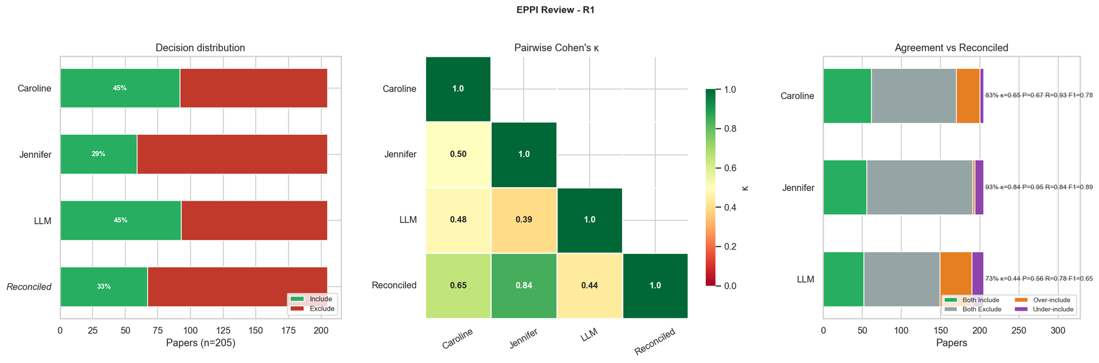
Figure 4a. Calibration Round 1 (n = 205). Initial criteria version.
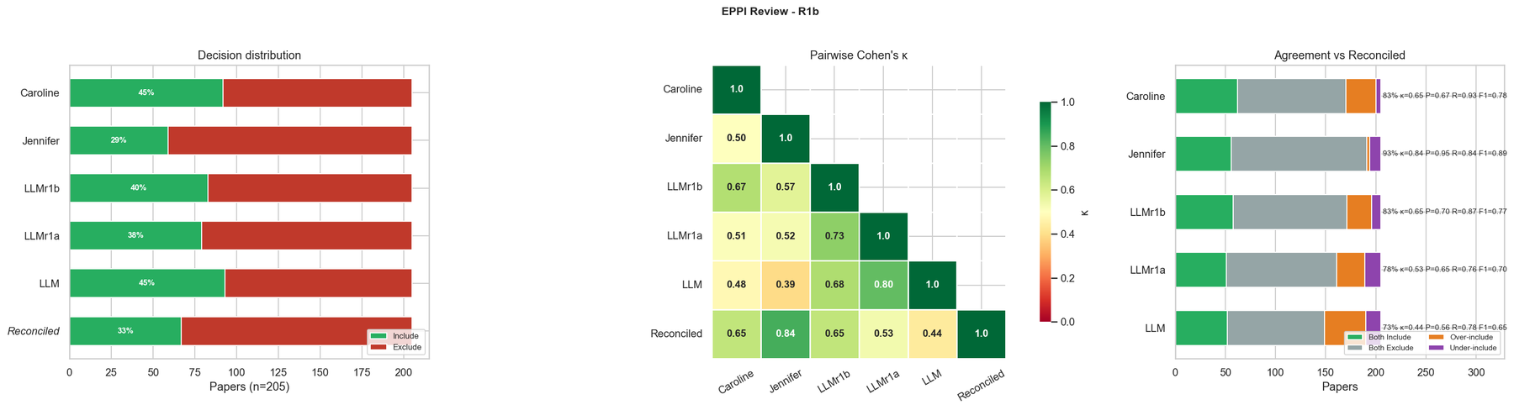
Figure 4b. Calibration Round 1b (n = 205). After first criteria revision.
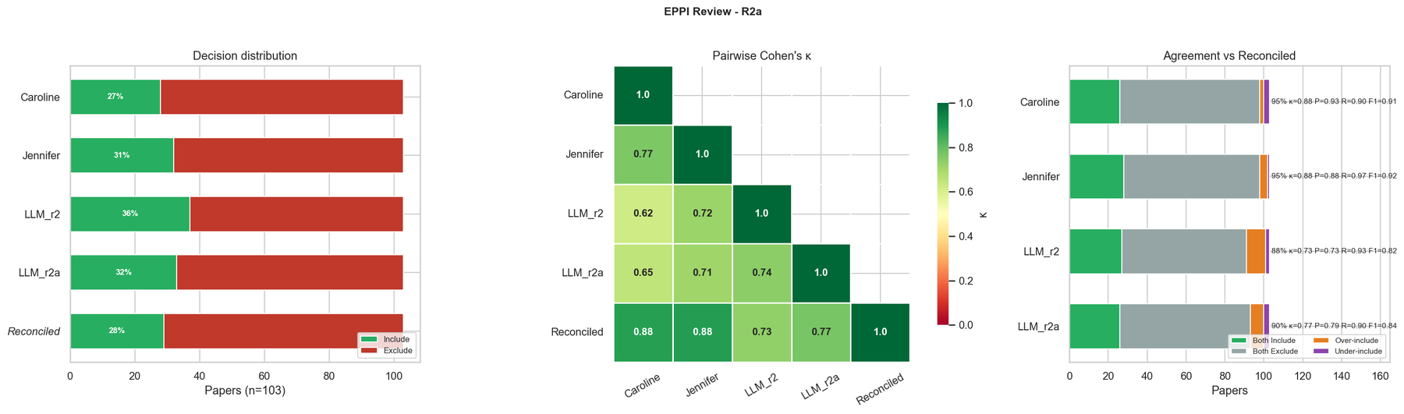
Figure 4c. Calibration Round 2a (n = 103). After second criteria revision.
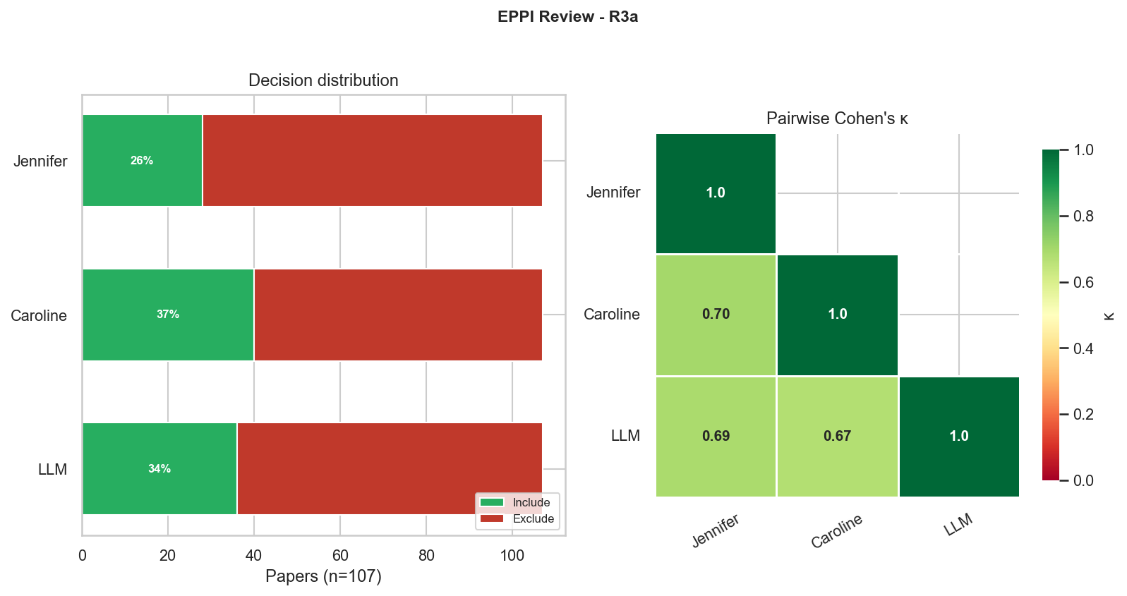
Figure 4d. Calibration Round 3a (n = 107). Final criteria version.

7. Title and Abstract Screening (Step 12)
Pipeline reference
Step 12: step12_screen_abstracts.py — https://github.com/bristlepine/ilri-climate-adaptation-effectiveness/blob/main/scripts/step12_screen_abstracts.py
Outputs: outputs/step12/ (step12_results.csv, step12_results.meta.json, step12_results_details.jsonl)

Step 12 applied the LLM screener to all 17,021 records using the criteria.yml finalised through calibration. The LLM evaluated each record against five PCCM criteria, returning a decision (yes / no / unclear), a reason, and a direct quotation from the abstract for each. Quotations were verified against the abstract text; unverifiable quotes downgraded the criterion to 'unclear'. A record was excluded only if at least one criterion was explicitly 'no'; any 'unclear' or absent abstract defaulted to inclusion.
Results: 6,206 included, 10,815 excluded, 1,314 retained due to missing abstract. The most frequent exclusion criterion was Concept (9,197 records), followed by Population (5,318 records). All decisions were cached to a JSONL file keyed on record identifier and abstract source, enabling incremental re-runs.
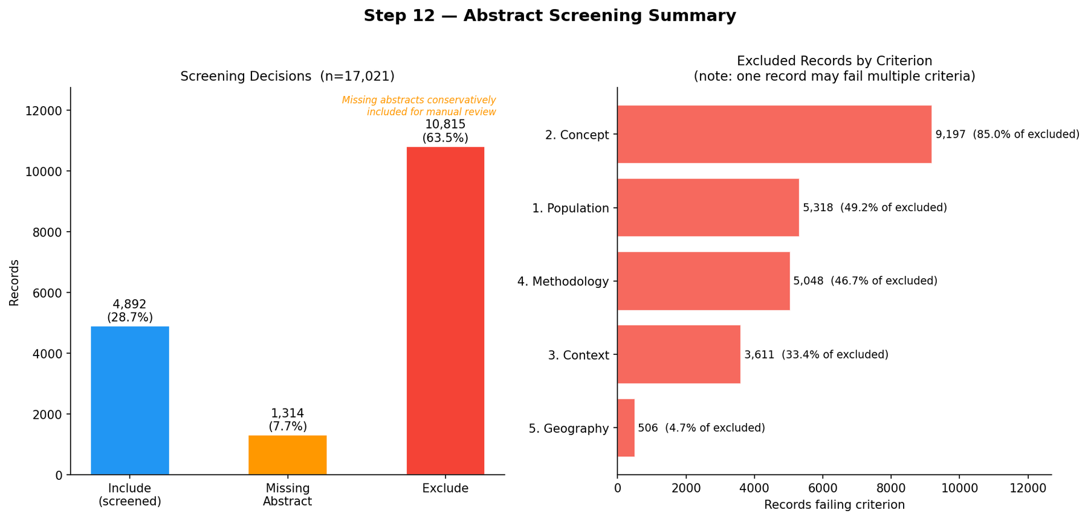
Figure 5. Title/abstract screening outcome summary (Step 12). Shows include/exclude/unclear counts and the most common exclusion criteria.

8. Full-Text Retrieval (Step 13)
Pipeline reference
Step 13: step13_retrieve_fulltext.py — https://github.com/bristlepine/ilri-climate-adaptation-effectiveness/blob/main/scripts/step13_retrieve_fulltext.py
Outputs: outputs/step13/ (step13_manifest.csv, step13_summary.json, fulltext/ directory)

Step 13 attempted to download full texts for all 6,206 records passing abstract screening, using: Unpaywall (open-access URLs by DOI), Elsevier Full-Text API (institutional access), Semantic Scholar, and OpenAlex. Downloads were capped at 25 MB. 929 full texts were retrieved (515 via Unpaywall, 331 via Elsevier, 70 via Semantic Scholar). 5,277 records could not be retrieved automatically and were flagged for manual acquisition via institutional library access.

9. Full-Text Screening (Step 14)
Pipeline reference
Step 14: step14_screen_fulltext.py — https://github.com/bristlepine/ilri-climate-adaptation-effectiveness/blob/main/scripts/step14_screen_fulltext.py
Outputs: outputs/step14/ (step14_results.csv, step14_results.meta.json, step14_results_details.jsonl)

Step 14 applied the LLM screener to retrieved full texts, truncated to 12,000 characters to cover abstract, introduction, and methods. Text was extracted from PDFs using pypdf and from HTML using trafilatura or BeautifulSoup. Records without a retrieved full text were retained conservatively. Of 6,206 records assessed: 314 were screened from full text; 184 confirmed included; 130 excluded. The most frequent full-text exclusion criterion was Concept (104 records).
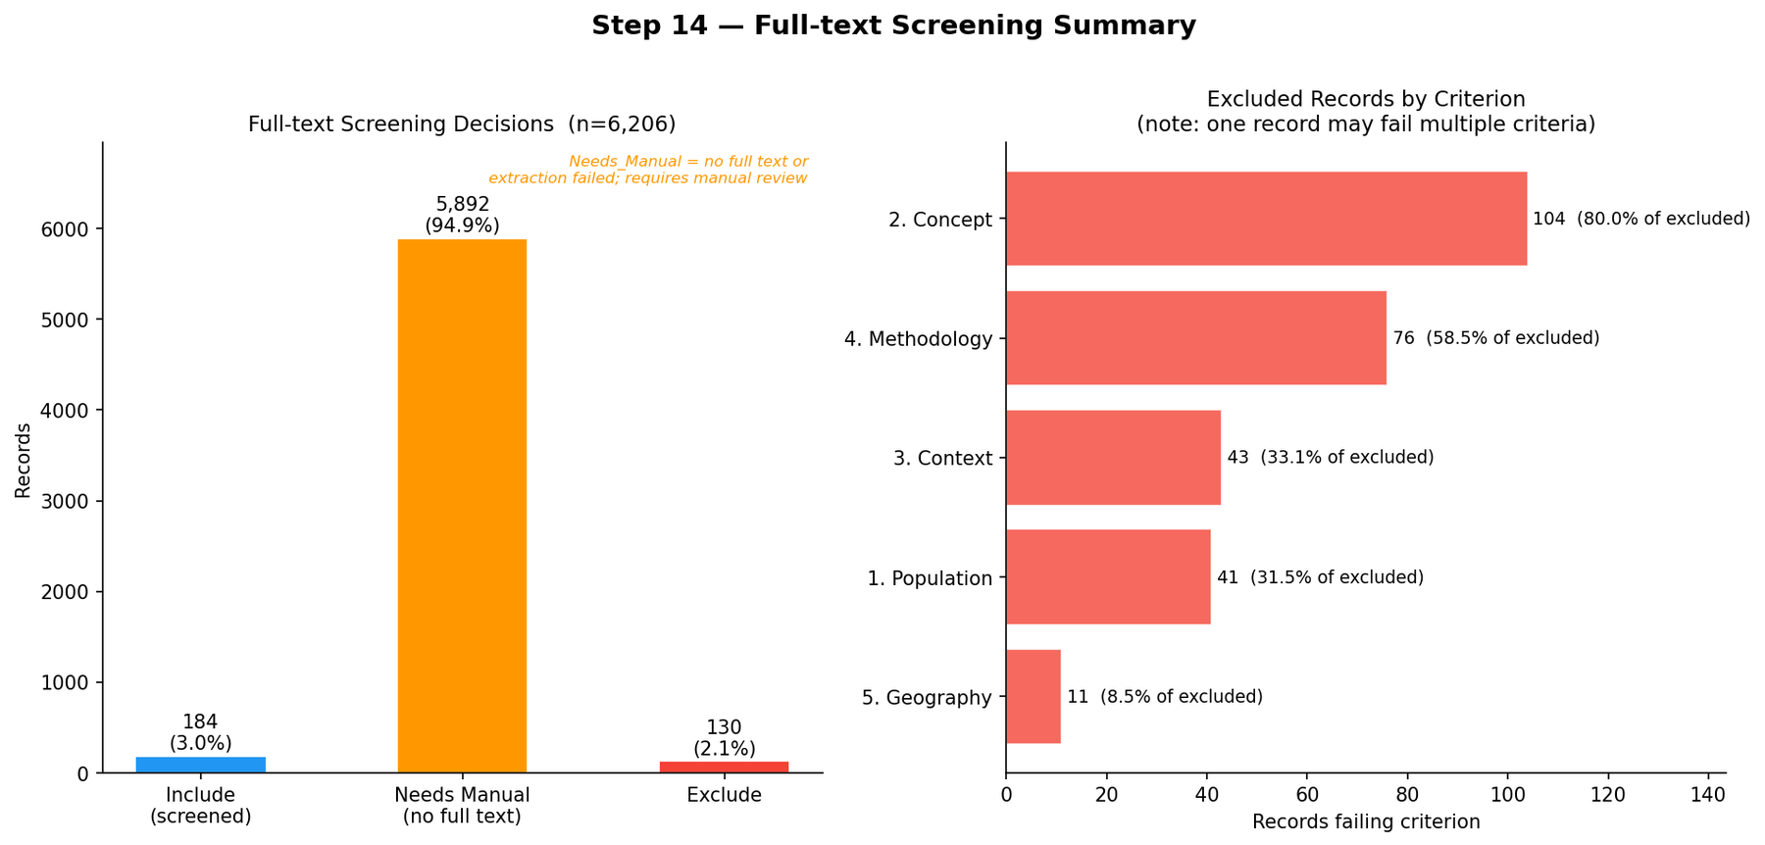
Figure 6. Full-text screening outcome summary (Step 14).

10. Data Extraction and Coding (Step 15)
Pipeline reference
Step 15: step15_extract_data.py — https://github.com/bristlepine/ilri-climate-adaptation-effectiveness/blob/main/scripts/step15_extract_data.py
Outputs: outputs/step15/ (step15_coded.csv, step15_coded.meta.json, step15_needs_review.csv)

Step 15 extracted structured coding data from all included records against a 20-field schema covering: publication year and type, country or region, geographic scale, producer type (crop, livestock, fisheries, agroforestry, mixed), whether the study assessed adaptation processes or outcomes, methodological approach, effectiveness metric, and equity/inclusion dimensions. The LLM was supplied with full text (where available) or abstract, and the coding source was recorded per record. All extracted data were subject to human spot-checking prior to use in the final evidence map.
Of 6,076 records: 184 coded from full text, 4,583 from abstract only, 1,309 with neither. The coding source field allows readers to weight evidence confidence accordingly.
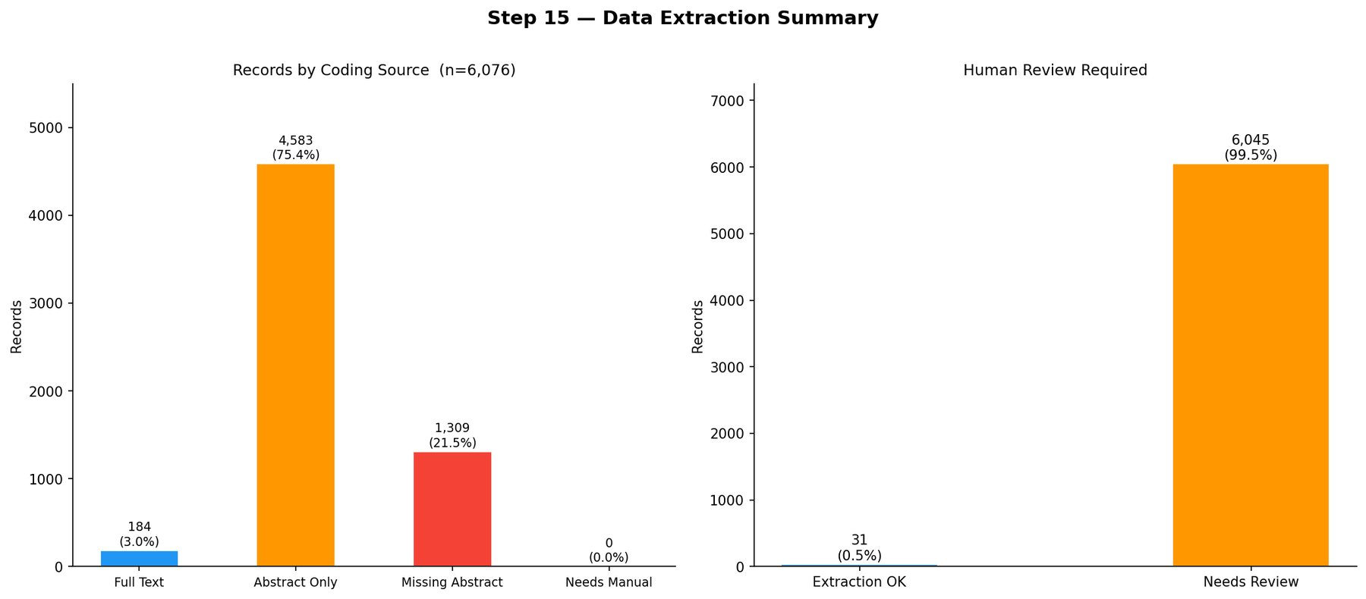
Figure 7. Data extraction summary by coding source (Step 15).

11. Systematic Map Outputs (Step 16)
Pipeline reference
Step 16: step16_map_visualise.py — https://github.com/bristlepine/ilri-climate-adaptation-effectiveness/blob/main/scripts/step16_map_visualise.py
Outputs: outputs/step16/ (roses_flow.png, temporal_trends.png, geographic_bar.png, producer_type_bar.png, methodology_bar.png, domain_heatmap.png, equity_bar.png)

Step 16 generated all publication-ready figures directly from the coded dataset. Figures are updated automatically as further full texts are retrieved and coded. All exports are PNG at 300 DPI.
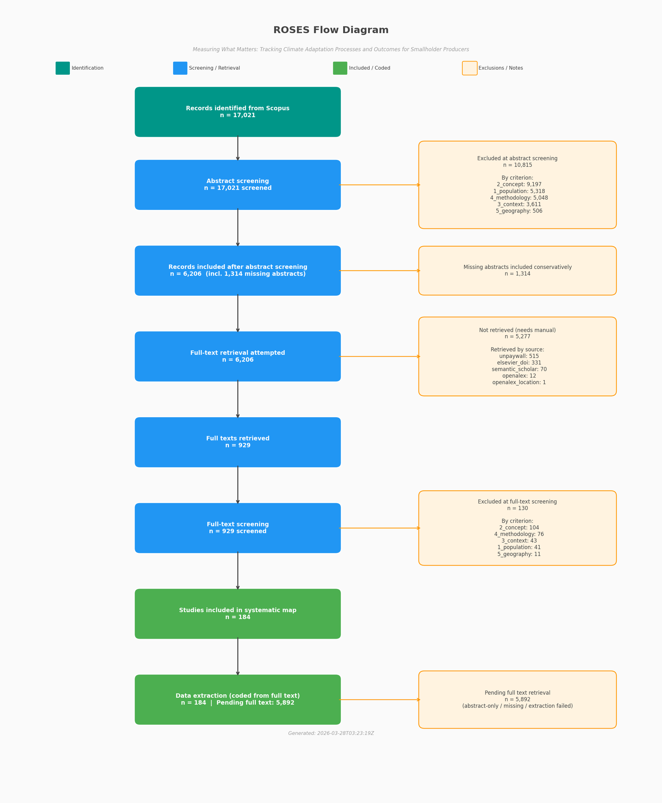
Figure 8. ROSES flow diagram showing record counts at each stage of the systematic map pipeline.
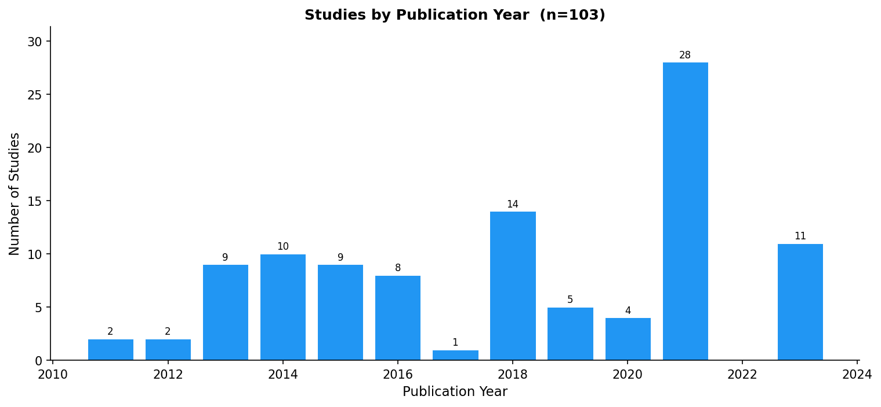
Figure 9. Temporal trends in publications included in the systematic map.
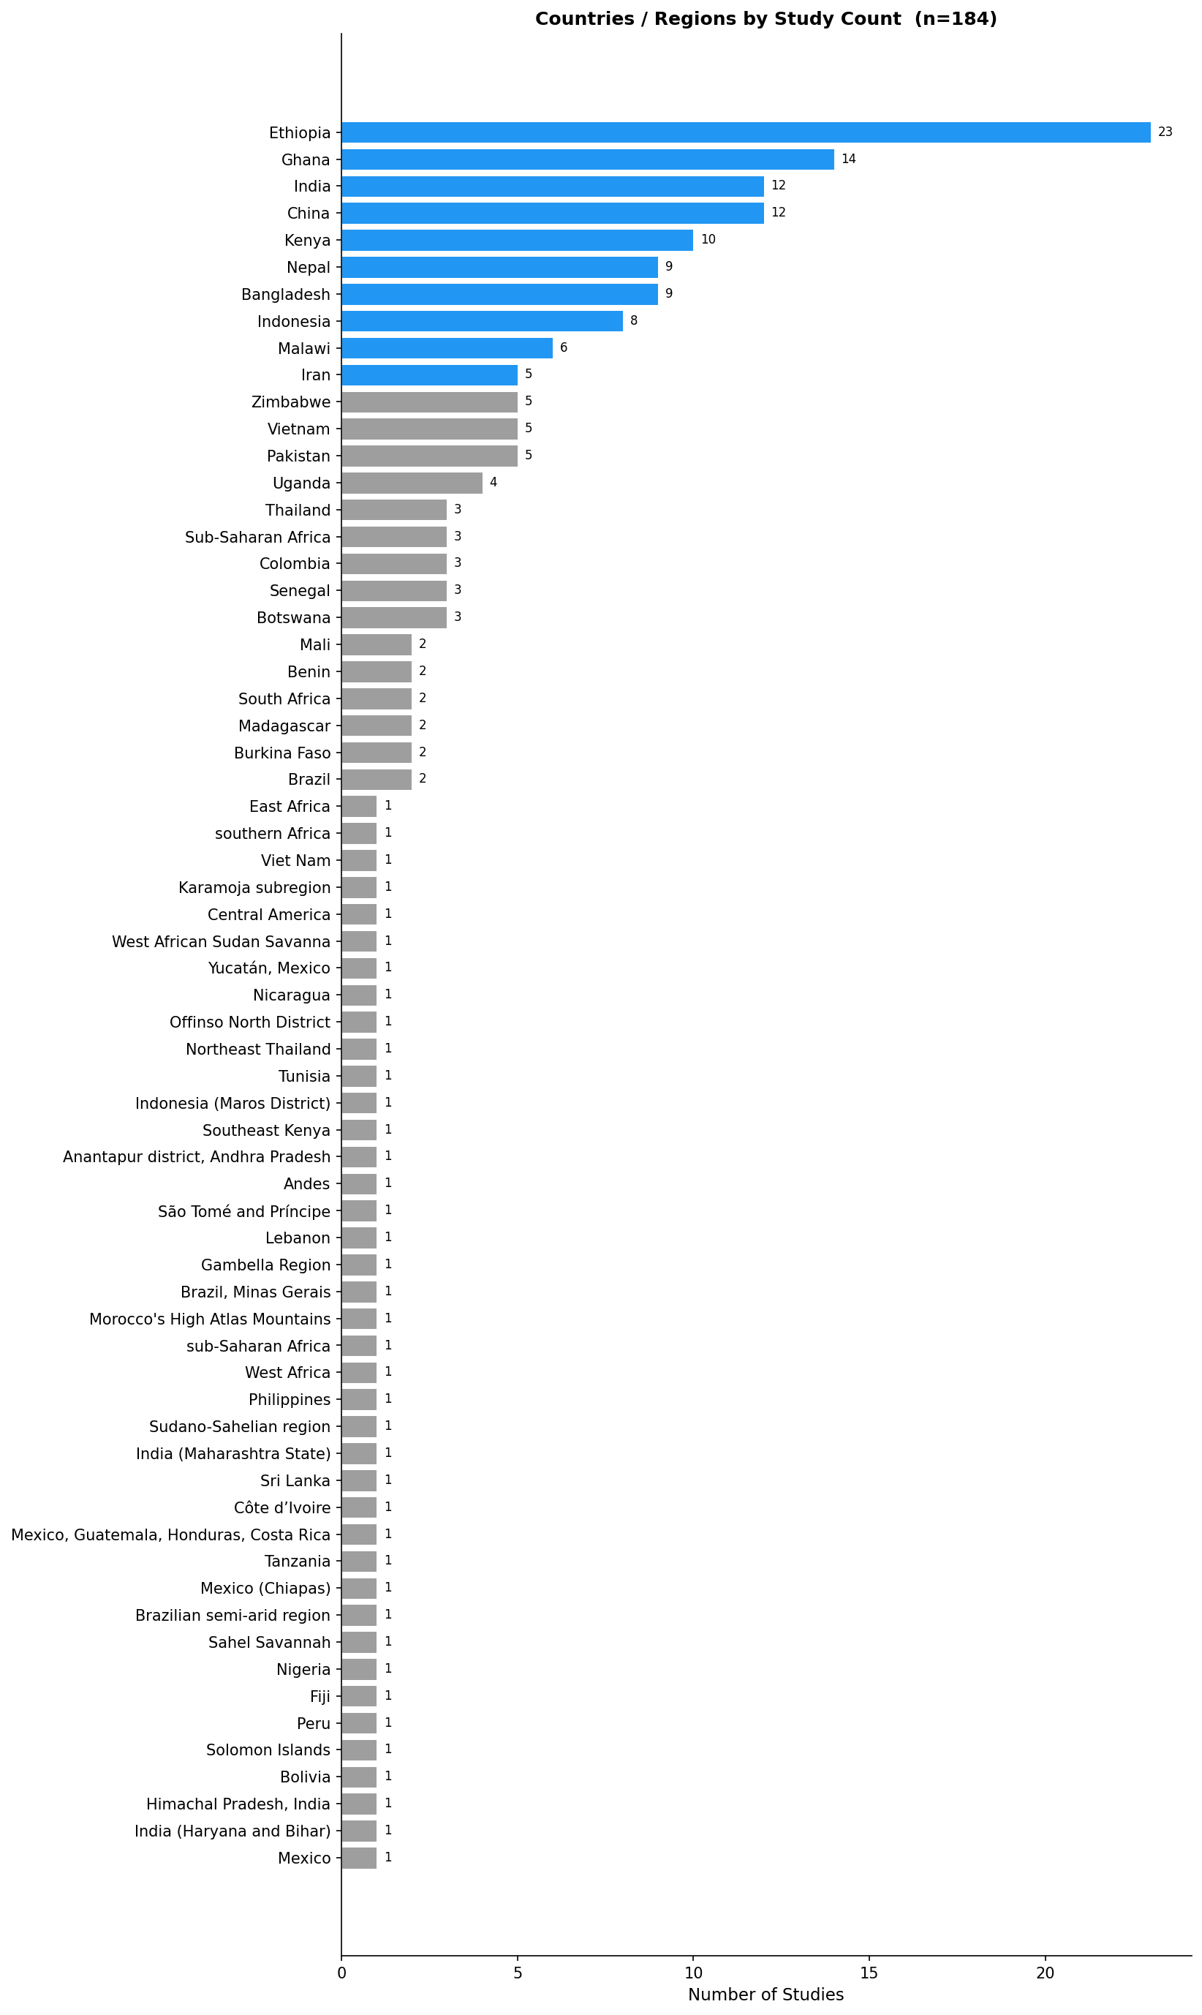
Figure 10. Geographic distribution of included studies (top countries by count).
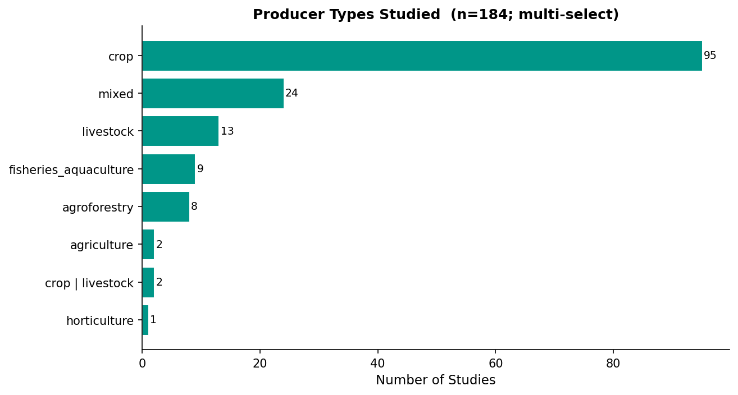
Figure 11. Breakdown of included studies by producer type.
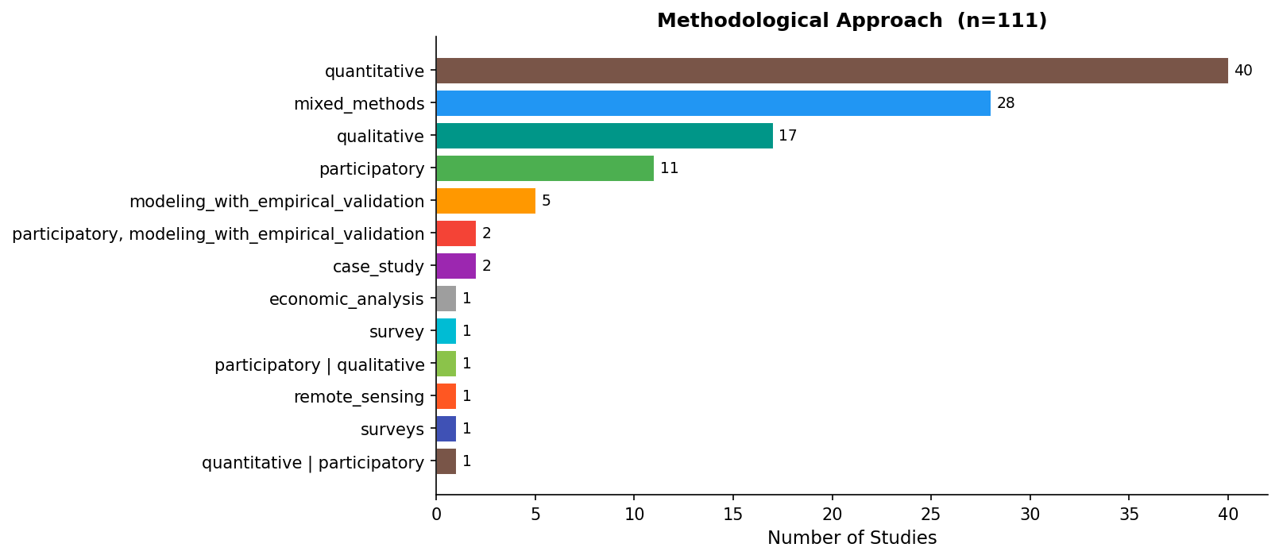
Figure 12. Breakdown of included studies by methodological approach.
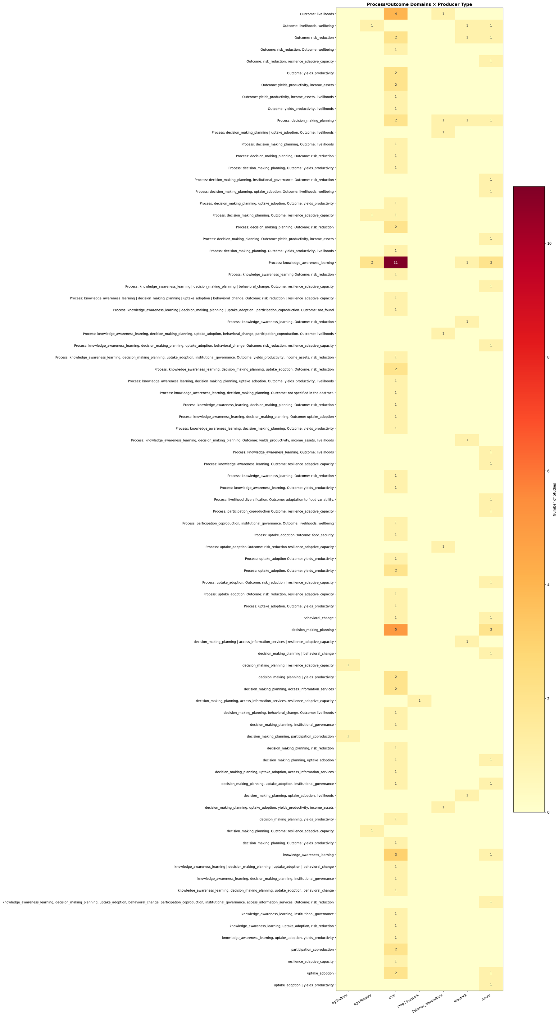
Figure 13. Domain heatmap: adaptation process versus outcome by producer type.

12. Reproducibility and Transparency
The following design principles were applied throughout to ensure the pipeline is reproducible and its decisions are auditable:
Deterministic LLM outputs. Temperature was set to 0.0 for all LLM calls. Given a fixed model and fixed input, outputs are reproducible across runs.
Comprehensive caching. All external API responses and LLM decisions are written to cache files (JSON or JSONL). Re-runs process only new or expired records.
Quotation verification. LLM screening decisions must cite a passage from the abstract. If the cited passage cannot be located, the criterion is downgraded to 'unclear', providing a lightweight hallucination check.
Conservative defaults. Across all screening stages, the absence of required evidence defaults to inclusion rather than exclusion, minimising false negatives.
Iterative human calibration. Three calibration rounds with two independent human reviewers preceded full-corpus automated screening. Criteria were revised between rounds based on observed disagreements.
Coding source tracking. Every coded record carries a 'coding_source' field indicating whether extraction was from full text, abstract only, or title/metadata alone.
Version-controlled criteria. Eligibility criteria are stored in a single YAML file (criteria.yml), versioned alongside the code. Any change triggers re-screening of affected records on the next run.
ROSES flow diagram. A ROSES-compliant flow diagram is generated automatically at Step 16, documenting record counts at every stage of the pipeline.

13. Software and Dependencies
Component | Library / Service | Purpose
LLM inference | Ollama (qwen2.5:14b) | Local LLM for screening and extraction
Scopus API | Elsevier REST API | Record retrieval and abstract enrichment
DOI enrichment | Crossref, OpenAlex, Semantic Scholar | DOI lookup and abstract retrieval
Open access | Unpaywall API | Full-text URL discovery
Word documents | python-docx | Report and export generation
PDF parsing | pypdf | Full-text extraction from PDFs
HTML parsing | trafilatura, BeautifulSoup4 | Full-text extraction from HTML
Data handling | pandas | CSV processing throughout pipeline
Visualisation | matplotlib, seaborn | All figures
Geographic maps | geopandas (optional) | World choropleth in Step 16
IRR statistics | Custom Python (Cohen's kappa) | Inter-rater reliability analysis
Reference management | EPPI Reviewer | Human screening and RIS exports

This document was generated programmatically from pipeline output files on 06 April 2026. All statistics and figures are drawn directly from the JSON metadata files and PNG outputs produced at each pipeline step.

