Solutions 2: Exploring Compartmental Model Dynamics

Sam Abbott

# Learning Objectives

1. Understand how changing parameter values, and model structure, can influence model dynamics.
2. Understand the dynamics of the SEIR model in detail.
3. Understand the impact of risk group stratification on model dynamics.
4. Understand some of the complex dynamics produced by a more realistic model.

# Outline for Session

1. Set up (5 minutes)
2. Investigate the dynamics of a simple SEIR model (10 minutes)
3. Explore the impact of adding high and low risk latency to a SEIR model, in comparison to the SEIR model (10 minutes).
4. Investigate the complex dynamics of a more realistic SHLIR model (10 minutes) .
5. Explore the parameter space of multiple models and try to understand some of the general implications of model structures on dynamics (20 minutes).
6. Session wrap up (5 minutes)

# Solutions

The practical solutions are in **bold**, all code has been completed and the exercise models have been simmulated and summarised.

# Set up

In order to more systematically explore the parameter space of multiple models we have provided an interactive interface. Start the interactive interface by running the following in R.

if (!library(shiny, logical.return = TRUE)) {  
 install.packages("shiny")  
 library(shiny)  
}  
shiny::runGitHub("exploreidmodels", "seabbs")

If having problems running the application then talk to an instructor and/or try the hosted web version (<http://seabbs.co.uk/shiny/exploreidmodels/>).

Use this interface to explore the some of the model that have already been discussed and to answer the following ec. Instructions for using the interactive interface can be found in the about section of the application.

# Exercises

## 1. A Simple SEIR Model of Tuberculosis (TB)

As a first exercise, we are going to explore the simple SEIR model, as seen in the design a model practical, in R. For reference the SEIR model flow diagram seen in the first practical’s solutions.[1] The equations below are a translation of this into R code.

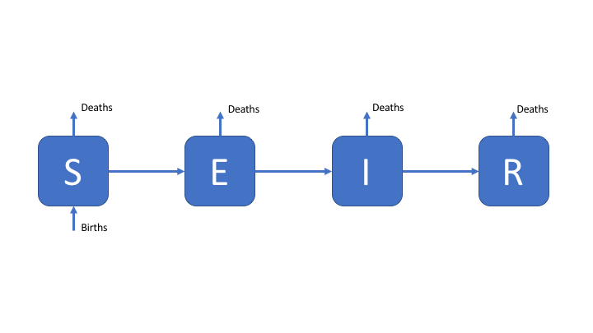

Figure 1: An SEIR model of TB transmission, including simple demographic processes

### Explore

Model dynamics are parameter dependent. Even in a simplistic model like the one outlined above parameter values can greatly alter the dynamics. Answer the following questions by varying the parameters and rerunning the model.

1. What is the impact of adding demographic processes (births and deaths)?
   * **Without demograpic processes Tuberculosis eventually dies out. The addition of demographic processes results in a continous supply of susceptibles that makes this less likely to happen. However if the disease is sufficiently infectious and has a short serial interval then even with demographic processes the supply of new susceptibles may run out, resulting in the disease dieing out.**
2. What happens when the transmission rate (beta) is reduced to 0.5?
   * **When the transmission rate is reduced to 0.5 Tuberculosis will die out without spreading any further than the index case. This is because the basic reproduction number is below 1 for this set of parameters.**
3. What happens as the rate of recovery is increased?
   * **As the rate of recovery is increased the size of the epidemic peak is decreased and the duration of the epidemic increases. The cumulative number of cases is reduced.**

## 2. Add High and Low Risk Compartments

To make the SEIR model slightly more realistic, and therefore better able to capture the observed dynamics of TB, we add a second latent population (as discussed in the solutions for practical 1). This change can be seen in the model flow diagram (Figure 2). Go back to [practical 1](https://bristolmathmodellers.github.io/biddmodellingcourse/articles/practical_1.html) if you need a refresher for the motivation behind this. We have also added reinfection for the low risk latent population.

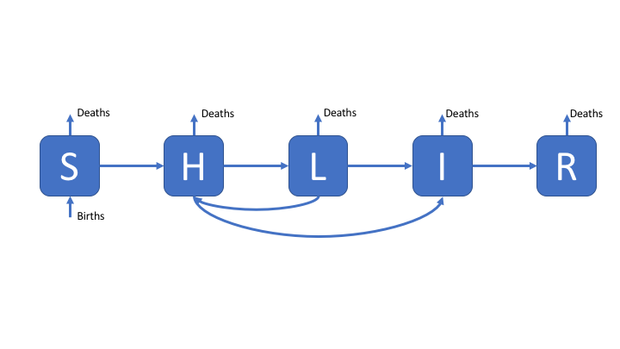

Figure 2: An SHLIR model of TB transmission, including simple demographic processes

### Explore

1. What has the impact of adding the second latent population been?
   * **It has reduced the peak epidemic size and slowed the initial spread of the disease. In addition there are fewer cumulative active cases but a larger pool of latently infected cases.**

## 3. A more realistic SHLIR model flow diagram

The most complex model supported by the interactive interface, this is a more realistic model that might be used in research. The SHLIR model flow diagram (Figure 3) includes: risk groups, treatment, and reinfection for those who have recovered from active disease. Whilst many realistic TB models use age structure this is not included here (if you are interested in discussing how you would include this talk to your instructors or contact [me](https://www.samabbott.co.uk/)). For simplicity we have assumed that it is possible to be born into both populations. For the motivation behind this model see [practical 1](https://bristolmathmodellers.github.io/biddmodellingcourse/articles/practical-one.html).

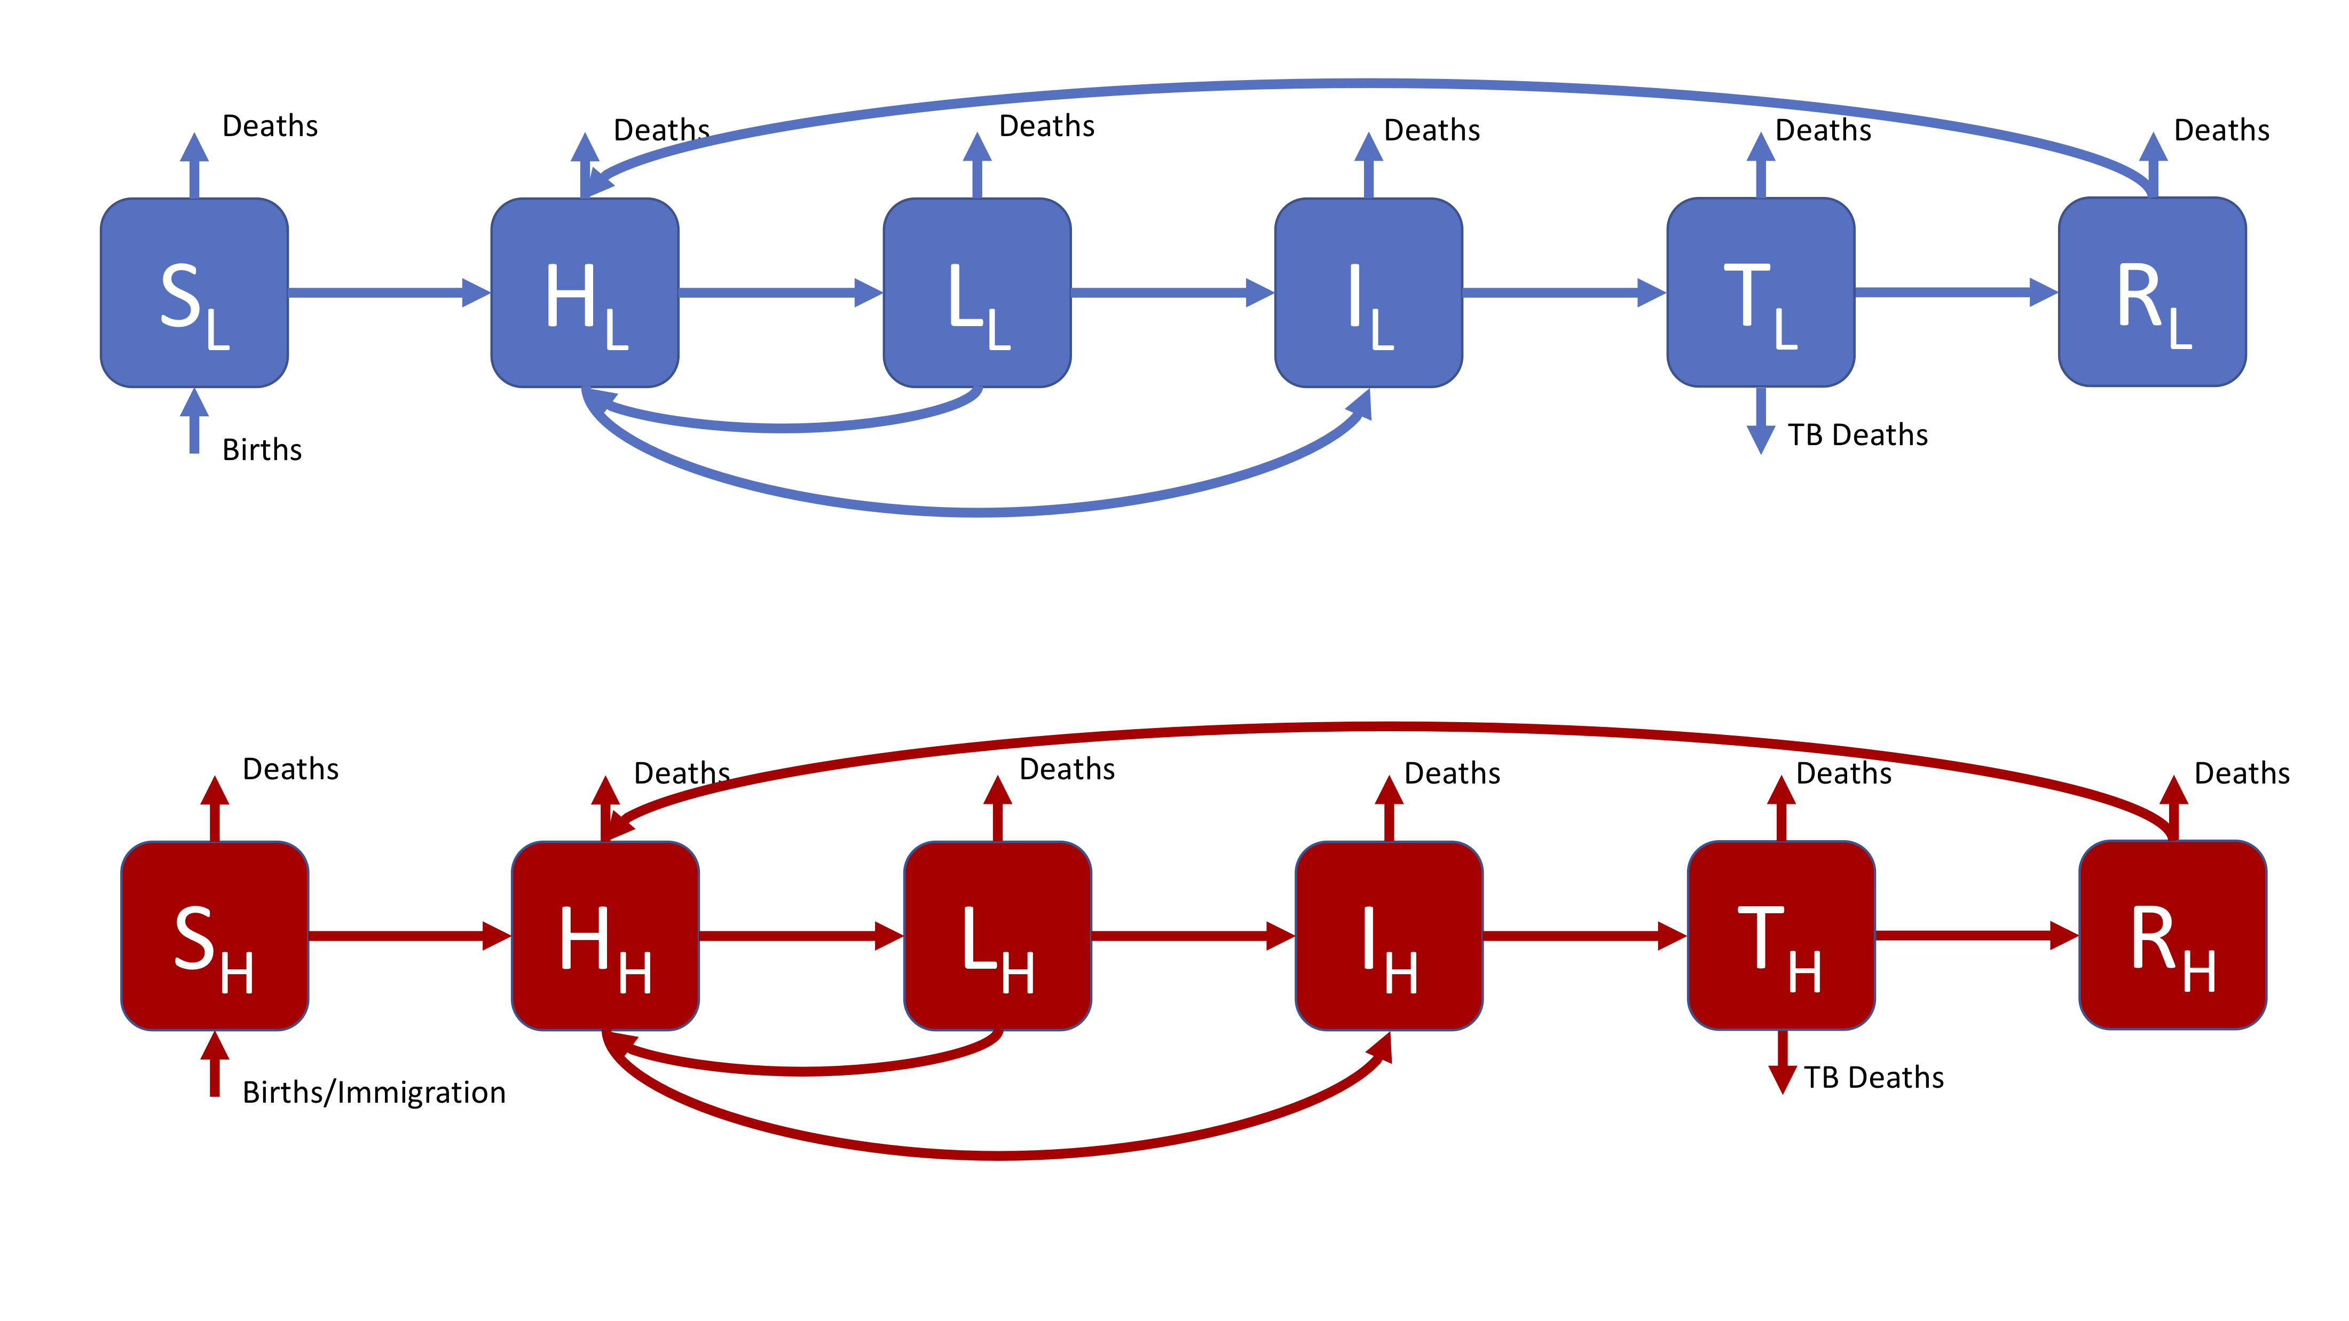

Figure 3: A realistic SHLIR model of TB transmission, including simple demographic processes

Figure 3 does not include the interaction between the high and low risk subgroups as this is through the force of infection. The force of infection is defined as,

Where is the force of infection in each risk group () and is the mixing rate between risk groups. It is assumed that within group contact rates are equivalent and defined such that,

It is also assumed that the between group contact rates are defined as (where ),

### Explore

1. What happens when one group has a much higher transmission probability (use the default settings for all other parameters), compared to when the transmission probability is the same for both groups?
   * **The proportion of cases that are in the high risk latent and infectious populations has increased.**
2. What is the impact of varying the mixing between high and low risk groups for the above scenario?
   * **As mixing is reduced the proportion of the low risk population that are infected is reduced.**
   * **As mixing is increased the disease dynamics become more homogeneous between groups.**

## 3. Explore model dynamics

* The interactive interface allows for exploration of multiple other models, using it can you identify some commonalities between different models? What generalisations can you draw from these commonalities.
  + **Adding birth and death process can lead to oscillating behaviour around some steady state.**
  + **Add additional latent compartments reduces the speed of progression of the epidemic through the population.**
  + **Highly infectious disease may die out in a short space of time if there is not a sufficient number of susceptibles.**

# References

1 Brooks-Pollock E, Cohen T, Murray M. The impact of realistic age structure in simple models of tuberculosis transmission. *PLoS One* 2010;**5**:3–8. doi:[10.1371/journal.pone.0008479](https://doi.org/10.1371/journal.pone.0008479)