NEWAGE

Dhaka, Friday, January 17,2025



Always Here for You

**REGD NO. DA 3004 VOL.XXII NO. 73 MAGH 3,1431 BS** [**www.newagebd.net**](http://www.newagebd.net)The Outspoken Daily12 Pages 12 TK

**Can life start again in Gaza?**

After 467 days of massacre committed by the state of Israel—under the leadership of the fascist Benjamin Netanyahu—the people of Gaza can now dream of waking up to sounds and smells different from what they have been accustomed to: bombs, drones, gunpowder, and corpses. On January 15, Israel and Hamas reached a ceasefire deal that had been on the table since May last year. The next day, however, the Israeli cabinet delayed voting on the deal, accusing Hamas of backtracking although Hamas had accepted the agreement that was announced. It was expected that the deal would come into effect on Sunday, but the cost of the latest delay only means that more Palestinian lives will be lost, as it has been for each and every day that Netanyahu decided to pull out of ceasefire agreement.

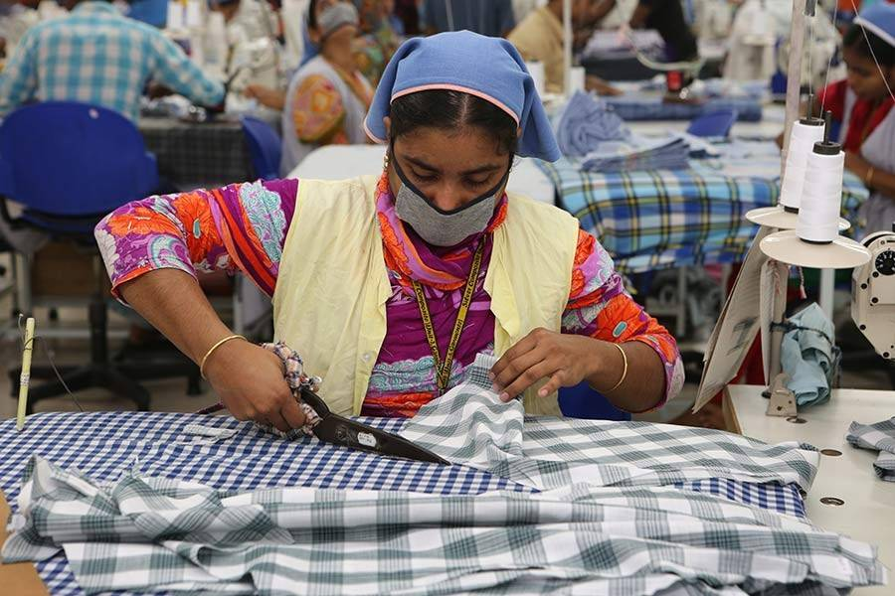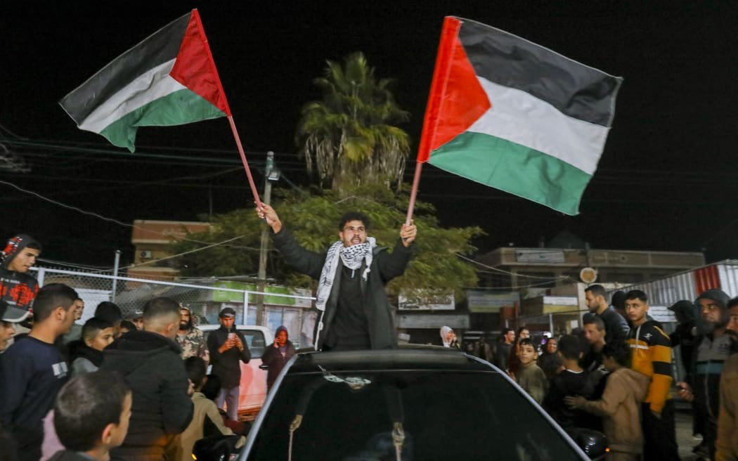

Ready Made Garments (RMG) imbroglio

People celebrate in central Gaza on January 15, 2025 as news spread that a ceasefire deal had been reached between Israel and Hamas, aimed at ending more than 15 months of war and genocide. PHOTO: AFP

It was no coincidence that the simmering discontent of garment workers burst into full blown labor unrest to synchronize with the July-August mass uprising. Workers who could not press home their demands earlier under a repressive regime known for patronizing crony capitalism considered it was their best chance to align their protests with the anti-discrimination mass movement spearheaded by students.



As the impacts of climate change become more pronounced worldwide, environmental education and youth engagement in climate action are becoming increasingly crucial. Environmental education does not merely address the science behind climate change and integrates knowledge about local ecosystems, sustainable practices, and disaster preparedness. 

**Understanding the rising concern of HMPV**

**5G implementation: spectrum allocation & infrastructure in Bangladesh**



Unprecedented improvements in speed, connectivity, and digital innovation are anticipated with the introduction of 5G technology. Given the potential for economic transformation that 5G technology holds, nations are vying to build strong 5G networks.