Guideline Survery:

Ebay and Amazon

* *Initial Summary:*
  + **Note:** Guidelines come from usability.gov
  + Ebay:
    - Ebay generally follows the guidelines presented by usability.gov, but there are a couple of guidelines that it fails on.
      * Ebay’s search bar is very easy to find and easy to use. It gives categories in the dropdown results and has a filter for categories right next to the search bar.
      * Ebay has several design choices that prove contrary to the guidelines and complicates several processes for the user with poor labeling and excess navigation
  + Amazon:
    - Amazon follows all the guidelines quite well, except one.
      * Amazon succeeds in the areas that Ebay failed.
      * Generally the different functions that Amazon provides are easy to use and clearly labeled.
      * Amazon’s only easily noticeable fault is that it uses the same page for registration and sign in.

**Guideline:** “Clearly differentiate navigation elements from one another, but group and place them in a consistent and easy to find place on each page.”

* + Ebay’s homepage is different than the pages for their different product sections. The homepage has the product sections listed on the side of a block in the middle of the page. In each of the product sections however, there is a list of product sections at the top of the page. Therefore, Ebay violates the guideline emphasizing consistency.
    - Ebay’s Homepage



Ebay’s Electronic’s Section

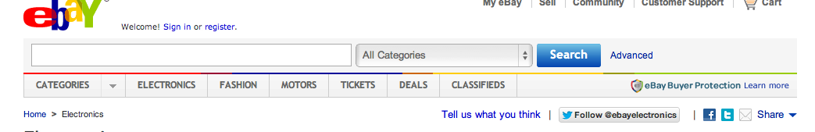

* + Amazon, however, keeps the same navigation bars at the top of the page as you navigate through different pages. This allows for consistency and makes it easy to find navigation buttons. It also adds a customized bar at the bottom of the original navigation bar based on the section you are in for added ease of navigation.
    - Amazon’s Homepage



Amazon’s Books page

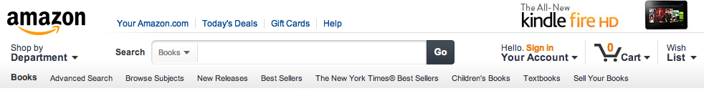

* **Guideline:** “To allow users to efficiently find what they want, design so that the most common tasks can be successfully completed in the fewest number of clicks.”
  + Ebay:
    - To write a review for a seller starting from an item that seller is selling, the user must navigate through several poorly labeled pages to find a small link that just says “Leave Feedback” at the very bottom of the page listing all of the seller’s reviews.
    - This actually violates a second guideline: **“Use link labels and concepts that are meaningful, understandable, and easily differentiated by users rather than designers.”**
      * The link to from an item to that seller’s reviews is simply labeled with a number.
        + 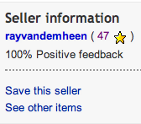
    - From the seller’s page itself you must click on a link to find all of their feedback, which has the link to leave feedback at the very bottom of the page.
    - 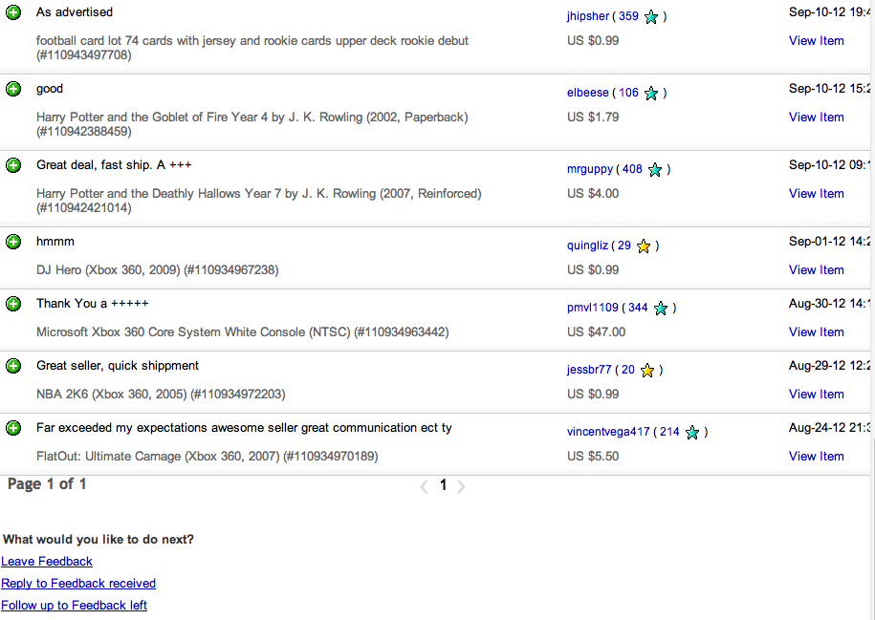
  + Amazon:
    - Most functions on Amazon can be found with only one click. Even when searching for items you can find different sections from the dropdown search results.
    - You can write a review from the item’s page and it is very clearly labeled with its function.
    - 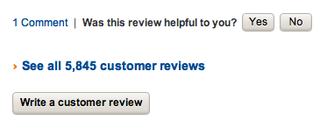
* **Guideline**: Make the link text consistent with the title or headings on the destination (i.e., target) page
  + Amazon: By clicking on the button to register for an account, you are brought to the same page used for signing in, with a button that can be checked to create an account. This confused many of the users in our tests. The page is only labeled as “Sign In,” so users may assume that they have clicked on the wrong link.
    - 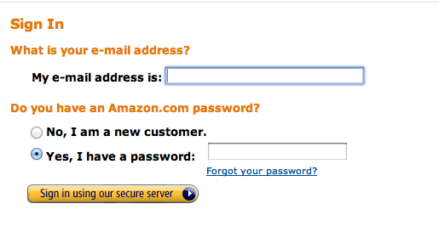
  + Ebay:
    - Ebay has a clear distinction between the sign in page and the registration page, with each accessed from separate links and clearly labeled
    - 
     