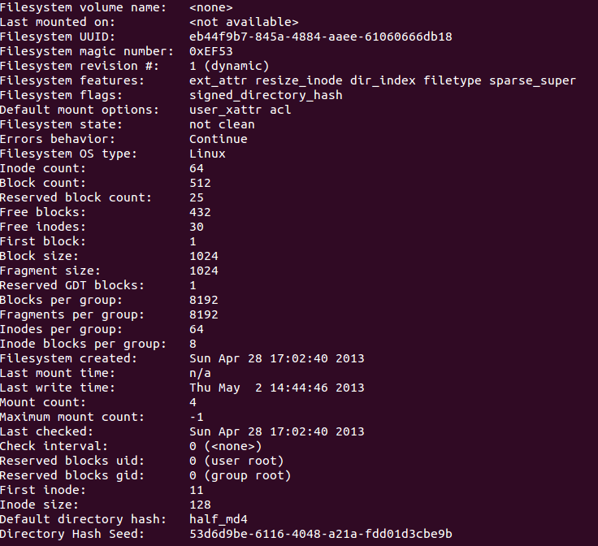The dumpe2fs command gives us some help reading the hexdump. Each block is 1024 bytes and each inode is 128 bytes.

First, the superblock. Since a block is 1024 bytes, 400 in hex. The superblock starts at 400 and ends at 800.

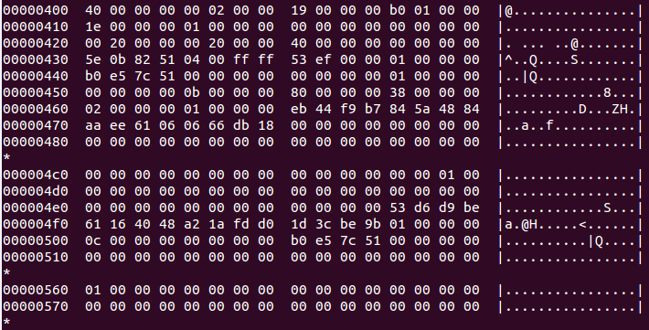

At the line marked by 430, we see the magic number EF53 at the 9th block over. The 40 at byte 400 signifies that there are 64 inodes (40 in hex).

Next we have