First a dd command to create the image from /dev/zero into image.

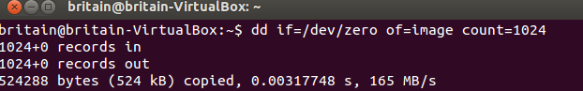

An ls command confirms the image was created.

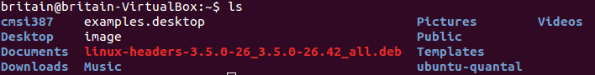

Formatting the image.

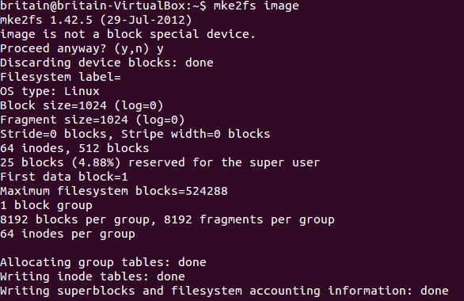

Check the current file systems for a comparison point, then mount the image and check the file systems again.

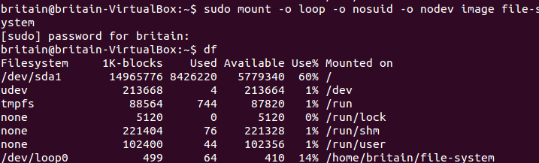

Used vim to create a file in the file-system directory, which is the mount point for the file system.

