Britain Southwick

CMSI 387

02/05/13

Process Survey

1. Root is running launchd, kextd, UserEventAgen, notifyd, diskarbitrati, configd, fseventsd, syslogd, opendirectory, distnoted, powerd, ntpd, cron, TBLoopDrivePa, stackshot, security, revision, mds, KernelEventAg, hidd, dynamic_pager, autofsd, coreservicesd, CVMServer, logind, and filecoordinat. I’m fairly certain a lot of those were truncated. To find this information I used man ps and ps –u root –jc, which displays processes owned by root in a format that shows the user name and the command name, rather than the UID and the command path. 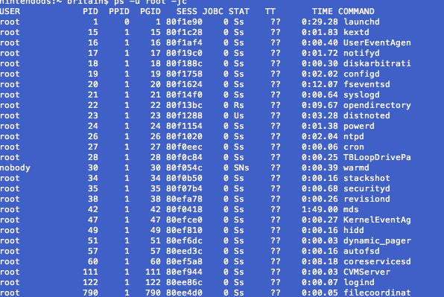
2. The processes running on my account are launchd, clamd, UserEventAgent, distnoted, Microsoft Word, Google Chrome, ClamXav, Dock, talagent, SystemUIServer, Finder, fontd, pboard, com.apple.doc.ext, vendorservice, warmd_agent, imagent, Airport Base Stati, Seagate Storage Ga, SpotifyWebHelper, ClamXavSentry, Mac Game Store Hel, Google Chrome Help, cookied, GrowlHelperApp, Microsoft AU Daemo, mdworker, Preview, lsboxd, AppleSpell, GitHub, ssh-agent, Terminal, xpchelper, quicklookd, and bash. The commands I used were man ps –u britain –jc. 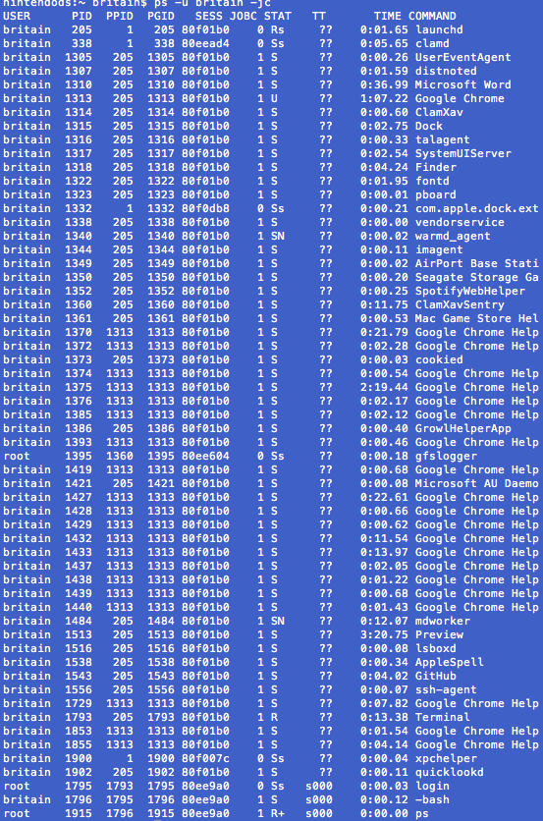

I/O and File Gymnastics

1. 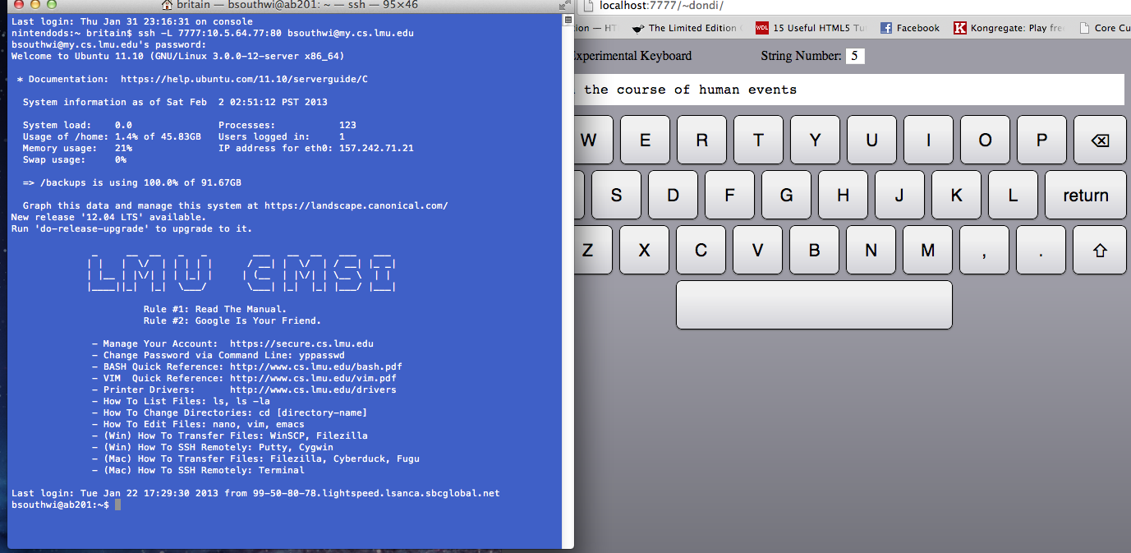

2. 