Britain Southwick

CMSI 387

02/05/13

Shell Gymnastics

1. 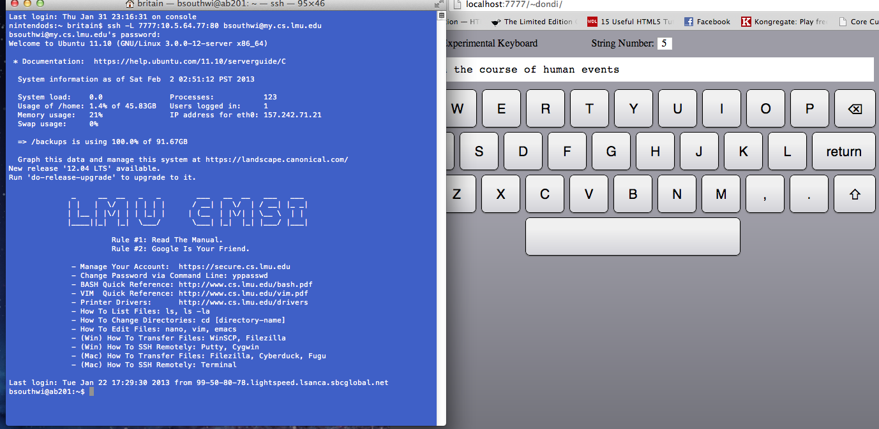

2.