LumiLettuce_metagenome
Britanny Beaudry
2026-05-12

[LumiLettuce] Descriptive & Inferential Statistics

I. Load libraries and inspect data set
Load the necessary libraries and create path to tidy data set. Read the tidy data set file in the form of RDS. This is better than .csv version because the RDS can save particular objects. For example, it preserves the variable type of each column making analysis easier.
library(tidyverse)
## Warning: package 'tidyverse' was built under R version 4.4.3
## ── Attaching core tidyverse packages ──────────────────────── tidyverse 2.0.0 ──
## ✔ dplyr 1.1.4 ✔ readr 2.1.5
## ✔ forcats 1.0.0 ✔ stringr 1.5.1
## ✔ ggplot2 3.5.1 ✔ tibble 3.2.1
## ✔ lubridate 1.9.4 ✔ tidyr 1.3.1
## ✔ purrr 1.0.4
## ── Conflicts ────────────────────────────────────────── tidyverse_conflicts() ──
## ✖ dplyr::filter() masks stats::filter()
## ✖ dplyr::lag() masks stats::lag()
## ℹ Use the conflicted package (<http://conflicted.r-lib.org/>) to force all conflicts to become errors
library(plotly)
##
## Attaching package: 'plotly'
##
## The following object is masked from 'package:ggplot2':
##
## last_plot
##
## The following object is masked from 'package:stats':
##
## filter
##
## The following object is masked from 'package:graphics':
##
## layout
library(ggplot2) # to make figures
library(kableExtra) # to make tables
## Warning: package 'kableExtra' was built under R version 4.4.3
##
## Attaching package: 'kableExtra'
##
## The following object is masked from 'package:dplyr':
##
## group_rows
library(factoextra) # to make PCA
## Warning: package 'factoextra' was built under R version 4.4.3
## Welcome! Want to learn more? See two factoextra-related books at https://goo.gl/ve3WBa
library(patchwork)
## Warning: package 'patchwork' was built under R version 4.4.3
library(car) # Levene's test
## Warning: package 'car' was built under R version 4.4.3
## Loading required package: carData
## Warning: package 'carData' was built under R version 4.4.3
##
## Attaching package: 'car'
##
## The following object is masked from 'package:dplyr':
##
## recode
##
## The following object is masked from 'package:purrr':
##
## some
library(vegan) # For diversity() function
## Warning: package 'vegan' was built under R version 4.4.3
## Loading required package: permute
## Warning: package 'permute' was built under R version 4.4.3
library(ggsignif)
## Warning: package 'ggsignif' was built under R version 4.4.3
library(rstatix)
## Warning: package 'rstatix' was built under R version 4.4.3
##
## Attaching package: 'rstatix'
##
## The following object is masked from 'package:stats':
##
## filter
library(phyloseq)
library(gt)
## Warning: package 'gt' was built under R version 4.4.3
library(ggsci)
## Warning: package 'ggsci' was built under R version 4.4.3
library(RColorBrewer) # to make figures
# Use the function 'here' to create a path to tidy data set
data_tidy_path <- here::here("data/processed")
#data_tidy_path
#list.files(data_tidy_path)
# the RDS file is generated by companion script to tidy data (blueC_data_tidying_R)
lumilettuce <- readRDS(file.path(data_tidy_path,"full_data.rds"))
glimpse(lumilettuce)
## Rows: 18,988
## Columns: 24
## $ sample_id <chr> "PMnBb1", "PMnBb1", "PMnBb1", "PMnBb1", "PMnBb1"…
## $ superkingdom <chr> "Bacteria", "Bacteria", "Bacteria", "Bacteria", …
## $ kingdom <chr> "Bacteria_none", "Bacteria_none", "Bacteria_none…
## $ phylum <chr> "Proteobacteria", "Bacteroidota", "Bacteroidota"…
## $ class <chr> "Gammaproteobacteria", "Bacteroidia", "Rhodother…
## $ order <chr> "Pseudomonadales", "Chitinophagales", "Rhodother…
## $ family <chr> "Pseudomonadaceae", "Saprospiraceae", "Rhodother…
## $ genus <chr> "Pseudomonas", "Saprospiraceae_uncultured", "Rho…
## $ count <dbl> 3541, 2312, 1523, 1350, 1345, 1099, 1053, 952, 7…
## $ collection_date <date> 2025-11-20, 2025-11-20, 2025-11-20, 2025-11-20,…
## $ season <chr> "Autumn", "Autumn", "Autumn", "Autumn", "Autumn"…
## $ diel_phase <fct> Midnight, Midnight, Midnight, Midnight, Midnight…
## $ site_name <chr> "Pescalgarve", "Pescalgarve", "Pescalgarve", "Pe…
## $ sample_type <chr> "Ulva", "Ulva", "Ulva", "Ulva", "Ulva", "Ulva", …
## $ morphotype <chr> "Blade", "Blade", "Blade", "Blade", "Blade", "Bl…
## $ host_species <chr> "Ulva obscura", "Ulva obscura", "Ulva obscura", …
## $ tide_state <fct> Flood, Flood, Flood, Flood, Flood, Flood, Flood,…
## $ sky_condition <fct> Clear, Clear, Clear, Clear, Clear, Clear, Clear,…
## $ precipitation <fct> None, None, None, None, None, None, None, None, …
## $ temp_degC <dbl> 12.3, 12.3, 12.3, 12.3, 12.3, 12.3, 12.3, 12.3, …
## $ dissolved_oxygen_mg_L <dbl> 11.1, 11.1, 11.1, 11.1, 11.1, 11.1, 11.1, 11.1, …
## $ pH <dbl> 8.36, 8.36, 8.36, 8.36, 8.36, 8.36, 8.36, 8.36, …
## $ salinity_psu <dbl> 25, 25, 25, 25, 25, 25, 25, 25, 25, 25, 25, 25, …
## $ PAR_umol_photons_m2_s <dbl> 0, 0, 0, 0, 0, 0, 0, 0, 0, 0, 0, 0, 0, 0, 0, 0, …
head(lumilettuce)
## # A tibble: 6 × 24
## sample_id superkingdom kingdom phylum class order family genus count
## <chr> <chr> <chr> <chr> <chr> <chr> <chr> <chr> <dbl>
## 1 PMnBb1 Bacteria Bacteria_none Proteobac… Gamm… Pseu… Pseud… Pseu… 3541
## 2 PMnBb1 Bacteria Bacteria_none Bacteroid… Bact… Chit… Sapro… Sapr… 2312
## 3 PMnBb1 Bacteria Bacteria_none Bacteroid… Rhod… Rhod… Rhodo… Rhod… 1523
## 4 PMnBb1 Bacteria Bacteria_none Bacteroid… Bact… Cyto… Cyclo… Cycl… 1350
## 5 PMnBb1 Bacteria Bacteria_none Proteobac… Gamm… Ente… Enter… Esch… 1345
## 6 PMnBb1 Bacteria Bacteria_none Proteobac… Gamm… Ster… Woese… Woes… 1099
## # ℹ 15 more variables: collection_date <date>, season <chr>, diel_phase <fct>,
## # site_name <chr>, sample_type <chr>, morphotype <chr>, host_species <chr>,
## # tide_state <fct>, sky_condition <fct>, precipitation <fct>,
## # temp_degC <dbl>, dissolved_oxygen_mg_L <dbl>, pH <dbl>, salinity_psu <dbl>,
## # PAR_umol_photons_m2_s <dbl>
There are 24 columns and 18,988 rows in this data set. It includes both the microbiome data and the metadata. There are categorical and continuous variables.

II. Abiotic environment

1. Abiotic summary table
Many of the metadata variables are continuous environmental parameters. They help us to understand the context. Some, could also be interesting to explore later on to see if there are correlations in the data associated with these continuous variables. This table compares the metrics (mean, standard deviation, median, interquartile range, minimum, and maximum) for the continuous environmental variables of the data set across all diel phases between the two sites. This helps us establish the baseline environmental conditions across sites and time of day.
table_summary_continuous <- lumilettuce |>
filter(!is.na(sample_id), !is.na(diel_phase), !is.na(site_name), !is.na(temp_degC), !is.na(salinity_psu), !is.na(dissolved_oxygen_mg_L), !is.na(pH), !is.na(PAR_umol_photons_m2_s)) |>
distinct(sample_id, .keep_all = TRUE) |>
pivot_longer(
cols = c(temp_degC, dissolved_oxygen_mg_L, pH, salinity_psu,
PAR_umol_photons_m2_s),
names_to = "Variable",
values_to = "Value") |>
# Change the name of the Variable column to make it better suited for a table
mutate(
Variable = case_when(
Variable == "temp_degC" ~ "Temperature (°C)",
Variable == "dissolved_oxygen_mg_L" ~ "Dissolved Oxygen (mg/L)",
Variable == "pH" ~ "pH",
Variable == "salinity_psu" ~ "Salinity (PSU)",
Variable == "PAR_umol_photons_m2_s" ~ "PAR (µmol photons m⁻² s⁻¹)",
TRUE ~ Variable)
) |>
# There will be a top-header and a sub-header for site name and descriptive
# statistic variable, respectively
group_by(diel_phase, Variable, site_name) |>
summarise(
Mean = round(mean(Value, na.rm = TRUE), 2),
SD = round(sd(Value, na.rm = TRUE), 2),
Median = round(median(Value, na.rm = TRUE), 2),
IQR = round(IQR(Value, na.rm = TRUE), 2),
`Min - Max` = sprintf("%.2f - %.2f", min(Value, na.rm = TRUE), max(Value, na.rm = TRUE)),
.groups = "drop") |>
pivot_wider(
names_from = site_name,
values_from = c(Mean, SD, Median, IQR, `Min - Max`),
names_glue = "{site_name}_{.value}") |>
arrange(diel_phase, Variable) |>
select(
diel_phase, Variable,
Pescalgarve_Mean, Pescalgarve_SD, Pescalgarve_Median, Pescalgarve_IQR, `Pescalgarve_Min - Max`,
`Ria de Alvor_Mean`, `Ria de Alvor_SD`, `Ria de Alvor_Median`, `Ria de Alvor_IQR`, `Ria de Alvor_Min - Max`
)
# This is not the final table
View(table_summary_continuous)
table_summary_continuous |>
select(-diel_phase) |>
kbl(
# Sub-headers for metrics
col.names = c("Variable",
"Mean", "SD", "Median", "IQR", "Min - Max",
"Mean", "SD", "Median", "IQR", "Min - Max"),
align = c("l", "c", "c", "c", "c", "c", "c", "c", "c", "c", "c")) |>
kable_classic(
full_width = FALSE,
html_font = "Times New Roman",
font_size = 13) |>
# Top header spanning across site groups
add_header_above(c(" " = 1, "Pescalgarve" = 5, "Ria de Alvor" = 5)) |>
pack_rows("Dawn", 1, 5) |>
pack_rows("Noon", 6, 10) |>
pack_rows("Dusk", 11, 15) |>
pack_rows("Midnight", 16, 20) |>
# Save this table as a .png in correct folder in directory to add to manuscript
save_kable(file = "../output/tables/table_summary_continuous.png", zoom = 3)
## file:///C:/Users/brita/AppData/Local/Temp/RtmpYfd7wQ/table_summary_continuous7cfc9885df5.html screenshot completed
When comparing between the two sites, we can already see that that the standard variation is 0 at all times for Ria de Alvor, which makes sense because there is a sample size n=1 for all site/diel phase combination. Dissolved oxygen (DO) and pH are quite similar in both sites. The largest differences for sites are pH, salinity, and PAR.
DO, salinity, and pH remain stable across all time points. PAR varies a lot because it remains low at dawn, dusk, and midnight, with the lowest values at dawn, but then has a peak increase at noon. This pattern is consistent across both sites. Temperature appears to fluctuate slightly during the day.

2. Boxplots for continuous environmental variables
The continuous environmental variables temperature, PAR, and salinity showed interesting variation in the table. These boxplots explore the abiotic parameters and how they fluctuate in function of site and tiem of day.
# Remove NAs
boxplot_env_data <- lumilettuce |>
distinct(sample_id, .keep_all = TRUE) |>
filter(!is.na(diel_phase), !is.na(site_name), !is.na(dissolved_oxygen_mg_L), !is.na(PAR_umol_photons_m2_s), !is.na(salinity_psu), !is.na(temp_degC), !is.na(temp_degC)) |>
# To remove the water samples
filter(sample_type != "Water filter" | is.na(sample_type))
# Boxplot for DO
boxplot_DO <- ggplot(boxplot_env_data, aes(x = diel_phase,y = dissolved_oxygen_mg_L, fill = site_name, colour = site_name)) +
geom_boxplot(
alpha = 0.2, # opacity
outlier.shape = NA, # no need to show outliers
width = 0.5,
position = position_dodge(width=0.75)
) +
# Add a diamond shape for the mean of each box
stat_summary(
aes(group = site_name),
fun = mean,
geom = "point",
shape = 23,
size = 3.5,
colour = "black",
fill = "black",
position = position_dodge(width = 0.75)
) +
geom_point(
position = position_jitterdodge(jitter.width =0.15, dodge.width=0.75),
size = 2.5,
alpha = 0.3,
) +
# Teal for Pescalgarve and orchid for Ria de Alvor
scale_fill_manual(values=c("Pescalgarve"="#008080", "Ria de Alvor"="#DA70D6")) +
scale_colour_manual(values=c("Pescalgarve"="#008080", "Ria de Alvor"="#DA70D6")) +
theme_classic(base_size =12) +
labs(
x = "Diel Phase",
y = "Dissolved Oxygen (mg/L)",
fill = "Site Name",
colour = "Site Name"
) +
theme(
axis.title = element_text(face="bold"),
axis.text = element_text(colour="black"),
legend.position = "right",
lengend.title = element_text(face="bold")
)
# Display DO boxplot
boxplot_DO
## Warning in plot_theme(plot): The `lengend.title` theme element is not defined
## in the element hierarchy.
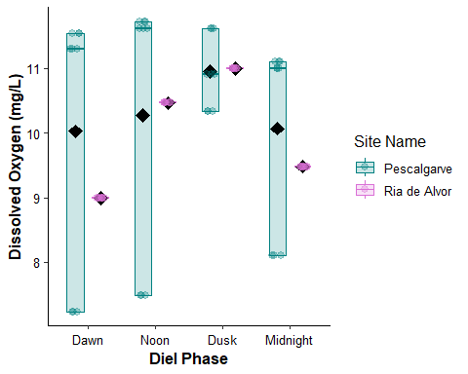
# Save the DO boxplot
dir.create("../output/figures", recursive = TRUE, showWarnings = FALSE)
ggsave(
filename = "../output/figures/boxplot_DO.png",
width = 8.5,
height = 5.5,
dpi = 300
)
## Warning in plot_theme(plot): The `lengend.title` theme element is not defined in the element hierarchy.
## The `lengend.title` theme element is not defined in the element hierarchy.
There are 9 observations for each box with 3 unique values for each box of Pescalgarve. A black diamond symbolizing the mean was added to each box. Ria de Alvor only has 9 of the same measurements (repeated) for each diel phase.
Pescalgarve has a slight increase in DO at dusk, whereas the other diel phases appear stable at around 10 mg/L. Ria de Alvor shows a greater increase at noon and dusk before going back down at midnight. Ria de Alvor varies between 9 and 11 mg/L.
# Boxplot for PAR
boxplot_PAR <- ggplot(boxplot_env_data, aes(x = diel_phase,y = PAR_umol_photons_m2_s, fill = site_name, colour = site_name)) +
geom_boxplot(
alpha = 0.2, # opacity
outlier.shape = NA, # no need to show outliers
width = 0.5,
position = position_dodge(width=0.75)
) +
# Add a diamond shape for the mean of each box
stat_summary(
aes(group = site_name),
fun = mean,
geom = "point",
shape = 23,
size = 3.5,
colour = "black",
fill = "black",
position = position_dodge(width = 0.75)
) +
geom_point(
position = position_jitterdodge(jitter.width =0.15, dodge.width=0.75),
size = 2.5,
alpha = 0.3,
) +
# Teal for Pescalgarve and orchid for Ria de Alvor
scale_fill_manual(values=c("Pescalgarve"="#008080", "Ria de Alvor"="#DA70D6")) +
scale_colour_manual(values=c("Pescalgarve"="#008080", "Ria de Alvor"="#DA70D6")) +
theme_classic(base_size =12) +
labs(
x = "Diel Phase",
y = "PAR (µmol photons m^2 s^1)",
fill = "Site Name",
colour = "Site Name"
) +
theme(
axis.title = element_text(face="bold"),
axis.text = element_text(colour="black"),
legend.position = "right",
lengend.title = element_text(face="bold")
)
# Display PAR boxplot
boxplot_PAR
## Warning in plot_theme(plot): The `lengend.title` theme element is not defined
## in the element hierarchy.
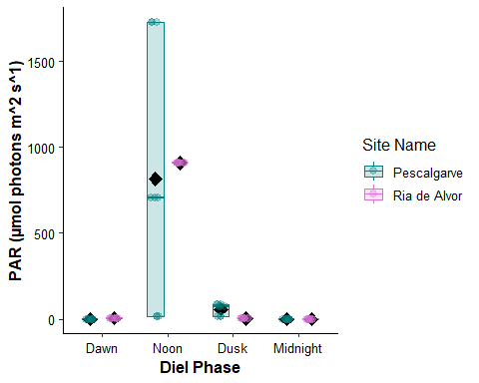
# Save the salinity boxplot
dir.create("../output/figures", recursive = TRUE, showWarnings = FALSE)
ggsave(
filename = "../output/figures/boxplot_PAR.png",
width = 8.5,
height = 5.5,
dpi = 300
)
## Warning in plot_theme(plot): The `lengend.title` theme element is not defined in the element hierarchy.
## The `lengend.title` theme element is not defined in the element hierarchy.
For the photosynthetically active radiation, the major variation appears to be due to diel phase. The values for Pescalgarve and Ria de Alvor are almost equivalent. They also are very similar at midnight, dawn, and dusk. The largest change occurs at noon where there is a drastic increase in PAR, which makes sense because that it the time of day when the sun is at its peak.
# Boxplot for salinity
boxplot_sal <- ggplot(boxplot_env_data, aes(x = diel_phase,y = salinity_psu, fill = site_name, colour = site_name)) +
geom_boxplot(
alpha = 0.2, # opacity
outlier.shape = NA, # no need to show outliers
width = 0.5,
position = position_dodge(width=0.75)
) +
# Add a diamond shape for the mean of each box
stat_summary(
aes(group = site_name),
fun = mean,
geom = "point",
shape = 23,
size = 3.5,
colour = "black",
fill = "black",
position = position_dodge(width = 0.75)
) +
geom_point(
position = position_jitterdodge(jitter.width =0.15, dodge.width=0.75),
size = 2.5,
alpha = 0.3,
) +
# Teal for Pescalgarve and orchid for Ria de Alvor
scale_fill_manual(values=c("Pescalgarve"="#008080", "Ria de Alvor"="#DA70D6")) +
scale_colour_manual(values=c("Pescalgarve"="#008080", "Ria de Alvor"="#DA70D6")) +
theme_classic(base_size =12) +
labs(
x = "Diel Phase",
y = "Salinity (PSU)",
fill = "Site Name",
colour = "Site Name"
) +
theme(
axis.title = element_text(face="bold"),
axis.text = element_text(colour="black"),
legend.position = "right",
lengend.title = element_text(face="bold")
)
# Display salinity boxplot
boxplot_sal
## Warning in plot_theme(plot): The `lengend.title` theme element is not defined
## in the element hierarchy.
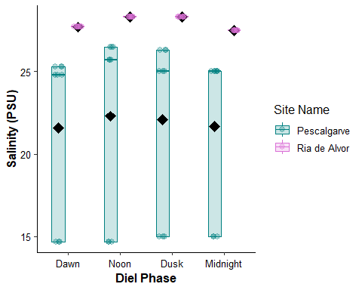
# Save the salinity boxplot
dir.create("../output/figures", recursive = TRUE, showWarnings = FALSE)
ggsave(
filename = "../output/figures/boxplot_sal.png",
width = 8.5,
height = 5.5,
dpi = 300
)
## Warning in plot_theme(plot): The `lengend.title` theme element is not defined in the element hierarchy.
## The `lengend.title` theme element is not defined in the element hierarchy.
The salinity in Pescalgarve is lower at all diel phases than at Ria de Alvor. Pescalgarve has a generally stable salinity with a slight increase at midday, remaining around 22.5 PSU. Ria de Alvor also has a stable salinity at around 28 PSU. In this case, the variation in salinity appears to be due to site differences, not diel phase.
# Boxplot for temperature
boxplot_temp <- ggplot(boxplot_env_data, aes(x = diel_phase,y = temp_degC, fill = site_name, colour = site_name)) +
geom_boxplot(
alpha = 0.2, # opacity
outlier.shape = NA, # no need to show outliers
width = 0.5,
position = position_dodge(width=0.75)
) +
# Add a diamond shape for the mean of each box
stat_summary(
aes(group = site_name),
fun = mean,
geom = "point",
shape = 23,
size = 3.5,
colour = "black",
fill = "black",
position = position_dodge(width = 0.75)
) +
geom_point(
position = position_jitterdodge(jitter.width =0.15, dodge.width=0.75),
size = 2.5,
alpha = 0.3,
) +
# Teal for Pescalgarve and orchid for Ria de Alvor
scale_fill_manual(values=c("Pescalgarve"="#008080", "Ria de Alvor"="#DA70D6")) +
scale_colour_manual(values=c("Pescalgarve"="#008080", "Ria de Alvor"="#DA70D6")) +
theme_classic(base_size =12) +
labs(
x = "Diel Phase",
y = "Temperature (ºC)",
fill = "Site Name",
colour = "Site Name"
) +
theme(
axis.title = element_text(face="bold"),
axis.text = element_text(colour="black"),
legend.position = "right",
lengend.title = element_text(face="bold")
)
# Display temperature boxplot
boxplot_temp
## Warning in plot_theme(plot): The `lengend.title` theme element is not defined
## in the element hierarchy.
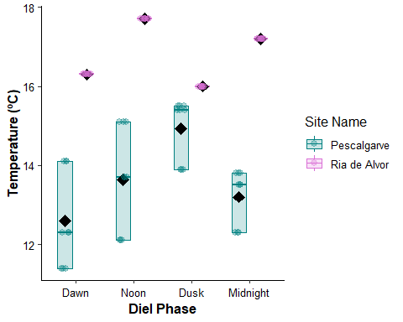
# Save the temperature boxplot
dir.create("../output/figures", recursive = TRUE, showWarnings = FALSE)
ggsave(
filename = "../output/figures/boxplot_temp.png",
width = 8.5,
height = 5.5,
dpi = 300
)
## Warning in plot_theme(plot): The `lengend.title` theme element is not defined in the element hierarchy.
## The `lengend.title` theme element is not defined in the element hierarchy.
At Pescalgarve, the mean water temperature is at around 13ºC at midnight and then decreases at dawn before increasing steadily through noon reaching its peak at dusk. The Ria de Alvor has a different pattern. The mean water temperatures are higher than Pescalgarve with peaks greater tenmperatures at midnight and noon and lower temperatures at dawn and dusk.
# Boxplot for pH
boxplot_pH <- ggplot(boxplot_env_data, aes(x = diel_phase,y = pH, fill = site_name, colour = site_name)) +
geom_boxplot(
alpha = 0.2, # opacity
outlier.shape = NA, # no need to show outliers
width = 0.5,
position = position_dodge(width=0.75)
) +
# Add a diamond shape for the mean of each box
stat_summary(
aes(group = site_name),
fun = mean,
geom = "point",
shape = 23,
size = 3.5,
colour = "black",
fill = "black",
position = position_dodge(width = 0.75)
) +
geom_point(
position = position_jitterdodge(jitter.width =0.15, dodge.width=0.75),
size = 2.5,
alpha = 0.3,
) +
# Teal for Pescalgarve and orchid for Ria de Alvor
scale_fill_manual(values=c("Pescalgarve"="#008080", "Ria de Alvor"="#DA70D6")) +
scale_colour_manual(values=c("Pescalgarve"="#008080", "Ria de Alvor"="#DA70D6")) +
theme_classic(base_size =12) +
labs(
x = "Diel Phase",
y = "pH",
fill = "Site Name",
colour = "Site Name"
) +
theme(
axis.title = element_text(face="bold"),
axis.text = element_text(colour="black"),
legend.position = "right",
lengend.title = element_text(face="bold")
)
# Display pH boxplot
boxplot_pH
## Warning in plot_theme(plot): The `lengend.title` theme element is not defined
## in the element hierarchy.
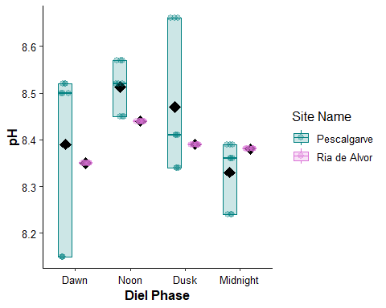
# Save the pH boxplot
dir.create("../output/figures", recursive = TRUE, showWarnings = FALSE)
ggsave(
filename = "../output/figures/boxplot_pH.png",
width = 8.5,
height = 5.5,
dpi = 300
)
## Warning in plot_theme(plot): The `lengend.title` theme element is not defined in the element hierarchy.
## The `lengend.title` theme element is not defined in the element hierarchy.
Both sites seem to follow a similar pattern. With the exception of midnight, pH measurements are lower for Ria de Alvor than Pescalgarve. There is a slight increase at noon for both sites but the overall variability is very little for both sites.

3. Multifaceted boxplot abiotic variables
This will generate one figure with all the abiotic variable boxplots and only show the legend once to avoid repetitions.
# Filter and clean the data
boxplot_env_data <- lumilettuce |>
distinct(sample_id, .keep_all = TRUE) |>
filter(
!is.na(diel_phase),
!is.na(site_name),
!is.na(dissolved_oxygen_mg_L),
!is.na(PAR_umol_photons_m2_s),
!is.na(salinity_psu),
!is.na(temp_degC),
!is.na(pH)
) |>
filter(sample_type != "Water filter" | is.na(sample_type))
# Generate standardized boxplots
create_env_boxplot <- function(data, y_var, y_label) {
ggplot(data, aes(x = diel_phase, y = .data[[y_var]], fill = site_name, colour = site_name)) +
geom_boxplot(
alpha = 0.2,
outlier.shape = NA,
width = 0.5,
position = position_dodge(width = 0.75)
) +
stat_summary(
aes(group = site_name),
fun = mean,
geom = "point",
shape = 23,
size = 3.5,
colour = "black",
fill = "black",
position = position_dodge(width = 0.75)
) +
geom_point(
position = position_jitterdodge(jitter.width = 0.15, dodge.width = 0.75),
size = 2.5,
alpha = 0.3
) +
scale_fill_manual(values = c("Pescalgarve" = "#008080", "Ria de Alvor" = "#DA70D6")) +
scale_colour_manual(values = c("Pescalgarve" = "#008080", "Ria de Alvor" = "#DA70D6")) +
theme_classic(base_size = 12) +
labs(
x = "Diel Phase",
y = y_label,
fill = "Site Name",
colour = "Site Name"
) +
theme(
axis.title = element_text(face = "bold"),
axis.text = element_text(colour = "black"),
legend.title = element_text(face = "bold", size = 25),
legend.text = element_text(size = 20),
# Add a solid border, light background, and padding around the legend box
legend.box.background = element_rect(colour = "black", linewidth = 0.9, fill = "grey"),
legend.margin = margin(t = 10, r = 12, b = 10, l = 12)
)
}
# Create the 5 individual subplots
p_do <- create_env_boxplot(boxplot_env_data, "dissolved_oxygen_mg_L", "Dissolved Oxygen (mg/L)")
p_par <- create_env_boxplot(boxplot_env_data, "PAR_umol_photons_m2_s", expression(bold(paste("PAR (", mu, "mol photons m"^-2*" s"^-1*")"))))
p_sal <- create_env_boxplot(boxplot_env_data, "salinity_psu", "Salinity (PSU)")
p_temp <- create_env_boxplot(boxplot_env_data, "temp_degC", "Temperature (°C)")
p_ph <- create_env_boxplot(boxplot_env_data, "pH", "pH")
# Assemble with patchwork
# - guide_area() fills the 6th slot with the collected legend
# - tag_levels supplies A-E for the 5 plots and leaves the 6th empty ("")
multi_abiotic_boxplot <- (p_do + p_par + p_sal + p_temp + p_ph + guide_area()) +
plot_layout(
ncol = 3,
nrow = 2,
guides = "collect"
) +
plot_annotation(
tag_levels = list(c("A", "B", "C", "D", "E", "")),
theme = theme(
plot.tag = element_text(face = "bold", size = 14)
)
) &
theme(
legend.position = "inside"
)
print(multi_abiotic_boxplot)
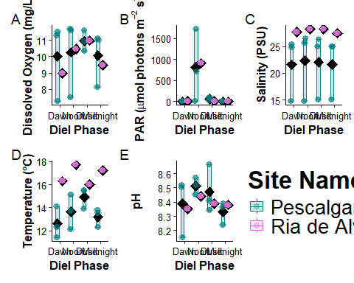
# Save
dir.create("../output/figures", recursive = TRUE, showWarnings = FALSE)
ggsave(
filename = "../output/figures/multipanel_environmental_boxplots.png",
plot = multi_abiotic_boxplot,
width = 13,
height = 8.5,
dpi = 300
)

4. Mann-Whitney U test & Kruskal-Wallis
First, I will verify whether my data is normally distributed for each environmental variable using the Shapiro-Wilk test. The null hypothesis (if the p-value is greater than 0.05) states that the data is normally distributed. Then, I will test for the homogeneity of variances. The null hypothesis states that the variances are equal across all groups. If the data is parametric, i will perform a Two-Way ANOVA. If not, I will perform a Mann-Whitney U Test for site_name (2 levels) and a Kruskall-Wallis for diel_phase (4 levels). I can then perform a Dunn test to see where the significant differences are.
# Check for normality using Shapiro-Wilk test
shapiro.test(boxplot_env_data$dissolved_oxygen_mg_L) # data is not normally distributed
##
## Shapiro-Wilk normality test
##
## data: boxplot_env_data$dissolved_oxygen_mg_L
## W = 0.89009, p-value = 1.255e-05
shapiro.test(boxplot_env_data$PAR_umol_photons_m2_s) # data is not normally distributed
##
## Shapiro-Wilk normality test
##
## data: boxplot_env_data$PAR_umol_photons_m2_s
## W = 0.55356, p-value = 1.84e-13
shapiro.test(boxplot_env_data$salinity_psu) # data is not normally distributed
##
## Shapiro-Wilk normality test
##
## data: boxplot_env_data$salinity_psu
## W = 0.6603, p-value = 1.264e-11
shapiro.test(boxplot_env_data$temp_degC) # data is not normally distributed
##
## Shapiro-Wilk normality test
##
## data: boxplot_env_data$temp_degC
## W = 0.91806, p-value = 0.0001756
shapiro.test(boxplot_env_data$pH) # data is not normally distributed
##
## Shapiro-Wilk normality test
##
## data: boxplot_env_data$pH
## W = 0.92445, p-value = 0.00034
# Create boxplots for both variables to see whether there are outliers
boxplot(dissolved_oxygen_mg_L ~ diel_phase, data = boxplot_env_data) # outliers
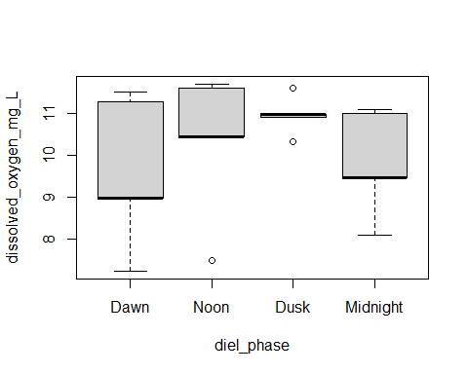
boxplot(dissolved_oxygen_mg_L ~ site_name, data = boxplot_env_data) # no outliers
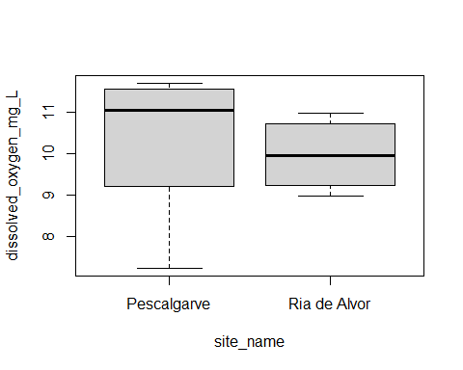
boxplot(PAR_umol_photons_m2_s ~ diel_phase, data = boxplot_env_data) # outliers
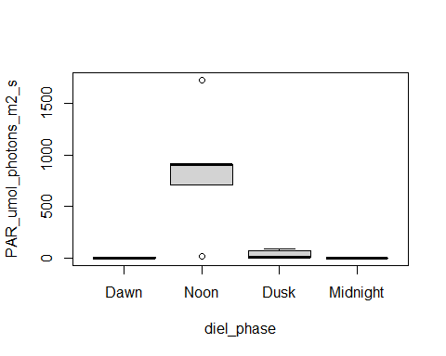
boxplot(PAR_umol_photons_m2_s ~ site_name, data = boxplot_env_data) # outliers
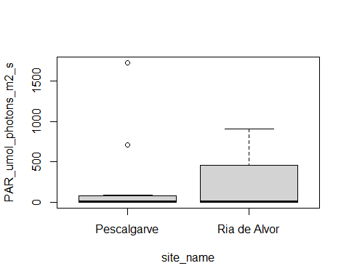
boxplot(salinity_psu ~ diel_phase, data = boxplot_env_data) # outliers
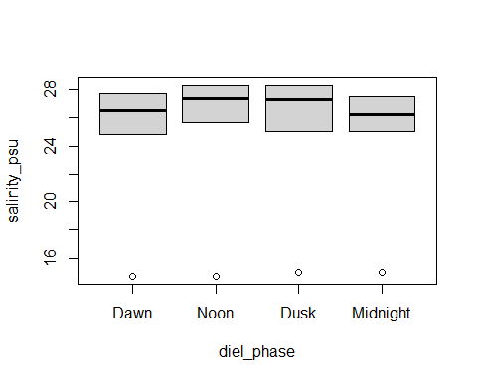
boxplot(salinity_psu ~ site_name, data = boxplot_env_data) # no outliers
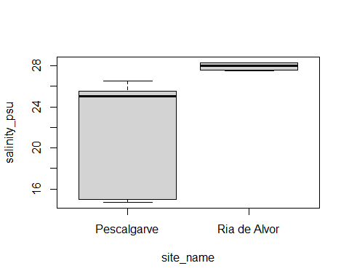
boxplot(temp_degC ~ diel_phase, data = boxplot_env_data) # outliers
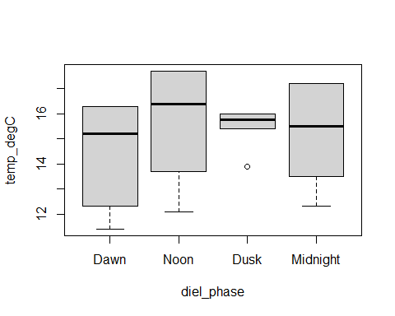
boxplot(temp_degC ~ site_name, data = boxplot_env_data) # no outliers
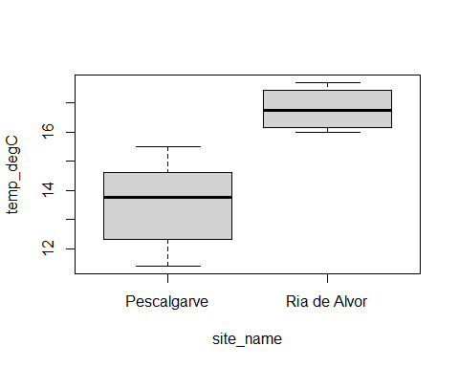
boxplot(pH ~ diel_phase, data = boxplot_env_data) # outliers
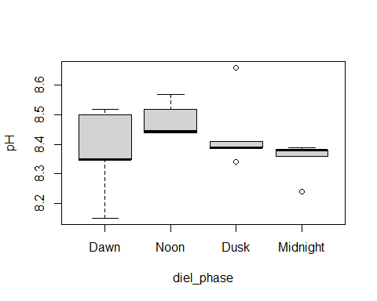
boxplot(pH ~ site_name, data = boxplot_env_data) # no outliers
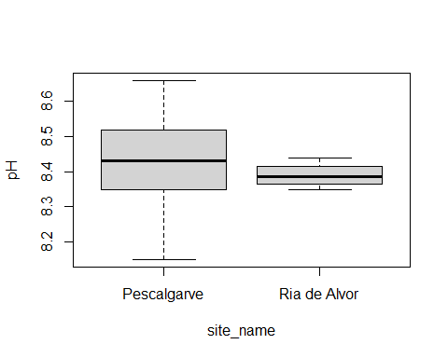
# Perform Levene's test for homogeneity of variances
# Use center = median if there are outliers (more robust)
leveneTest(dissolved_oxygen_mg_L ~ diel_phase, data = boxplot_env_data, center = median) # not equal
## Levene's Test for Homogeneity of Variance (center = median)
## Df F value Pr(>F)
## group 3 3.077 0.03328 *
## 68
## ---
## Signif. codes: 0 '***' 0.001 '**' 0.01 '*' 0.05 '.' 0.1 ' ' 1
leveneTest(dissolved_oxygen_mg_L ~ site_name, data = boxplot_env_data, center = mean) # not equal
## Warning in leveneTest.default(y = y, group = group, ...): group coerced to
## factor.
## Levene's Test for Homogeneity of Variance (center = mean)
## Df F value Pr(>F)
## group 1 15.581 0.0001858 ***
## 70
## ---
## Signif. codes: 0 '***' 0.001 '**' 0.01 '*' 0.05 '.' 0.1 ' ' 1
leveneTest(PAR_umol_photons_m2_s ~ diel_phase, data = boxplot_env_data, center = median) # not equal
## Levene's Test for Homogeneity of Variance (center = median)
## Df F value Pr(>F)
## group 3 10.869 6.405e-06 ***
## 68
## ---
## Signif. codes: 0 '***' 0.001 '**' 0.01 '*' 0.05 '.' 0.1 ' ' 1
leveneTest(PAR_umol_photons_m2_s ~ site_name, data = boxplot_env_data, center = median) # equal
## Warning in leveneTest.default(y = y, group = group, ...): group coerced to
## factor.
## Levene's Test for Homogeneity of Variance (center = median)
## Df F value Pr(>F)
## group 1 0.0074 0.9319
## 70
leveneTest(salinity_psu ~ diel_phase, data = boxplot_env_data, center = median) # equal
## Levene's Test for Homogeneity of Variance (center = median)
## Df F value Pr(>F)
## group 3 0.0064 0.9993
## 68
leveneTest(salinity_psu ~ site_name, data = boxplot_env_data, center = mean) # not equal
## Warning in leveneTest.default(y = y, group = group, ...): group coerced to
## factor.
## Levene's Test for Homogeneity of Variance (center = mean)
## Df F value Pr(>F)
## group 1 219.56 < 2.2e-16 ***
## 70
## ---
## Signif. codes: 0 '***' 0.001 '**' 0.01 '*' 0.05 '.' 0.1 ' ' 1
leveneTest(temp_degC ~ diel_phase, data = boxplot_env_data, center = median) # not equal
## Levene's Test for Homogeneity of Variance (center = median)
## Df F value Pr(>F)
## group 3 11.212 4.576e-06 ***
## 68
## ---
## Signif. codes: 0 '***' 0.001 '**' 0.01 '*' 0.05 '.' 0.1 ' ' 1
leveneTest(temp_degC ~ site_name, data = boxplot_env_data, center = mean) # not equal
## Warning in leveneTest.default(y = y, group = group, ...): group coerced to
## factor.
## Levene's Test for Homogeneity of Variance (center = mean)
## Df F value Pr(>F)
## group 1 10.068 0.002241 **
## 70
## ---
## Signif. codes: 0 '***' 0.001 '**' 0.01 '*' 0.05 '.' 0.1 ' ' 1
leveneTest(pH ~ diel_phase, data = boxplot_env_data, center = median) # equal
## Levene's Test for Homogeneity of Variance (center = median)
## Df F value Pr(>F)
## group 3 2.0889 0.1098
## 68
leveneTest(pH ~ site_name, data = boxplot_env_data, center = mean) # not equal
## Warning in leveneTest.default(y = y, group = group, ...): group coerced to
## factor.
## Levene's Test for Homogeneity of Variance (center = mean)
## Df F value Pr(>F)
## group 1 38.209 3.738e-08 ***
## 70
## ---
## Signif. codes: 0 '***' 0.001 '**' 0.01 '*' 0.05 '.' 0.1 ' ' 1
# Mann-Whitney U test for site_nmae
wilcox.test(dissolved_oxygen_mg_L ~ site_name, data = boxplot_env_data, exact = FALSE) # significant diff
##
## Wilcoxon rank sum test with continuity correction
##
## data: dissolved_oxygen_mg_L by site_name
## W = 891, p-value = 0.006081
## alternative hypothesis: true location shift is not equal to 0
wilcox.test(PAR_umol_photons_m2_s ~ site_name, data = boxplot_env_data, exact = FALSE) # no diff
##
## Wilcoxon rank sum test with continuity correction
##
## data: PAR_umol_photons_m2_s by site_name
## W = 594, p-value = 0.5345
## alternative hypothesis: true location shift is not equal to 0
wilcox.test(salinity_psu ~ site_name, data = boxplot_env_data, exact = FALSE) # significant diff
##
## Wilcoxon rank sum test with continuity correction
##
## data: salinity_psu by site_name
## W = 0, p-value = 1.619e-13
## alternative hypothesis: true location shift is not equal to 0
wilcox.test(temp_degC ~ site_name, data = boxplot_env_data, exact = FALSE) # significant diff
##
## Wilcoxon rank sum test with continuity correction
##
## data: temp_degC by site_name
## W = 0, p-value = 2.387e-13
## alternative hypothesis: true location shift is not equal to 0
wilcox.test(pH ~ site_name, data = boxplot_env_data, exact = FALSE) # significant diff
##
## Wilcoxon rank sum test with continuity correction
##
## data: pH by site_name
## W = 823.5, p-value = 0.04744
## alternative hypothesis: true location shift is not equal to 0
# Kruskal-Wallis test for diel_phase
kruskal.test(dissolved_oxygen_mg_L ~ diel_phase, data = boxplot_env_data) # significant diff
##
## Kruskal-Wallis rank sum test
##
## data: dissolved_oxygen_mg_L by diel_phase
## Kruskal-Wallis chi-squared = 9.4905, df = 3, p-value = 0.02343
kruskal.test(PAR_umol_photons_m2_s ~ diel_phase, data = boxplot_env_data) # significant diff
##
## Kruskal-Wallis rank sum test
##
## data: PAR_umol_photons_m2_s by diel_phase
## Kruskal-Wallis chi-squared = 55.608, df = 3, p-value = 5.093e-12
kruskal.test(salinity_psu ~ diel_phase, data = boxplot_env_data) # no diff
##
## Kruskal-Wallis rank sum test
##
## data: salinity_psu by diel_phase
## Kruskal-Wallis chi-squared = 6.3346, df = 3, p-value = 0.09642
kruskal.test(temp_degC ~ diel_phase, data = boxplot_env_data) # no diff
##
## Kruskal-Wallis rank sum test
##
## data: temp_degC by diel_phase
## Kruskal-Wallis chi-squared = 2.6797, df = 3, p-value = 0.4437
kruskal.test(pH ~ diel_phase, data = boxplot_env_data) # significant diff
##
## Kruskal-Wallis rank sum test
##
## data: pH by diel_phase
## Kruskal-Wallis chi-squared = 26.91, df = 3, p-value = 6.15e-06
# Dunn test for significantly different variables
dunn_test(dissolved_oxygen_mg_L ~ diel_phase, data = boxplot_env_data, p.adjust.method = "holm") # dawn and dusk
## # A tibble: 6 × 9
## .y. group1 group2 n1 n2 statistic p p.adj p.adj.signif
## * <chr> <chr> <chr> <int> <int> <dbl> <dbl> <dbl> <chr>
## 1 dissolved_oxy… Dawn Noon 18 18 1.98 0.0477 0.191 ns
## 2 dissolved_oxy… Dawn Dusk 18 18 2.70 0.00694 0.0416 *
## 3 dissolved_oxy… Dawn Midni… 18 18 0.504 0.614 0.943 ns
## 4 dissolved_oxy… Noon Dusk 18 18 0.720 0.472 0.943 ns
## 5 dissolved_oxy… Noon Midni… 18 18 -1.48 0.140 0.420 ns
## 6 dissolved_oxy… Dusk Midni… 18 18 -2.20 0.0281 0.141 ns
dunn_test(PAR_umol_photons_m2_s ~ diel_phase, data = boxplot_env_data, p.adjust.method = "holm")
## # A tibble: 6 × 9
## .y. group1 group2 n1 n2 statistic p p.adj p.adj.signif
## * <chr> <chr> <chr> <int> <int> <dbl> <dbl> <dbl> <chr>
## 1 PAR_umol_p… Dawn Noon 18 18 5.10 3.44e- 7 1.72e- 6 ****
## 2 PAR_umol_p… Dawn Dusk 18 18 2.22 2.67e- 2 5.33e- 2 ns
## 3 PAR_umol_p… Dawn Midni… 18 18 -1.99 4.61e- 2 5.33e- 2 ns
## 4 PAR_umol_p… Noon Dusk 18 18 -2.88 3.96e- 3 1.19e- 2 *
## 5 PAR_umol_p… Noon Midni… 18 18 -7.09 1.32e-12 7.91e-12 ****
## 6 PAR_umol_p… Dusk Midni… 18 18 -4.21 2.54e- 5 1.02e- 4 ***
dunn_test(pH ~ diel_phase, data = boxplot_env_data, p.adjust.method = "holm")
## # A tibble: 6 × 9
## .y. group1 group2 n1 n2 statistic p p.adj p.adj.signif
## * <chr> <chr> <chr> <int> <int> <dbl> <dbl> <dbl> <chr>
## 1 pH Dawn Noon 18 18 4.11 0.0000397 0.000199 ***
## 2 pH Dawn Dusk 18 18 1.59 0.113 0.225 ns
## 3 pH Dawn Midnight 18 18 -0.649 0.516 0.516 ns
## 4 pH Noon Dusk 18 18 -2.52 0.0116 0.0465 *
## 5 pH Noon Midnight 18 18 -4.76 0.00000196 0.0000117 ****
## 6 pH Dusk Midnight 18 18 -2.23 0.0254 0.0763 ns
All the p-values for the Shapiro-Wilk test are smaller than 0.05, which means that I must reject the null hypothesis. This means that the data is not normally distributed. The homogeneity of variances also fails in most cases, meaning the data is non-parametric. The Mann-Whitney U test showed significant difference between both sites for all variables except PAR.
The Kruskal-Wallis test showed significant difference between diel phases for DO, PAR, and pH.
The Dunn test shows that the significant difference for DO is between dawn and dusk, which is consistent with the previous box plot. For PAR, the largest significant differences are between dawn and noon and noon and midnight, then between dusk and midnight, and finally between noon and dusk. For pH, the largest significant difference is between noon and midnight, then dawn and noon, and finally noon and dusk.

5. PCA abiotic variables
This Principle component analysis (PCA) looks at the five (5) abiotic variables and the two sites. The direction and length of the arrows indicates how strongly each variable correlates with the axes and with each other.
# Define environmental variables
env_vars <- c("dissolved_oxygen_mg_L", "PAR_umol_photons_m2_s",
"salinity_psu", "temp_degC", "pH")
# Filter complete cases
pca_data <- boxplot_env_data |>
drop_na(all_of(env_vars), site_name)
# Perform PCA (center = TRUE, scale. = TRUE is essential for mixed units)
pca_env <- prcomp(pca_data[, env_vars], center = TRUE, scale. = TRUE)
# Clean variable labels for vector arrows
pretty_labels <- c(
"dissolved_oxygen_mg_L" = "DO",
"PAR_umol_photons_m2_s" = "PAR",
"salinity_psu" = "Salinity",
"temp_degC" = "Temp",
"pH" = "pH"
)
rownames(pca_env$rotation) <- pretty_labels[rownames(pca_env$rotation)]
# Generate the PCA Biplot
pca_abiotic <- fviz_pca_biplot(
pca_env,
title = NULL,
geom.ind = "point",
habillage = pca_data$site_name,
palette = c("Pescalgarve" = "#008080", "Ria de Alvor" = "#DA70D6"),
pointshape = 19,
pointsize = 3,
alpha.ind = 0.7,
addEllipses = TRUE, # 95% concentration ellipses
ellipse.type = "convex", # "convex" polygon or "confidence" ellipse
ellipse.alpha = 0.15,
col.var = "black", # Vector arrow styling
arrowsize = 0.7,
repel = TRUE, # Avoid text label overlap
labelsize = 4.5
) +
labs(
color = "Site Name",
fill = "Site Name",
shape = "Site Name"
) +
theme_classic(base_size = 12) +
theme(
axis.title = element_text(face = "bold"),
axis.text = element_text(colour = "black"),
legend.title = element_text(face = "bold"),
legend.position = "right",
legend.box.background = element_rect(colour = "black", linewidth = 0.6, fill = "grey98"),
legend.margin = margin(8, 10, 8, 10)
)
print(pca_abiotic)
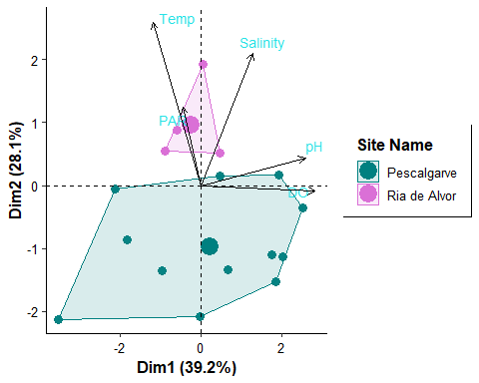
# Save
dir.create("../output/figures", recursive = TRUE, showWarnings = FALSE)
ggsave(
filename = "../output/figures/pca_abiotic.png",
plot = pca_abiotic,
width = 8.5,
height = 6.5,
dpi = 300
)
The first two principle components account for 67.3% of the total variance, which is adequate. The primary drivers of Dim1 (39.2%) are dissolved oxygen and pH. The primary drivers of Dim2 (28.1%) are temperature and salinity, with PAR also playing a smaller role. The samples from Pescalgarve clustered almost exclusively in the negative values of Dim2 which means that suggests that they are characterized by lower temperature and salinity. Ria de Alvor samples are fewer and clustered in the positive values of Dim2, characterized by higher temperatures and salinities. Pescalgarve samples also span across a wide range of Dim1 and Dim2 suggesting greater environmental variability than the tighter cluster of Ria de Alvor. This suggests Ria de Alvor has a more stable and homogeneous environment than Pescalgarve.

III. Host vs. water specificity

1. Taxonomic stacked barplot Ulva and seawater
This is a broad taxonomic stacked barplot for the relative abundance between Ulva and seawater across sites. The bacteria are shown at the order level. This allows us to have a quick overview of which bacterial orders are found in both water filter samples and the seaweed, and which are unique to the seaweed host.
# Filter data for valid sites, and sample types (Ulva vs Seawater)
bacteria_data <- lumilettuce |>
filter(!is.na(order), order != "", order != "unknown", order != "Unclassified") |>
filter(sample_type %in% c("Ulva", "Water filter"), !is.na(site_name))
# Identify the Top 10 most abundant bacterial Orders across the data set
top_10_orders <- bacteria_data |>
group_by(order) |>
summarise(total_count = sum(count, na.rm = TRUE), .groups = "drop") |>
slice_max(order_by = total_count, n = 10) |>
pull(order)
# Collapse lower-abundance orders into "Other" and calculate Relative Abundance (%)
order_rel_abund <- bacteria_data |>
mutate(
order_grouped = if_else(order %in% top_10_orders, order, "Other (< 2%)")
) |>
# Aggregate counts per Site, Sample Type, and Order
group_by(site_name, sample_type, order_grouped) |>
summarise(count = sum(count, na.rm = TRUE), .groups = "drop_last") |>
# Convert to relative abundance percentage (sums to 100% per bar)
mutate(relative_abundance = (count / sum(count)) * 100) |>
ungroup() |>
# Reorder factors so "Other" is at the bottom of the stack and dominant orders are on top
mutate(
order_grouped = factor(
order_grouped,
levels = c("Other (< 2%)", rev(top_10_orders))
)
)
# Custom distinct color palette (10 distinct colors and neutral grey for 'Other')
custom_colors <- c(
"Other (< 2%)" = "#D3D3D3",
"Pseudomonadales" = "#1F77B4",
"Flavobacteriales" = "#FF7F0E",
"Enterobacterales" = "#2CA02C",
"Cytophagales" = "#D62728",
"Chitinophagales" = "#9467BD",
"Bacteroidales" = "#8C564B",
"Rhodobacterales" = "#E377C2",
"Caulobacterales" = "#7F7F7F",
"Sphingobacteriales" = "#BCBD22",
"Burkholderiales" = "#17BECF"
)
# Create the stacked barplot
barplot_ulva_seawater <- ggplot(order_rel_abund, aes(x = sample_type, y = relative_abundance, fill = order_grouped)) +
geom_bar(stat = "identity", position = "stack", width = 0.65, colour = "black", linewidth = 0.25) +
facet_wrap(~site_name) +
scale_fill_manual(values = custom_colors, guide = guide_legend(reverse = TRUE)) +
scale_y_continuous(expand = expansion(mult = c(0, 0.02)), labels = function(x) paste0(x, "%")) +
labs(
x = "Sample Type",
y = "Relative Abundance (%)",
fill = "Microbial Order"
) +
theme_classic(base_size = 12) +
theme(
axis.title = element_text(face = "bold"),
axis.text = element_text(colour = "black", size = 11),
strip.text = element_text(face = "bold", size = 12),
strip.background = element_rect(colour = "black", fill = "grey93", linewidth = 0.6),
legend.title = element_text(face = "bold", size = 11),
legend.text = element_text(size = 10),
legend.position = "right",
panel.spacing = unit(1.5, "lines")
)
print(barplot_ulva_seawater)
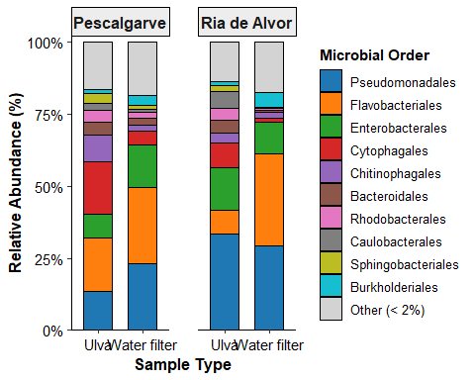
dir.create("../output/figures", recursive = TRUE, showWarnings = FALSE)
ggsave(
filename = "../output/figures/barplot_ulva_seawater.png",
plot = barplot_ulva_seawater,
width = 9.5,
height = 6,
dpi = 300
)
We can see from this barplot that the two dominant bacterial orders are Pseudomonadales and Flavobacteriales for both sample types at both sites. At Pescalgarve, the Ulva samples contain more Cytophagales than in the water filter sample. This suggests that Ulva recruits this order specifically. The same is seen in the samples collected at Ria de Alvor. In the seaweed sample of Ria de Alvor, we see less Flavobacteriales than in the water filter sample. The Pescalgarve seaweed sample also has more Chitinophagales than in the respective water filter sample.

2. Alpha diversity comparison
The alpha diversity analysis helps portray the bacterial community in both sites and in both sample types. Three comparisons are performed here: observed species richness, Shannon’s diversity index (H’), and Pielou’s evenness (J’).
# Filter for valid sample types
bact_data <- lumilettuce |>
filter(
sample_type %in% c("Ulva", "Water filter"),
!is.na(site_name),
!is.na(genus),
count > 0
)
# Calculate alpha diversity metrics per sample_id
alpha_metrics <- bact_data |>
group_by(sample_id, sample_type, site_name, diel_phase) |>
summarise(
Observed_Richness = n_distinct(genus),
Shannon = diversity(count, index = "shannon"),
Evenness = Shannon / log(Observed_Richness),
.groups = "drop"
)
print(alpha_metrics)
## # A tibble: 88 × 7
## sample_id sample_type site_name diel_phase Observed_Richness Shannon Evenness
## <chr> <chr> <chr> <fct> <int> <dbl> <dbl>
## 1 PDk1w Water filt… Pescalga… Dusk 161 3.62 0.713
## 2 PDk2w Water filt… Pescalga… Dusk 137 3.50 0.712
## 3 PDk3w Water filt… Pescalga… Dusk 100 3.38 0.734
## 4 PDkBb1 Ulva Pescalga… Dusk 248 4.20 0.762
## 5 PDkBb2 Ulva Pescalga… Dusk 281 4.44 0.788
## 6 PDkBb3 Ulva Pescalga… Dusk 266 4.36 0.780
## 7 PDkFl1 Ulva Pescalga… Dusk 192 4.48 0.853
## 8 PDkFl2 Ulva Pescalga… Dusk 187 4.24 0.811
## 9 PDkFl3 Ulva Pescalga… Dusk 221 4.41 0.816
## 10 PDkNt1 Ulva Pescalga… Dusk 201 4.31 0.813
## # ℹ 78 more rows
# Build standardized alpha diversity box plots
create_alpha_boxplot <- function(data, y_var, y_label) {
ggplot(data, aes(x = sample_type, y = .data[[y_var]], fill = sample_type, colour = sample_type)) +
geom_boxplot(
alpha = 0.3,
outlier.shape = NA,
width = 0.45,
colour = "black",
linewidth = 0.6
) +
# Add diamond shape for the mean
stat_summary(
fun = mean,
geom = "point",
shape = 23,
size = 3.5,
colour = "black",
fill = "black"
) +
# Jittered individual sample points
geom_jitter(
width = 0.15,
size = 2.5,
alpha = 0.6
) +
# Color scheme: green for Ulva, blue for seawater
scale_fill_manual(values = c("Ulva" = "#2E8B57", "Water filter" = "#4682B4")) +
scale_colour_manual(values = c("Ulva" = "#2E8B57", "Water filter" = "#4682B4")) +
theme_classic(base_size = 12) +
labs(
x = "Sample Type",
y = y_label,
fill = "Sample Type",
colour = "Sample Type"
) +
theme(
axis.title = element_text(face = "bold"),
axis.text = element_text(colour = "black", size = 11),
legend.position = "none"
)
}
# Generate the 3 individual alpha diversity subplots
p_richness <- create_alpha_boxplot(alpha_metrics, "Observed_Richness", "Observed Genus Richness")
p_shannon <- create_alpha_boxplot(alpha_metrics, "Shannon", "Shannon Diversity Index (H')")
p_evenness <- create_alpha_boxplot(alpha_metrics, "Evenness", "Pielou's Evenness (J')")
# Faceted box plot comparing Ulva vs seawater across both sites
create_faceted_alpha <- function(data, y_var, y_label) {
create_alpha_boxplot(data, y_var, y_label) +
facet_wrap(~site_name) +
theme(
strip.text = element_text(face = "bold", size = 11),
strip.background = element_rect(colour = "black", fill = "grey93", linewidth = 0.5)
)
}
p_rich_site <- create_faceted_alpha(alpha_metrics, "Observed_Richness", "Observed Genus Richness")
p_shan_site <- create_faceted_alpha(alpha_metrics, "Shannon", "Shannon Diversity Index (H')")
p_even_site <- create_faceted_alpha(alpha_metrics, "Evenness", "Pielou's Evenness (J')")
combined_site_alpha <- (p_rich_site / p_shan_site / p_even_site) +
plot_annotation(tag_levels = "A")
print(combined_site_alpha)
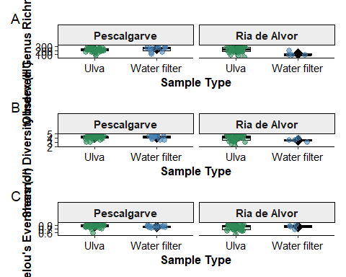
dir.create("../output/figures", recursive = TRUE, showWarnings = FALSE)
ggsave(
filename = "../output/figures/alpha_diversity_ulva_vs_seawater.png",
plot = combined_site_alpha,
width = 8,
height = 10,
dpi = 300
)
The observed genus richness appears to be similar between sample types from Pescalgarve, but not in Ria de Alvor. The Shannon diversity index appears to be the same for both sample types in Pescalgarve again, but a slight difference for the water filter samples at Ria de Alvor. The evenness seems very similar across sample type and site.

3. Mann-Whiteny U Test
First, I will verify whether my data is normally distributed for each environmental variable using the Shapiro-Wilk test. The null hypothesis (if the p-value is greater than 0.05) states that the data is normally distributed. Then, I will test for the homogeneity of variances. The null hypothesis states that the variances are equal across all groups. If the data is parametric, i will perform a Two-Way ANOVA. If not, I will perform a Mann-Whitney U Test for site_name (2 levels) and sample type (2 levels).
shapiro.test(alpha_metrics$Observed_Richness) # not normally distributed
##
## Shapiro-Wilk normality test
##
## data: alpha_metrics$Observed_Richness
## W = 0.96896, p-value = 0.03293
shapiro.test(alpha_metrics$Shannon) # not normally distributed
##
## Shapiro-Wilk normality test
##
## data: alpha_metrics$Shannon
## W = 0.9173, p-value = 3.198e-05
shapiro.test(alpha_metrics$Evenness) # not normally distributed
##
## Shapiro-Wilk normality test
##
## data: alpha_metrics$Evenness
## W = 0.9235, p-value = 6.509e-05
boxplot(Observed_Richness ~ site_name, data = alpha_metrics) # outliers
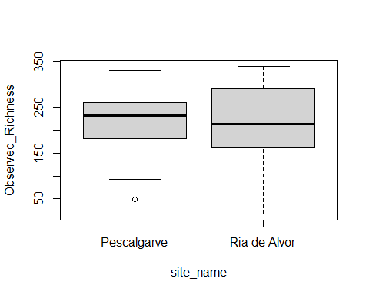
boxplot(Observed_Richness ~ sample_type, data = alpha_metrics) # outliers
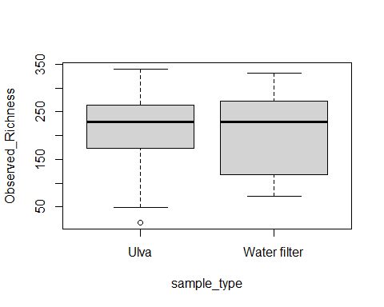
boxplot(Shannon ~ site_name, data = alpha_metrics) # outliers
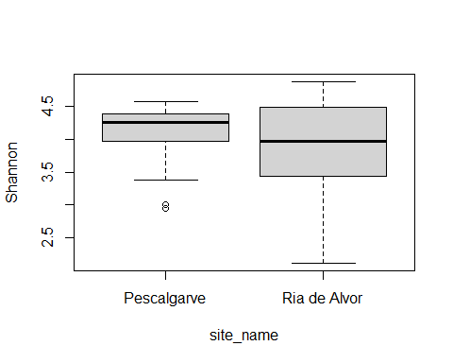
boxplot(Shannon ~ sample_type, data = alpha_metrics) # outliers
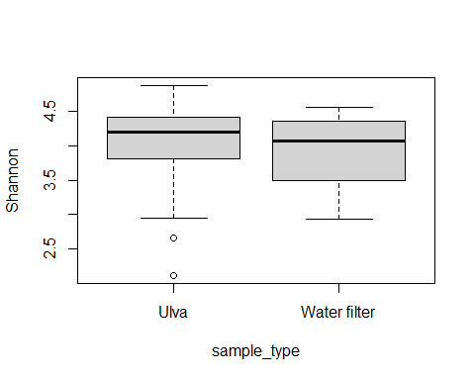
boxplot(Evenness ~ site_name, data = alpha_metrics) # outliers
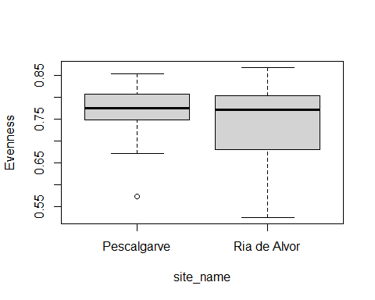
boxplot(Evenness ~ sample_type, data = alpha_metrics) # outliers
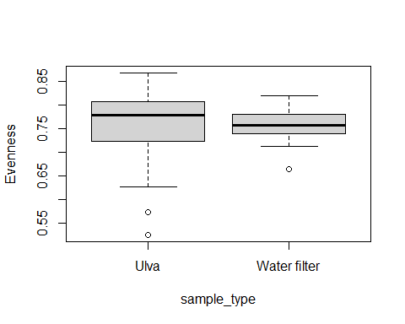
# They all have outliers, so it is better to use the median as the center (more robust) for Levene's test
leveneTest(Observed_Richness ~ site_name, data = alpha_metrics, center = median) # not homogeneous
## Warning in leveneTest.default(y = y, group = group, ...): group coerced to
## factor.
## Levene's Test for Homogeneity of Variance (center = median)
## Df F value Pr(>F)
## group 1 7.2219 0.008645 **
## 86
## ---
## Signif. codes: 0 '***' 0.001 '**' 0.01 '*' 0.05 '.' 0.1 ' ' 1
leveneTest(Observed_Richness ~ sample_type, data = alpha_metrics, center = median) # not homogeneous
## Warning in leveneTest.default(y = y, group = group, ...): group coerced to
## factor.
## Levene's Test for Homogeneity of Variance (center = median)
## Df F value Pr(>F)
## group 1 4.1579 0.04451 *
## 86
## ---
## Signif. codes: 0 '***' 0.001 '**' 0.01 '*' 0.05 '.' 0.1 ' ' 1
leveneTest(Shannon ~ site_name, data = alpha_metrics, center = median) # not homogeneous
## Warning in leveneTest.default(y = y, group = group, ...): group coerced to
## factor.
## Levene's Test for Homogeneity of Variance (center = median)
## Df F value Pr(>F)
## group 1 12.725 0.0005926 ***
## 86
## ---
## Signif. codes: 0 '***' 0.001 '**' 0.01 '*' 0.05 '.' 0.1 ' ' 1
leveneTest(Shannon ~ sample_type, data = alpha_metrics, center = median) # homogeneous
## Warning in leveneTest.default(y = y, group = group, ...): group coerced to
## factor.
## Levene's Test for Homogeneity of Variance (center = median)
## Df F value Pr(>F)
## group 1 0.0015 0.9691
## 86
leveneTest(Evenness ~ site_name, data = alpha_metrics, center = median) # not homogeneous
## Warning in leveneTest.default(y = y, group = group, ...): group coerced to
## factor.
## Levene's Test for Homogeneity of Variance (center = median)
## Df F value Pr(>F)
## group 1 6.1167 0.01536 *
## 86
## ---
## Signif. codes: 0 '***' 0.001 '**' 0.01 '*' 0.05 '.' 0.1 ' ' 1
leveneTest(Evenness ~ sample_type, data = alpha_metrics, center = median) # homogeneous
## Warning in leveneTest.default(y = y, group = group, ...): group coerced to
## factor.
## Levene's Test for Homogeneity of Variance (center = median)
## Df F value Pr(>F)
## group 1 2.6464 0.1074
## 86
# The data is not parametric, Mann-Whitney U test must be performed
wilcox.test(Observed_Richness ~ site_name, data = alpha_metrics, exact = FALSE) # no significant diff
##
## Wilcoxon rank sum test with continuity correction
##
## data: Observed_Richness by site_name
## W = 998.5, p-value = 0.7501
## alternative hypothesis: true location shift is not equal to 0
wilcox.test(Observed_Richness ~ sample_type, data = alpha_metrics, exact = FALSE) # no significant diff
##
## Wilcoxon rank sum test with continuity correction
##
## data: Observed_Richness by sample_type
## W = 585, p-value = 0.9267
## alternative hypothesis: true location shift is not equal to 0
wilcox.test(Shannon ~ site_name, data = alpha_metrics, exact = FALSE) # no significant diff
##
## Wilcoxon rank sum test with continuity correction
##
## data: Shannon by site_name
## W = 1103, p-value = 0.2324
## alternative hypothesis: true location shift is not equal to 0
wilcox.test(Shannon ~ sample_type, data = alpha_metrics, exact = FALSE) # no significant diff
##
## Wilcoxon rank sum test with continuity correction
##
## data: Shannon by sample_type
## W = 634, p-value = 0.5339
## alternative hypothesis: true location shift is not equal to 0
wilcox.test(Evenness ~ site_name, data = alpha_metrics, exact = FALSE) # no significant diff
##
## Wilcoxon rank sum test with continuity correction
##
## data: Evenness by site_name
## W = 1105, p-value = 0.2259
## alternative hypothesis: true location shift is not equal to 0
wilcox.test(Evenness ~ sample_type, data = alpha_metrics, exact = FALSE) # no significant diff
##
## Wilcoxon rank sum test with continuity correction
##
## data: Evenness by sample_type
## W = 669, p-value = 0.317
## alternative hypothesis: true location shift is not equal to 0
They all have a p-value greater than 0.01. This means there is no significance difference in observed richness, Shannon diversity, or evenness between seaweed and water samples.

4. Principal Coordinates analysis
This section investigates the beta diversity ordination of bacterial communities between Ulva and seawater across sites. These plots are based on abundance-weighed Bray-Curtis dissimilarity and incidence-based Jaccard distance.
# Prepare the data
bact_clean <- lumilettuce |>
filter(
superkingdom == "Bacteria",
sample_type %in% c("Ulva", "Water filter"),
!is.na(site_name),
!is.na(genus),
count > 0
)
# Extract sample-level metadata
metadata <- bact_clean |>
distinct(sample_id, sample_type, site_name, diel_phase) |>
arrange(sample_id)
comm_matrix <- bact_clean |>
# Sum duplicate genus counts per sample first
group_by(sample_id, genus) |>
summarise(count = sum(count, na.rm = TRUE), .groups = "drop") |>
# Pivot into wide format
pivot_wider(
names_from = genus,
values_from = count,
values_fill = 0
) |>
arrange(sample_id) |>
column_to_rownames("sample_id")
# Ensure the metadata matches community matrix rows exactly
metadata <- metadata |> filter(sample_id %in% rownames(comm_matrix))
# Compute dissimilarity matrices & PCoA ordinations
# Bray-Curtis (abundance-weighted)
dist_bc <- vegdist(comm_matrix, method = "bray")
pcoa_bc <- cmdscale(dist_bc, k = 2, eig = TRUE)
var_bc_1 <- round((pcoa_bc$eig[1] / sum(pcoa_bc$eig[pcoa_bc$eig > 0])) * 100, 1)
var_bc_2 <- round((pcoa_bc$eig[2] / sum(pcoa_bc$eig[pcoa_bc$eig > 0])) * 100, 1)
df_pcoa_bc <- as.data.frame(pcoa_bc$points) |>
rownames_to_column("sample_id") |>
rename(PCoA1 = V1, PCoA2 = V2) |>
left_join(metadata, by = "sample_id")
# Jaccard (presence-absence / incidence-based)
dist_jacc <- vegdist(comm_matrix, method = "jaccard", binary = TRUE)
pcoa_jacc <- cmdscale(dist_jacc, k = 2, eig = TRUE)
var_jacc_1 <- round((pcoa_jacc$eig[1] / sum(pcoa_jacc$eig[pcoa_jacc$eig > 0])) * 100, 1)
var_jacc_2 <- round((pcoa_jacc$eig[2] / sum(pcoa_jacc$eig[pcoa_jacc$eig > 0])) * 100, 1)
df_pcoa_jacc <- as.data.frame(pcoa_jacc$points) |>
rownames_to_column("sample_id") |>
rename(PCoA1 = V1, PCoA2 = V2) |>
left_join(metadata, by = "sample_id")
# Helper function to plot PCoA ordinations
plot_pcoa <- function(df, var1, var2, dist_name) {
ggplot(df, aes(x = PCoA1, y = PCoA2, colour = sample_type, fill = sample_type, shape = site_name)) +
# 95% Normal Confidence Ellipses around Sample Types
stat_ellipse(
aes(group = sample_type),
geom = "polygon",
alpha = 0.15,
type = "t",
level = 0.95,
show.legend = FALSE
) +
geom_point(size = 3.5, alpha = 0.85, stroke = 0.8) +
scale_colour_manual(values = c("Ulva" = "#006400", "Water filter" = "#008ECC")) +
scale_fill_manual(values = c("Ulva" = "#006400", "Water filter" = "#008ECC")) +
scale_shape_manual(values = c("Pescalgarve" = 16, "Ria de Alvor" = 17)) +
theme_classic(base_size = 12) +
labs(
title = paste("PCoA -", dist_name),
x = paste0("PCoA1 (", var1, "%)"),
y = paste0("PCoA2 (", var2, "%)"),
colour = "Sample Type",
fill = "Sample Type",
shape = "Site Name"
) +
theme(
plot.title = element_text(face = "bold", size = 13, hjust = 0.5),
axis.title = element_text(face = "bold"),
axis.text = element_text(colour = "black"),
legend.title = element_text(face = "bold"),
legend.position = "right",
legend.box.background = element_rect(colour = "black", linewidth = 0.5, fill = "grey98"),
legend.margin = margin(6, 8, 6, 8)
)
}
# Generate individual PCoA plots
p_bc <- plot_pcoa(df_pcoa_bc, var_bc_1, var_bc_2, "Bray-Curtis Dissimilarity")
p_jacc <- plot_pcoa(df_pcoa_jacc, var_jacc_1, var_jacc_2, "Jaccard Distance (Presence-Absence)")
# Combine multi-panel figure & save
combined_pcoa <- (p_bc + p_jacc) +
plot_layout(ncol = 2, guides = "collect") +
plot_annotation(
tag_levels = "A",
theme = theme(plot.tag = element_text(face = "bold", size = 14))
) &
theme(legend.position = "bottom")
print(combined_pcoa)
## Warning: The following aesthetics were dropped during statistical transformation: shape.
## ℹ This can happen when ggplot fails to infer the correct grouping structure in
## the data.
## ℹ Did you forget to specify a `group` aesthetic or to convert a numerical
## variable into a factor?
## The following aesthetics were dropped during statistical transformation: shape.
## ℹ This can happen when ggplot fails to infer the correct grouping structure in
## the data.
## ℹ Did you forget to specify a `group` aesthetic or to convert a numerical
## variable into a factor?
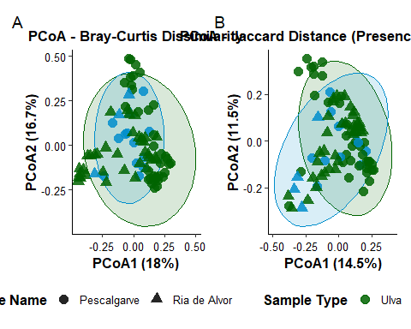
dir.create("../output/figures", recursive = TRUE, showWarnings = FALSE)
ggsave(
filename = "../output/figures/beta_diversity_pcoa_ulva_vs_seawater.png",
plot = combined_pcoa,
width = 12,
height = 5.5,
dpi = 300
)
## Warning: The following aesthetics were dropped during statistical transformation: shape.
## ℹ This can happen when ggplot fails to infer the correct grouping structure in
## the data.
## ℹ Did you forget to specify a `group` aesthetic or to convert a numerical
## variable into a factor?
## The following aesthetics were dropped during statistical transformation: shape.
## ℹ This can happen when ggplot fails to infer the correct grouping structure in
## the data.
## ℹ Did you forget to specify a `group` aesthetic or to convert a numerical
## variable into a factor?
Thre is a lot of overlap in both plots. This suggests that the surrounding planktonic bacteria share core taxonomic members with the algal surface. The principal coordinates explain a low percentage of total community variance.

5. PERMANOVA
This PERMANOVA tests whether community composition varied by sampling site and sample type between the water filter and seaweed samples.
bact_clean <- lumilettuce |>
filter(
superkingdom == "Bacteria",
sample_type %in% c("Ulva", "Water filter"),
!is.na(site_name),
!is.na(genus),
!genus %in% c("Unknown", "Unclassified", ""),
count > 0
)
metadata <- bact_clean |>
distinct(sample_id, sample_type, site_name, diel_phase) |>
arrange(sample_id)
# Create the community matrix with id_cols = sample_id
comm_matrix <- bact_clean |>
group_by(sample_id, genus) |>
summarise(count = sum(count, na.rm = TRUE), .groups = "drop") |>
pivot_wider(
id_cols = sample_id,
names_from = genus,
values_from = count,
values_fill = 0
) |>
arrange(sample_id) |>
column_to_rownames("sample_id") |>
as.matrix()
# Check that it is purely numeric
is.numeric(comm_matrix) # returns TRUE
## [1] TRUE
# Abundance-weighted Bray-Curtis
dist_bray <- vegdist(comm_matrix, method = "bray")
# Incidence-based Jaccard
dist_jacc <- vegdist(comm_matrix, method = "jaccard", binary = TRUE)
cat("\n=================== PERMANOVA: BRAY-CURTIS ===================\n")
##
## =================== PERMANOVA: BRAY-CURTIS ===================
permanova_bray <- adonis2(
dist_bray ~ sample_type * site_name,
data = metadata,
permutations = 999,
by = "margin"
)
print(permanova_bray)
## Permutation test for adonis under reduced model
## Marginal effects of terms
## Permutation: free
## Number of permutations: 999
##
## adonis2(formula = dist_bray ~ sample_type * site_name, data = metadata, permutations = 999, by = "margin")
## Df SumOfSqs R2 F Pr(>F)
## sample_type:site_name 1 0.5375 0.02916 2.9018 0.001 ***
## Residual 84 15.5580 0.84411
## Total 87 18.4314 1.00000
## ---
## Signif. codes: 0 '***' 0.001 '**' 0.01 '*' 0.05 '.' 0.1 ' ' 1
cat("\n=================== PERMANOVA: JACCARD ===================\n")
##
## =================== PERMANOVA: JACCARD ===================
permanova_jacc <- adonis2(
dist_jacc ~ sample_type * site_name,
data = metadata,
permutations = 999,
by = "margin"
)
print(permanova_jacc)
## Permutation test for adonis under reduced model
## Marginal effects of terms
## Permutation: free
## Number of permutations: 999
##
## adonis2(formula = dist_jacc ~ sample_type * site_name, data = metadata, permutations = 999, by = "margin")
## Df SumOfSqs R2 F Pr(>F)
## sample_type:site_name 1 0.5547 0.03113 3.0106 0.001 ***
## Residual 84 15.4770 0.86855
## Total 87 17.8193 1.00000
## ---
## Signif. codes: 0 '***' 0.001 '**' 0.01 '*' 0.05 '.' 0.1 ' ' 1
# Test homogeneity of multivariate dispersion (betadisper)
# Tests if within-group variance differs (helps validate PERMANOVA results)
cat("\n--- Dispersion Test: Sample Type (Bray-Curtis) ---\n")
##
## --- Dispersion Test: Sample Type (Bray-Curtis) ---
disp_type <- betadisper(dist_bray, metadata$sample_type)
print(anova(disp_type))
## Analysis of Variance Table
##
## Response: Distances
## Df Sum Sq Mean Sq F value Pr(>F)
## Groups 1 0.00711 0.0071117 0.5033 0.48
## Residuals 86 1.21524 0.0141307
cat("\n--- Dispersion Test: Site Name (Bray-Curtis) ---\n")
##
## --- Dispersion Test: Site Name (Bray-Curtis) ---
disp_site <- betadisper(dist_bray, metadata$site_name)
print(anova(disp_site))
## Analysis of Variance Table
##
## Response: Distances
## Df Sum Sq Mean Sq F value Pr(>F)
## Groups 1 0.00149 0.0014864 0.0939 0.76
## Residuals 86 1.36157 0.0158322
# Visualize dispersions
par(mfrow = c(1, 2))
plot(disp_type, main = "Dispersion: Sample Type")
plot(disp_site, main = "Dispersion: Site Name")
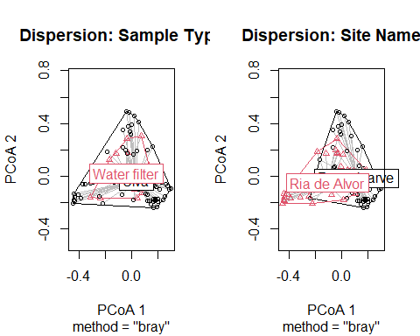
par(mfrow = c(1, 1))
This means that the community composition varied significantly by sampling site and sample type.

