Design Document

Team CtrlAltDefeat - Brittany Nall & Melissa Smith

CS414 – Fall 2018

# Design Class Diagram

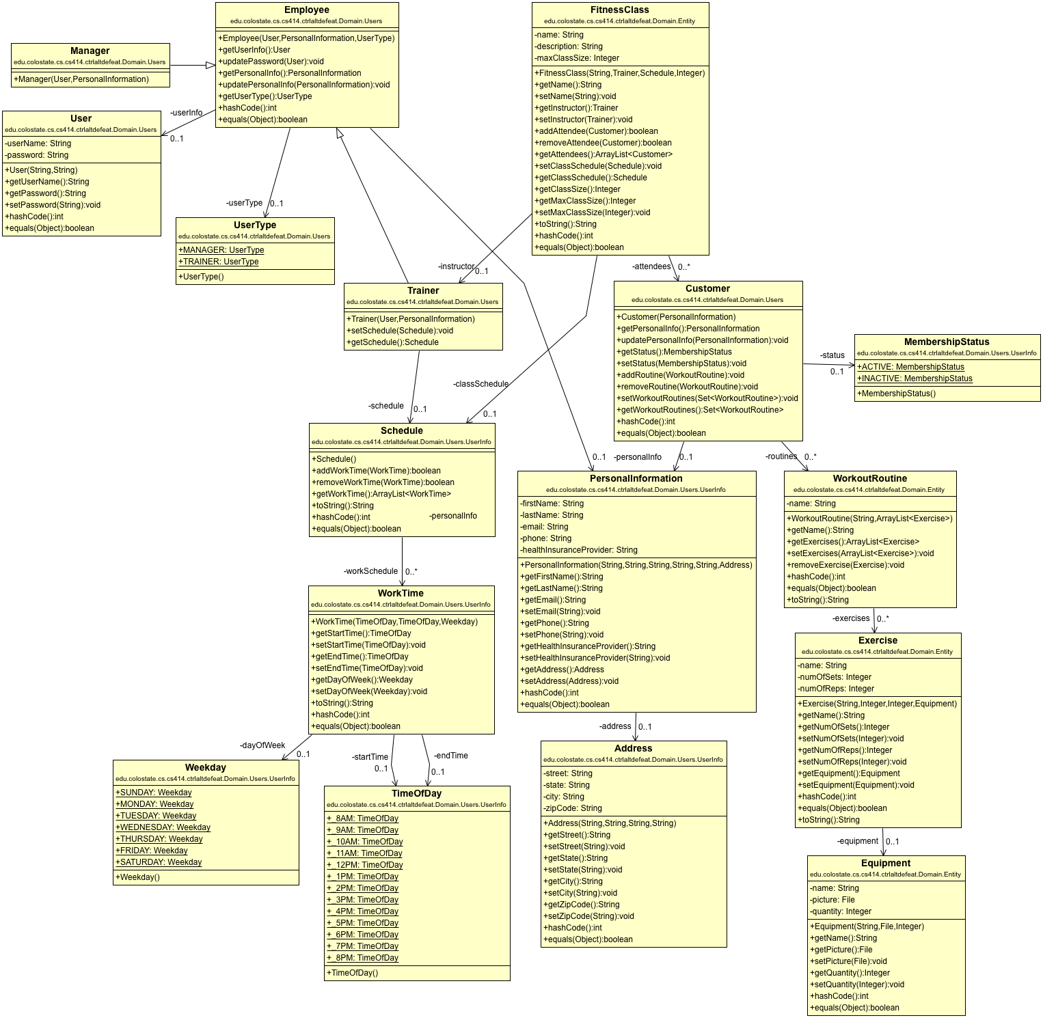Pictures of the class diagrams are standalone outside the document due to size.

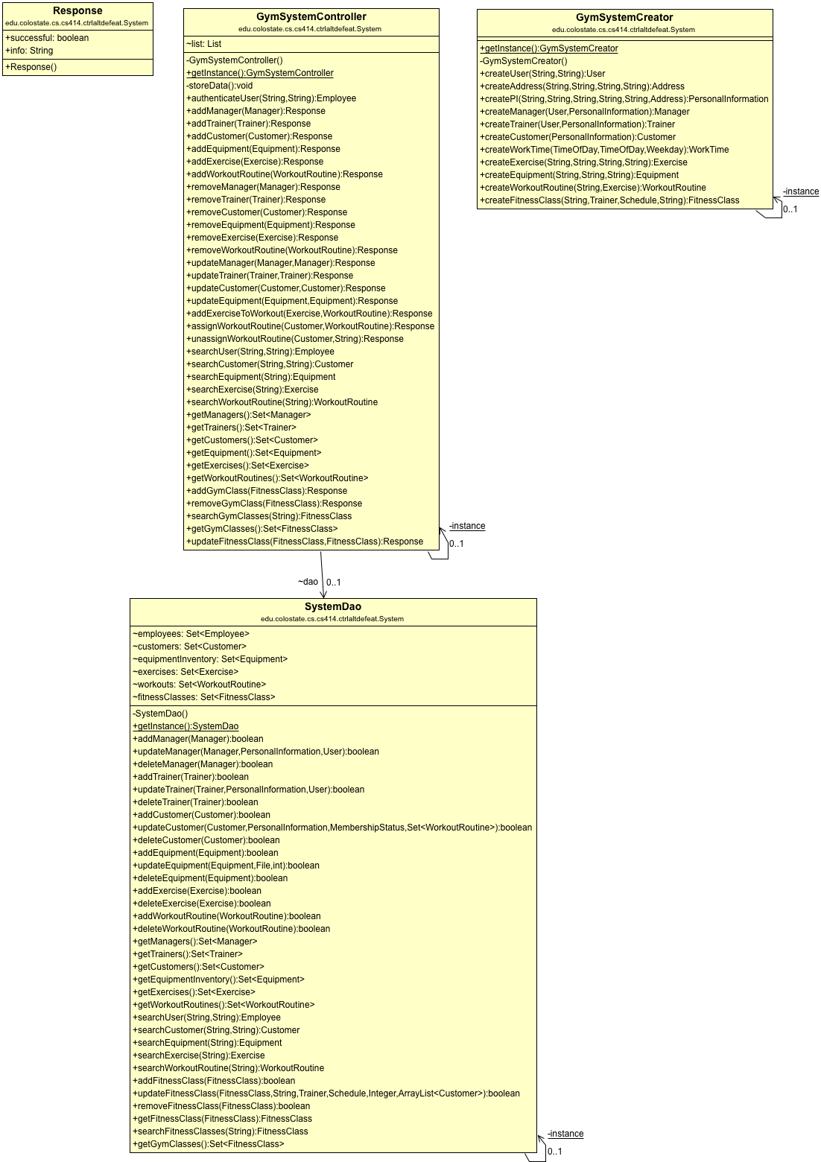

# Sequence Diagrams

## Create Manager

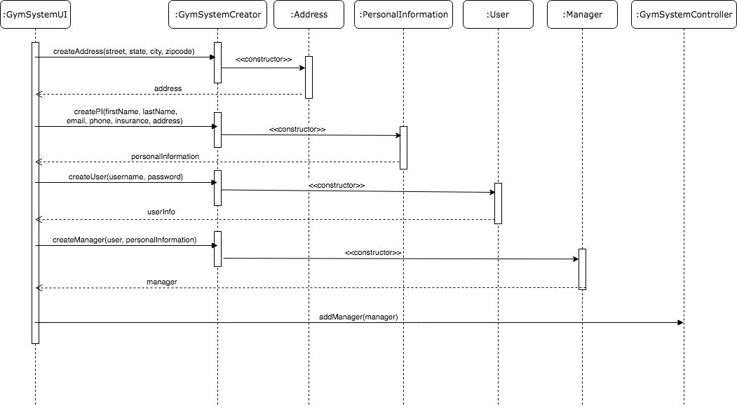

## Create Workout Routine

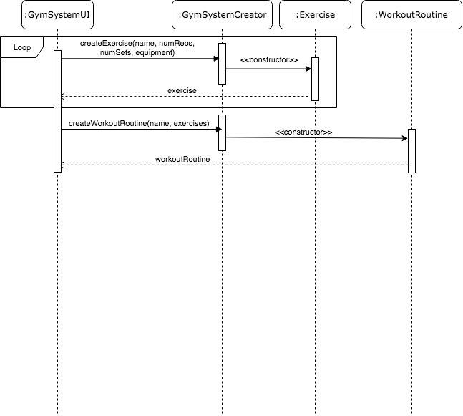

## Assign a Workout to a Customer

