Abigail Higham

Political Science 328

Professor Goodliffe

Section 006

Aryanna Hyde

Final Exam: Part 4

Esteemed Undersecretary of the State,

To help investigate what causes domestic unrest in countries around the world, I was asked to specifically investigate how democracy affects internals stability. The data I was given involves Polity scores, real GDP, average years of education, population, and inflation rate. With the data I was provided with, I ran statistical analyses to help better understand what can predict coups. My findings are that a country’s polity score can be an important determinant of if they will experience a coup, but there are other factors that are considerably important, population, inflation, and GDP.

For my methodology, I ran statistical tests that analyze the relationships between democracy and coups. I ran different tests that included different factors that could contribute to reducing the amount of coups, and this helped me explore different possibilities of relationships between coups and democracy. This method was most appropriate, because coups and democracy are caused by many different socioeconomic factors. From my methodology, I was able to look at different types of relationships that coups and democracy may have.

My findings are that polity score matters, but there are other factors that are considerably important. Population and GDP can influence the likelihood of coups. My theory behind this is that states with large populations and high GDP have more of the necessary resources to combat any type of military coup, whereas smaller states with less money have less security and resources to combat a coup. As well, the politics of states that are smaller and a lower real GDP can be easily influenced by outside forces and can serve as a proxy war to larger states, such as Syria. Polity score can be influenced by these same factors as well.

There are limitations to my findings. One of my main concerns are that there might be potential factors that cause coups that I did not have the data for. In this data set, there is a lot of general information about civilian populations, but there is not a lot of information about their military. I would be interested to see how the size of the military relative to population, conscription, and ethnic division could influence coups. Also, it is difficult to say that a specific region is more prone to coups than others, because besides North America, there have been a lot of military coups throughout the world. My findings do suggest that there could be some type of relationship between real GDP, population size, and polity score, but there are other factors that could potentially help predict coups.

My recommendations are that you should look towards states with smaller populations, less GDP, inflation rates, and lower polity scores. Collectively, these factors indicate key countries that could be at risk for instability.

In conclusion, there is a lot more to be understood about coups, but looking at key indicators that are easily accessible, such as population, GDP, and inflation, can help point out countries that could potentially have a coup.

**APPENDIX**

**State Assumptions:**  [Goodliffe PP 3/22]

1. $u_{it}$ has a mean zero, given that the state fixed effect and the entire history of the Xs for that state.
2. $\left(X_{i1},…,X_{iT},Y_{i1},…,Y_{iT}\right)$ are i.i.d.
3. ${(X}_{i1},Y_{i1})$ have finite fourth moments
4. There is no perfect multicollinearity.

**Graph 1: Histogram of Percentage of Population with Secondary Education**

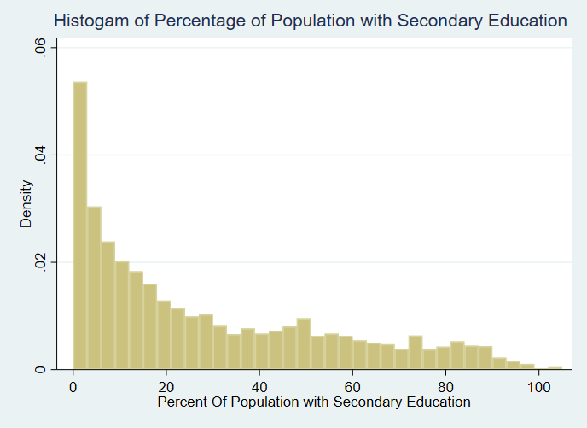

***Graph 1: Histogram of Percentage of Population with Secondary Education:*** *From this graph, we can see that the variable, percentage of population with secondary education, is strongly right-skewed. To make the data easier to interpret, I will use the natural log of percentage of population with a secondary education.*

**Graph 2: Histogram of Percentage of Population Employed in Agriculture**

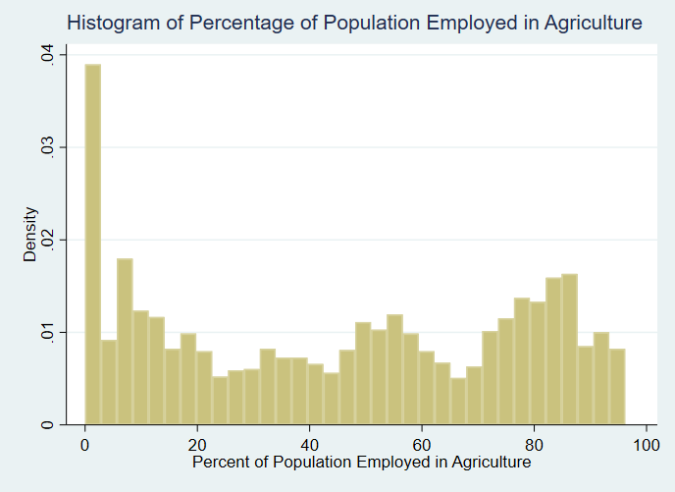

***Graph 2: Histogram of Percentage of Population Employed in Agriculture:*** *From this graph, we can see that the variable, percentage of population employed in agriculture, is strongly right-skewed. To make the data easier to interpret, I will use the natural log of percentage of population employed in agriculture.*

**Graph 3: Histogram of Country Population**

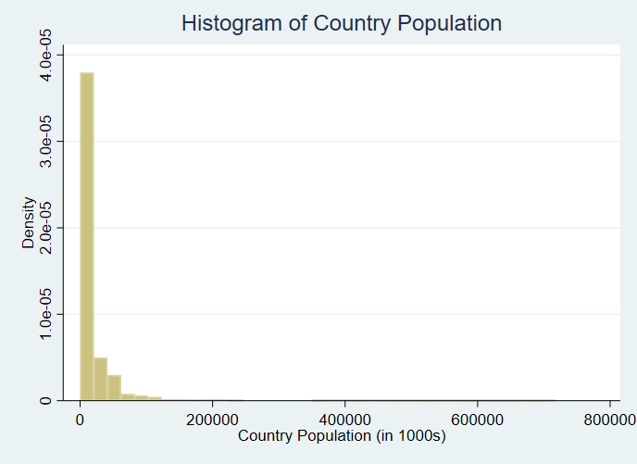

***Graph 3: Histogram of Country Population*** *From this graph, we can see that the variable, country population, is strongly right-skewed. To make the data easier to interpret, I will use the natural log of country population.*

**Graph 4: Histogram of Real GDP Per Capita**

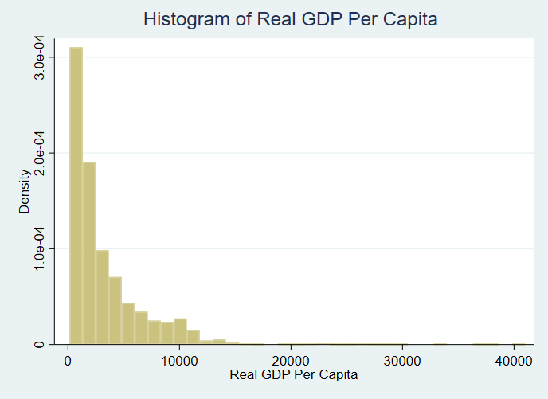

***Graph 4: Histogram of Real GDP Per Capita:*** *From this graph, we can see that the variable, Real GDP per Capita, is strongly right-skewed. To make the data easier to interpret, I will use the natural log of GDP per Capita.*

**Graph 5: Histogram of Annual Inflation Rate**

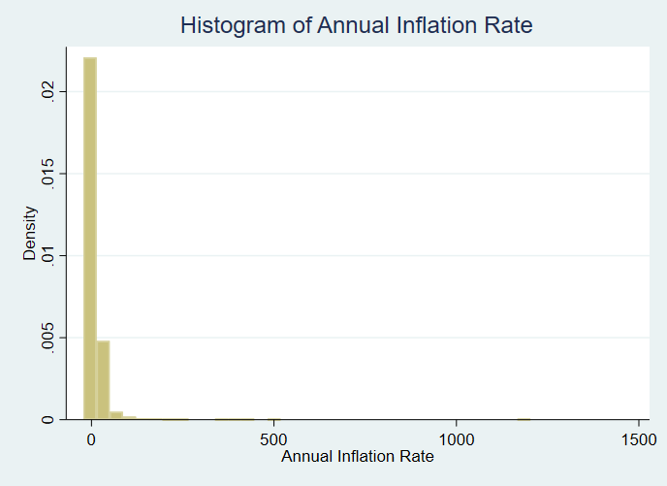

**Graph 5: Histogram of Annual Inflation Rate**: *From this graph, we can see that the variable, Annual Inflation Rate, is strongly right-skewed. To make the data easier to interpret, I will use the natural log of Annual Inflation Rate.*

**Graph 6: Scatterplot of Coup Attempts and Polity Scores**

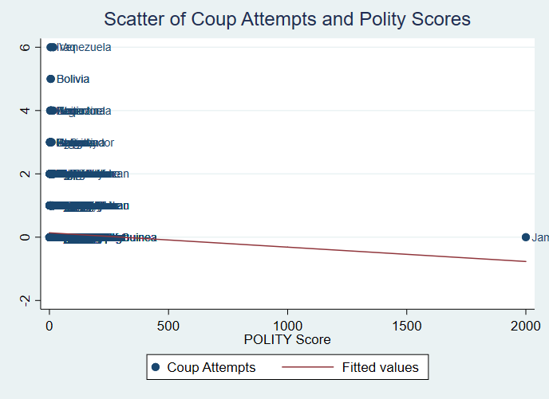

***Graph 6: Scatterplot of Coup Attempts and Polity Scores:*** *From this graph, we can see one extreme outlier, Jamaica. After examining the data, it appears someone mislabeled one of Jamaica’s polity scores as 2000 instead of 20, which was Jamaica’s score for every other year. I changed the observation’s polity score to 20.*

**Graph 7: Scatterplot of Coup Attempts and Polity Scores without Outlier**

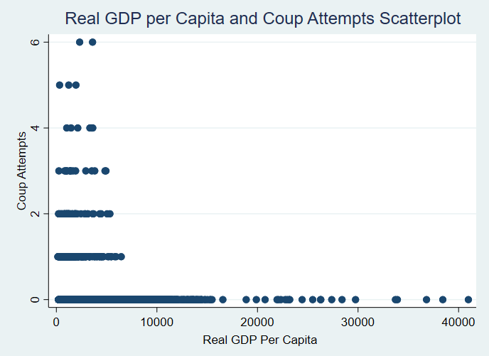

***Graph 7: Scatterplot of Coup Attempts and Polity Scores without Outlier:*** *From this graph, we can see that coups occur in countries with less than 10,000 units of Real GDP per Capita.*

**Graph 8: Scatter of Countries and Amount of Coups**

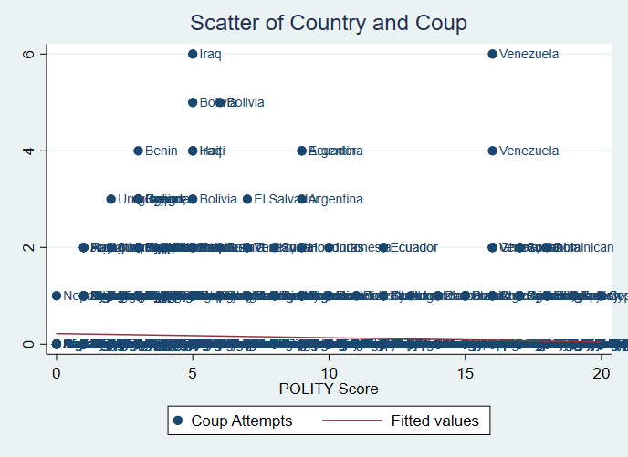

***Graph 8: Scatter of Countries and Amount of Coups:*** *From this graph, we can see that there is not a strong relationship with Polity score and the number of coups a country has. It appears that the countries that have coups are more likely to happen with lower scores, but there are still coups that have occurred with higher polity scores.*

**Graph 9: Adjusted Polity Predictions with 95% Confidence Intervals**

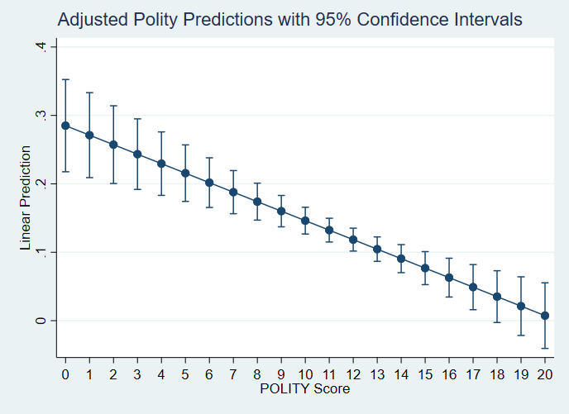

***Graph 9: Adjusted Polity Predictions with 95% Confidence Intervals****: From this graph, it appears that a higher polity score has an associated lower predicted number of coups, holding all else constant. For a higher polity score of 16, the model estimates that there will be no coup.*

**Graph 10: Adjusted Logged Population Predictions with 95% Confidence Intervals**

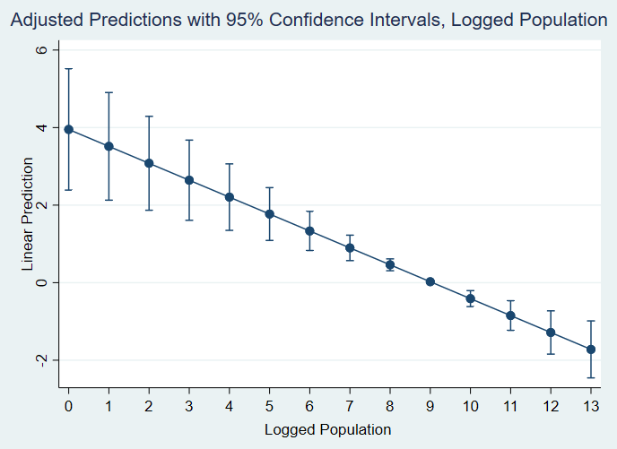

***Graph 10: Adjusted Logged Population Predictions with 95% Confidence Intervals:*** *From this graph, we can see there is an associated decrease in likelihood of a coup with larger log populations.*

**Graph 11: Predictive Margins for Interaction Logged Real GDP and Polity Score**

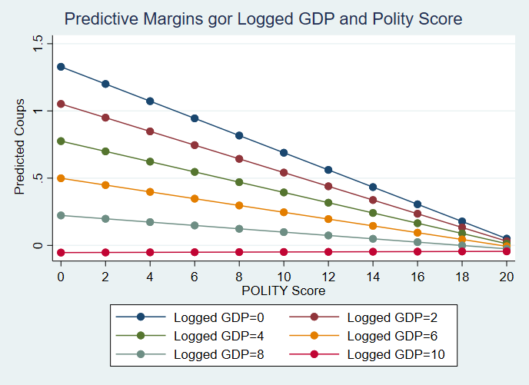

***Graph 11: Predictive Margins for Interaction Logged GDP and Polity Score:*** *From this graph, we can see the varying levels of GDP and Polity scores have different slopes. To control for this, I am going to run an interaction term for real GDP and Polity scores.*

**VIF Test**

|  |  |
| --- | --- |
| **Variable** | **VIF** |
| **Polity** | 92.08 |
| **Logged GDP** | 5.65 |
| **Polity x Logged GDP** | 111.71 |
| **Logged Secondary Education** | 2.70 |
| **Logged Population** | 1.04 |
| **Logged Inflation Rate** | 1.10 |
| **Mean VIF** | 35.71 |

***Table 1: VIF Test:*** *From this table, we can see that our model does not have problems of high multicollinearity. The variables with high VIF scores, polity, logged real GDP, and the interaction term, should be accounted for by Stata.*

**Graph 12: Lvr2plot**

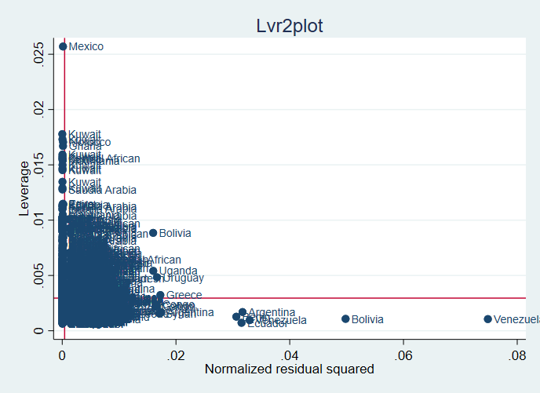

***Graph 12: Lvr2plot:*** *The graph shows us that Venezuela and Bolivia have a very large residuals, but they don’t have much leverage. Mexico has high leverage, but it does not have a large residual. If there were any observations in the top right corner, then I would further investigate.*

**Table 2: Cook’s D Test**

|  |
| --- |
| **Iceland** |
| **India** |
| **Barbados** |

***Table 2: Cook’s D Test:*** *From my Cook’s D test, I identified three influential outliers that I could consider removing. The three outliers do not significantly change the data, so I will keep my first model as the preferred model.*

**Table 3: Ovtest**

|  |  |
| --- | --- |
|  | Ho: model has no omitted variables |
| F(3, 2362) | 3.00 |
| Prob > F | 0.0294 |

***Table 3: Ovtest:*** *From this test, we can see that the p-value, .0294, is less than .05. Because of this, we can reject the null hypothesis that there are no omitted variables in the model.*

**Table of Models**

|  |  |  |
| --- | --- | --- |
|  | (1) | (2) |
| VARIABLES | Model 1: including outliers | Model 2: without outliers |
|  |  |  |
| Polity | -0.064*** | -0.061** |
|  | (0.024) | (0.024) |
| Logged Real GDP | -0.138** | -0.128** |
|  | (0.062) | (0.063) |
| Polity x Logged Real GDP | 0.006** | 0.006* |
|  | (0.003) | (0.003) |
| Logged Average Years of Education | 0.069** | 0.070** |
|  | (0.027) | (0.028) |
| Logged Population | -0.436*** | -0.443*** |
|  | (0.090) | (0.093) |
| Logged Inflation Rate | 0.023** | 0.021** |
|  | (0.010) | (0.010) |
| Constant | 4.925*** | 4.915*** |
|  | (0.730) | (0.747) |
|  |  |  |
| Observations | 2,372 | 2,294 |
| R-squared | 0.030 | 0.030 |
| Number of country1 | 104 | 101 |

Standard errors in parentheses

*** p<0.01, ** p<0.05, * p<0.1

**Note:** I chose an fixed effects model, because the corr(u_i, Xb)of .9249. I also chose to exclude the percentage of people who work in agriculture, because substantively, agriculture is both a job that can pay well or poorly. The p-value of agriculture was extremely high, and when I removed it, some of my other variables became more significant.

**Interpretations of Model 1:**

For every additional Polity point added, there is an associated .064 decrease in the amount of estimated coups.

For every additional 1% increase in logged Real GDP, there is an associated .138% decrease in the amount of estimated coups.

For every additional 1% increase in logged average years of education, there is an associated .069% decrease in the amount of estimated coups.

For every additional 1% increase in logged population, there is an associated decrease of .436% decrease in the amount of estimated coups.

For every additional 1% increase in logged inflation rate, there is an associated increase of .023% in the amount of estimated coups.

**GRADER’S APPENDIX**

**Do File**

encode cname, gen(country1)

xtset country1 year

xtsum

xtline coup

xtline coup, overlay

gen region1 = region

tab country1, gen(state)

tab region, gen(continent)

twoway scatter coup polity, mlabel(country1) || lfit coup polity

replace polity = 20 in 1836

twoway scatter coup polity, mlabel(country1) || lfit coup polity, clstyle(p2)

scatter coup rgdptt

hist edsec

gen lnedsec = ln(edsec)

hist ag

gen lnag=ln(ag)

hist pop

gen lnpop = ln(pop)

tab polity

hist rgdptt

gen lnrgdp = ln(rgdptt)

hist inf

*inflation??

gen lninf =ln(inf)

xtreg coup polity, fe cluster(country1)

xtreg coup polity lnag lnedsec lnpop lnrgdp lninf, fe cluster(country1)

test lnrgdp polity

xtreg coup c.polity##c.lnrgdp lnedsec lnpop lninf, fe cluster(country1)

testparm c.polity##c.lnrgdp

margins, at(polity=(0(2)20) lnrgdp=(0(2)10))

marginsplot, noci

*statistically significant

ssc install outreg2

xtreg coup c.polity##c.lnrgdp lnedsec lnpop lninf, fe i(country1)

outreg2 using abbey9.doc, word dec(3)

margins, at(polity=(0(1)20)) atmeans vsquish

xtreg coup c.polity##c.lnrgdp lnedsec lnpop lninf, fe i(country1)

margins, at(lnpop=(0(1)13)) atmeans vsquish

marginsplot

margins, at(polity=(0(1)20)) atmeans vsquish

marginsplot

margins, at(polity=(0(2)20) lnrgdp=(0(2)10))

marginsplot, noci

reg coup c.polity##c.lnrgdp lnedsec lnpop lninf

lvr2plot, mlabel(country1)

vif

ovtest

xtreg coup c.polity##c.lnrgdp lnedsec lnpop lninf, fe i(country1)

predict d, cooksd

sort d

di 4/2372

list country1 coup d if d>4/2372

list country1 coup d if d>7

*India Iceland Barbados

xtreg coup c.polity##c.lnrgdp lnedsec lnpop lninf if d<7, fe i(country1)

outreg2 using abbey9.doc, word dec(3)

log close

**Log File**

. use "C:\Users\ahigham4\Downloads\coups.dta"

(Instability & Growth)

. do "C:\Users\ahigham4\AppData\Local\Temp\STD2670_000000.tmp"

. encode cname, gen(country1)

. xtset country1 year

panel variable: country1 (strongly balanced)

time variable: year, 1950 to 1982

delta: 1 unit

. xtsum

. xtline coup

. xtline coup, overlay

. do "C:\Users\ahigham4\AppData\Local\Temp\STD2670_000000.tmp"

. xtreg coup polity lnag lnedsec lnpop lnrgdp lninf, fe cluster(country1)

Fixed-effects (within) regression Number of obs = 1,781

Group variable: country1 Number of groups = 103

R-sq: Obs per group:

within = 0.0250 min = 6

between = 0.0005 avg = 17.3

overall = 0.0009 max = 21

F(6,102) = 3.74

corr(u_i, Xb) = -0.9690 Prob > F = 0.0021

(Std. Err. adjusted for 103 clusters in country1)

------------------------------------------------------------------------------

| Robust

coup | Coef. Std. Err. t P>|t| [95% Conf. Interval]

-------------+----------------------------------------------------------------

polity | -.0149517 .0050087 -2.99 0.004 -.0248864 -.0050171

lnag | -.0585173 .0981953 -0.60 0.553 -.2532872 .1362525

lnedsec | .0784657 .0591414 1.33 0.188 -.0388411 .1957724

lnpop | -.523802 .2479055 -2.11 0.037 -1.015521 -.0320826

lnrgdp | -.1427013 .1001981 -1.42 0.157 -.3414439 .0560412

lninf | .024038 .0150808 1.59 0.114 -.0058747 .0539507

_cons | 5.912535 2.206367 2.68 0.009 1.536216 10.28885

-------------+----------------------------------------------------------------

sigma_u | .83267478

sigma_e | .40698929

rho | .80716801 (fraction of variance due to u_i)

------------------------------------------------------------------------------

.

end of do-file

. do "C:\Users\ahigham4\AppData\Local\Temp\STD2670_000000.tmp"

. test lnrgdp polity

( 1) lnrgdp = 0

( 2) polity = 0

F( 2, 102) = 6.07

Prob > F = 0.0032

.

end of do-file

. do "C:\Users\ahigham4\AppData\Local\Temp\STD2670_000000.tmp"

. xtreg coup c.polity##c.lnrgdp lnedsec lnpop lninf, fe cluster(country1)

Fixed-effects (within) regression Number of obs = 2,372

Group variable: country1 Number of groups = 104

R-sq: Obs per group:

within = 0.0300 min = 8

between = 0.0009 avg = 22.8

overall = 0.0016 max = 33

F(6,103) = 3.84

corr(u_i, Xb) = -0.9567 Prob > F = 0.0017

(Std. Err. adjusted for 104 clusters in country1)

------------------------------------------------------------------------------

| Robust

coup | Coef. Std. Err. t P>|t| [95% Conf. Interval]

-------------+----------------------------------------------------------------

polity | -.0639114 .0339665 -1.88 0.063 -.1312759 .0034531

lnrgdp | -.1381897 .0943583 -1.46 0.146 -.3253271 .0489476

|

c.polity#|

c.lnrgdp | .0064368 .0045989 1.40 0.165 -.0026841 .0155577

|

lnedsec | .0691365 .0363666 1.90 0.060 -.0029881 .141261

lnpop | -.4363696 .1852034 -2.36 0.020 -.8036769 -.0690622

lninf | .0230759 .0124409 1.85 0.066 -.0015976 .0477494

_cons | 4.925197 1.499853 3.28 0.001 1.950592 7.899803

-------------+----------------------------------------------------------------

sigma_u | .69101229

sigma_e | .4149388

rho | .73498295 (fraction of variance due to u_i)

------------------------------------------------------------------------------

.

end of do-file

. do "C:\Users\ahigham4\AppData\Local\Temp\STD2670_000000.tmp"

. testparm c.polity##c.lnrgdp

( 1) polity = 0

( 2) lnrgdp = 0

( 3) c.polity#c.lnrgdp = 0

F( 3, 103) = 6.89

Prob > F = 0.0003

.

end of do-file

. do "C:\Users\ahigham4\AppData\Local\Temp\STD2670_000000.tmp"

. margins, at(polity=(0(2)20) lnrgdp=(0(2)10))

. marginsplot, noci

Variables that uniquely identify margins: polity lnrgdp

.

end of do-file

. do "C:\Users\ahigham4\AppData\Local\Temp\STD2670_000000.tmp"

. ssc install outreg2

checking outreg2 consistency and verifying not already installed...

all files already exist and are up to date.

.

. xtreg coup c.polity##c.lnrgdp lnedsec lnpop lninf, fe i(country1)

Fixed-effects (within) regression Number of obs = 2,372

Group variable: country1 Number of groups = 104

R-sq: Obs per group:

within = 0.0300 min = 8

between = 0.0009 avg = 22.8

overall = 0.0016 max = 33

F(6,2262) = 11.66

corr(u_i, Xb) = -0.9567 Prob > F = 0.0000

------------------------------------------------------------------------------

coup | Coef. Std. Err. t P>|t| [95% Conf. Interval]

-------------+----------------------------------------------------------------

polity | -.0639114 .0237007 -2.70 0.007 -.1103889 -.0174339

lnrgdp | -.1381897 .061962 -2.23 0.026 -.2596981 -.0166814

|

c.polity#|

c.lnrgdp | .0064368 .0030652 2.10 0.036 .000426 .0124477

|

lnedsec | .0691365 .027237 2.54 0.011 .0157244 .1225485

lnpop | -.4363696 .0902282 -4.84 0.000 -.6133082 -.2594309

lninf | .0230759 .0099676 2.32 0.021 .0035293 .0426225

_cons | 4.925197 .7304867 6.74 0.000 3.492703 6.357691

-------------+----------------------------------------------------------------

sigma_u | .69101229

sigma_e | .4149388

rho | .73498295 (fraction of variance due to u_i)

------------------------------------------------------------------------------

F test that all u_i=0: F(103, 2262) = 4.43 Prob > F = 0.0000

. outreg2 using abbey9.doc, word dec(3)

abbey9.doc

dir : seeout

.

end of do-file

. do "C:\Users\ahigham4\AppData\Local\Temp\STD2670_000000.tmp"

. xtreg coup c.polity##c.lnrgdp lnedsec lnpop lninf if d<7, fe i(country1)

d not found

r(111);

end of do-file

r(111);

. do "C:\Users\ahigham4\AppData\Local\Temp\STD2670_000000.tmp"

. xtreg coup c.polity##c.lnrgdp lnedsec lnpop lninf, fe i(country1)

.

end of do-file

. do "C:\Users\ahigham4\AppData\Local\Temp\STD2670_000000.tmp"

. predict d, cooksd

(1,555 missing values generated)

. sort d

. di 4/2372

.00168634

.

end of do-file

. do "C:\Users\ahigham4\AppData\Local\Temp\STD2670_000000.tmp"

. xtreg coup c.polity##c.lnrgdp lnedsec lnpop lninf if d<7, fe i(country1)

Fixed-effects (within) regression Number of obs = 2,294

Group variable: country1 Number of groups = 101

R-sq: Obs per group:

within = 0.0297 min = 8

between = 0.0019 avg = 22.7

overall = 0.0023 max = 33

F(6,2187) = 11.16

corr(u_i, Xb) = -0.9480 Prob > F = 0.0000

------------------------------------------------------------------------------

coup | Coef. Std. Err. t P>|t| [95% Conf. Interval]

-------------+----------------------------------------------------------------

polity | -.0613084 .0241669 -2.54 0.011 -.108701 -.0139159

lnrgdp | -.1275537 .0630936 -2.02 0.043 -.2512833 -.0038242

|

c.polity#|

c.lnrgdp | .0060808 .0031259 1.95 0.052 -.0000492 .0122108

|

lnedsec | .0703573 .0277434 2.54 0.011 .0159511 .1247635

lnpop | -.4432905 .0925817 -4.79 0.000 -.6248477 -.2617333

lninf | .0209612 .0102207 2.05 0.040 .000918 .0410045

_cons | 4.915027 .7472795 6.58 0.000 3.449575 6.380479

-------------+----------------------------------------------------------------

sigma_u | .64847949

sigma_e | .42024189

rho | .70424602 (fraction of variance due to u_i)

------------------------------------------------------------------------------

F test that all u_i=0: F(100, 2187) = 4.44 Prob > F = 0.0000

.

end of do-file

. do "C:\Users\ahigham4\AppData\Local\Temp\STD2670_000000.tmp"

. outreg2 using abbey9.doc, word dec(3)

abbey9.doc

dir : seeout

.

end of do-file

. shellout using `"abbey9.doc"'

.