1. **Briefly describe the artifact. What is it? When was it created?**

The artifact I have chosen to complete the Software Engineering and Design Enhancement is from the CS 360: Mobile Architecture and Programming course. Within Project Two of that course my goal was to create a mobile app through Android Studio. The application’s intention was to be a warehouse inventory application that could hold and display data for inventory within a warehouse or similar environment. The original file was created in August of 2024.

1. **Justify the inclusion of the artifact in your ePortfolio. Why did you select this item? What specific components of the artifact highlight your skills and abilities in software development? How was the artifact improved?**

I selected this item to align with the course outcomes; 1 (Employ strategies for building collaborative environments that enable diverse audiences to support organizational decision-making in the field of computer science.) and 4 (Demonstrate an ability to use well-founded and innovative techniques, skills, and tools in computing practices for the purpose of implementing computer solutions that deliver value and accomplish industry-specific goals). Implementing the dark mode feature demonstrates the ability to create inclusive, user-centered solutions that consider diverse preferences and accessibility needs, aligning with the course outcome of building collaborative environments for diverse audiences. By designing an adaptable theme and using Android Studio’s tools like XML and Material Design, this enhancement highlights the use of innovative techniques and industry-standard practices. The dynamic theme toggle allows users to personalize their experience, reflecting a collaborative approach to meeting user needs. This enhancement not only improves user experience but also highlights the ability to implement well-founded solutions that deliver value and align with industry-specific goals.

In relation to my specific skills and abilities, the improvements made within Enhancement One display my ability to continually review code for errors, properly comment and make my comments easy to follow, and maintaining the code in such a way to retain scalable properties.

1. **Did you meet the course outcomes you planned to meet with this enhancement in Module One? Do you have any updates to your outcome-coverage plans?**

I do believe I have met the course outcomes mentioned, and have no additional updates to the course outcome section of the assignment at this time.

1. **Reflect on the process of enhancing and modifying the artifact. What did you learn as you were creating it and improving it? What challenges did you face?**

As I was creating my baseline for the theme switch enhancement, I realized my initial code had more problems to overcome than initially perceived. I’m learning more about Android Studio’s software as I go through to continue improving upon my code. A challenge I am facing at the moment includes getting the software to retain my dashboard as I switch between themes.

Screenshots to prove progress towards enhancement:

Updated themes and colors xml files:

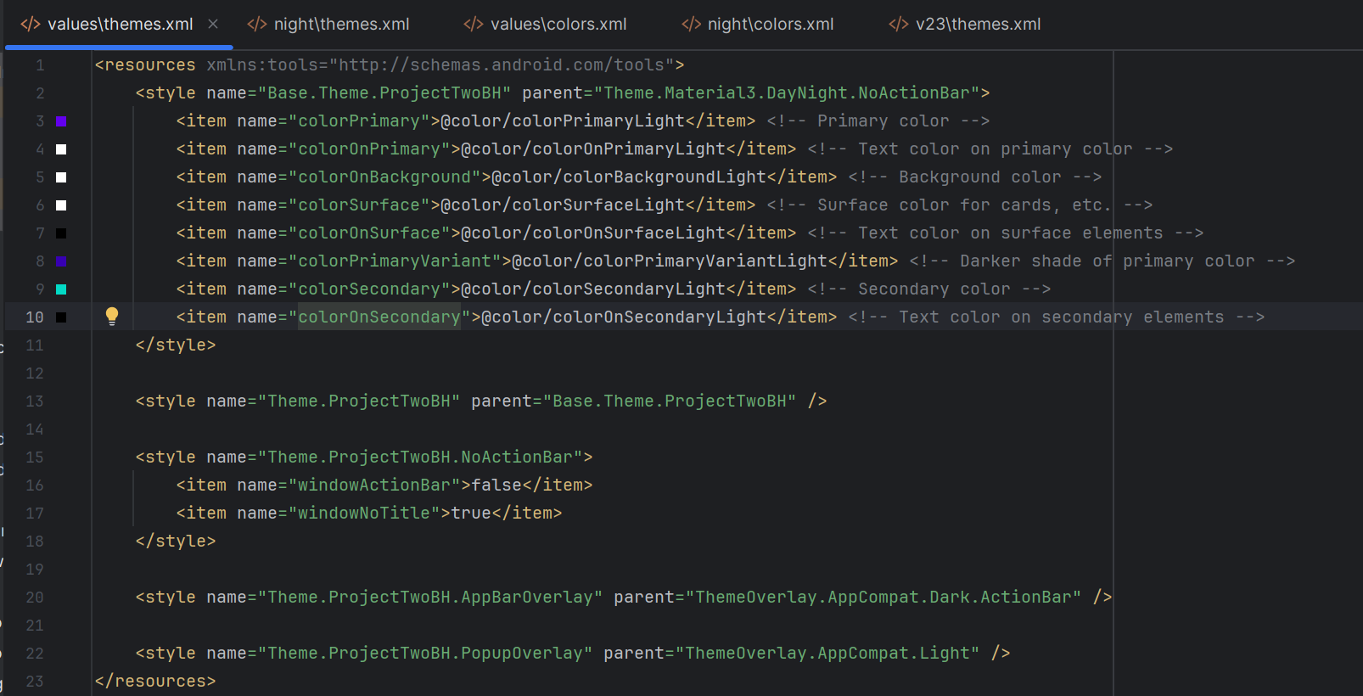

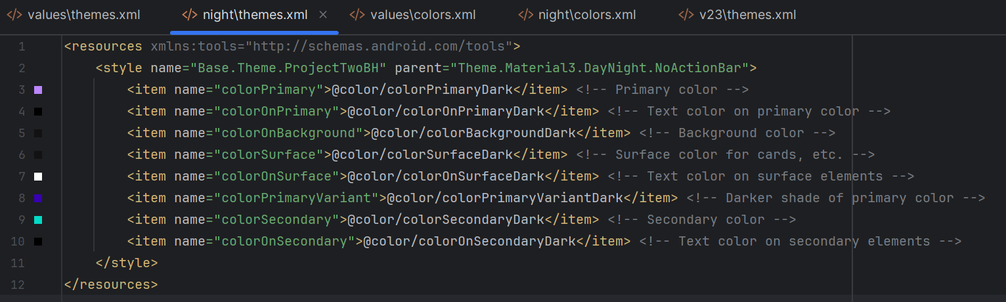

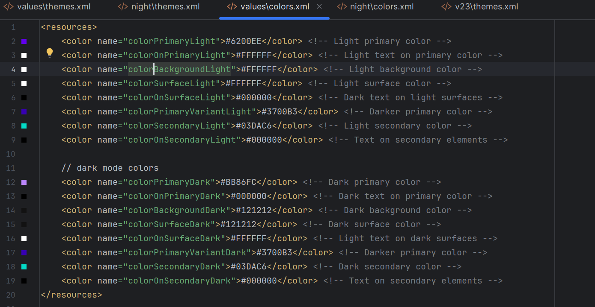

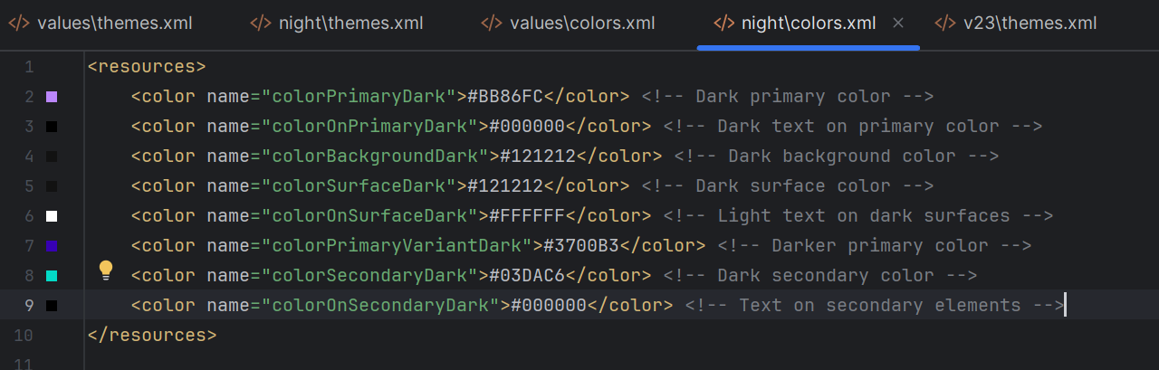

Settings screen created with a toggle for light and dark mode:

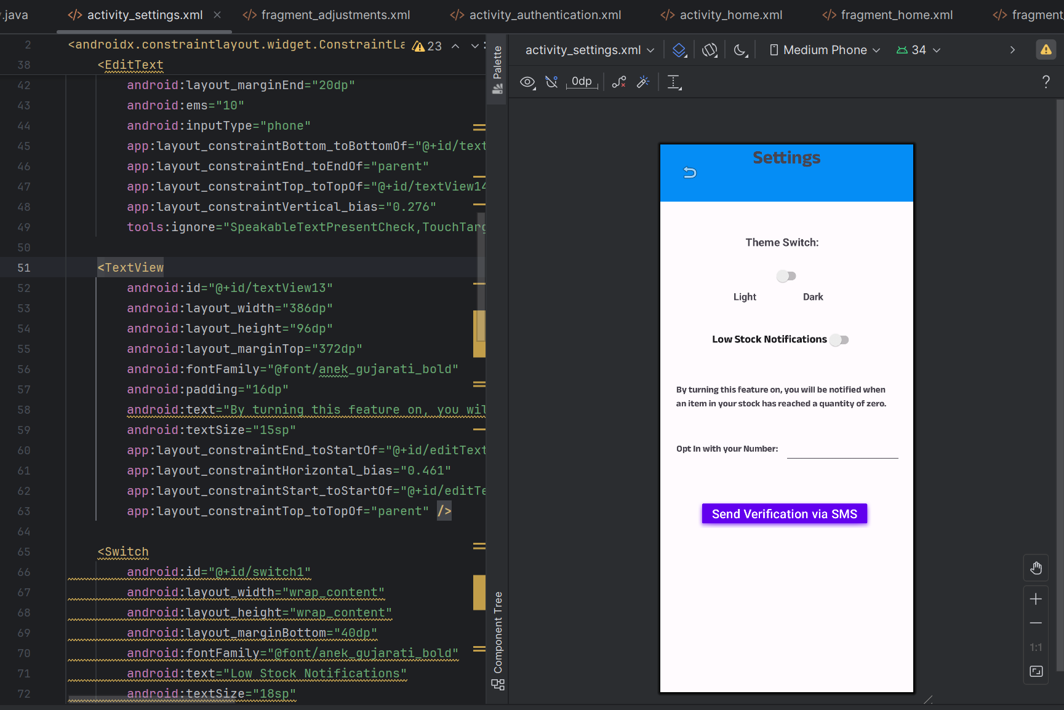

Light and Dark Mode Preview:

