Rafael Brito
Credit Card Fraud Detection: Simple NN versus Google Cloud Platform AutoML

Problem Statement:
Banks are required to continuously develop and deploy newer models to detect fraud more accurately. This case study compares the efficacy of fraud detection between a Keras “home-grown” Simple NN versus Google’s newest AutoML service (Beta) from Google Cloud Platform (GCP).

Overview of Technology:
Google AutoML (https://cloud.google.com/automl/) is a beta cloud service that claims to automatically produce and deploy high quality Machine Learning models without corporations (or individuals) necessarily to be Machine Learning experts. For comparison purposes, we will build and train a Keras Simple Neural Network against the same dataset.

Data Set:
Data arises from a kaggle public dataset with 492 frauds out of 284,807 transactions. Data has been already PCA’d on all features but time and amount.
URL: https://www.kaggle.com/mlg-ulb/creditcardfraud
Large size: 150 MB Format of data file: csv

High Level Overview of steps:
1. Downloaded data set locally and pre-process: scale time and amount features, generated sampled data for training purposes.
2. Ran Keras NN model and determined confusion matrix.
3. On Google Cloud: ingested data on Google Cloud BigQuery
4. On AutoML: run Training (sampled data) and Predictions (entire data sample). Determine confusion matrix.
5. Compare confusion matrices and determine the winner.

References:
- Chawla, Nitesh: Data Mining for Imbalanced Datasets, An Overview (https://www3.nd.edu/~dial/publications/chawla2005data.pdf)
- Bachmann, Janio: Credit Fraud, Dealing with Imbalanced Dataset (https://www.kaggle.com/janiobachmann/credit-fraud-dealing-with-imbalanced-datasets)

Lessons Learned & Pros/Cons:
- Imbalanced dataset: imperative to create a under sample for training;
- AutoML is very easy to use and provide a solid alternative for businesses to consume Machine Learning without necessary hiring developers.
YouTube URLs
- Short video https://youtu.be/LL-xICch1d8
- Long video https://youtu.be/R27Q3H0rRk4

Rafael Brito - Report

On this case, we compare the metrics between a simple neural network with Google AutoML using a credit card fraud dataset.

Executive Summary

- Google AutoML was better on false positives (0% versus 4.5%)

- Simple NN was much better on false negatives (4% versus 23%)

- There is room to improve on both solutions:
  - On Google AutoML: training with subsample with 50/50 for fraud
  - On Simple RNN: Using SMOTE and more elaborate Neural Network models

Net-net:
Google AutoML was acceptable considering there was “zero” coding and “zero” pre-processing of data. AutoML is a strong option for corporations to quickly deploy and use ML models without any know-how.

The Dataset

Kaggle Public Dataset: https://www.kaggle.com/mlg-ulb/creditcardfraud with 66MB compressed, 150MB uncompressed.

Data is transactions made by credit cards in September 2013 by european cardholders. The dataset is highly unbalanced, 492 frauds out of 284,807 transactions with frauds account for 0.172% of all transactions.

For confidentiality purposes most of features are not identified - they are labeled as V1, V2,.., V28 – and their values are already normalized.

Simple Neural Network

Attention: All references of the code on this report are on Creditcardfraud_RafaelBrito_code.ipynb with respective output Creditcardfraud_RafaelBrito_code.pdf

The code was inspired by kernel
https://www.kaggle.com/janiobachmann/credit-fraud-dealing-with-imbalanced-datasets

First, loading the data (150MB) with panda

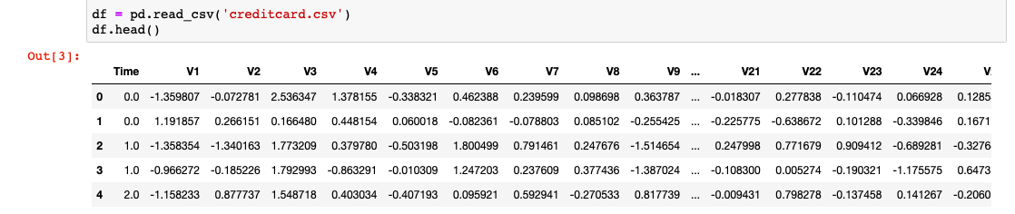

Scaling the two features, Time and Amount with sklearn.preprocessing (as RobustScaler)

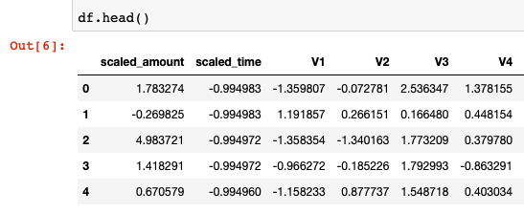

Only 0.172% of all transactions are positive for fraud: not advisable to train using the dataset “as is” (model will be biased to negative for fraud).

For best results, we need to create subsample with a 50/50 ratio of fraud and non-fraud transactions and use for training.

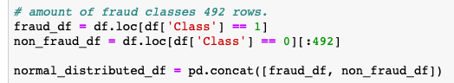
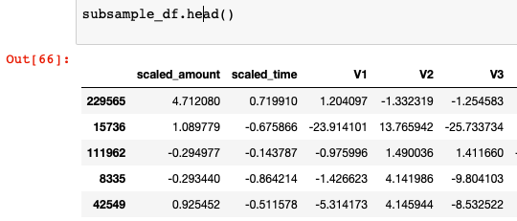
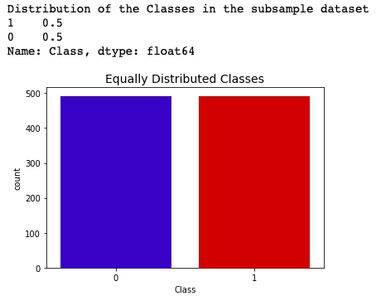

Let’s check the influential features: plot from the total sample and only the subsample (using seaborn):
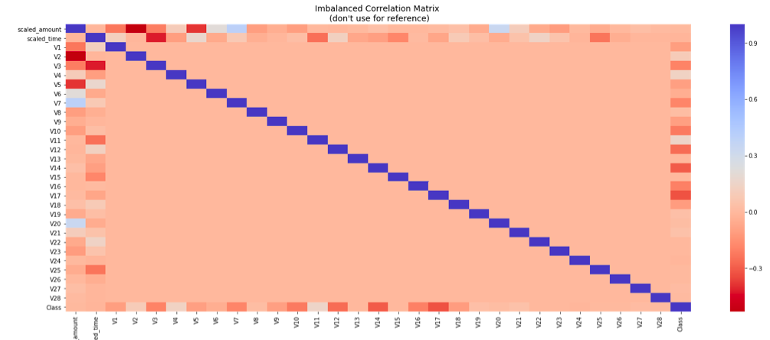

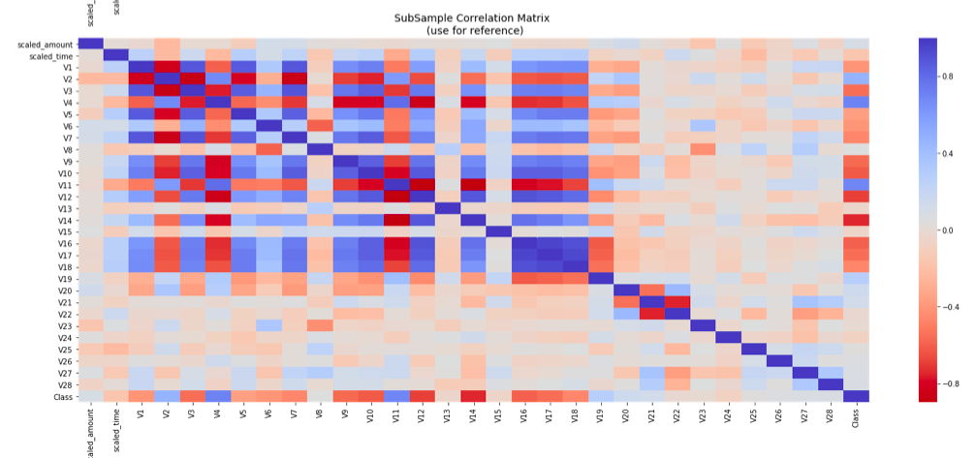

Correlation Matrix: V17, V14, V12 and V10 are negatively correlated. V2, V4, V11, and V19 are positively correlated. I will zoom the row for better understanding:

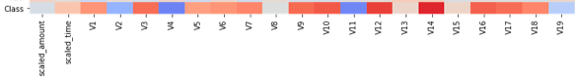

Here is the model:

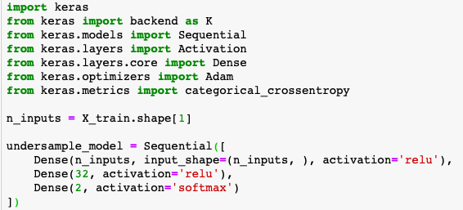

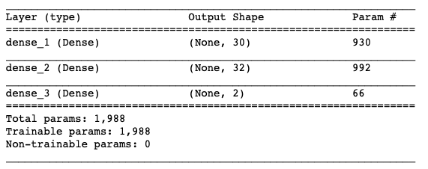

Final accuracy was 0.943

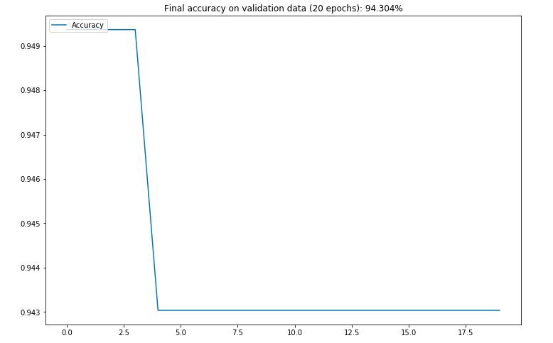

Lesson learned: I wanted to calculate and plot the F1 score but keras dropped its calculation (https://github.com/keras-team/keras/issues/5794). I tried to use a callback method here (https://stackoverflow.com/questions/43547402/how-to-calculate-f1-macro-in-keras) but custom metric did not work for sequential models.

Key metric is confusion matrix:

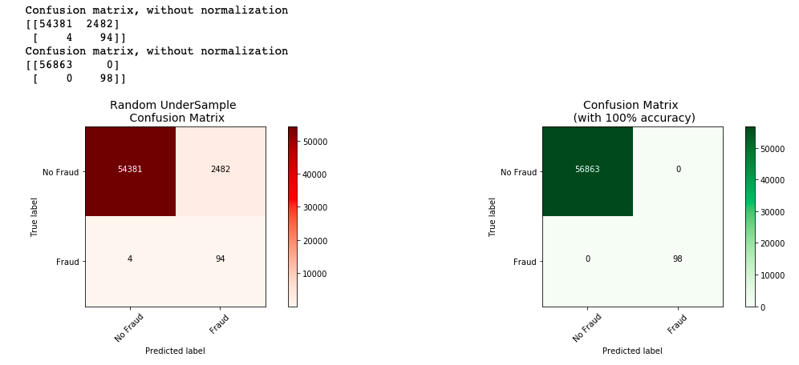

There were 2482 false positives (4.5%) and 4 false negative (4%). The false positive is an important metric as a credit card customer: you do not want your legitimate transactions being bumped.

Google AutoML

Create your GCP account here:
https://cloud.google.com

And create a project (in the case below is “My ML Project 69736”)

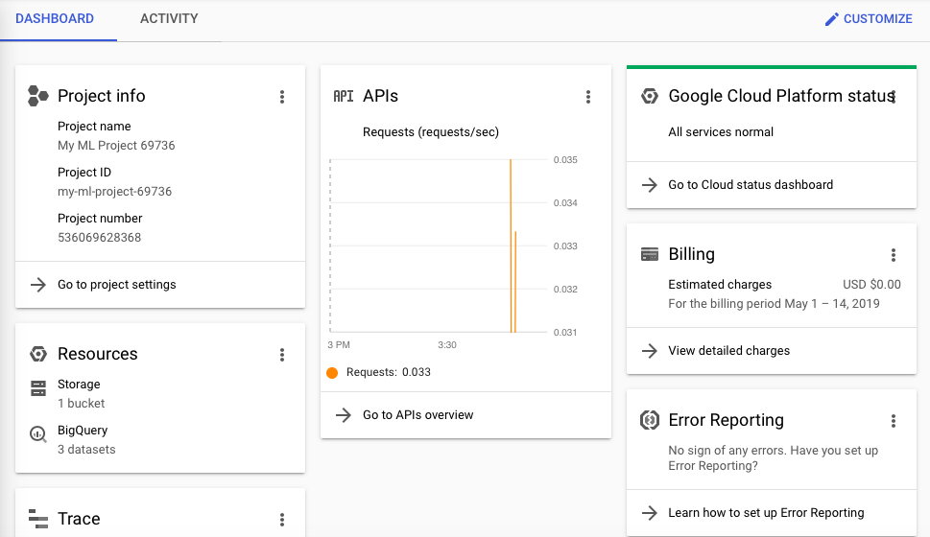
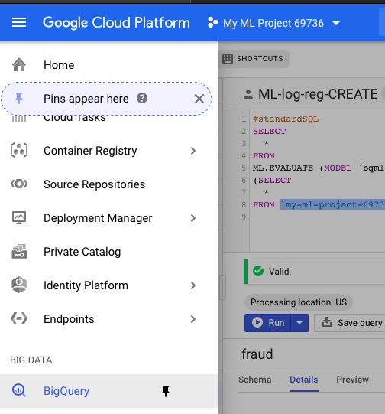

Make sure your billing has the $300 credit:

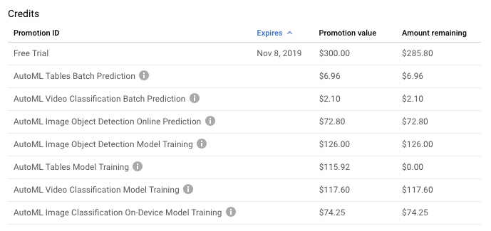

Google AutoML is a cloud service requiring the user to create an account on Google Cloud Platform (GCP). GCP gives $300 credit for the first year. AutoML gives an additional 6 hours of compute (around $120).

https://cloud.google.com/automl/



Loaded the creditcard.csv on BigQuery. In this case added on my google drive:

BigQuery

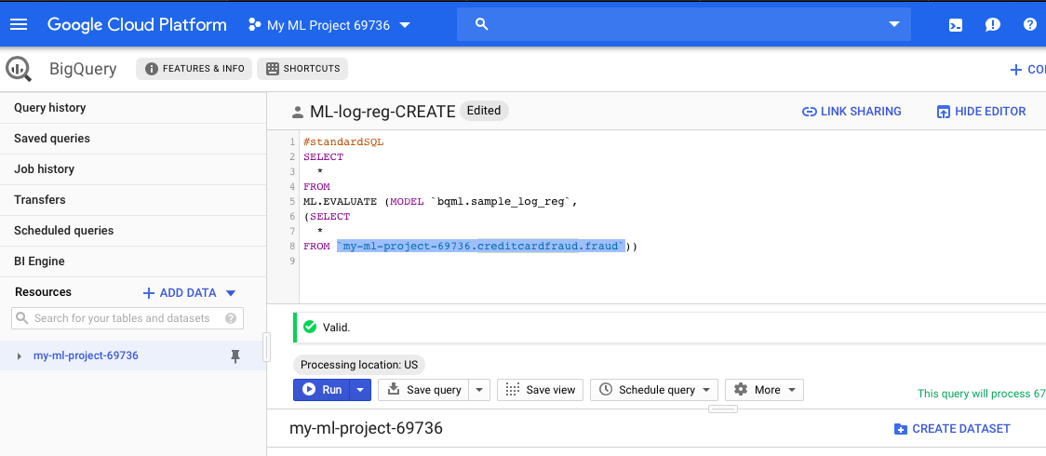

Once the dataset is created, create a table from the CSV. Lesson learned: there is one entry with an invalid time format. Click at “ignore unknown values”.

The data will show on BigQuery:

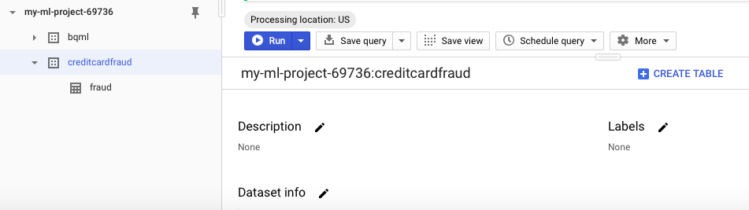

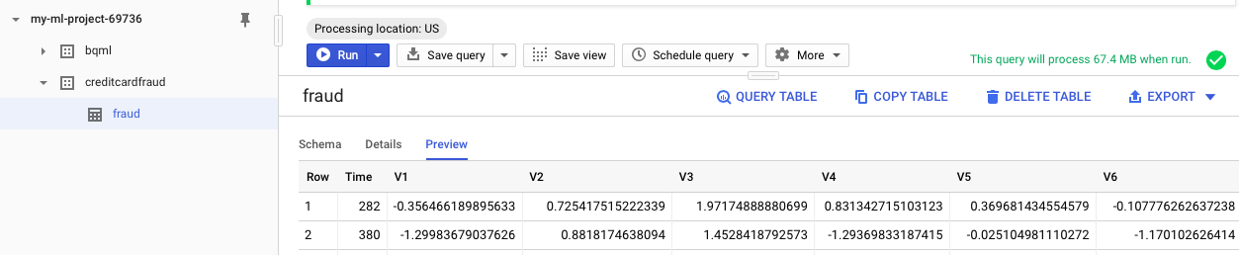

Now, go to AutoML Tables

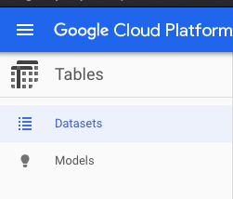

Create a new dataset

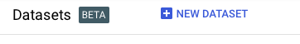

Import the data from bigquery

Click at “Schema”

And set the “target column” to Class

Follow the Flow of AutoML: Analyze.
It took 30 minutes and generated correlation features. The differences from our home-grown solution were considered: V7, V3 and V5 showed as per Google. V2, V4, v11 did not show.

Click at Train. Set the limit of 6 hours for training.

It took 5 hours to be completed and an email was sent.
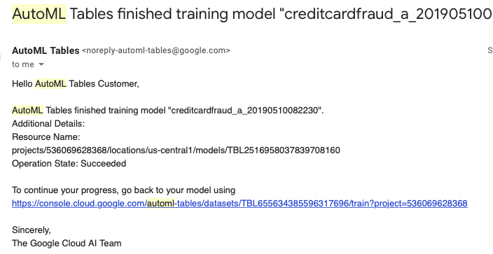

Click at Evaluate

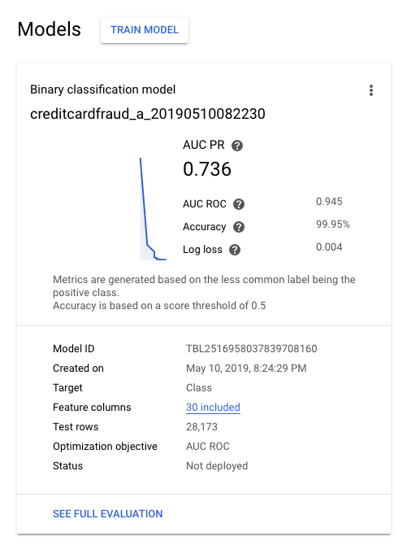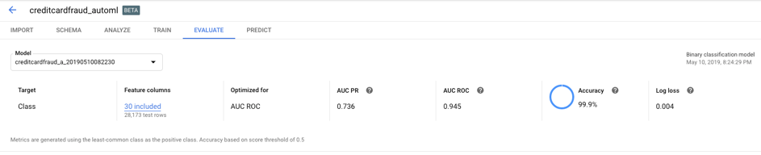

Look at the key metric: confusion matrix

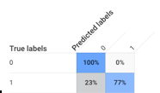

Bonus: deployed the model as a RESTful API

It required to create a service account and with respective key.

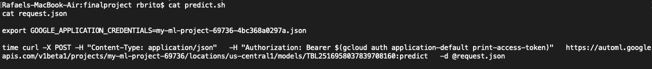

Return:
