Practicum Case | 
COMP7116 | COMP7116001 | COMP7116016 | MATH6168 | MATH6168016
Computer Vision
Computer Science | O221-COMP7116-NC01-06
Valid on Odd Semester 2024/2025 | Revision 00

Learning Outcome
- LO1 – Describe various computational principles and standard image processing operators in computer vision

Topic
- Session 6 – Image Matching

Sub Topics
- Feature Descriptor
- Feature Matching

Soal
Case
GeNCi Sushi
GeNCi Sushi is a restaurant that specializes in selling many types of sushis such as nigiri, sashimi, maki, and many more. The owner of the restaurant wants to make a program that can automatically detect different types of sushi. As a programmer and a close friend of the owner, you want to help him make the program that can automatically detect many types of sushi using Python, you are allowed to use either SIFT, AKAZE, or ORB for the algorithm.
- Feature Matching
- Make a program that can perform feature matching to find corresponding points or features between the object image and the images in the dataset.
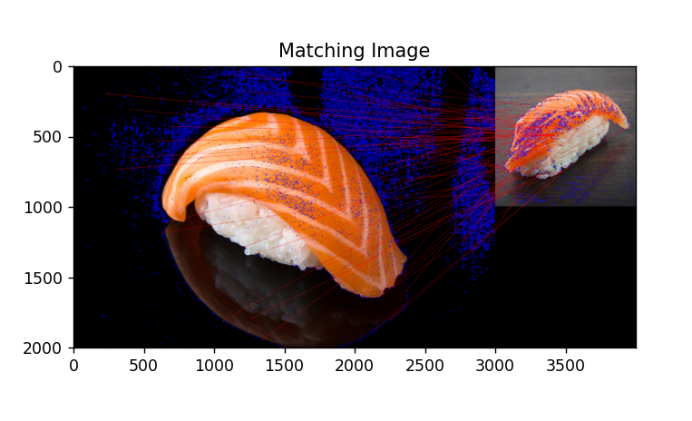
Figure 1. Example of Feature Matching

