Practicum Case | 
COMP7116 | COMP7116001 | COMP7116016 | MATH6168 | MATH6168016
Computer Vision
Computer Science | O221-COMP7116-NC01-10
Valid on Odd Semester 2024/2025 | Revision 00

Learning Outcome
- LO1 – Describe various computational principles and standard image processing operators in computer vision

Topic
- Session 10 – Object Detection

Sub Topics
- Face Detection
- Face Recognition

Soal
Case
Fixing Good
Fixing Good is a popular TV show consisting of multiple famous actors that is currently often discussed. The studio of the show wants to make sure the actors and staffs that is working on the show does not slack off and is working properly. To achieve that, they are asking you as a programmer to make a face recognition program that can automatically detect the faces of their actors and staffs, which is done to make sure that they are present for the day, you can use Python to make the program.
- Face Detection
- Make a program that can perform face detection which identifies and extracts the faces from the images dataset. This can be achieved by initializing a cascade classifier using the Haar cascade for face detection. This step focuses on collecting face images and their corresponding labels for training the face recognition model.

- Face Recognition
- After face detection make sure the program can perform face recognition, you can achieve this by using an LBPH (Local Binary Patterns Histograms) face recognizer. This part of the code should be able to recognize faces using a trained model and annotates the images with the recognized person’s name and confidence level.
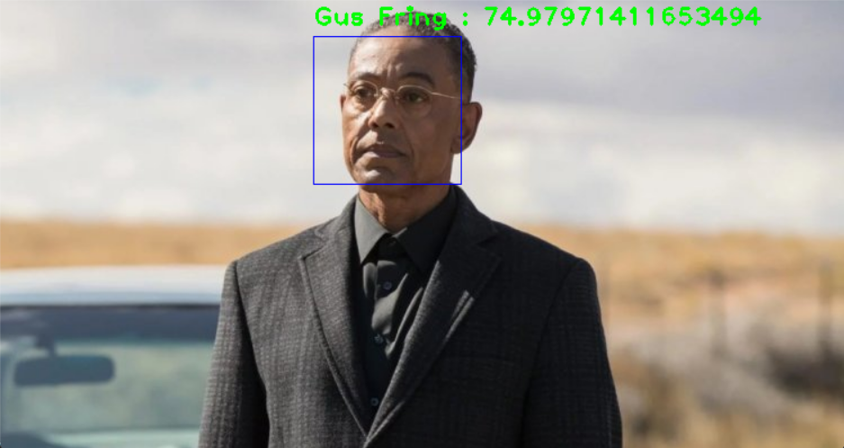
Figure 1. Example of Face Recognition Testing Result
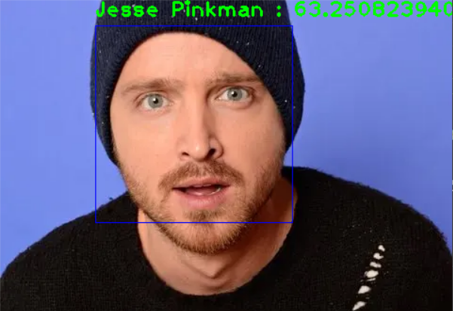
Figure 2. Example of Face Recognition Testing Result
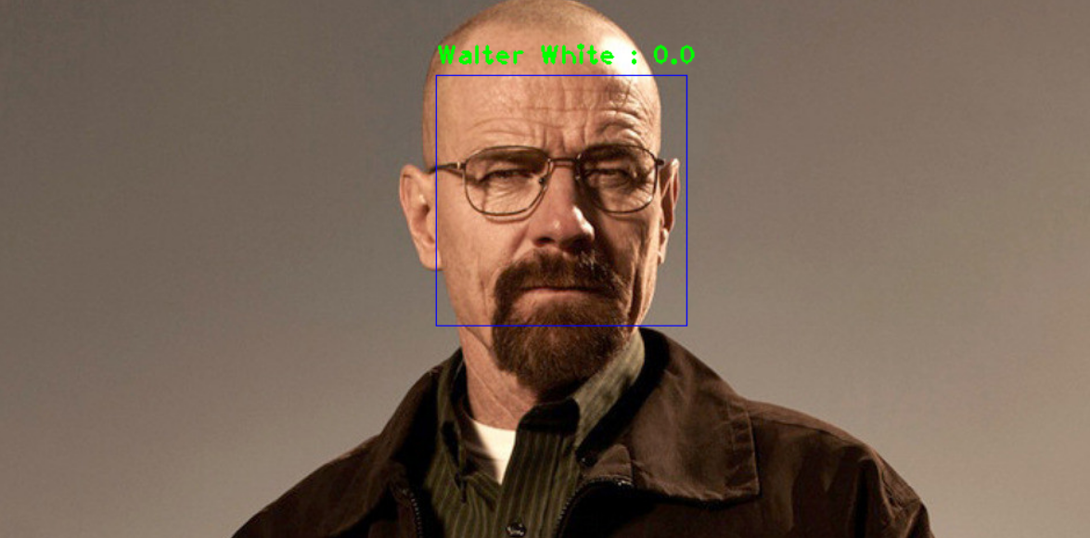
Figure 3. Example of Face Recognition Testing Result

