Microsoft WAW02

Section 26 05 73

Fault Current, Arc Flash and Over Current Protective Device Coordination Study

**Fault Current, Arc Flash and Over Current Protective Device Coordination Study Specification**

Project Number 20_D065

Document Number WAW02-E-SP-010

IFC Issue

Oct 2020

|  |  |  |  |  |  |  |
| --- | --- | --- | --- | --- | --- | --- |
|  | | | | | | |
|  | | | | | | |
| Fault Current, Arc Flash and Over Current Protective Device Coordination Study | | | | | | |
|  | | | | | | |
| Project Number 20_D065 | | | | | | |
| Document Number WAW02-E-SP-010 | | | | | | |
|  | | | | | | |
|  | | | | | | |
|  | | | | | | |
|  | | | | | | |
|  | | | | | | |
|  | | | | | | |
|  | | | | | | |
|  | | | | | | |
| **CURRENT ISSUE** | | | | | | |
| Issue No: | | 03 | | Issue Date: | | 02/10/2020 |
| Sign Off | | Originator: | | Checker: | | Reason For Issue: |
| Print Name: | | Nico Brits | | John Clarke | | IFC Issue |
|  | | | | | | |
|  | | | | | | |
| **PREVIOUS ISSUES (Type Names)** | | | | | | |
| Issue No: | Date: | | Originator: | | Checker: | Reason For Issue: |
| 01 | 17/08/2020 | | John Clarke | | Gary O’Keefe | 50% Review |
| 02 | 21/09/2020 | | Nico Brits | | John Clarke | 90% Review |
|  |  | |  | |  |  |
|  |  | |  | |  |  |

Table of Contents

1. Part 1 General 4

1.1. Summary 4

1.2. Submittal Documentation Requirements 5

1.3. Submittals 5

1.4. Quality Assurance 6

2. Part 2 Products 6

2.1. Computer Software Developers 6

2.2. Computer Software Program Requirements 6

3. Part 3 Execution 7

3.1. Examination 7

3.2. Power System Data 7

3.3. Naming Convention 8

3.4. Fault Current Study 9

3.5. Coordination Study 11

3.6. Arc Flash Hazard Assessment Study 13

3.7. Software Files 14

# Part 1 General

## Summary

* + 1. This Section includes computer-based, fault-current, overcurrent protective device coordination, and arc flash hazard assessment studies based on construction Drawings and load studies, prior to completion of project construction. Protective devices shall be set based on results of the protective device coordination study.
    2. The fault current study shall be first completed by the 30% design review and submitted to Microsoft for review. The fault current studies shall be updated as design changes are made and the final model and reports shall reflect the final construction drawings.
    3. The coordination, fault current, and arc flash studies shall be completed prior to the electrical testing agent commencing any electrical testing. The testing shall be halted if discrepancies are found between the study and equipment found installed in the field and escalated to the Microsoft Commissioning manager. These studies shall be completed and the breakers and relays programmed prior to any electrical equipment being energized. The studies shall be completed early enough to allow for Microsoft and the A/E to review and approve the studies, including any time required for addressing comments. The coordination, fault current, and arc flash studies shall be updated as design changes are made and the final model and reports shall reflect the final construction drawings. The A/E is accountable for updating the firm doing these studies in timely manner (one week or less) of any design or equipment changes that would impact the accuracy of the study so they can make the necessary updates to the studies.
    4. The Contractor shall coordinate the submission with the Coordination Engineer to provide necessary cable lengths and submittals for Contractor furnished equipment.
    5. The Manufacturer shall coordinate the submission with the coordination engineer to provide necessary cable lengths and submittals for Owner furnished equipment.
    6. Engineer of record will participate in the development and reviews of these studies which will either be done by same firm or contracted to outside firms specializing in these types of studies. The engineer of record as well as the individual(s) performing the study shall also meet with the utility to coordinate and obtain the necessary settings and fault current data required. This may require several meetings, phone calls, and emails.
    7. Drawings, Division 00 Procurement and Contracting Requirements, and Division 01 Specification Sections apply to this Section.
    8. The studies contained within this document shall be completed to show the worst case examples in normal trip mode settings and also the worst case examples in low arc mode settings.
    9. Both Alternating Current (AC) and Direct Current (DC) arc flash studies shall be performed under this specification.
    10. These studies shall start with the incoming utility substation sources to the site and go all the way to the rack mounted power strips. The fault current rating of this rack mounted equipment is 10K AIC and this shall be verified as being fully rated. Upstream ground fault protective settings on the UPS output PDU/Switchboards must be validated as coordinating with the rack branch circuit breakers – typically 30 amp at the 415/240 volt level in the distribution. Other sizes may also be present and will need to be confirmed also.

## Submittal Documentation Requirements

1. Furnish documentation associated with this bid proposal and Contract including submittals, shop drawings, O&M manuals, test procedures, and test reports as follows. These requirements are in addition to submittal requirements stated elsewhere and shall not deprive the Owner of rights under other provisions of the Contract Documents.
   * + 1. Submit documents in portable document format (PDF).
       2. Submit documents in REVIT – Latest version for Drawings and Microsoft Word (latest version) for text format when requested.
2. Provide a Compliance Review of the Specifications, Drawings and Addenda. The Compliance Review is a paragraph-by-paragraph review of the Specifications with the following information; “C”, “D” or “E” marked in the margin of the original Specifications and any subsequent Addenda.
   * + 1. “C”: Comply with no exceptions.
       2. “D”: Comply with deviations. For each and every deviation, provide a numbered footnote with reasons for the proposed deviation and how the intent of the Specification can be satisfied.
       3. “E”: Exception, do not comply. For each and every exception, provide a numbered footnote with reasons and possible alternatives.
3. Unless a deviation or exception is specifically noted in the Compliance Review, it is assumed

that the Bidder is in complete compliance with the plans and Specifications. Deviations or

exceptions taken in cover letters, subsidiary documents, by omission or by contradiction do

not release the Bidder from being in complete compliance, unless the exception or deviation

has been specifically noted in the Compliance Review. Bidders may submit the latest state-of-

the-art components and their standard control components in lieu of the specified items. The

A/E and Owner will review deviations from the Specifications.

## Submittals

1. Product Data: For computer software program to be used for studies.
2. Product Certificates: For coordination-study and fault-current-study computer software programs, certifying compliance with IEEE 399, EN 60909 - Short-circuit currents in three-phase a.c. systems.
3. Qualification Data: For coordination-study specialist.
4. Other Action Submittals: The following submittals shall be made after the approval process for system protective devices has been completed. Submittals shall be in digital form.

1. Coordination-study input data, including completed computer program input data sheets.

2. Study and Equipment fault current Evaluation Reports clearly showing equipment ratings and calculated fault current levels. Report will show pass or fail for each piece of equipment.

3. Coordination-Study Report.

4. Arc flash assessment (both AC and DC) and labels for all buses in the electrical system.

5. Preliminary fault current and coordination study shall be performed prior to purchase of the electrical equipment to ensure equipment is fully rated for the available fault current and ensure that fuses and circuit breaker provided will coordinate properly.

6. Native electronic files of the model and calculations used for the above studies and calculations.

## Quality Assurance

A. Studies shall use computer programs that are distributed nationally and are in wide use. Software algorithms shall comply with requirements of standards and guides specified in this Section. Manual calculations are not acceptable.

B. Coordination-Study Specialist Qualifications: An entity experienced in the application of computer software used for studies, having performed successful studies of similar magnitude on electrical distribution systems using similar devices.

1. Professional engineer, licensed in the state where Project is located, shall be responsible for the study. All elements of the study shall be performed under the direct supervision and control of engineer of record.

C. Comply with IEEE 242, EN 60909 for short-circuit currents and coordination time intervals.

D. Comply with IEEE 399 for general study procedures.

# Part 2 Products

## Computer Software Developers

A. Computer Software Developers: Subject to compliance with requirements, provide products by one of the following:

1. In order of preference ETAP, SKM

2. Microsoft Data Centre Engineer equal or approved

## Computer Software Program Requirements

* + 1. Comply with IEEE 399, EN 60909
    2. Comply with IS EN 62271 - High-voltage switchgear and controlgear , IEEE 1584 and IS EN 50110 - Operation of electrical installations for arc flash analysis as appropriate.
    3. Analytical features of fault-current-study computer software program shall include "mandatory," "very desirable," and "desirable" features as listed in IEEE 399 and EN 60909.
    4. Computer software program shall be capable of plotting and diagramming time-current- characteristic curves as part of its output. Computer software program shall report device settings and ratings of overcurrent protective devices and shall demonstrate selective coordination by computer-generated, time-current coordination plots.
       1. Optional Features:
          1. Arcing faults.
          2. Simultaneous faults.
          3. Explicit negative sequence.
          4. Mutual coupling in zero sequence.

# Part 3 Execution

## Examination

* + 1. Examine Project overcurrent protective device submittals for compliance with electrical distribution system coordination requirements and other conditions affecting performance. Devices to be coordinated are indicated on Drawings.
       1. Proceed with coordination study only after relevant equipment submittals have been assembled. Overcurrent protective devices that have not been submitted and approved prior to coordination study may not be used in study.

## Power System Data

* + 1. Electrical Contractor shall provide all contractor furnished equipment submittals and low and medium voltage feeder lengths
    2. Gather and tabulate the following input data to support coordination study:
       1. Product Data for overcurrent protective devices specified in other Division 26 Sections and involved in overcurrent protective device coordination studies. Use equipment designation tags that are consistent with electrical distribution system diagrams, overcurrent protective device submittals, input and output data, and recommended device settings.
       2. Impedance of utility service entrance.
       3. Electrical Distribution System Diagram: In hard-copy and electronic-copy formats, showing the following:
          1. Circuit-breaker and fuse-current ratings and types.
          2. Relays and associated power and current transformer ratings and ratios.
          3. Transformer kilovolt amperes, primary and secondary voltages, connection type, impedance, and X/R ratios.
          4. Generator kilovolt amperes, size, voltage, and source impedance.
          5. Cables: Indicate conduit material, sizes of conductors, conductor material, insulation, and length. Use AS BUILT lengths for final calculations and evaluations.
          6. Cable Bus / Busway ampacity and impedance.
          7. Motor horsepower and code letter designation according to EN ISO 8528

- Reciprocating internal combustion engine driven alternating current generating sets and EN 60034 - Rotating electrical machines.

* + - 1. Data sheets to supplement electrical distribution system diagram, cross-referenced with tag numbers on diagram, showing the following:
         1. Special load considerations, including starting inrush currents and frequent starting and stopping.
         2. Transformer characteristics, including primary protective device, magnetic inrush current, and overload capability.
         3. Motor full-load current, locked rotor current, service factor, starting time, type of start, and thermal-damage curve.
         4. Generator thermal-damage curve.
         5. Ratings, types, and settings of utility company's overcurrent protective devices.
         6. Special overcurrent protective device settings or types stipulated by utility company.
         7. Time-current-characteristic curves of devices indicated to be coordinated.
         8. Manufacturer, frame size, interrupting rating in amperes rms symmetrical, ampere or current sensor rating, long-time adjustment range, short-time adjustment range, and instantaneous adjustment range for circuit breakers.
         9. Manufacturer and type, ampere-tap adjustment range, time-delay adjustment range, instantaneous attachment adjustment range, and current transformer ratio for overcurrent relays.
         10. Panelboards, switchboards, motor-control center ampacity, and interrupting rating in amperes rms symmetrical.

## Naming Convention

* + 1. The below naming convention shall be followed in the software model:
       1. When there is more than one switch on a bus, they shall be identified as S1, S2, etc.

|  |  |
| --- | --- |
| **SOFTWARE ID** | **DEVICE** |
| **A** | ATS |
| **B** | BUS |
| **C** | CABLE |
| **F** | FUSE |
| **G** | GENERATOR |
| **L** | LOAD |
| **M** | MOTOR |
| **R** | RELAY |
| **S** | SUBSTATION SWITCH |
| **T** | STATIC TRANSFER SWITCH |
| **V** | VFD |
| **U** | UPS |
| **W** | BUSWAY |
| **X** | TRANSFORMER |
| **P** | PANEL - RESERVE ONLY |

|  |  |
| --- | --- |
| SOFTWARE ID | DEVICE |
| MCB01 | MAIN BREAKER 1 |
| MCB02 | MAIN BREAKER 2 |
| FCB01 | FEEDER BREAKER 1 |
| FCB02 | FEEDER BREAKER 2 |
| LB | LOADBANK |
| MCB01 | GENERATOR BREAKER 1 |
| MCB02 | GENERATOR BREAKER 2 |

|  |  |
| --- | --- |
| **SOFTWARE ID** | **DEVICE** |
| FCB01 | 1st BREAKER READING LEFT TO RIGHT |
| FCB02 | 2nd BREAKER READING LEFT TO RIGHT |

## Fault Current Study

* + 1. Calculate the maximum available short-circuit current in amperes rms symmetrical at circuit- breaker positions of the electrical power distribution system. The calculation shall be for a current immediately after initiation and for a three-phase bolted short circuit at each of the following:
       1. Switchgear and switchboard bus.
       2. Medium-voltage controller.
       3. Motor-control center.
       4. Distribution panelboards.
       5. UPS systems
       6. Automatic transfer switches
       7. Static Switches,
       8. Transformers
       9. Branch circuit panelboards.
       10. Enclosed controllers, disconnect switches.
       11. PDUs (Power Distribution Units)
       12. Remote Power Panelboards (RPPs).
       13. The rack mounted power strip 10 KAIC rated device.
    2. Study electrical distribution system from normal and alternate power sources throughout electrical distribution system for Project. Include studies of system-switching configurations and alternate operations that could result in maximum fault conditions. Provide fault current reports that include these modes of operation that apply to the design.
       1. On Utility power, source 1 and source 2
       2. On Generator power with single or paralleled generators supporting load.
    3. Calculate momentary and interrupting duties on the basis of maximum available fault current available from the utility.
    4. Calculations to verify interrupting ratings of overcurrent protective devices shall comply with IS EN 60909, IEEE 141, IEEE 242.
       1. Transformers:
          1. EU Directive 2009/125/EC - framework for the setting of eco design requirements for energy-using products.

b. IEE C57.12.00

1. IS EN 50588 - Medium voltage transformers 50 Hz, with highest voltage for equipment not exceeding 36 kV.
2. IS EN 50629 - Energy performance of large power transformers.
3. IEEE C57.96
4. IEC EN 60076 and IEE C57.96 - Power transformers.
5. IEC / TR 60616 - Terminal and tapping markings for power transformers.
   * + 1. Medium-Voltage Circuit Breakers:
          1. IEEE C37.010
          2. IS EN 62271 - High-voltage switchgear and controlgear.
          3. IS EN 61869 - Instrument transformers.
          4. IS EN 62271-103 - High-voltage switchgear and controlgear - Part 103: Switches for rated voltages above 1 kV up to and including 52 kV.
          5. IS EN 60529 - Degrees of protection provided by enclosures (IP Code).
       2. Low-Voltage Circuit Breakers:
          1. IEEE 1015
          2. IEEE C37.20.1
          3. IS EN 62271 - High-voltage switchgear and controlgear,
          4. IS EN 60529 - Degrees of protection provided by enclosures (IP Code).
          5. IS EN 60947 - Low-voltage switchgear and controlgear.
          6. EN 61869 - Instrument transformers.
          7. LV Switchgear shall comply with European Low Voltage Directive: (LVD) 2014/35/EU.
       3. Low-Voltage Fuses:
          1. IEEE C37.46
          2. IS EN 60269 - Low-voltage fuses.
     1. Study Report:
        1. Show calculated X/R ratios and equipment interrupting rating (1/2-cycle) fault currents on electrical distribution system diagram.
        2. Show interrupting (5-cycle) and time-delayed currents (6 cycles and above) on medium-voltage breakers as needed to set relays and assess the sensitivity of overcurrent relays.
     2. Equipment Evaluation Report:
        1. For 415-V overcurrent protective devices, ensure that interrupting ratings are equal to or higher than calculated 1/2-cycle symmetrical fault current.
        2. For devices and equipment rated for asymmetrical fault current, apply multiplication factors listed in the standards to 1/2-cycle symmetrical fault current.
        3. Verify adequacy of phase conductors at maximum three-phase bolted fault currents; verify adequacy of equipment grounding conductors and grounding electrode conductors at maximum ground-fault currents. Ensure that short-circuit withstand ratings are equal to or higher than calculated 1/2-cycle symmetrical fault current.
        4. Equipment Evaluation Report - To include the device and equipment fault current rating, the calculated fault current level at that equipment, and clearly indicate Pass/Fail for each.
     3. When reviewing and providing comments on equipment submittals, verify that equipment being proposed meets the required fault current ratings shown by the fault current study.

## Coordination Study

* + 1. Perform coordination study using approved computer software program. Prepare a written report using results of fault-current study. Comply with IEEE 399
       1. Calculate the maximum and minimum 1/2-cycle short-circuit currents.
       2. Calculate the maximum and minimum interrupting duty (5 cycles to 2 seconds) short- circuit currents.
       3. Calculate the maximum and minimum ground-fault currents.
    2. Comply with IEEE 141 and IS EN 60909 recommendations for fault currents and time intervals.
    3. Transformer Primary Overcurrent Protective Devices:
       1. Device shall not operate in response to the following:
          1. Inrush current when first energized.
          2. Utility generated transient events including single phase disturbances and momentary outages and sags and swells.
          3. Self-cooled, full-load current or forced-air-cooled, full-load current, whichever is specified for that transformer.
          4. Permissible transformer overloads according to IEEE C57.96, IEC EN 60076 and IEC 60905 if required by unusual loading or emergency conditions.
       2. Device settings shall protect transformers according to IEEE C57.12.00 and IEC EN 60076, for fault currents.
    4. Motors served by voltages more than 415-V shall be protected according to IEEE 620 and IS- EN 60034.
    5. Conductor Protection: Protect cables against damage from fault currents according to IS EN 60228 - Conductors of insulated cables, and IEC 60502 - Power cables with extruded insulation and their accessories for rated voltages from 1 kV, and conductor melting curves in IEEE 242. Demonstrate that equipment withstands the maximum short-circuit current for a time equivalent to the tripping time of the primary relay protection or total clearing time of the fuse. To determine temperatures that damage insulation, use curves from cable manufacturers or from listed standards indicating conductor size and short-circuit current.
    6. Coordination-Study Report: Prepare a written report indicating the following results of coordination study:
       1. Provide a tabular Format of Settings Selected for Overcurrent Protective Devices:
          1. Device identification tag.
          2. Relay-current transformer ratios; and tap, time-dial, and instantaneous-pickup values.
          3. Circuit-breaker sensor rating; and long-time, short-time, and instantaneous settings.
          4. Fuse-current rating and type.
          5. Ground-fault relay-pickup and time-delay settings.
          6. Dual LV breaker settings for reduced arc flash hazard levels during energized maintenance activities on all breakers sized 1200A and above.
          7. All medium voltage relay and low voltage trip unit settings shall be provided in tabular format. This shall include protective under and over voltage, under and over frequency, reverse power, phase imbalance, phase rotation, time delays, etc. Medium Voltage Overvoltage shall be an alarm and trip function. For sites with paralleling generators other trip functions may apply here.
          8. The utility protective relay settings and curves shall be included in the site power coordination study to show proper coordination with these upstream utility devices.
       2. Coordination Curves: Prepared to determine settings of overcurrent protective devices to achieve selective coordination. Graphically illustrate that adequate time separation exists between devices installed in series, including power utility company's upstream devices. Coordination curves should also include an electrical single line of that portion of the distribution off to the right side of the page so it is clear which breakers are being represented. Prepare separate sets of curves for the switching schemes and for emergency periods where the power source is local generation. Show the following information:
          1. Device identification tag
          2. Voltage and current ratio for curves
          3. Three-phase and single-phase damage points for each transformer
          4. No damage, melting, and clearing curves for fuses
          5. Cable damage curves
          6. Transformer inrush points. When multiple transformers are present on a bus the combined inrush shall be identified and plotted to show breaker or fuse coordinates correctly
          7. Maximum fault-current cutoff point
          8. Single line of electrical distribution for part of the design covered by the TCC’s on this sheet

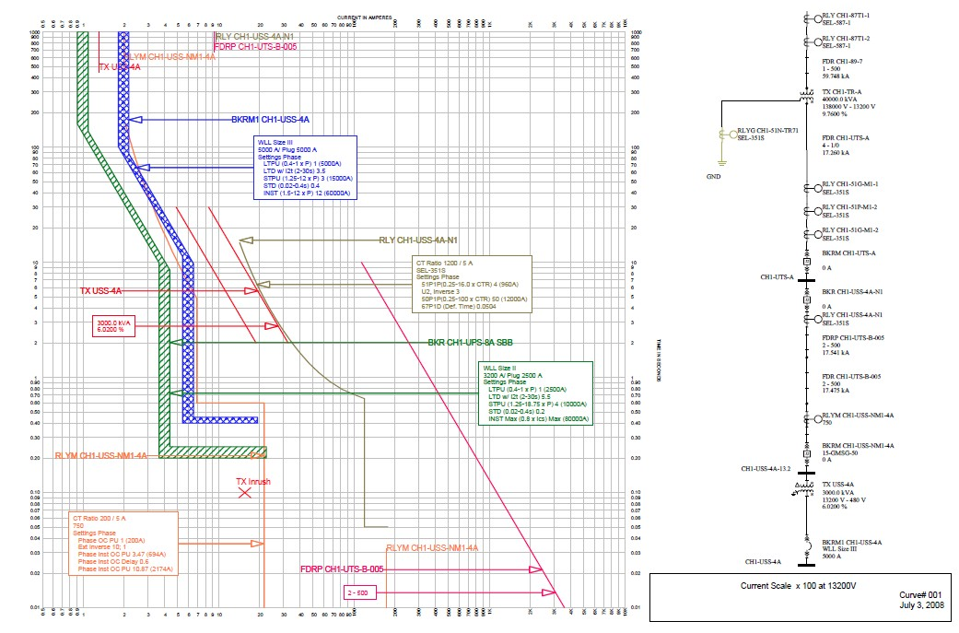

1. Recommendations: Identify areas of concern where coordination between protective devices cannot be achieved. Provide recommendations for modifications necessary to achieve or improve coordination.
2. Completed data sheets for setting of low and medium voltage overcurrent protective devices (trip units, fuses, and protective relays).
3. When reviewing and providing comments on equipment submittals, verify the overcurrent devices being proposed meet the requirements shown by the overcurrent device coordination study. For example, if medium voltage fuses are being proposed, verify they properly coordinate with upstream and downstream devices.
4. Reserved.

## Arc Flash Hazard Assessment Study

* + 1. Perform arc flash calculations to determine the arc flash boundary, incident energy, and personal protective equipment (PPE) category at each medium and low voltage switchgear, switchboard, and panel board located throughout the facility.
       1. AC and DC arc flash assessment shall be carried out.
       2. Base calculations on protective device settings recommended in the above-noted coordination study.
       3. Include dual settings for improved safety on protective relays, if those relays or trip units have dual setting capabilities. This would typically apply to main breakers.
       4. Perform calculations in accordance with IS EN 60909, IEC 61482-2 - Live working - Protective clothing against the thermal hazards of an electric arc - Requirements, IEEE 1584 and EN 50110.
    2. Tabulate results.
    3. Recommendations: Identify areas of concern and provide recommendations to reduce incident energy where PPEs are calculated to be Category 4 or higher.
    4. Provide detailed requirements for labels complying with IEC 61482-2 and as detailed below that are to be placed on the electrical components that define the hazard and safety gear required to work on the systems while energized, including the flash protection boundary, flash hazard category, and the minimum arc rating. Two labels will be provided showing the operating mode (utility or generator) with highest hazard level in normal operation and the highest hazard level while in low arc setting mode. Coordinate details of the label colours and sizes with A/E and Owner.

## Software Files

* + 1. At completion of the study and as part of the turn over the entire set software files used in the short circuit, coordination, and arc flash study will be turned over to Microsoft so they can be used as base for future projects or changes. See example on next page.

Arc Flash Label Example

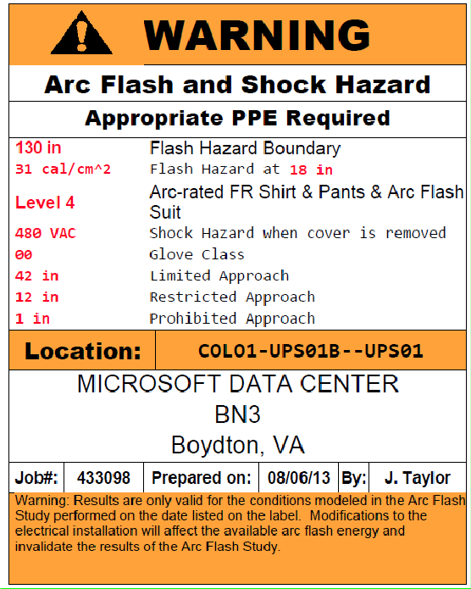

END OF SECTION