23Nov2015

Open the instructions below to create unit testing

<https://developer.apple.com/library/ios/documentation/DeveloperTools/Conceptual/testing_with_xcode/chapters/01-introduction.html#//apple_ref/doc/uid/TP40014132>

Below are screen shots of the sequences Britney follow. Zila was only a witness taking screen shots and directing the test per the instructions in the html file above.

We are not able to continue the test because the program cra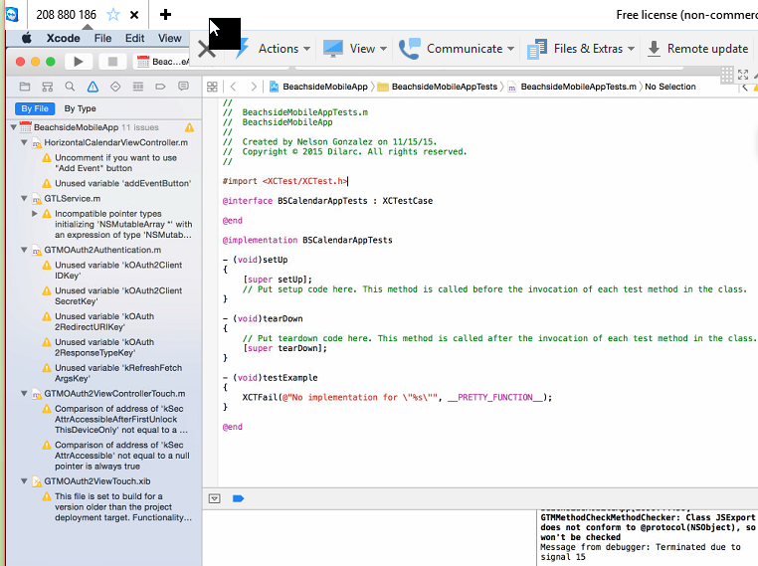shed as the screen shots indicates below

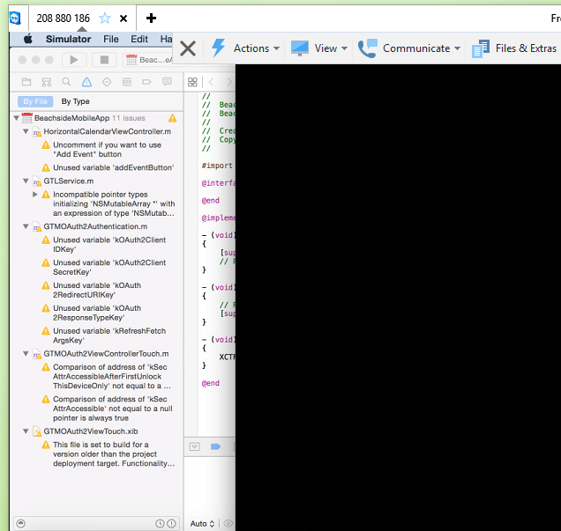

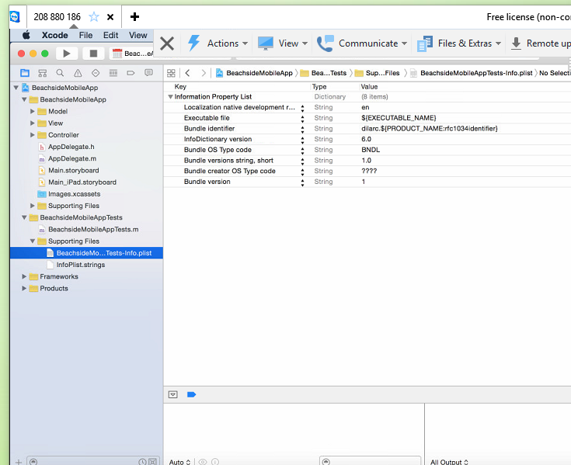

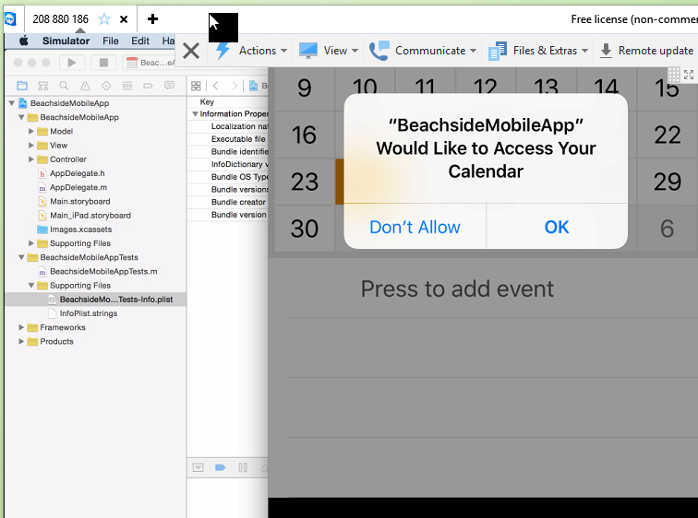

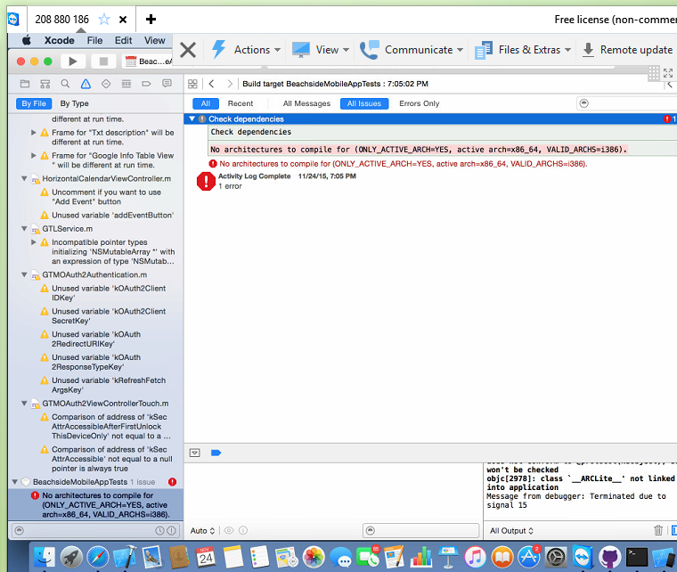

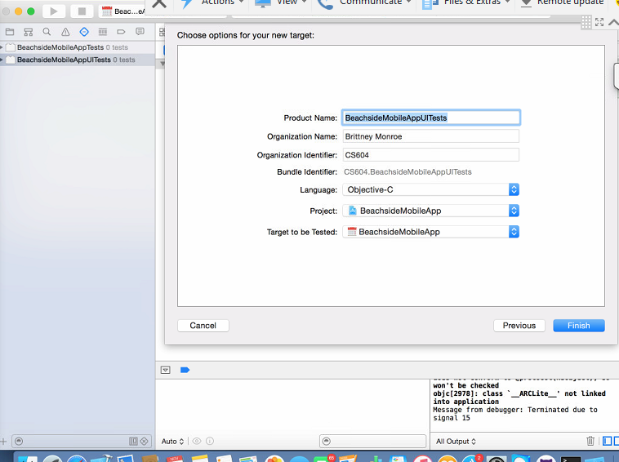

Test Stopped at 7:10