Sunday, Nov 22 at 4:30

After about 7 hours attempting to run the application, Yash went into my machine on Nov 22 at 2:00 p.m. (thru Team Viewer) and played for about one hour. She concluded I didn’t have the latest version of the program. We download the version that was four days old from github.com and I was able to run the application; however the resolution was too large and I couldn’t see the entire screen.

I re-load the application using “full screen” resolution and that still didn’t solve the problem.

Changed IO device from 5 s to 6 and the following error showed up

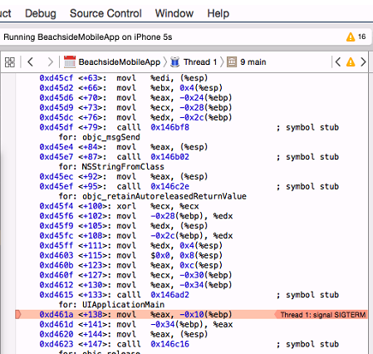

After reload, I opened calendar, but can’t make the font smaller or the entire app screen available. I tried to scrow the screen down, and it goes right back up.

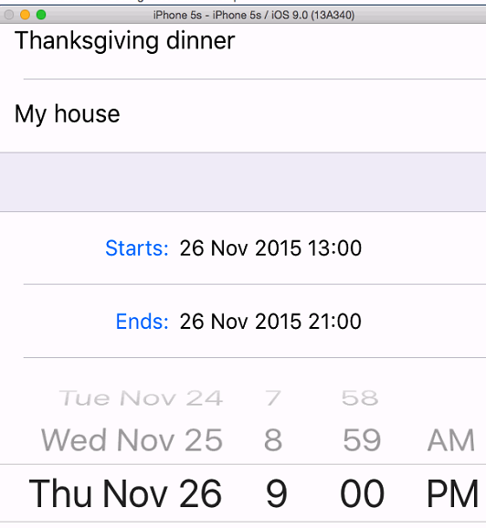

Rotated screen and I was able to see the top.

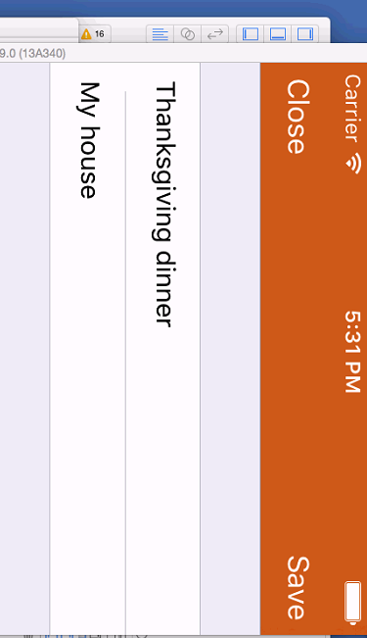

Need to fix misspelling in error message.

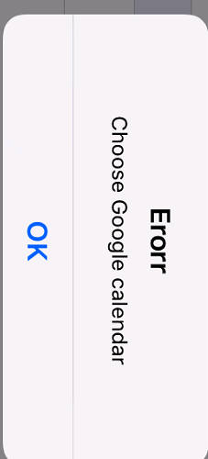

Attempt to create a new Calendar and got an error. Notice the error message here doesn’t have the misspelling.

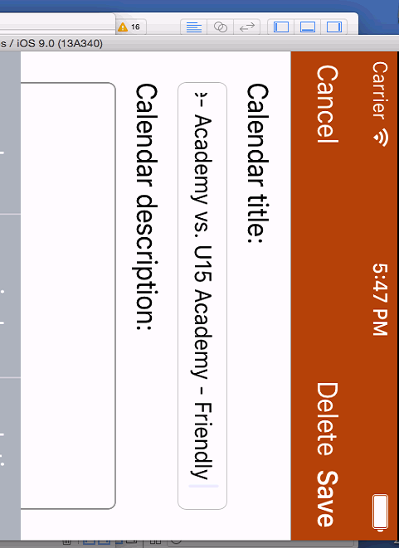

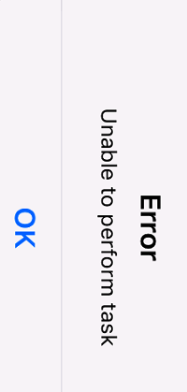

Went to Setting/ Configure/ Edit/Calendar

Tried to create a new calendar using Google

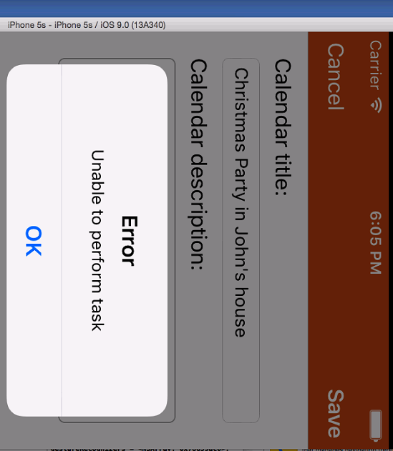

Went to Settings/Configure Account

I was not able to see the bottom of the screen again. So I used Command Up-arrow

Tried to set up Google email and program “froze” in the Continue button, in the “Verify it’s you” window

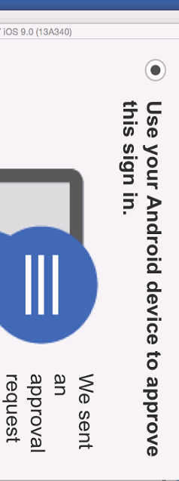

Tried to enter a new Apple Event I was able to, but can’t find a way to get out of this screen

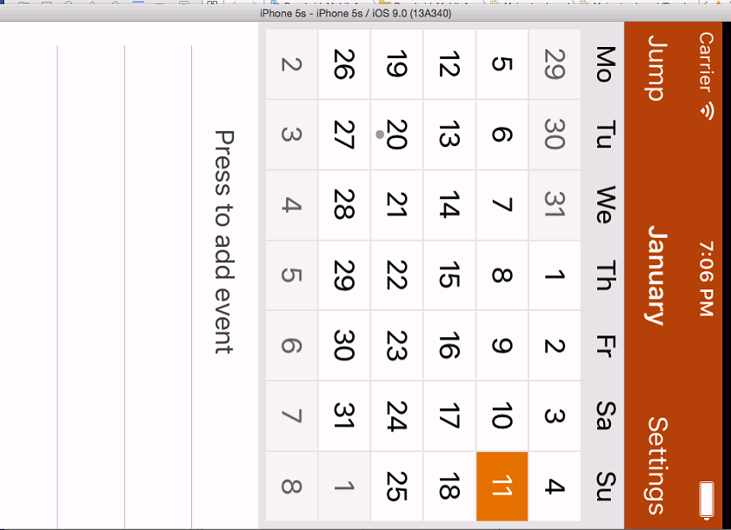

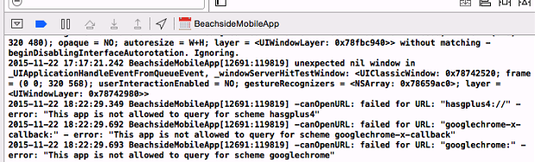

Ending test at Sunday, 7:15 p.m.