Brittany Smith
Module 4.3 Assignment
9/10/2026
Movies! ERD
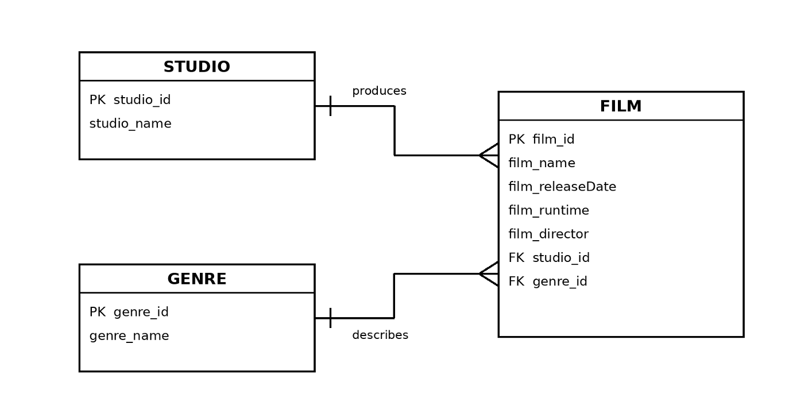
Crow's-foot relationships: one studio can produce many films, and one genre can describe many films. Each film references one studio and one genre through foreign keys.

