Brittany Smith
Module 4.2 Assignment
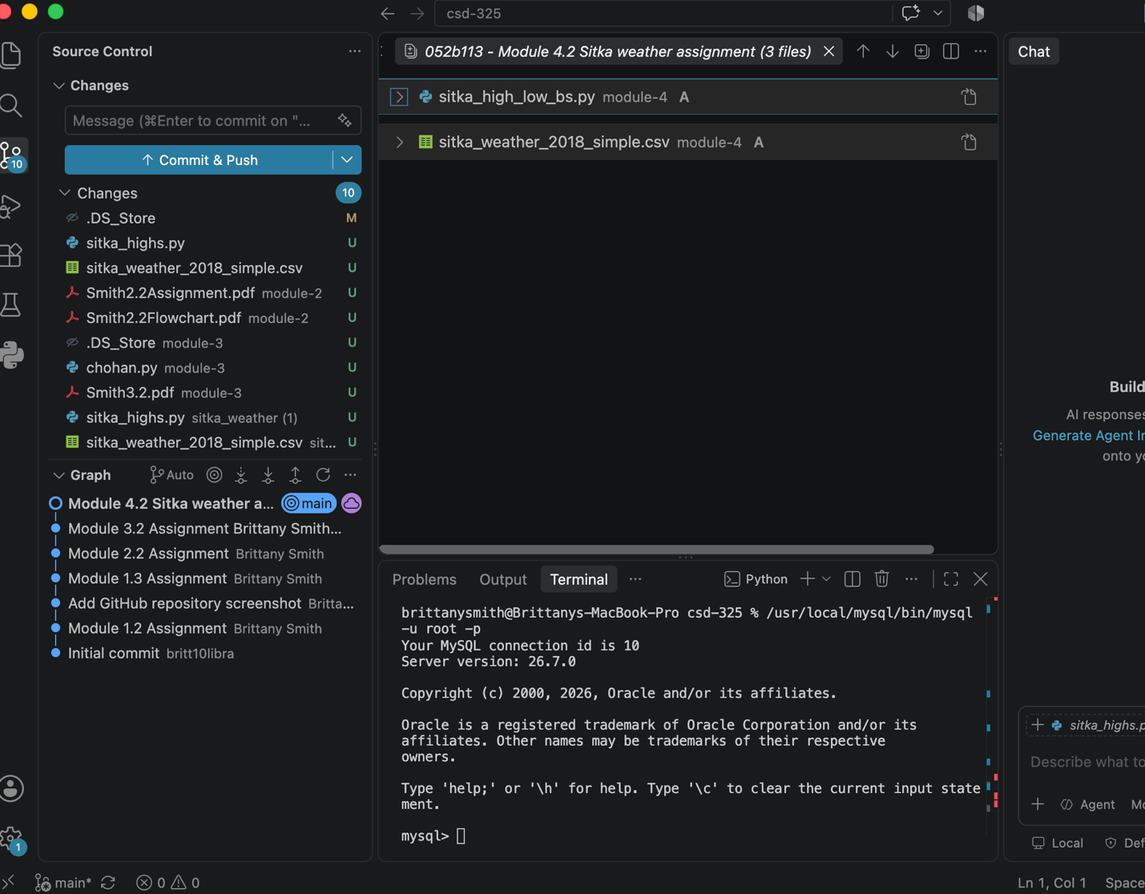
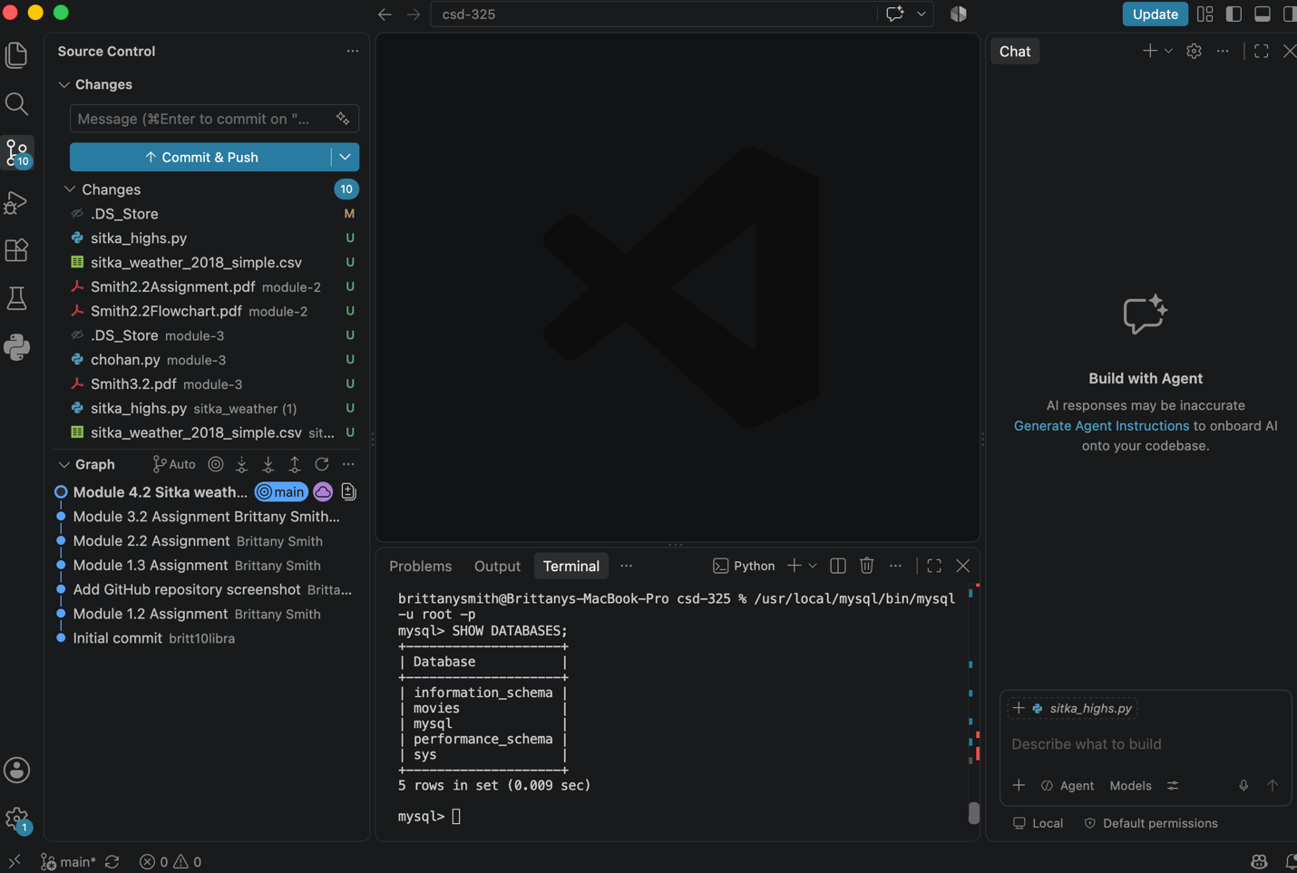

UPPER(): Function used text needs to be displayed consistently in uppercase (names, titles)
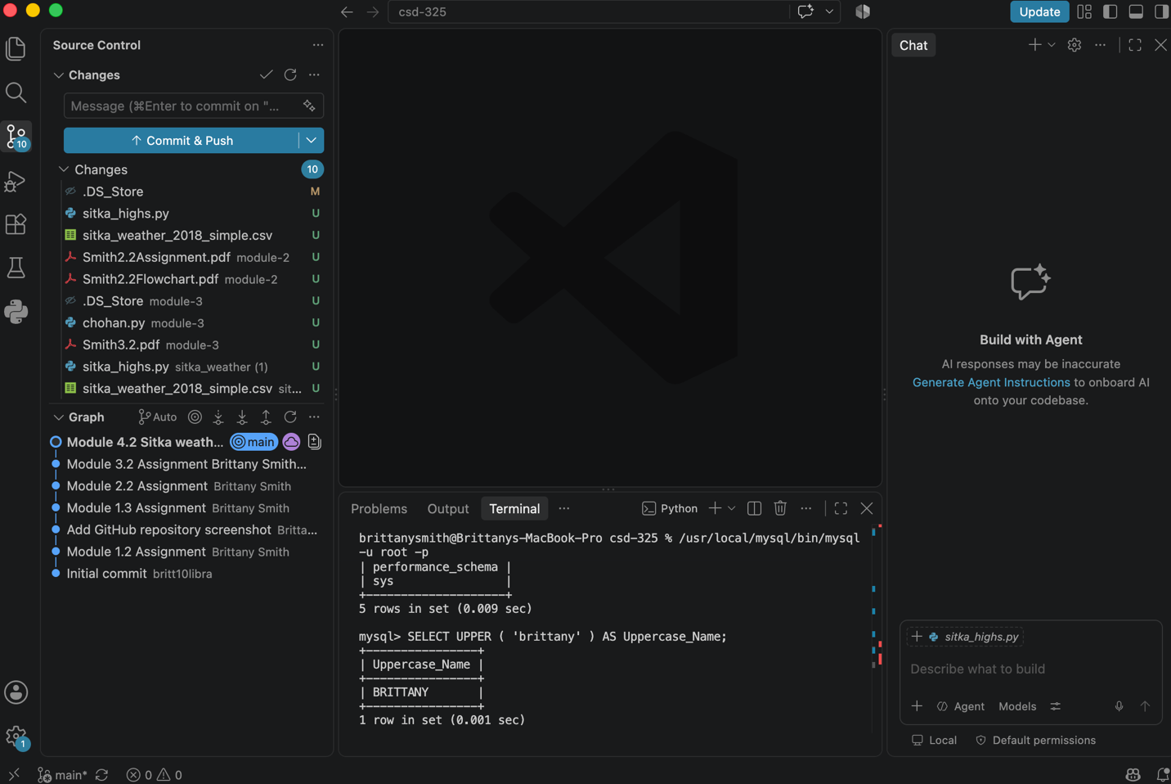

LENGTH(): function used to determine how many characters are in a text value
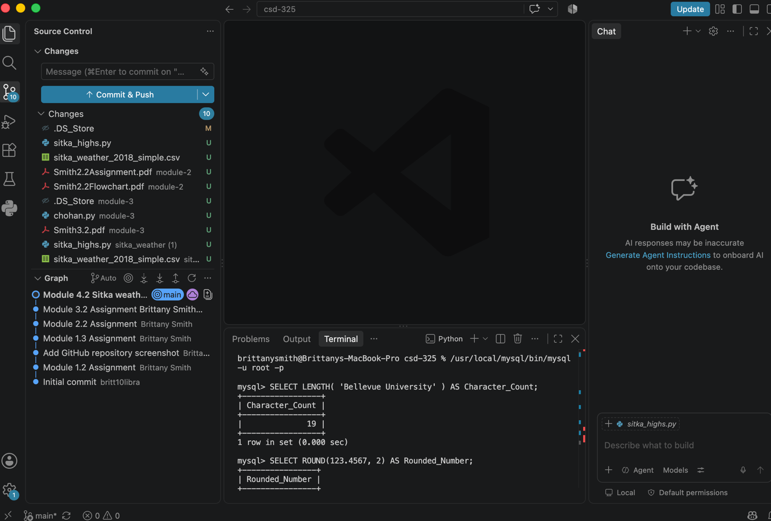

ROUND(): function used when numeric values need to be limited to a certain number of decimal places (money, measurements, temperature)
