Brittany Smith
Module 8.2 Assignment
9/20/26

Flowchart:
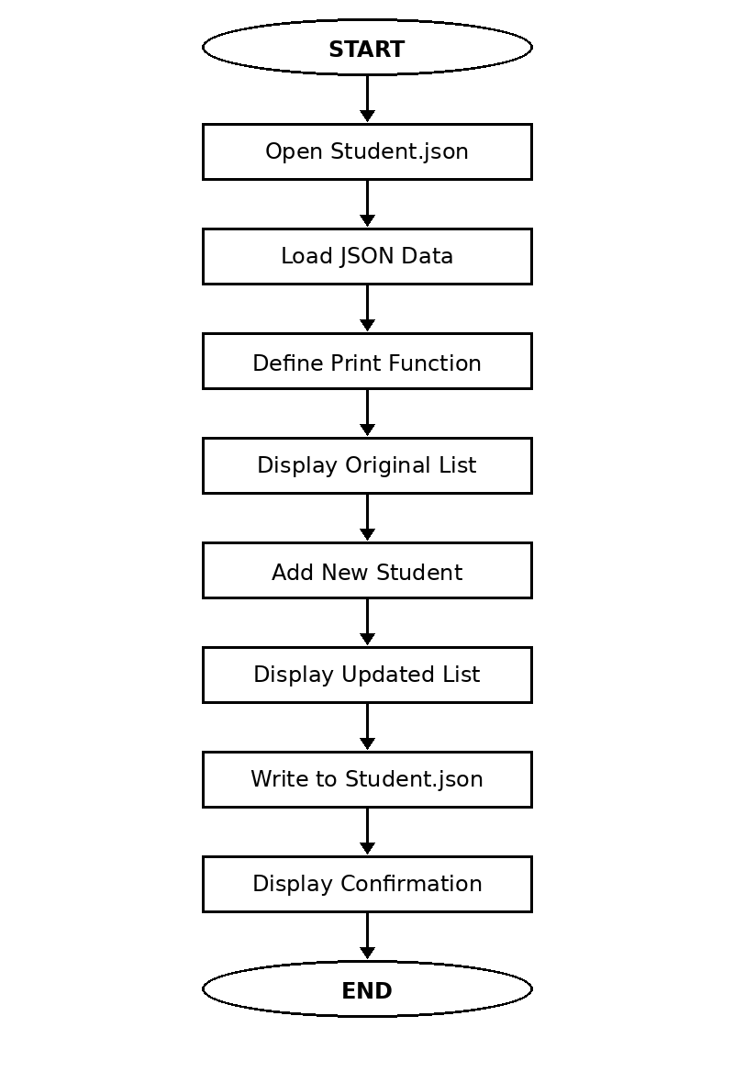

Program Results:
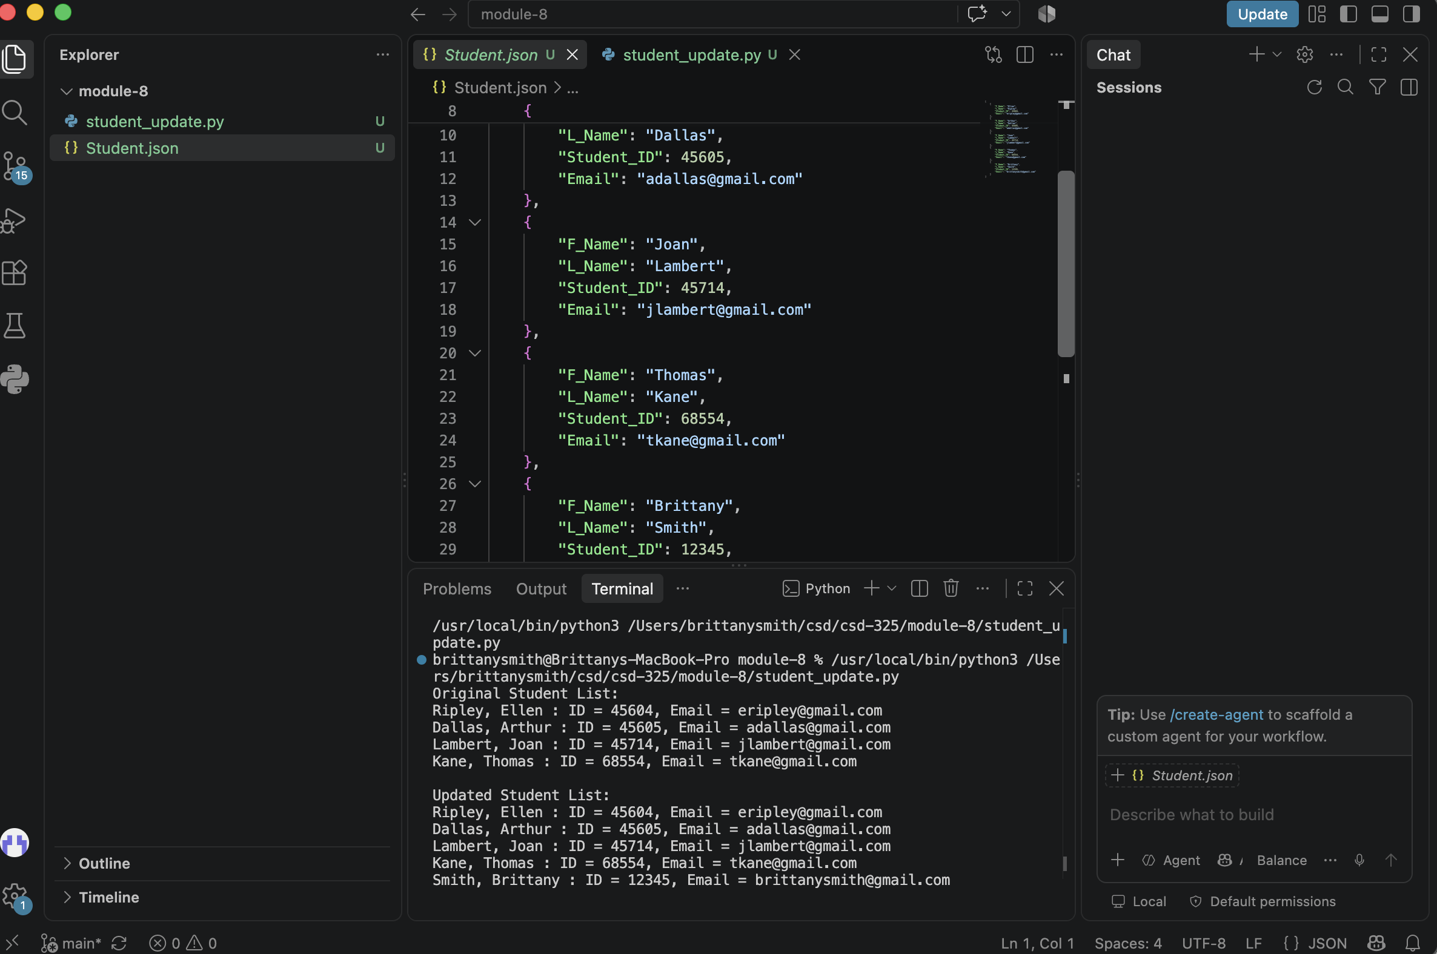

Student.json File Change Notification:
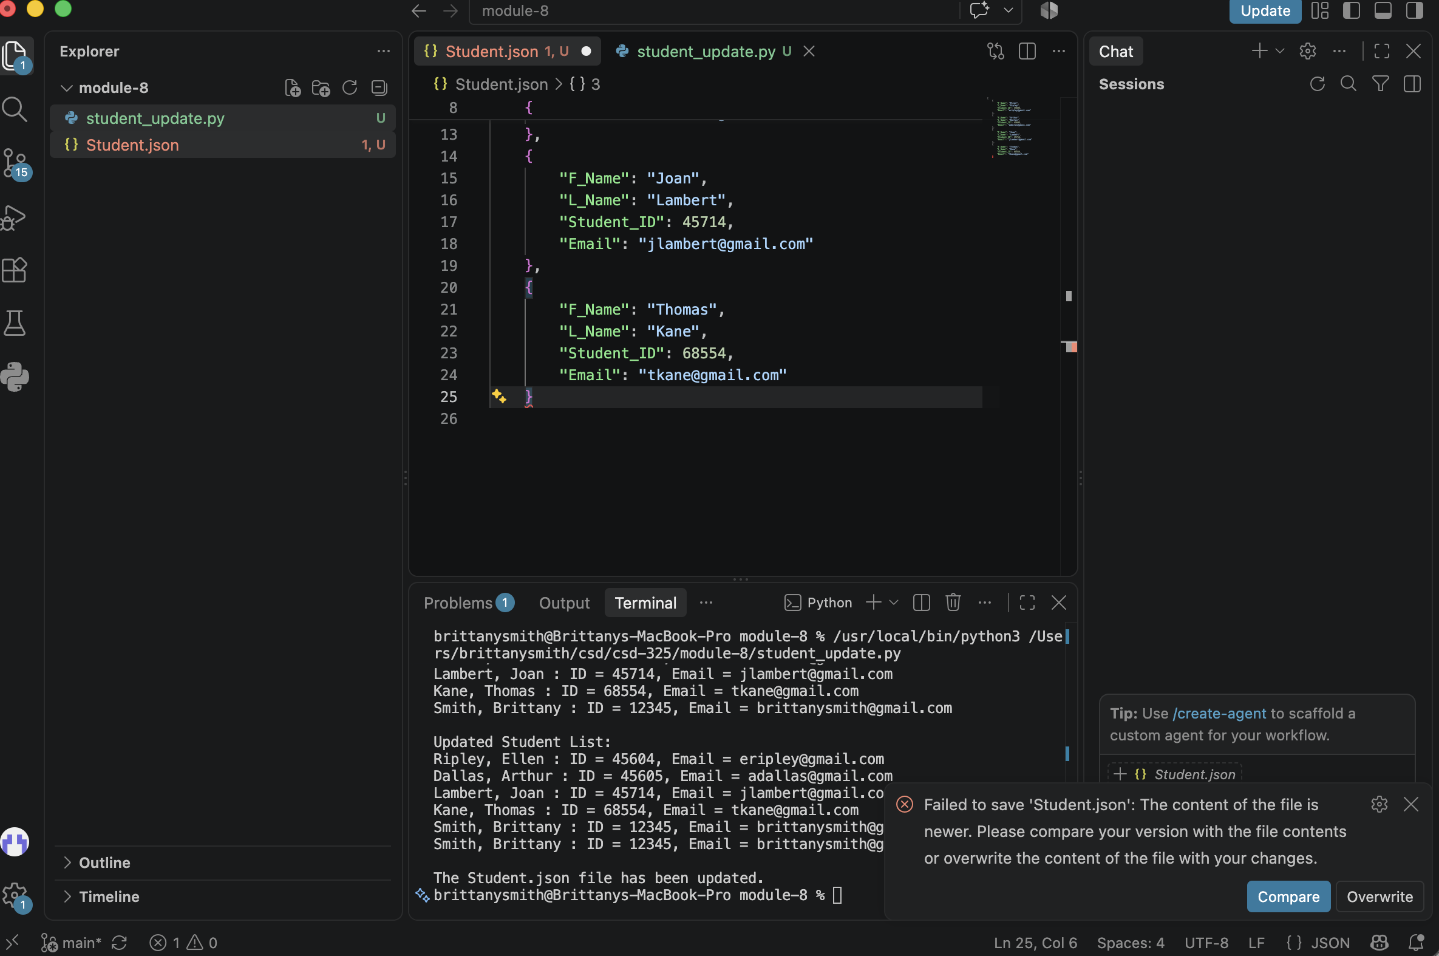

Updated Student.json File:
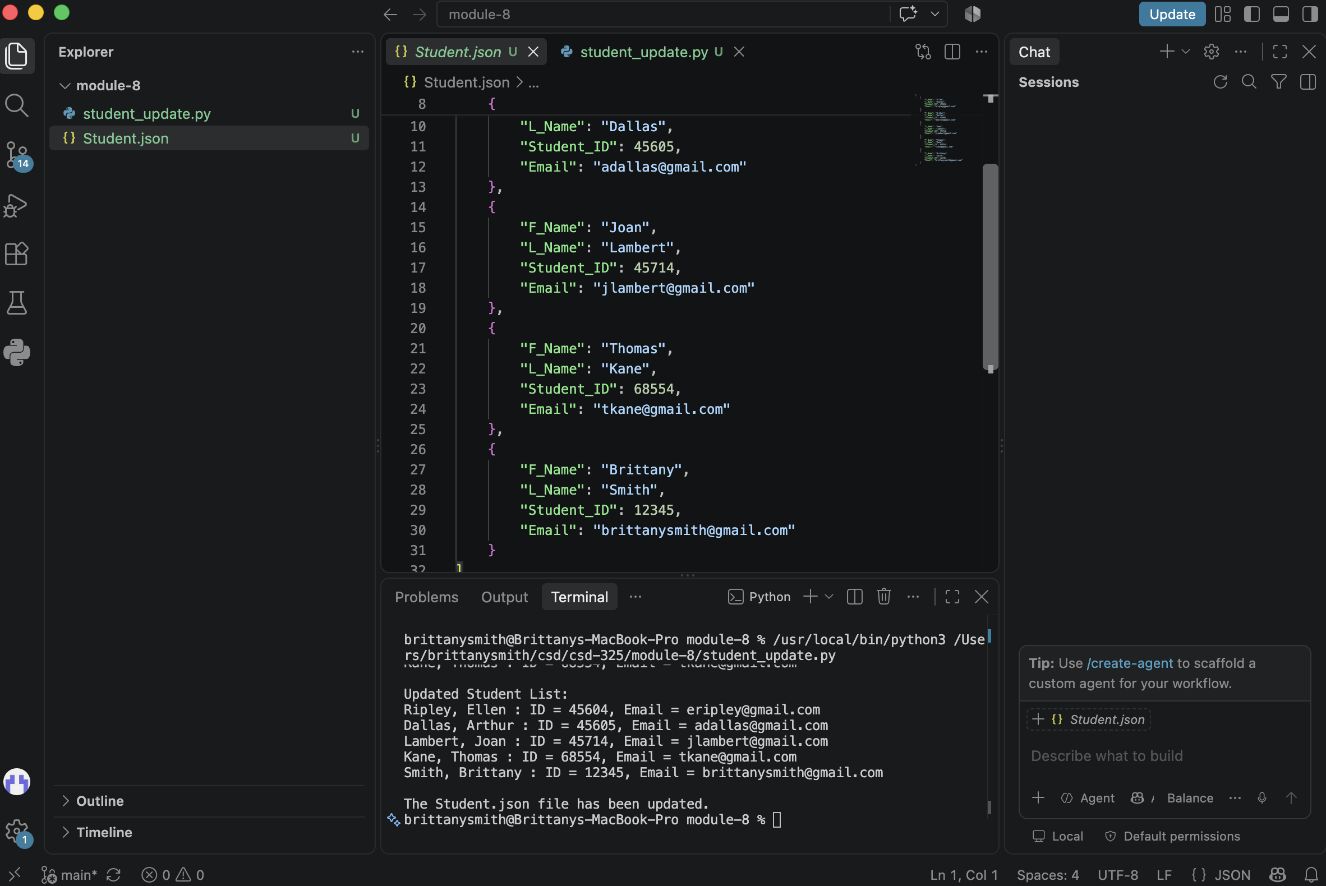

Updated Json Contents:
[
{
"F_Name": "Ellen",
"L_Name": "Ripley",
"Student_ID": 45604,
"Email": "eripley@gmail.com"
},
{
"F_Name": "Arthur",
"L_Name": "Dallas",
"Student_ID": 45605,
"Email": "adallas@gmail.com"
},
{
"F_Name": "Joan",
"L_Name": "Lambert",
"Student_ID": 45714,
"Email": "jlambert@gmail.com"
},
{
"F_Name": "Thomas",
"L_Name": "Kane",
"Student_ID": 68554,
"Email": "tkane@gmail.com"
},
{
"F_Name": "Brittany",
"L_Name": "Smith",
"Student_ID": 12345,
"Email": "brittanysmith@gmail.com"
}
]

