Brittany Smith
Module 2.2 Assignment
Screenshot 1 - Breakpoint
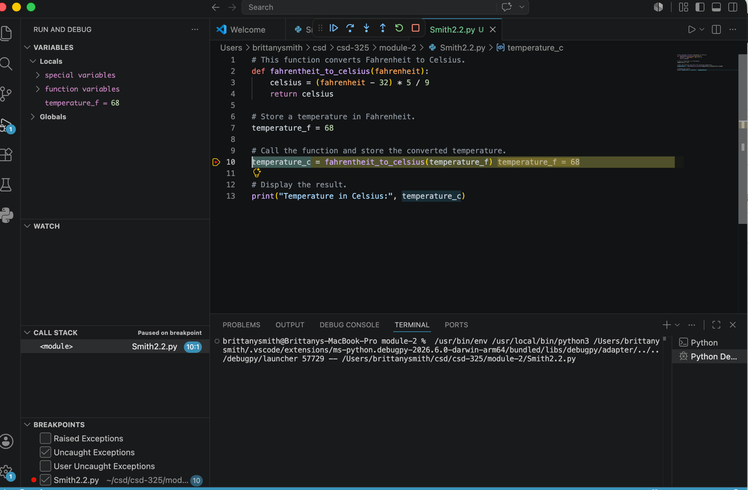

Screenshot 2 – Step Into Function
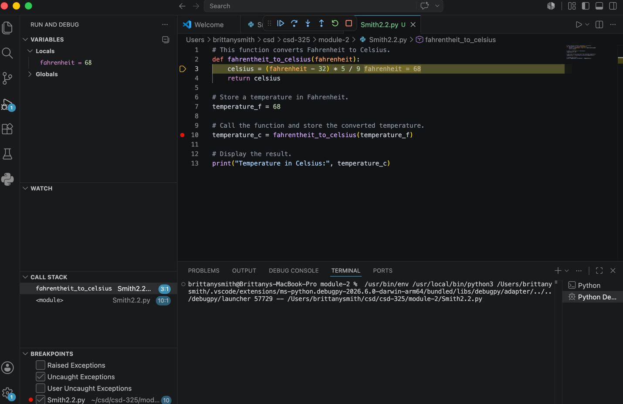

Screenshot 3 – Step Over/Calculated Value
