Brittany Smith
Module 9.2 Assignment
9/27/26
API Tutorial- Astronauts
The program successfully connected to the API. The JSON response was formatted using the jprint function. (See next page)
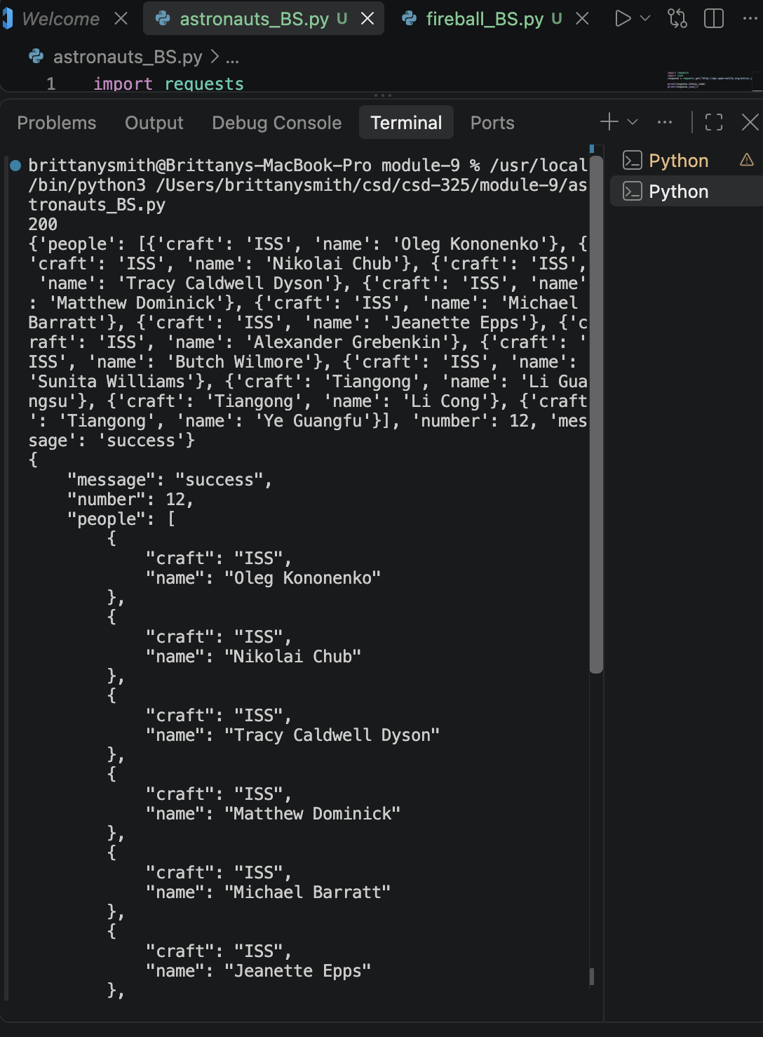

Fireball API Program
I used the NASA/JPL Fireball Data API. The program tested the connection to the API, displayed the unformatted JSON response, then used the jprint function to format the response.
