Module 3 Course Project

Adding Basic Navigation

Brittaney Gonzalez

Rasmussen College

Author Note

This paper is being submitted on August 26, 2018, for Darice Corey’s CIS4655C – Advanced Mobile Web Development course.

The purpose of this project, is add basic navigation to our Course Project website. After incorporating this to our pages, we are to test it using Chrome Developer Tools. By testing five different viewpoints in both landscape and portrait, we can test the responsiveness of the website. Screenshots are included below.

1. Galaxy S5

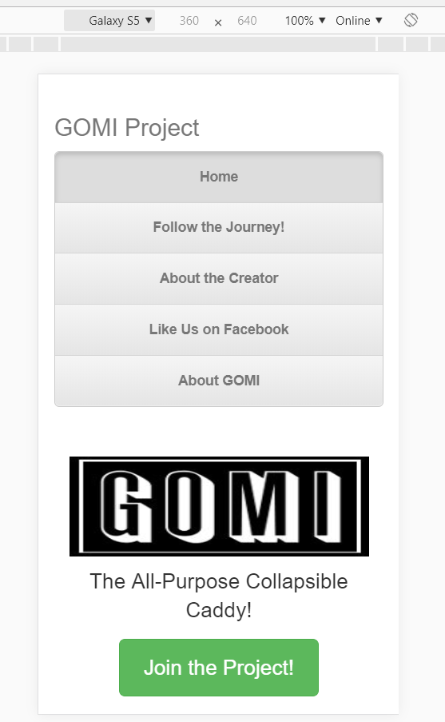 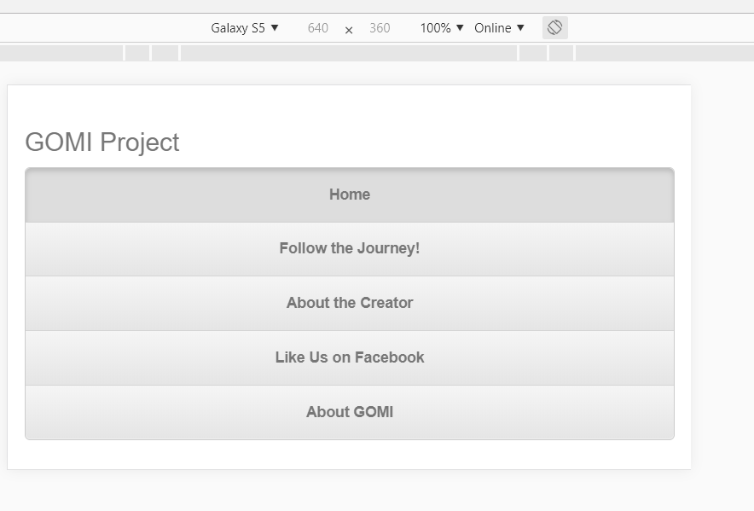

1. Pixel 2

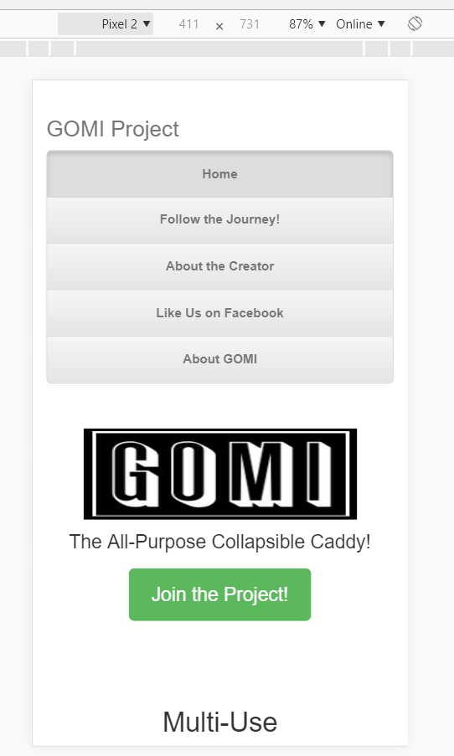 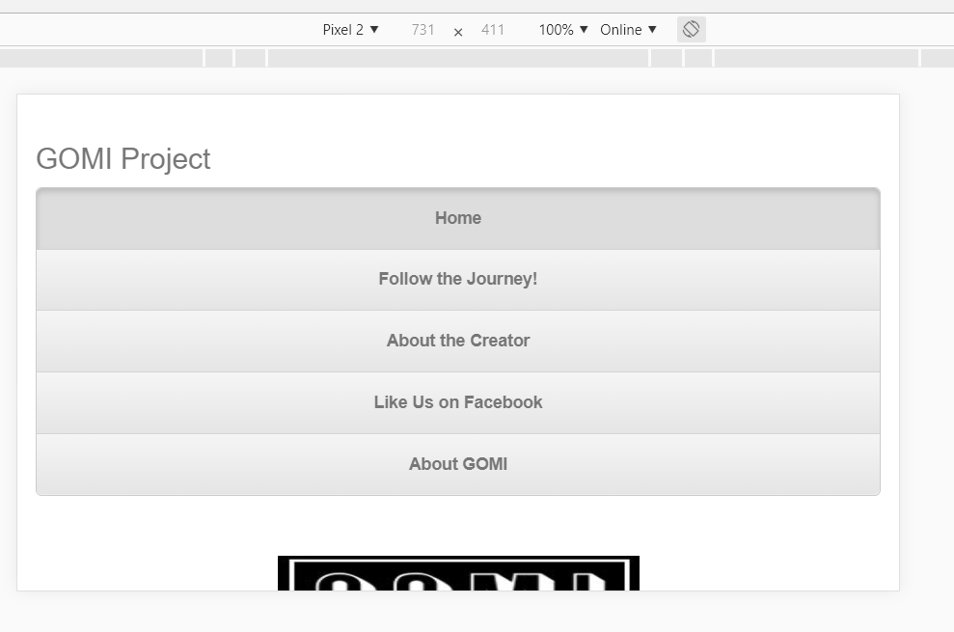

1. iPhone 5/SE

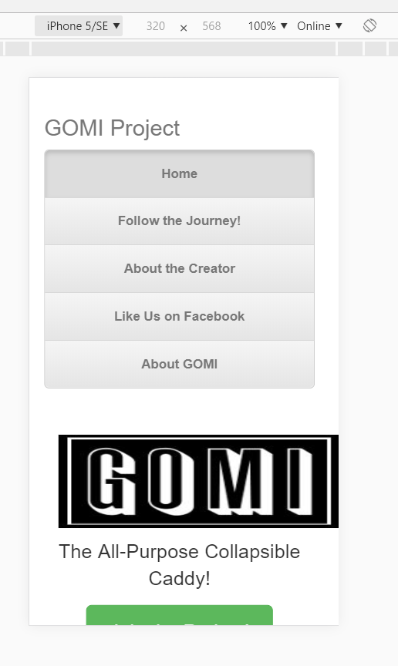 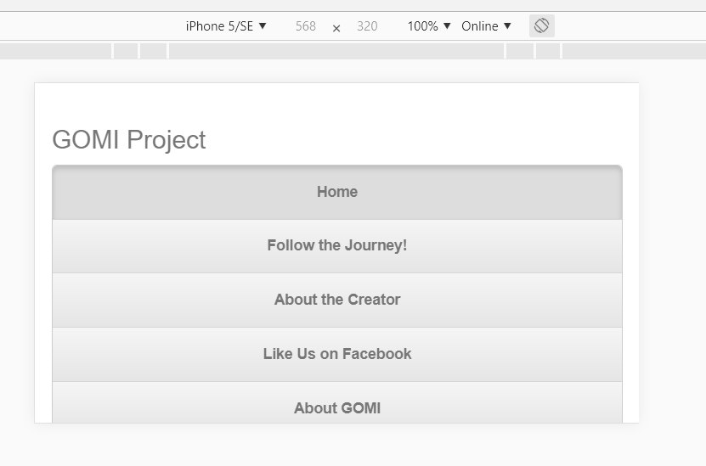

1. iPhone X

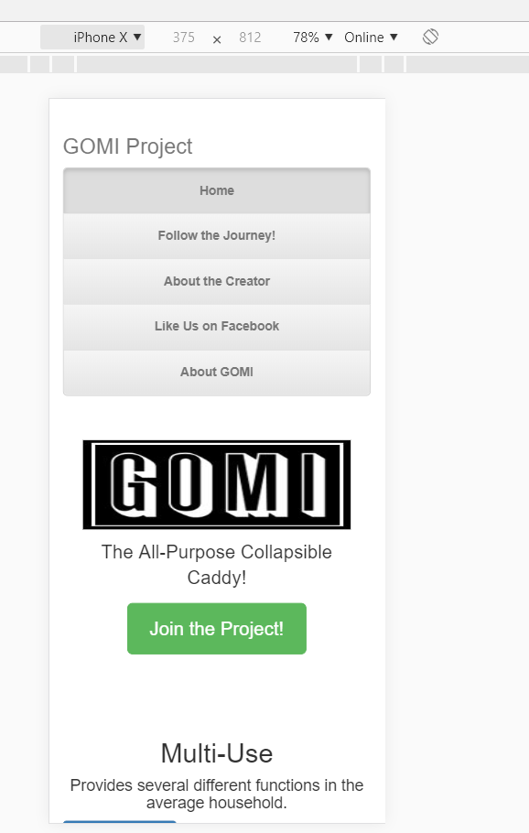 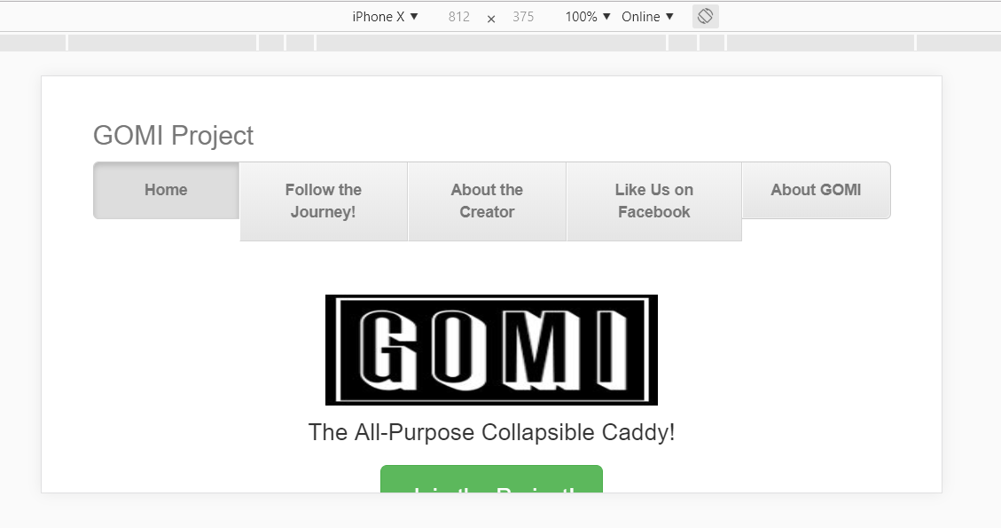

1. iPad

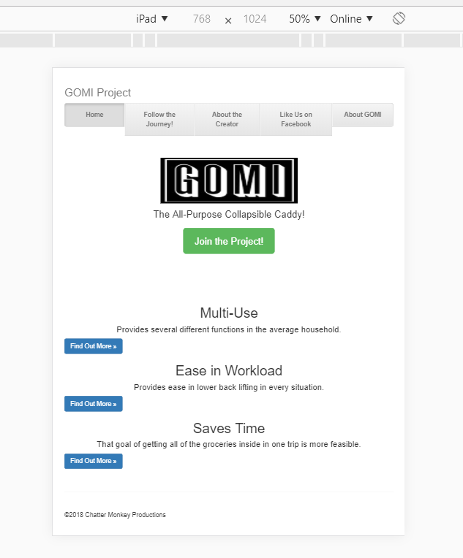 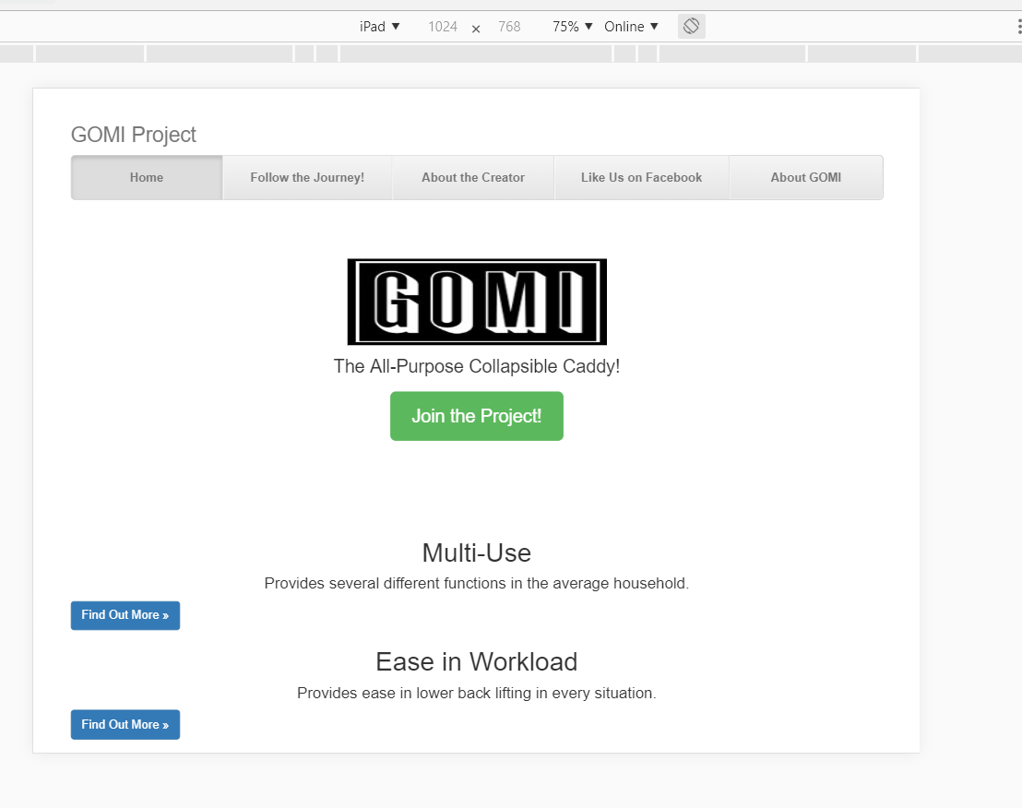

* FileZilla: https://sotd.us/brittaneygonzalez/CIS4655-Summer2018/Module_3/Project/Module_3_CP.html
* GitHub: <https://github.com/brittaney-gonzalez/Summer18Activity3>