Module 4 Course Project

Adding Style and Layout Components

Brittaney Gonzalez

Rasmussen College

Author Note

This paper is being submitted on September 1 2018, for Darice Corey’s CIS4655C – Advanced Mobile Web Development course.

The purpose of this project is to incorporate style and layout components to our existing website. We are to include the following features:

* 3 buttons with badges
* 2 labels
* 1 jumbotron
* 1 card

The screenshot of the page and the URLs are included below.

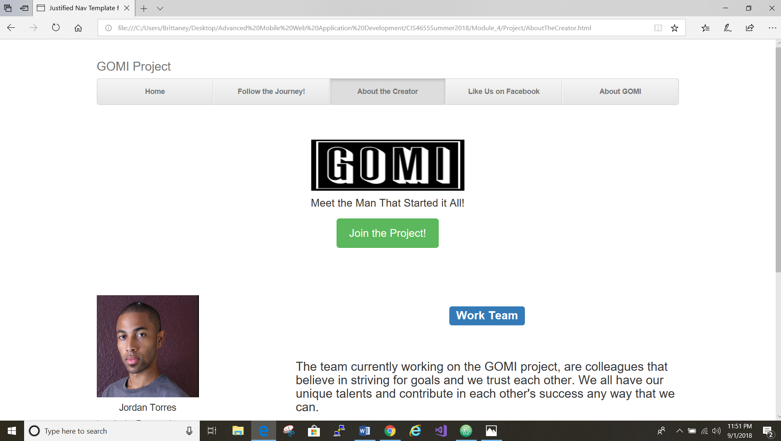

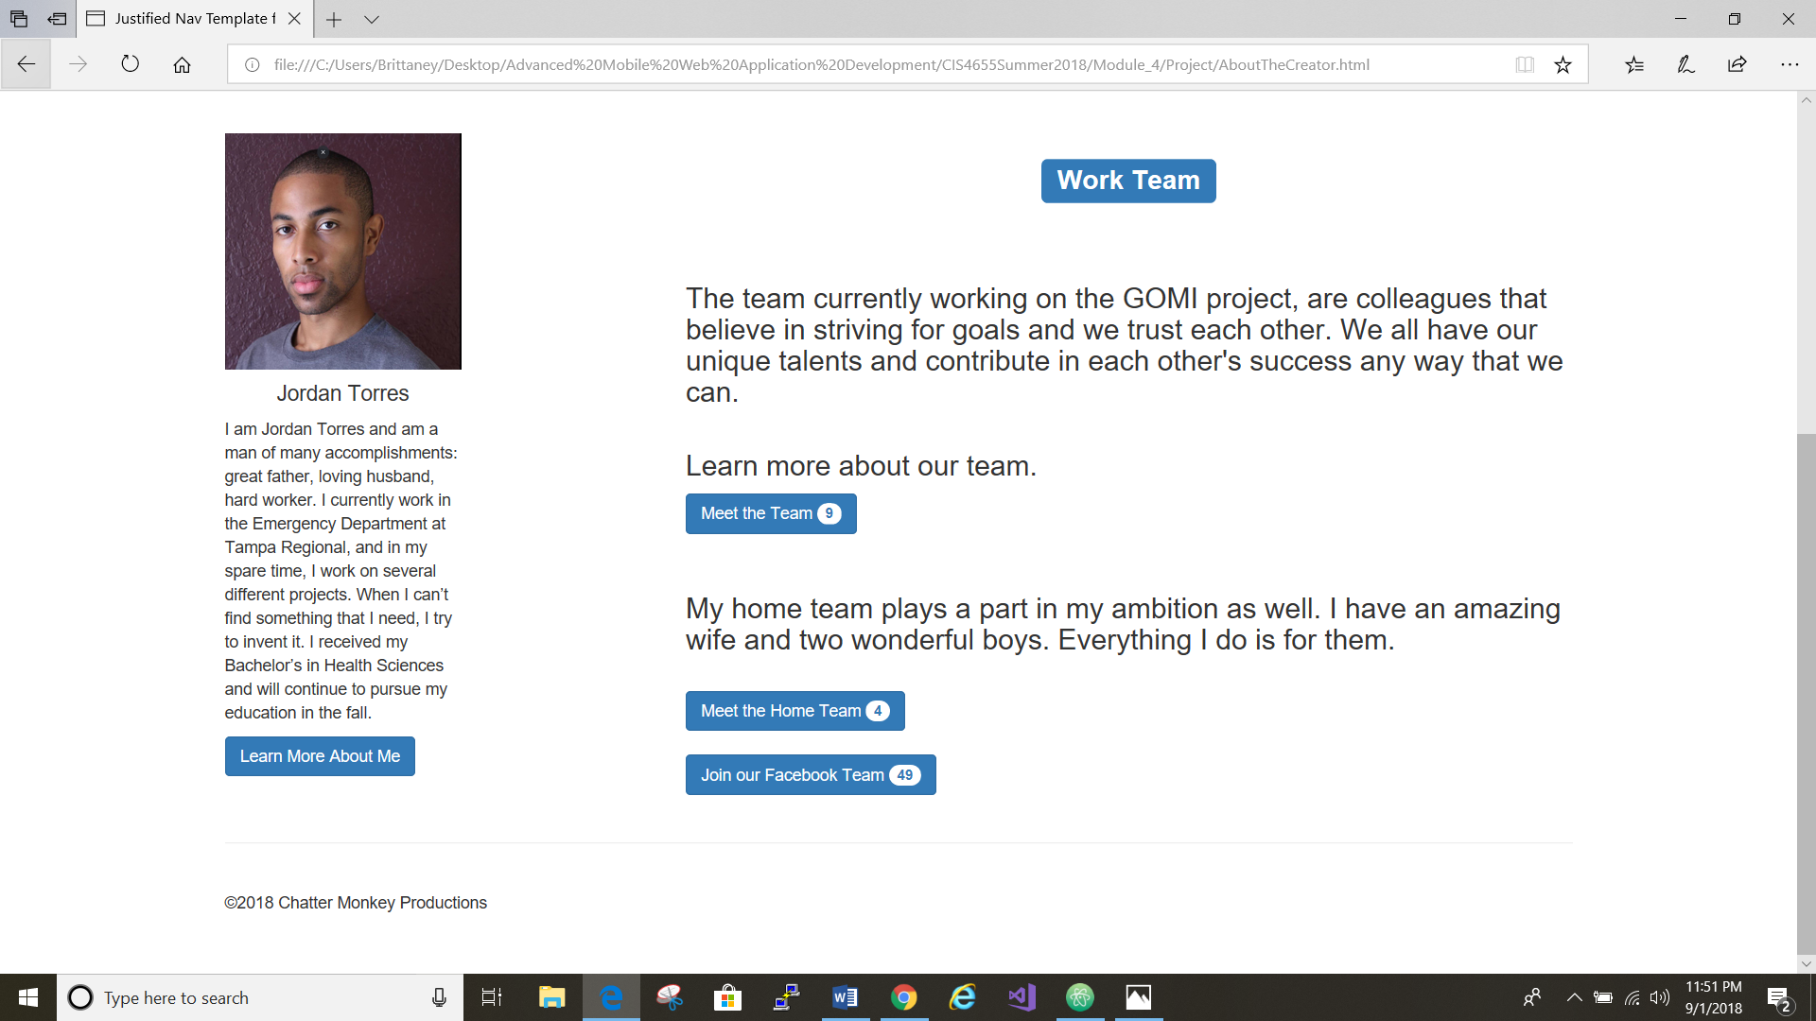

* FileZilla: <https://sotd.us/brittaneygonzalez/CIS4655-Summer2018/Module_4/Project/AboutTheCreator.html>
* GitHub: <https://github.com/brittaney-gonzalez/Summer_Module4_CourseProject>