Module 5 Course Project

Implement Simple Notification API and Final Site Delivery

Brittaney Gonzalez

Rasmussen College

Author Note

This paper is being submitted on September 14 2018, for Darice Corey’s CIS4655C – Advanced Mobile Web Development course.

The purpose of this project is to incorporate a new page that contains a form using Bootstrap framework and styling. We are to include the following features on the form:

* At least 2 text boxes
* At least 1 text area
* At least 1 set of check boxes
* At least 1 set of radios
* At least one dropdown with 3 options
* A submit button
* The form must have form validation to disallow submission when the submit button is clicked.
* The form does not require an action, since form processors were not covered in this course.

The screenshots of the page are shown in both portrait and landscape below. The URLs are included as well.

* iPhone X

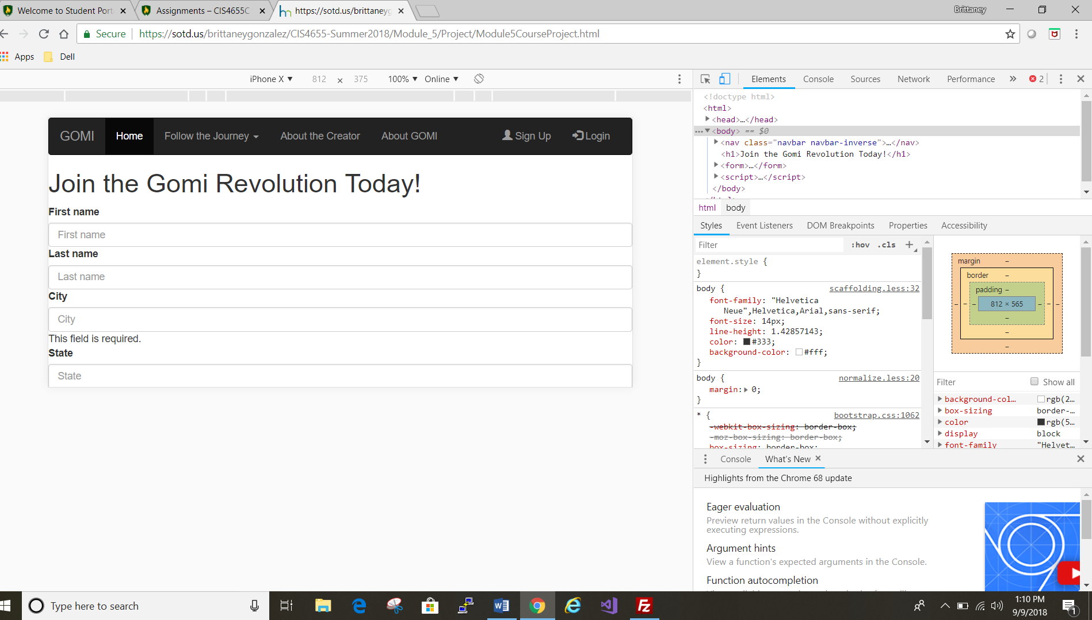 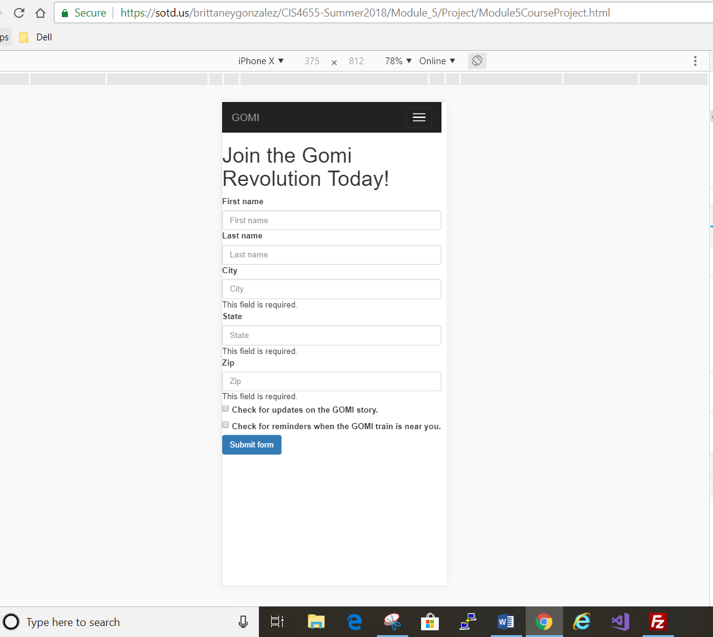

* Galaxy S5

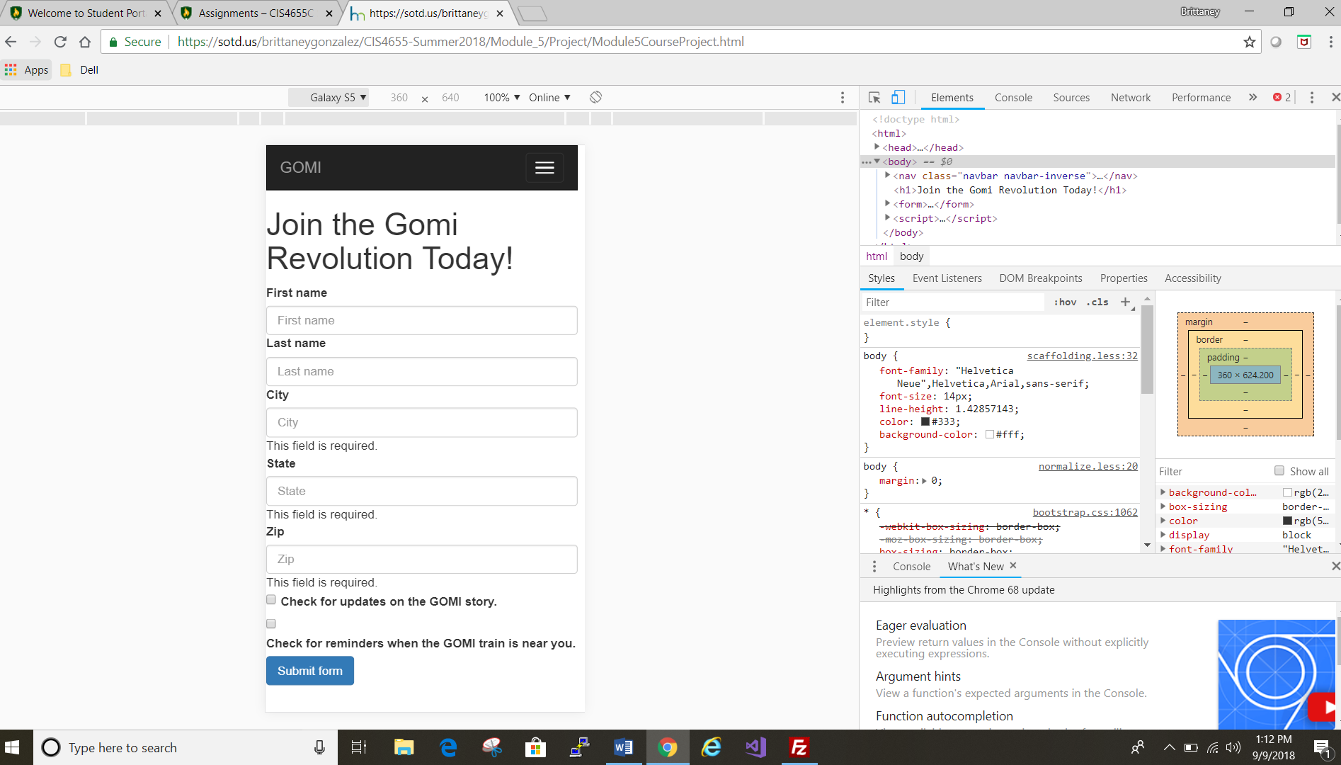 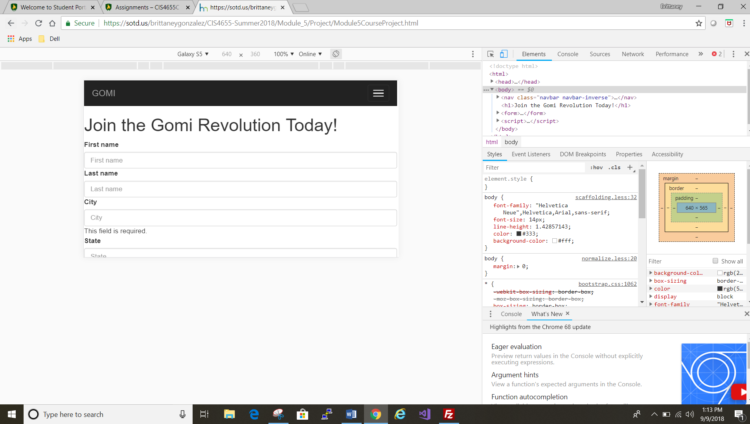

* Pixel 2XL

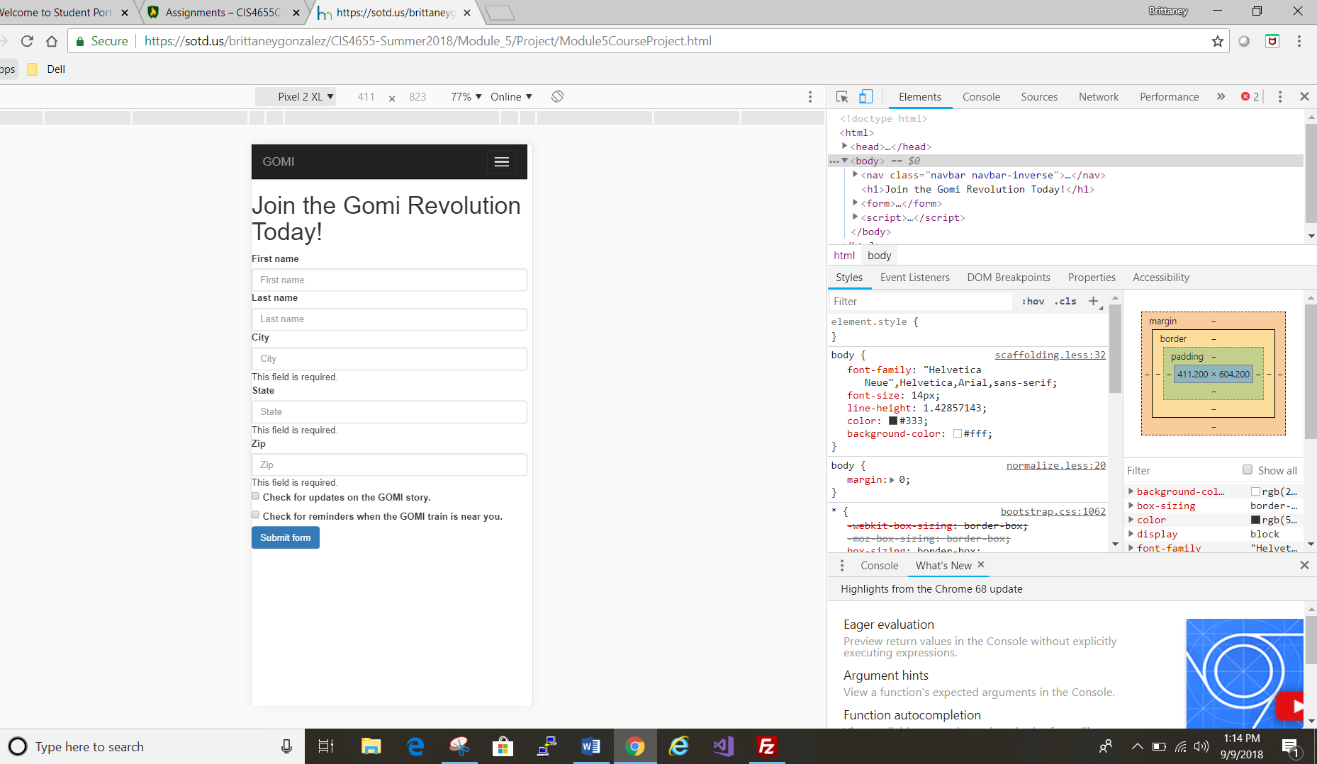 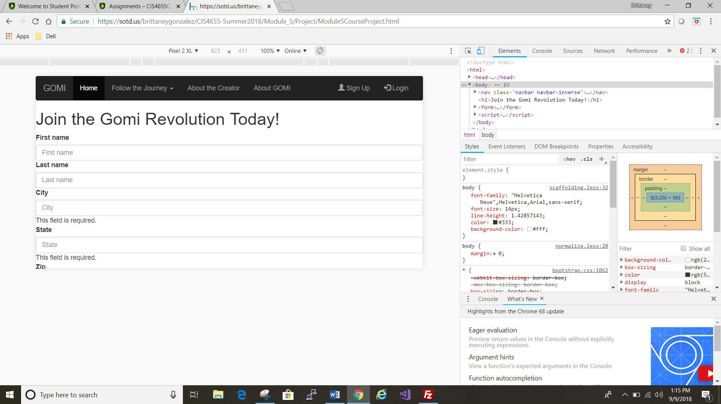

* iPad Pro

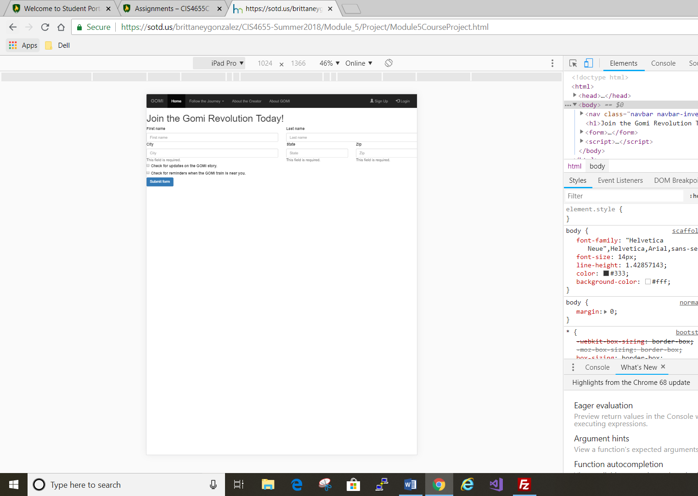 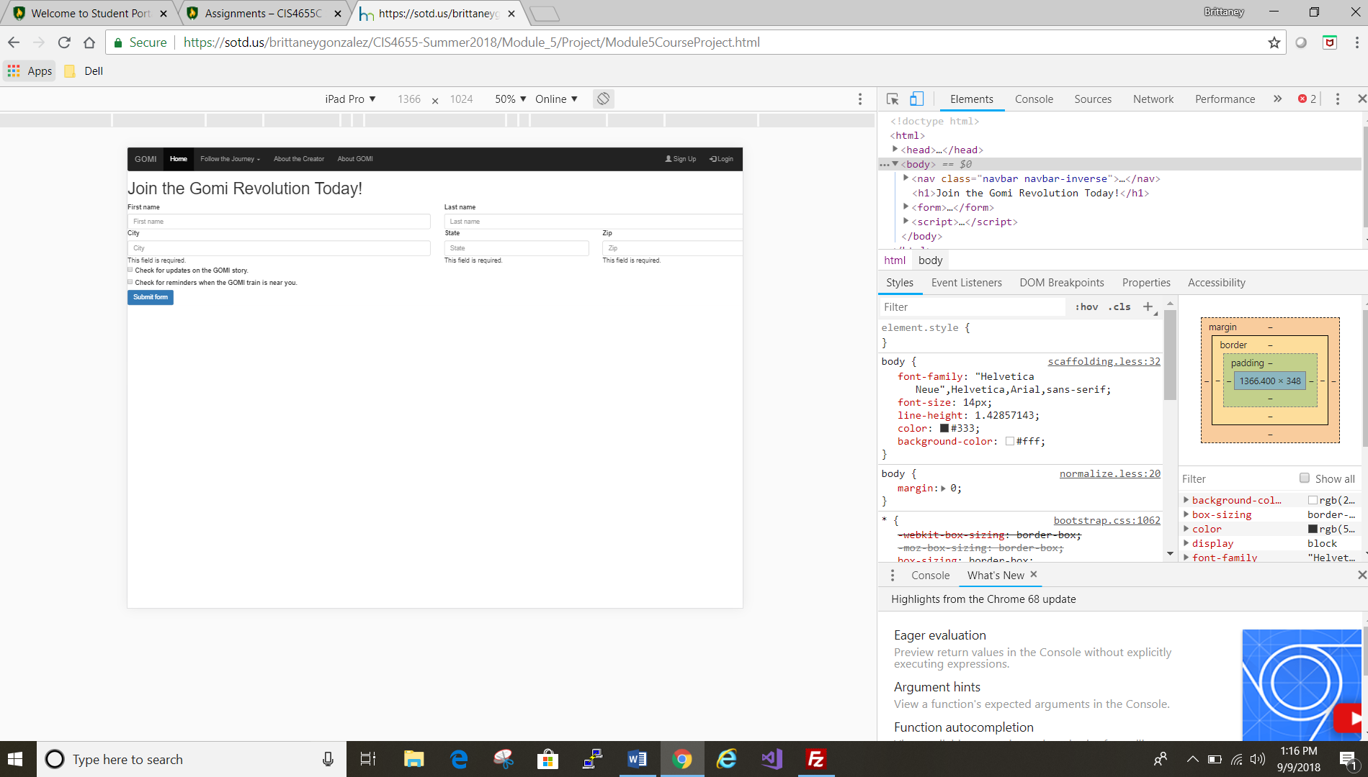

* Responsive

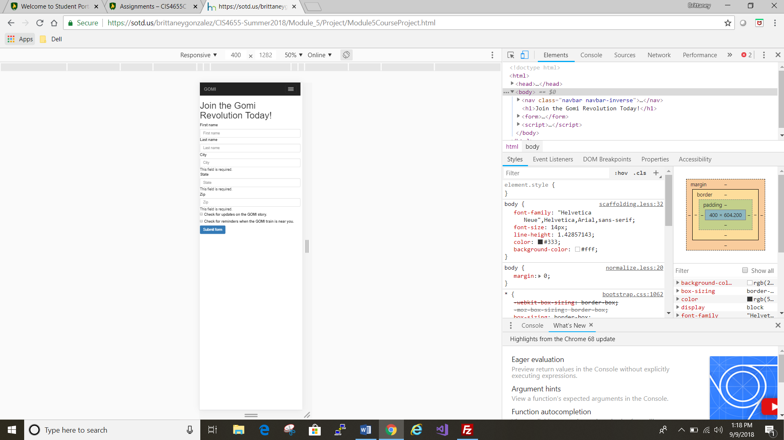 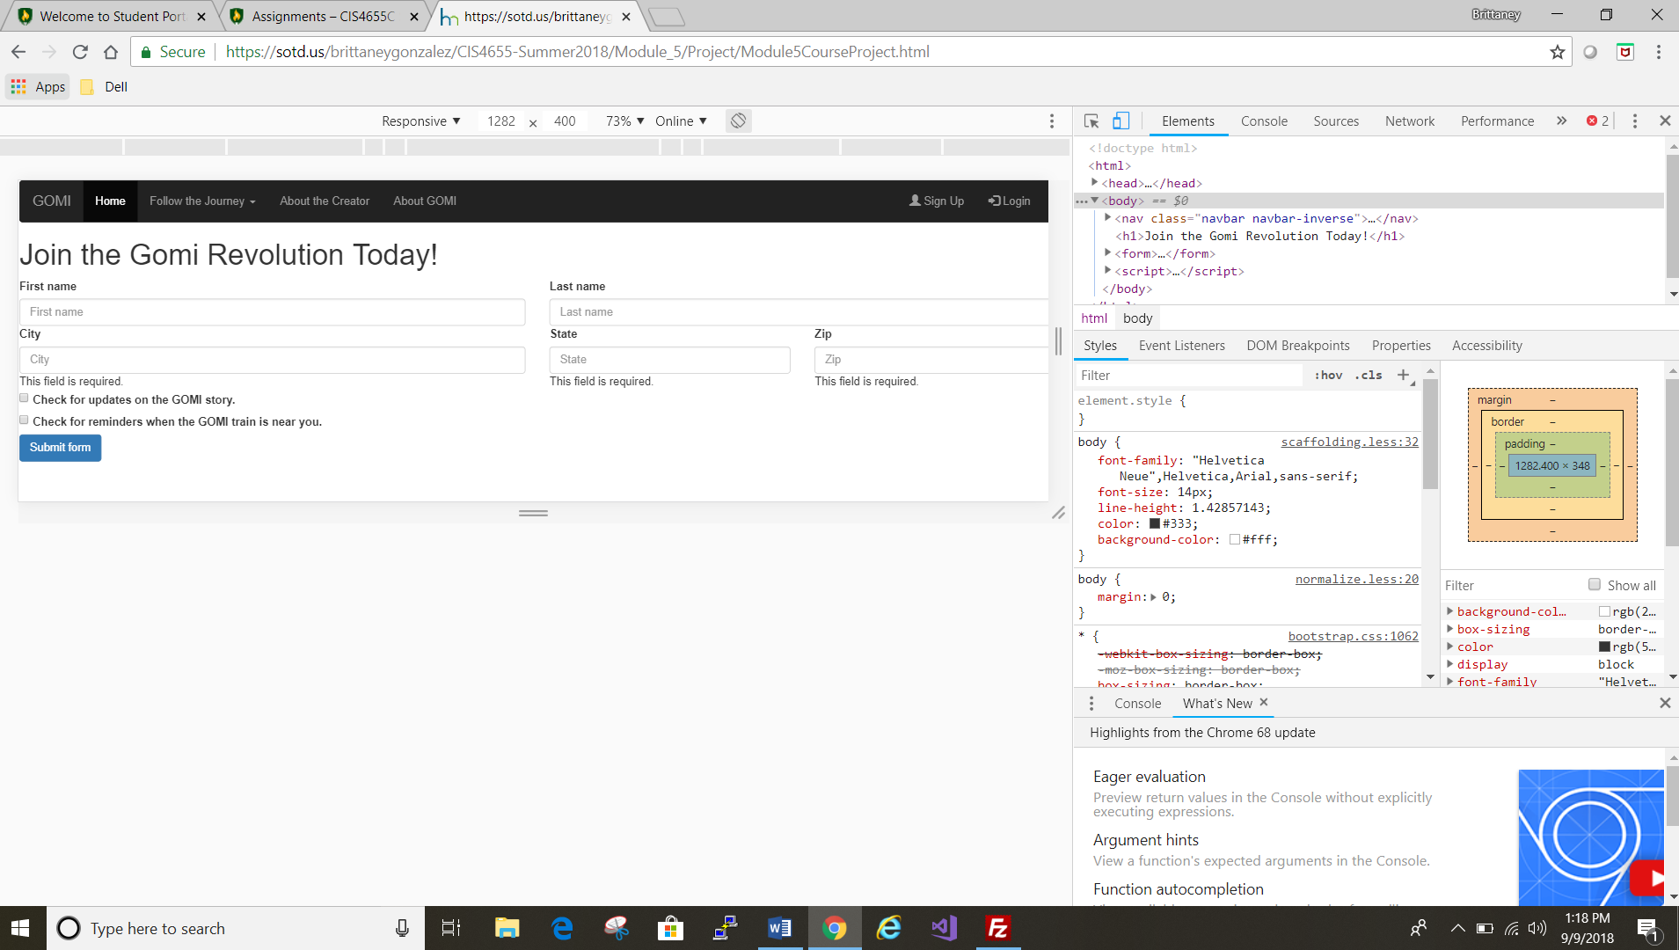

* Desktop Browser

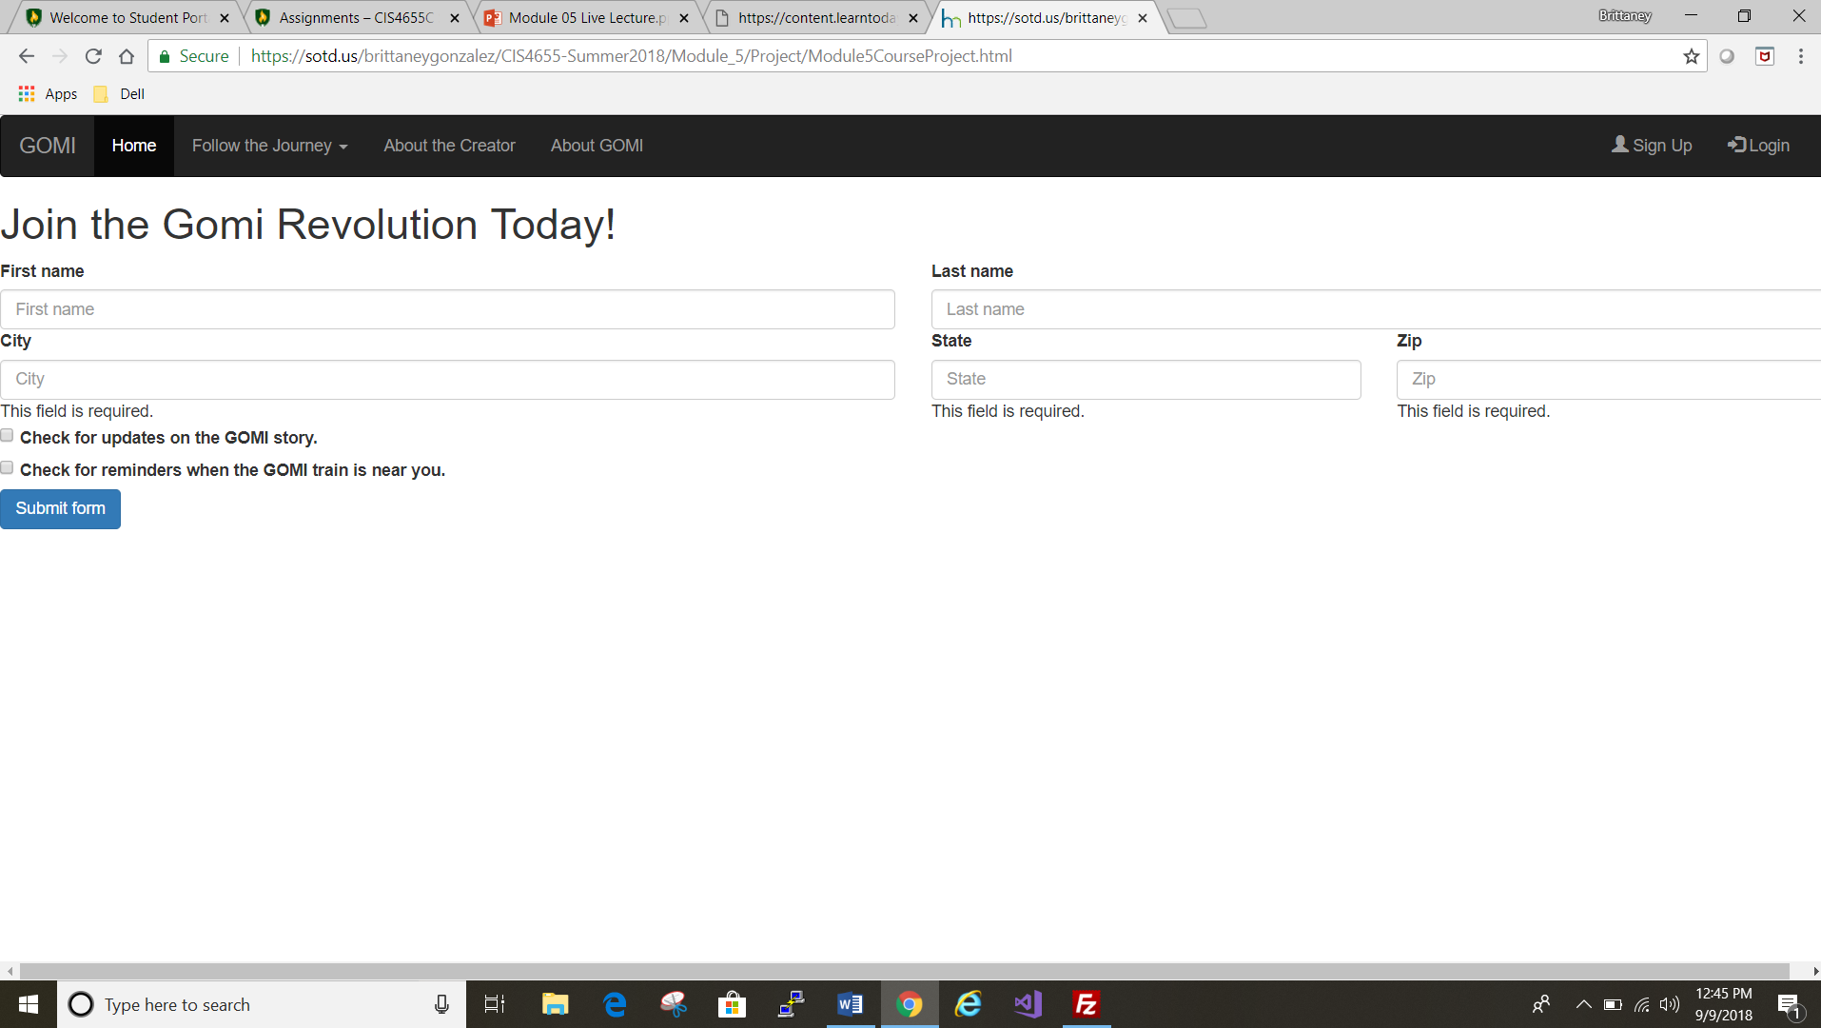

The new page is a basic form that is accessible from each of the other pages through the “Join the Project” button at the center of each page.

* FileZilla: <https://sotd.us/brittaneygonzalez/CIS4655-Summer2018/Module_5/Project/Module5CourseProject.html>
* GitHub: <https://github.com/brittaney-gonzalez/Summer_Module5_CourseProject>