SE 2200 Prototype
Project Title: Echoes of Anna
Solo Project
Name | Roles
Brittany | Project Lead  Developer  UI/UX Designer

Version Control Table
Version | Date | Description of Changes
1.0 | 11/02/2025 | Initial Draft
1.2 | 11/04/2025 | Added Key Screens & Interfaces section
1.3 | 11/05/2025 | Finalized key screens section and added flowchart
1.4 | 11/09/2025 | Included images and started section 5

Introduction
Echoes of Anna is a decision-based text adventure game designed to reimagine the classic narrative RPG by emphasizing meaningful player choice and emotional consequences. The game presents players with branching dialogue paths that evolve based on accumulated decisions, shaping both the story and the protagonist’s development.
This project aims to address a common shortcoming in typical text-based RPGs, limited or inconsequential decision making, by delivering a more interactive storytelling experience where choices leave lasting impacts. The game is aimed at fans of interactive fiction and writers interested in branching narrative design; Echoes of Anna provides a minimalistic but immersive environment focused entirely on dialogue, emotion, and consequence.
The purpose of this prototype is to visualize and test the game’s core systems, specifically the user interface for dialogue selection, decision tracking, and navigation flow. It will demonstrate the structure and feel of the main menu, player interaction loops, and Act I’s introductory decision tree. This prototype serves as a blueprint for the full games design, helping refine usability and narrative pacing before development continues.

Prototype Overview
Tools Used:
- Figma – for interface wireframes and layout design
- Draw.io – for story and user flow diagrams
- Unity – for a functional early demo of Act I
This prototype focuses on the foundational gameplay loop and visual structure of Echoes of Anna. It will include:
- A Title Screen that allows players to start a new game, load progress, access settings, or exit the game.
- A Dialogue Interface that displays narrative text and player dialogue choices, reflecting the tone and aesthetic of the full release.
- A Settings Menu for adjusting text size, audio volume, etc.
- Story Flow diagrams that illustrate how the branching narrative unfolds in Act I, highlighting key decision points.
- A Unity based demonstration showcasing the first acts playable dialogue, including functional choice progression, variable tracking, and autosave checkpoints.

Prototype Objectives:
- Demonstrate how player choices are presented, selected, and stored.
- Test the clarity and accessibility of the interface.
- Validate the logical flow of story branching within Act I as a foundation for future acts.

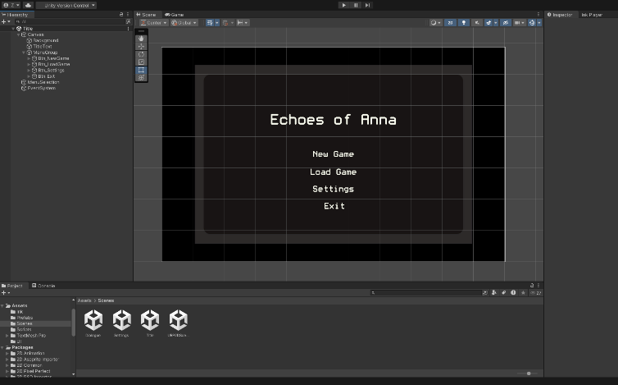
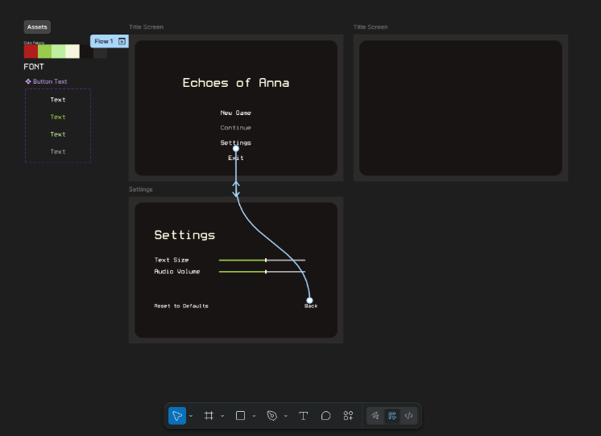
Key Screens and Interfaces
Figure 1 shows Unity workspace layout
Figure 2 shows Figma workspace layout
3.1 Title Screen
The purpose of the title screen is to serve as the players entry point to the game, providing access to key functions like starting a new game, continuing from a previous save, or adjusting settings. It also establishes the aesthetic/atmosphere of the game.

UI Elements and Features
- Game Title: Echoes of Anna displayed in the center of the screen, using a font that matches the digital terminal theme of the game.
- Main Menu Options:
  - New Game – begins a fresh playthrough.
  - Load Game – retrieves previous saved state from local storage.
  - Settings – opens the settings interface.
  - Exit – closes the game.
- Background: Softly blurred or static backdrop to enhance the atmosphere.

User Interaction
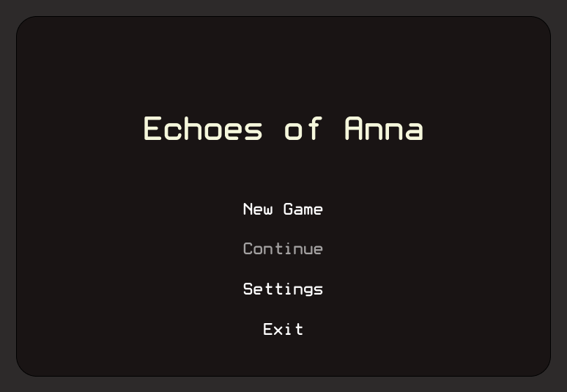
Players can navigate using mouse or keyboard, selecting options to navigate menus or continue the story. Interaction is supported by hover animations for visual feedback.
Figure 3 shows Title Screen Layout

3.2 Dialogue Screen
The purpose of the dialogue screen is to be the core gameplay interface where the story unfolds. The screen presents narrative text and dialogue choices that allow players to influence the story’s direction and underlying variables.

UI Elements and Features
- Dialogue Box: Centralized area displaying story text, designed with adjustable font size and high contrast for readability.
- Dialogue Colors: The player and protagonist, as well as system notifications will have different colored text to clearly show who is saying what.
- Choice Buttons: One to four selectable dialogue options, each representing different branches and outcomes, significant and small.
- Hidden Variable Tracking: The ink file will keep track of narrative variables (e.g. curiosity += 1) that influence future outcomes.
User Interaction
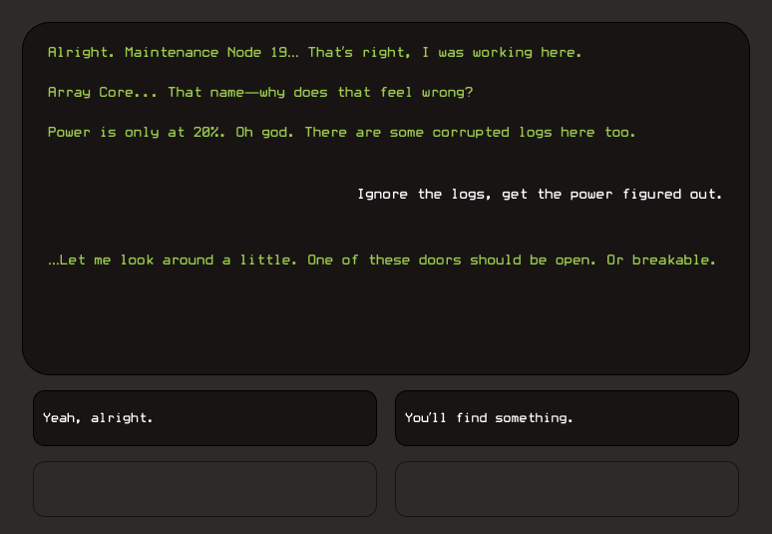
Players select a dialogue option to progress the story. Once selected, the text transitions smoothly to the next narrative block, with subtle sound cues and animations reinforcing feedback. The game records the choice and updates the players’ variable state accordingly.
Figure 4 shows Dialogue Screen Layout

3.3 Settings Screen
The purpose of the settings screen is to allow customization for accessibility and comfort, aligning with the SRS requirement for readable text (NFR1). It ensures the players can tailor their experience.
UI Elements and Features
- Text Size Slider: Adjusts dialogue and UI text for readability.
- Volume Control: Modifies sound effects and ambient audio levels.
- Reset to Defaults option: Returns settings to their default state.
- Back/Return Button: Returns player back to Title Screen or resumes the game if accessed during gameplay.
User Interaction
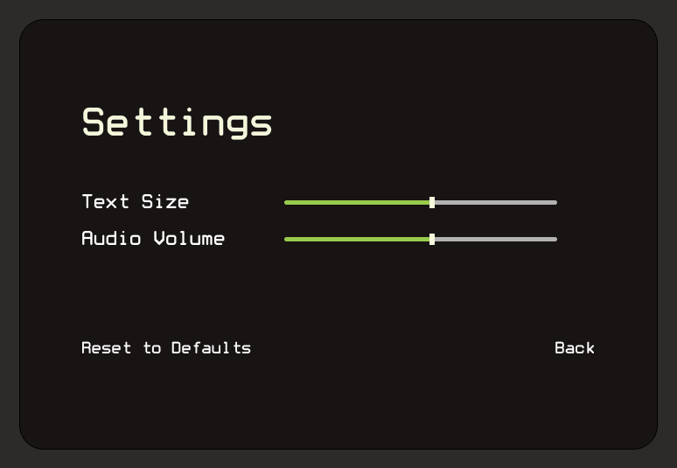
All options respond instantly to player input. The layout prioritizes clarity and simplicity, ensuring that players can quickly adjust se4ttins without leaving the experience for too long.
Figure 5 shows Settings Screen Layout

3.4 Design Intent Summary
The UI across all screens reinforce the simplicity and central narrative themes of the game (isolation, reflection, consequence) through the color palette, spacious layouts, and smooth, non-intrusive transitions. The consistent visual look keeps players focused on the emotional weight of their choices rather than being distracted by unnecessary UI complexity.

Key Screens and Interfaces
The user flow of Echoes of Anna reflects the player’s progression through the core game systems and demonstrates how narrative decisions influence future dialogue paths. The flow is designed to be intuitive, text-focused, and consistent with the pacing of the story.
This prototype will use Act I as a self-contained representation of the full gameplay loop. It allows users to experience the process of starting a new game, interacting with branching dialogue, and seeing the autosave function in practice.

Flow Description
The player launches the application and is presented with the Title Screen. They can start a new game, load existing progress, access settings, or exit. Assuming it is the first time they are opening the game, they will have no previous progress and therefore will select New Game and will be prompted to enter their name. The game will begin with initialized story variables: trust, curiosity, and autonomy, all starting at the default value 0. After this the player will be brought to the Dialogue Screen, and the narrative text will begin appearing line by line. Once the dialogue is finished, the player will be given dialogue options, anywhere between 2-4 choices. Choosing one of these options will continue the narrative path and may increment internal variables.
At defined story moments, like the end of a major conversation, the game will perform an auto-save, ensuring progress is preserved. At any point during the game, the player can access the settings menu, which will also act as a pause menu, and will be able to adjust font size and volume.

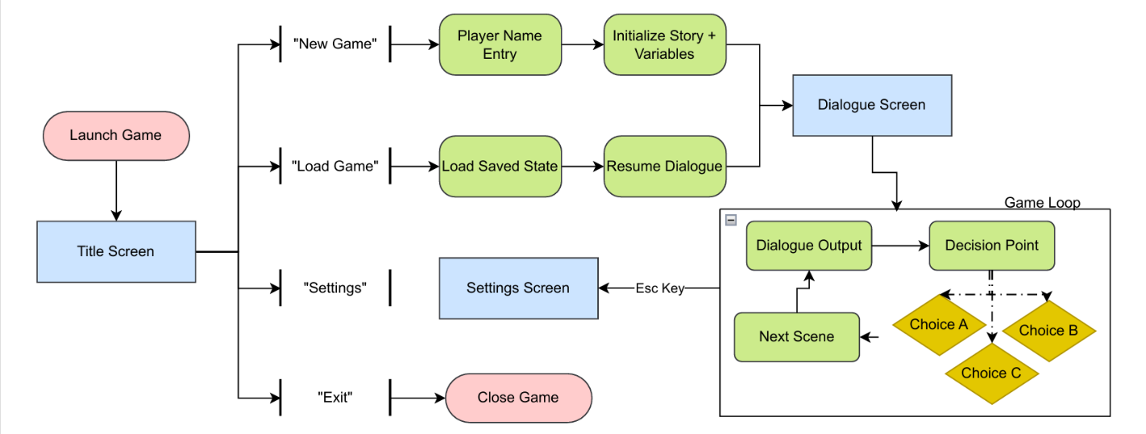
User Flow Diagram
Figure 6 shows the User Flow Diagram **Game auto saves after each loop
Flow Alignment with Project Objectives
This user flow supports the objectives outlined in the SRS. FR1-4 are present as the full gameplay loop from start to progressing to the next scene is established. FR5-6, 8, which outline the need for save and load functionality are demonstrated. FR7, which states that the player shall be able to configure settings is demonstrated as well.
The low structure provides a clear and testable representation of how players interact with the system and how choices function, which confirms the feasibility of expanding this logic into later, more complicated, acts of the story.

Design Considerations
The design of Echoes of Anna centers on minimalism, clarity, and tone to support an immersive storytelling experience. Every element, from font to color palette, was chosen with these main goals in mind. The interface avoids unnecessary visuals and instead favors subtle design elements.

Usability and Accessibility
Text is the core medium of this project, the prototype uses a clean typeface for dialogue, with an adjustable font size option.

