SRS – Final Version

Version Control Table
Version | Date | Description | Author
1.0 | Sep 24, 2025 | Initial Draft of SRS document | Brittany
1.1 | Sep 30, 2025 | Completed sections up to use case diagram | Brittany
1.2 | Oct 1, 2025 | Completed sections 2.3, 2.4 and 2.5 | Brittany
2.0 | Oct 3, 2025 | Finished final sections. V2 finalized | Brittany
2.1 | Oct 16, 2025 | Added product perspective section and updated use-case diagram | Brittany
2.2 | Oct 20, 2025 | Updated functional and nonfunctional requirements | Brittay
3.0 | Oct 24, 2025 | Added sections 4 & 5, finalized SRS. | Brittany

- Introduction
1.1 Purpose
The purpose of this document is to specify the project requirements for the Decision-Based text adventure RPG Game. This document will serve as a basis for system design, development, and testing, as well as design considerations and overview of all necessary specifications.

1.2 Scope
This project involves the development of a desktop application game that will use a complex dialogue decision tree with many branching paths, the story will be centered around one primary character. It will utilize a consequence system that tracks decisions and allows them to impact the story. The application will feature a simple user interface for navigating dialogue options, receiving feedback, and tracking narrative progress. A save/load function will be necessary as well as basic setting options regarding text size, audio control, etc. The project will not include voice acting or visual enhancements beyond a basic UI, it also won't include any character customization, aside from choosing a player name, and will not have the ability to have multiple saves.
1.3 Problem Definition
Most existing text-based RPGs offer limited dialogue choices that lead to predictable or inconsequential outcomes, undermining immersion and replay value. There is a need for more narrative-driven games in which dialogue options are numerous, nuanced, and genuinely significant, allowing each playthrough to feel distinct and ensuring that player agency remains at the center of the experience.

1.4 Definitions, Acronyms, and Abbreviations
Term | Definition
RPG | Role-Playing Game
UI | User Interface
OS | Operating System
GB | Gigabyte
Ink | Open-source scripting language for interactive stories
JSON | JavaScript Object Notation

1.5 References
Barrett, K. (2025, January 13). Software requirements specifications 101. QAT Global. https://qat.com/software-requirements-specifications-101/

- Overall Description
2.1 Product Perspective
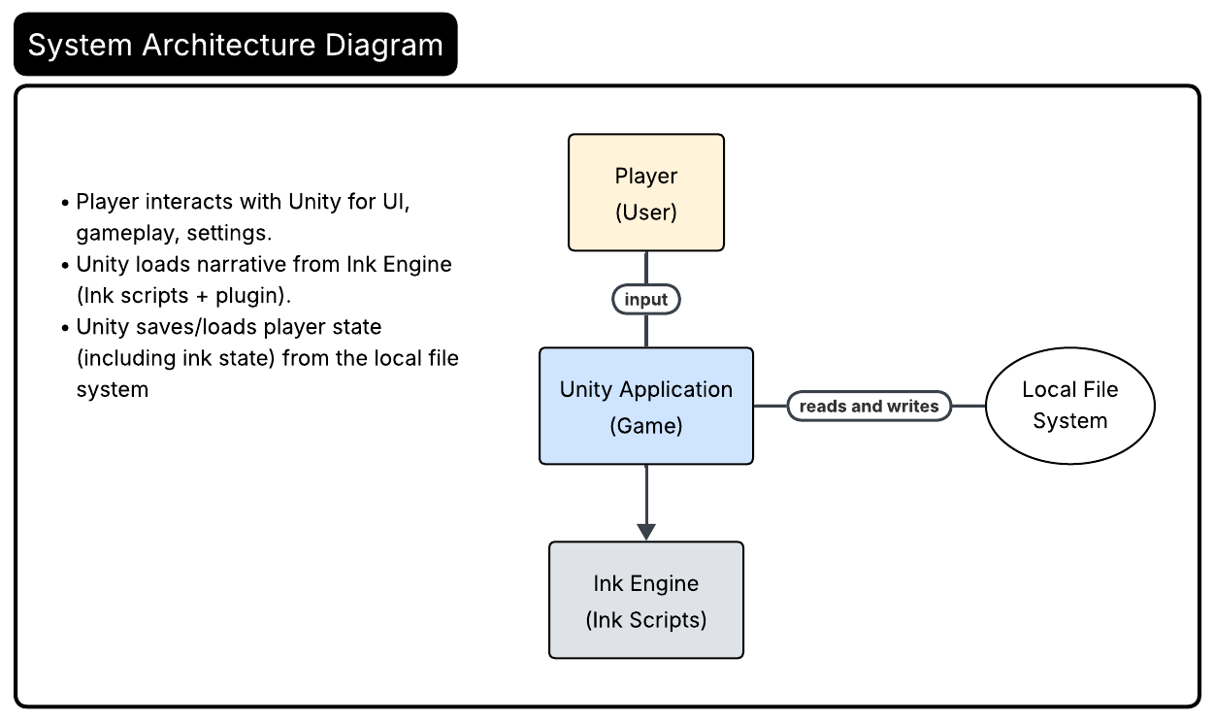
The game is a single-user desktop application built in Unity, with all narrative content authored in Ink. The Unity Ink Integration plugin loads and parses Ink story files at runtime, driving all branching logic and tracking story state. The game interacts with the local file system to save and load progress, a combination of serialized Ink state, player name, and player UI preferences. No network or external APIs are required. The admin role (for development and QA) will have access to the actual game files themselves and will be able to utilize Unities built-in debugging features.
Figure 1 shows the system architecture diagram for the game. The figure depicts interaction, such as the player interacts with the application, the application loads the narrative from ink using plugin, and the application reads and writes save from the user file

2.2 Product Functions
Function ID | Function Name | Description
F1 | Start New Game | Begin a new game session, initializing story state and consequence tracking for the player.
F2 | Player Name Selection | Enable the player to choose a name for themselves at the start of the game.
F3 | Branching Dialogue System | Present dialogue options from a complex decision tree, tracking choices and available paths.
F4 | Consequence Tracking | Record and manage player decisions, updating story branches and future dialogue options based on choices.
F5 | Feedback System | Provide immediate feedback or narrative response to the players’ dialogue choice.
F6 | Save Game | Allow the player to save their current progress.
F7 | Load Game | Enable the player to continue from their last saved state.
F8 | Settings Management | Adjust basic settings such as text size, audio volume, and UI preferences.
F9 | Exit Game | Allow the player to safely close the application, ensuring progress is saved if necessary.

2.3 Use-Case Model Survey
Use Case | Description
UC-1: Start New Game | Player begins a new game and chooses a name.
UC-2: Save Game | Player saves game at current progress.
UC-3: Load Game | When opening the game again, the player can load their previous save and resume from where they were.
UC-4: Open Settings | Player can view and modify default settings at any time.
UC-5: Exit Game | Player can close the game at any time.
UC-6: Access Debug Tools | Admin can view logs, reset game state, etc.
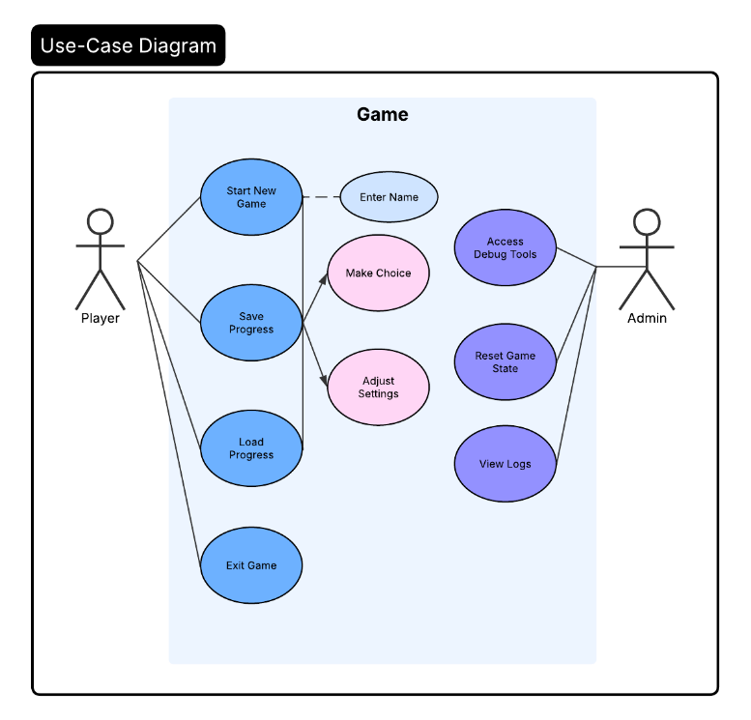
2.4 User Characteristics
Figure 2 shows the use case diagram for the game. As shown in the figure the player is able to make choices, adjust settings, save progress etc. The admin has access to debug tools, viewing logs etc.
This game is designed for players that are fans of interactive fiction, RPGs, and similar narrative-driven games who are looking for games where their decisions feel more meaningful. It will also be beneficial for writers looking to explore dynamic narrative branching storylines. Experienced players will find the mechanics very simple and straightforward, while newer players who don’t play games often will be able to easily pick them up and be able to have an enjoyable experience. Players will access the game through an application download and play in on their own system. It should take up only a minimal amount of disk space and be able to run with minimal system requirements.

2.5 Constraints
The game will utilize Unity, as this engine supports cross-platform development and many integrated tools. It will be a local executable game file that will need to be downloaded. Another constraint will be that as a solo developer, resources are limited. Though the game is simple, it will still have many components that will be a significant time commitment for one person. Since the game will have a large number of potential combinations and story paths, thoroughly testing the game to eliminate bugs is a major challenge. It will also need to comply with data privacy regulations as it does ask for the players name.
  - Assumptions and Dependencies
The game will be run on a common operating system, such as Windows, macOS, or Linux. It assumes the player can read and understand textual descriptions and commands and has a fundamental understanding of RPG mechanics like dialogue trees. The game assumes it will be interacted with using typical keyboard, mouse, and monitor. The game engine, Unity, can natively support the required features, such as save/load functionality and a scripting system for choices and consequences.

3. Specific Requirements
3.1 Functional Requirements
ID | Title | Description | Inputs | Outputs
FR1 | Game Start | The system shall present the player with options to start a new game or load an existing one. | User selection | New game state
FR2 | Input Player Name | The system shall prompt the user to enter a player name. | Keyboard input | Name stored
FR3 | Present Choices | The system shall display available narrative options. | Current Ink position | List of choices
FR4 | Process Choice | The system shall advance the Ink story and update all variables and consequences based on player input. | Player’s choice selection | Story progress
FR5 | Save Progress | The system shall save the Ink state, player name, and preferences to a local file. | Save command | File on disk
FR6 | Load Progress | The system shall allow the player to load a previous save. | Load command | Restored state
FR7 | Adjust Settings | The system shall allow the player to configure text size, audio volume, and related options. | Settings menu interaction | New settings
FR8 | Auto-Save | The system shall auto-save game progress at designated checkpoints or major decisions. | Checkpoint reached | File on disk

3.2 Non-functional Requirements
ID | Title | Description | Priority
NFR1 | Readablity | The system shall have a default font size should be easy to read and allow adjustment for accessibility. | High
NFR2 | Performance | The system shall have fast loading times, should load within seconds, and quick response time once a player makes a choice. | High
NFR3 | Stability | The system shall be stable and not crash. In a choice-based game this is crucial for maintaining immersion and story continuity. | High
NFR4 | Save Protection | The system shall protect player saved data from corruption or unauthorized access. | Medium
NFR5 | Low Hardware Requirements | The system shall have minimal CPU, memory, and storage requirements to run on wide range of devices. | Medium

3.3 Performance Requirements
- Compatible with common operating systems such as Windows, macOS, and Linux.
- The game should require negligible CPU power and memory. Any system with at least 1 to 2GB of RAM is sufficient.
- Should take up very little space, likely less than 1GB for the executable file and assets.
- The integrated graphics on any modern machine should be able to handle the basic UI.
- The game shouldn’t have any delay between player choice and system response. On a local system this should be instant.
- The game should load immediately on startup.

- Data Model and Description
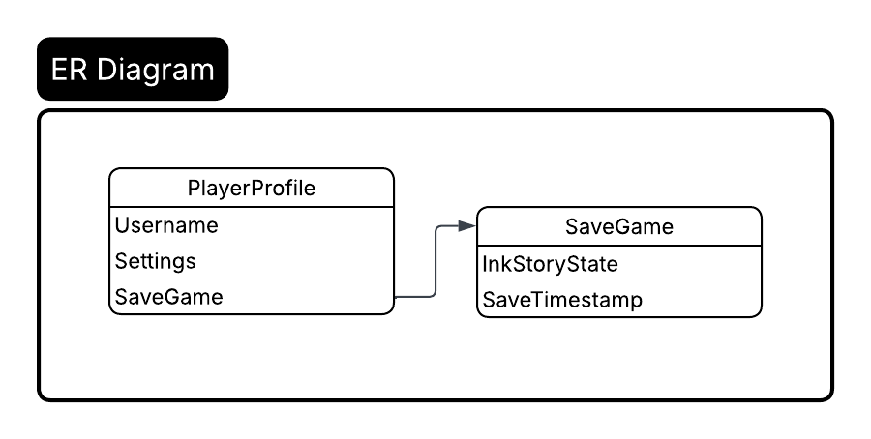
Figure 3 shows the ER diagram for the game. PlayerProfile holds player info and SaveGame record. SaveGame contains full Ink state and timestamp. Settings are a property of PlayerProfile.
4.1 Data Dictionary
Field Name | Data Type | Description
Username | String | Player name, entered at game start
InkStoryState | JSON/String | Serialized JSON of Ink’s complete narrative progress for current save
SaveTimestamp | DateTime | Timestamp for when progress was last saved
Settings | JSON/String | Player preferences: text size, audio level etc.
- External Interface Requirements
Interface | Description | Protocol/API
Unity Engine | Core game rendering, input, and logic. Manages preferences. | Unity API
Ink Integration  (Inkle) | Loads and executes Ink story scripts within Unity. Manages story state. | Ink Unity Plugin API
Local File System | For saving and loading Ink state, user name, and preferences.
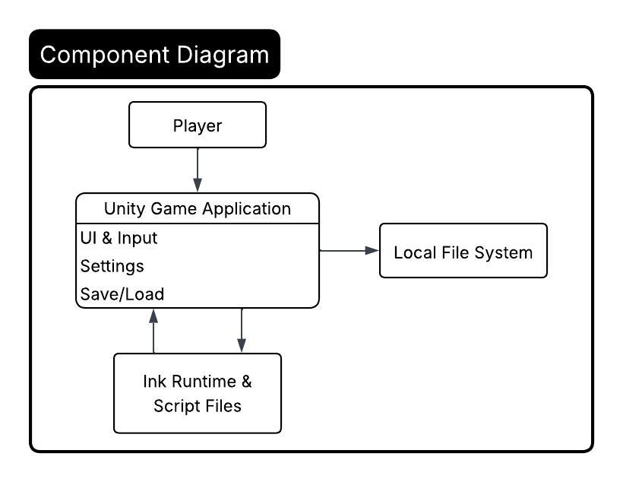
Figure 4 shows the component diagram for the game. Unity gets and sends story data to Ink runtime, Unity saves/loads current state to file system. Player only interacts via Unity UI.

