**System Requirements Specifications**

**Volt & Pepper Southeast Con Autonomous Robot**

**Abstract:**

**Revision History**

|  |  |  |
| --- | --- | --- |
| **Date** | **Reason for Change** | **Version** |
| Sep. 5, 2014 | Initial draft of document | 0.0.1 |
| Sep. 7, 2014 | Added requirements and user stories | 0.0.2 |
| Sep. 8, 2014 | Revised requirements, added definitions | 0.0.3 |
| Sep. 9, 2014 | Updated Definitions | 0.0.4 |
| Sep. 11, 2014 | Defined sections of document | 0.0.5 |
| Sep. 12, 2014 | Compiled components of SRS together | 0.0.6 |
|  |  |  |
|  |  |  |

**Table of Contents**

**Introduction**

**Purpose**

**Mission Statement**

**Scope**

**Team Info**

|  |  |
| --- | --- |
| **Name** | **Role** |
|  | Team Leader |
|  | Development Leader |
|  | Testing Leader |
|  | Software Configuration Manager |
|  |  |
|  |  |
|  |  |
|  |  |
|  |  |
|  |  |
|  |  |
|  |  |
| Nezar Bahksh | Scrum Master |
| Brittany Rompa | Product Manager |
| Nezar Bahksh | Developer |
| Greg Carkin | Developer |
| Gary Roach | Developer |
| Brittany Rompa | Developer |

**Overall Description**

**Stakeholders**

**Team**

**Instructors**

**ERAU**

**Nova Southeastern University & Broward College**

**ABET**

**Product Perspective**

**Product Functions**

**Constraints**

**Assumptions**

**Risks**

**Use Cases**

**Startup**

**Navigation**

**Simon**

**Etch A Sketch**

**Rubik’s Cube**

**Playing Card**

**Sequence Diagrams**

The following diagrams provide a sequence of actions in order to complete a task. The tasks are broken into 6 components based on the potential states of the robot. Initially there is the startup state which occurs when the robot receives the start signal, which has yet to be determined by the competition. The following state is an ongoing state having to do with navigation around the course. Thus it is named the navigation state. The last four states have to do with each of the games; a Simon state, Etch A Sketch state, Rubik’s cube state, and a playing card state. All of the states require preconditions and post conditions in order to enter and exit the state. The specific conditions have yet to be determined, but in general the main task of each state must be completed before the robot transitions to the following state. IE before the robot can exit the Simon state; it must have completed the task first.

The following figure provides the sequence of general activities for the startup state of the robot.



The following figure provides the sequence of general activities for the navigation state of the robot.



The following figure provides the sequence of general activities for the Etch A Sketch state of the robot.



The following figure provides the sequence of general activities for the playing card state of the robot.



The following figure provides the sequence of general activities for the Rubik’s cube state of the robot.



The following figure provides the sequence of general activities for the Simon state of the robot.



**Requirements**

**Functional**

* The robot shall traverse the course.
* The robot shall remain on the white line at all times.
* The robot shall recognize when it reaches an object.
* The robot shall complete each challenge once.
* The robot shall turn on Simon.
* The robot shall obtain a pattern from Simon.
* The robot shall input the obtained pattern into Simon.
* The robot shall input the obtained pattern within X seconds from Simon’s last output.
* The robot shall know when a pattern is complete.
* The robot shall know when the challenge is complete.
* The robot shall print “IEEE” on an Etch A Sketch.
* The robot shall rotate one row of a Rubik’s Cube 180 degrees.
* The robot shall obtain one playing card from a deck of cards.
* The robot shall complete the course with the playing card.
* The robot shall cross the finish line.

**Non-Functional**

* The robot shall fit within 1 ft3.
* The robot shall be autonomous.
* The robot shall remain on the course for 5 minutes.
* The robot shall interact with Simon for exactly 15 seconds.
* The robot shall complete the challenges in sequence.
* The robot shall execute all requirements within 5 minutes.

**Glossary**

*Robot*: The platform being built for the 2015 IEEE SoutheastCon

*Autonomous*: ------

*Course*: 5/8 inches x 4 feet x 8 feet Sanded Pine Plywood

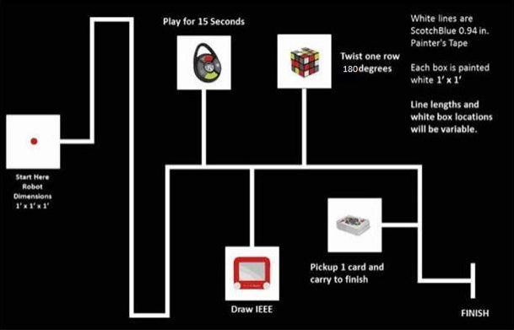

**Figure 1: 2015 IEEE SoutheastCon Hardware Competition course (IEEE)**

*Line*: Scotch Blue 0.94 inches x 60 yards. Painter's Tape, Model# 2090-1J Store SKU # 958999

*Recognize*: To identify from knowledge of appearance or characteristics. (recognize)

*Challenge:* One of the four tasks—Simon, Etch A Sketch, Rubik’s Cube, or playing card.

*Traverse*: To move along.

*Interact*: Turn on Simon, obtain and deliver output to Simon

*Pattern*: The sensory output sequence from Simon.

*Complete*: Finish interacting.

*Know*: To perceive or understand.

*Obtain*: Have possession of.

*Sequence*: Simon, Etch A Sketch, Rubik’s Cube, playing card, finish line

*Print*: To draw or produce.

*Turn on*: Power Simon “on” by pressing the middle button

*Output*: The pattern from Simon.

*Inpu*t: The pattern returned to Simon.

*Finish line*: Refer “FINISH” in Figure 1

*Simon*: - Simon Carabiner - “R”Web#:351215, SKU:226CE810, UPC/EAN/ISBN:014397018500

*Etch A Sketch*: Pocket Etch A Sketch - By: Ohio Art - “R”Web#:636061, SKU:FD79DD3F, UPC/EAN/ISBN:026511051508

*Rubik’s Cube*: - Rubik's 3x3 Cube - “R”Web#:374846, SKU:DAD09D9E, UPC/EAN/ISBN:714043050273

*Playing card*: A card from a standard 52-card deck – Toys”R”Us # (TBD)

*Deck of cards*: Standard 52-card deck – Toys”R”Us # (TBD)

Acronyms & Abbreviation

# References

IEEE. (n.d.). *SoutheastCon Hardware Competition Rules (DRAFT)*. Retrieved September 8, 2014, from http://sites.ieee.org/sb-unfc/files/2014/07/hardwareComp2015.pdf

*recognize*. (n.d.). Retrieved September 2014, from Dictionary.com: http://dictionary.reference.com/browse/recognize

Index