**MAKE SURE TO REREAD AND REWORD, PARTS OF THIS COPIES FROM THE GUIDE DOCUMENT**

**Stakeholders**

The following is a comprehensive list of individual parties that have a stake in the development, production, and operation of the VPS.

**Team**

The development team for the VPS will be graded on the adequate completion of the system by customers (ref to instructors). Grading of the product includes the product itself along with all artifacts created throughout the Capstone process.

**Dr. Barott, Dr. Seker, and Jorge Torres**

As costumers of the VPS product, Dr. Barott, Dr. Seker, and Jorge are interested in the completion of the product and all artifacts created throughout completion of the product. Additionally Dr. Barott and Dr. Seker are interested in the development team ensuring the product meets the standards set for the Capstone Senior Design project for the Department of Electrical, Computer, Software & Systems Engineering (ECSSE) Department of Embry-Riddle Aeronautical University (ERAU)

**ERAU**

The VPS will compete against other teams within ERAU to pick the best team to send to Southeast Con. If chosen the University will be applying its name to the project and as such all actions and the final product of the development team reflect the name of ERAU. Therefore, must conform to the required standards of the University as defined in the student handbook for the 2014-2015 academic year.

**ECSSE at ERAU**

The department is interested in the product being delivered on time, and is on or under budget, as specified by the budget document for this product; which is TBD as of 9/18/14.

**Nova Southeastern University & Broward College**

The hosting University / College is interested in the product complying with all regulations for the competition so not to cause harm to the University / College, or any persons which may come into contact with the product.

**Accreditation Board for Engineering and Technology, Inc. (ABET)**

This capstone project must abide by the standards of ABET in order to receive credit for completion of this two semester course.

Sequence Diagrams

Setup

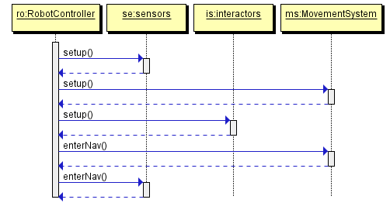

Nav

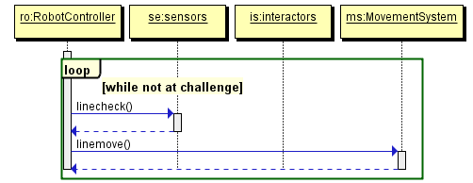

Simon

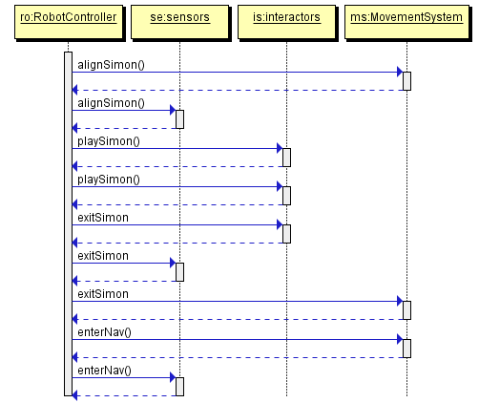

Etch

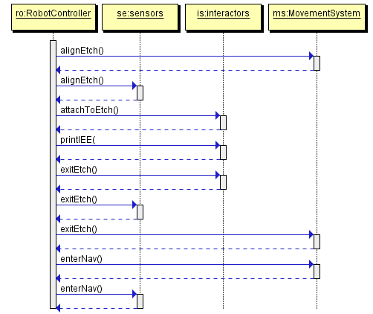

Cube

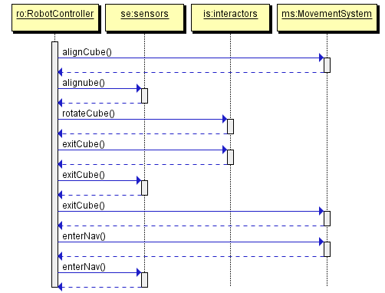

Card

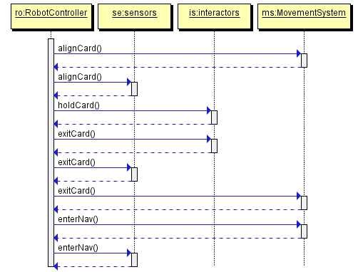

Shutdown

