**System Requirements**

**Specifications for Volt & Pepper System (VPS)**

Sponsor

**The Department of Electrical, Computer, Software & Systems Engineering at Embry-Riddle Aeronautical University**

Released September 18, 2014

**Volt & Pepper Development Team**

**Abstract**: <CHANGE> The system requirements specifications are enumerated and detailed within this document. These requirements act as a binding contract between the customer of the Volt & Pepper System and the Volt & Pepper Development Team. The stakeholders and involved parties are catalogued and the involvement of each party is detailed. This document is fully compliant with the Institute of Electrical and Electronics Engineers (IEEE) Std. 1233-1998, the *IEEE Recommended Practice for Software* *Requirements Specifications* <REF>

_______________________

# Revision History

|  |  |  |
| --- | --- | --- |
| **Date** | **Reason for Change** | **Version** |
| Sep. 5, 2014 | Initial draft of document | 0.0.1 |
| Sep. 7, 2014 | Added requirements and user stories | 0.0.2 |
| Sep. 8, 2014 | Revised requirements, added definitions | 0.0.3 |
| Sep. 9, 2014 | Updated Definitions | 0.0.4 |
| Sep. 11, 2014 | Defined document sections | 0.0.5 |
| Sep. 12, 2014 | Compiled components of SRS together | 0.0.6 |
| Sep. 14, 2014 | Refined document sections, style | 0.0.7 |
|  |  |  |

**Table of Contents**

Revision History ii

1. Introduction 1

1.1 Purpose 1

1.2 Mission Statement 1

1.3 Scope 1

1.4 Team Roles 1

1.5 Overview 1

2. General Description 2

2.1 Stakeholders 2

2.1.1 VPSDT 2

2.1.2. Dr. Barott, Dr. Seker, Jorge Torres 2

2.1.3 Embry-Riddle Aeronautical University 2

2.1.4 Nova Southeastern University &Broward College 2

2.1.5. IEEE 2

2.1.6 ABET 2

2.2 Product Perspective 2

2.3 Product Functions 2

2.4 User Characteristics 3

2.5 General Constraints 3

2.6 Assumptions and Dependencies 3

2.7 Use Cases 3

2.8 Sequence Diagrams 3

3. Requirements 3

3.1 Functional Requirements 3

3.2 Nonfunctional Requirements 4

A. Appendices 4

A.1 Appendix 1 4

A.2 Appendix 2 4

# 1. Introduction

## 1.1 Purpose

The purpose of this document is to provide a detailed account of the scope, high-level description, and system requirements of the Volt & Pepper System, henceforth known as VPS. The requirements include functional and nonfunctional requirements and system constraints. This document is aimed toward the customer of the VPS. This document is meant to capture the high-level requirements of the VPS.

## 1.2 Mission Statement

To create a fully autonomous robot that can traverse over a path marked by a white line, and complete four tasks. These tasks include playing Simon for 15 seconds, drawing IEEE on an Etch-A-Sketch, rotating one row of a Rubik’s cube 180 degrees, and picking up and carrying a playing card to the end of the course.

## 1.3 Scope

The VPS is intended to compete in the SoutheastCon 2015 competition. SoutheastCon is the annual IEEE Region 3 Technical, Professional, and Student Conference. It brings together Computer Scientists, Electrical, and Computer Engineering professionals, faculty and students to share the latest information through technical sessions, tutorials, and exhibits (IEEE, 2014).

## 1.4 Team Roles

|  |  |
| --- | --- |
| **Name** | **Role** |
| Nezar Bahksh | Team Leader  Scrum Master  Development Team |
| Gary Roach | Development Leader  Development Team |
| Brittany Rompa | Testing Leader  Prodct Owner  Development Team |
| Greg Carkin | Software Configuration Manager  Development Team |

## 1.5 Overview

This document is compliant with the standards set in IEEE Std 1233, 1998 Edition. The document has been divided into three sections. Section 1 serves as a introduction to the VPS, which describes the scope of the project and the team involved. Section 2 contains the general VPS description which includes the product stakeholders, functions of the VPS, and proposed use cases, and Section 3 contains the VPS functional and nonfunctional requirements.

The glossary contains all ambiguous words and phrases, as well as industry terms used in the document. Appendix A serves as the index for all diagrams, tables, and pictures used in the document.

# 2. General Description

## 2.1 Stakeholders

The following list contains all parties involved in or have a stake in the development of the VPS.

## 2.1.1 VPSDT

< from greg >

## 2.1.2. Dr. Barott, Dr. Seker, Jorge Torres

< from greg >

## 2.1.3 Embry-Riddle Aeronautical University

< from greg >

## 2.1.4 Nova Southeastern University &Broward College

< from greg >

## 2.1.5. IEEE

< from greg >

## 2.1.6 ABET

< from greg >

## 2.2 Product Perspective

The VPS is intended to be a self-propelled, autonomous robot that can complete a series of challenges for the 2015 IEEE SoutheastCon Hardware Competition.

## 2.3 Product Functions

The functionality of the VPS is divided into seven major functions: (1) The robot startup function, referred to as the setup throughout this document, (2) The robot navigation function, referred to as navigation throughout this document, (3) The robot Simon challenge function, referred to as Simon throughout this document, (4) The robot Etch A Sketch challenge function, referred to as Etch A Sketch throughout this document, (5) The robot Rubik’s cube function, referred to as Rubik’s cube throughout this document, (6) The robot playing card challenge function, referred to as playing card throughout this document, (7) The robot shut down function, referred to as shut down throughout this document, These functions do not impose a design constraint on the VPS, but are instead used to facilitate the requirements engineering process.

## 2.4 User Characteristics

This subsection of the SRS should describe those general characteristics of the eventual users of the product that will affect the specific requirements. (See the IEEE Guide to SRS for more details).

## 2.5 General Constraints

*This subsection of the SRS should provide a general description of any other items that will*

*limit the developer’s options for designing the system. (See the IEEE Guide to SRS for a partial list of possible general constraints).*

## 2.6 Assumptions and Dependencies

< still need >

## 2.7 Use Cases

<From Gary>

## 2.8 Sequence Diagrams

The following diagrams provide a sequence of actions in order to complete a task. The tasks are broken into 6 components based on the potential states of the robot. Initially there is the startup state which occurs when the robot receives the start signal, which has yet to be determined by the competition. The following state is an ongoing state having to do with navigation around the course. Thus it is named the navigation state. The last four states have to do with each of the games; a Simon state, Etch A Sketch state, Rubik’s cube state, and a playing card state. All of the states require preconditions and post conditions in order to enter and exit the state. The specific conditions have yet to be determined, but in general the main task of each state must be completed before the robot transitions to the following state. IE before the robot can exit the Simon state; it must have completed the task first.

# 3. Requirements

## 3.1 Functional Requirements

* + 1. The robot shall traverse the course.
       1. The robot shall remain on the white line, which marks the path of the course, at all times.
       2. The robot shall move to the next challenge once the current challenge is complete.
       3. The robot shall move to the finish line once all challenges are complete.
       4. The robot shall cross the finish line.
    2. The robot shall complete all four challenges, defined as: Simon, Etch A Sketch, Rubik’s Cube and playing card.
       1. The robot shall complete each challenge once.
       2. The robot shall keep track of progress on a challenge.
       3. The robot shall complete the challenges in a sequential matter.
       4. The robot shall execute the challenges one at a time.
    3. The robot shall complete the Simon challenge.
       1. The robot shall activate the Simon game.
       2. The robot shall obtain a pattern from Simon.
       3. The robot shall press the buttons on Simon in a pattern corresponding to the obtained pattern.
    4. The robot shall complete the Etch A Sketch challenge.
       1. The robot shall print “IEEE” on an Etch A Sketch.
    5. The robot shall complete the Rubik’s Cube challenge.
       1. The robot shall rotate one row of a Rubik’s Cube 180 degrees.
    6. The robot shall complete the playing card challenge.
       1. The robot shall obtain one playing card from a deck of cards.
       2. The robot shall complete the course with the playing card.

## 3.2 Nonfunctional Requirements

1. The robot shall fit within 1 ft3.
2. The robot shall be autonomous.
3. The robot shall remain on the course for 5 minutes.
4. The robot shall interact with Simon for exactly 15 seconds.
5. The robot shall complete the challenges in sequence.
6. The robot shall execute all requirements within 5 minutes.
7. The robot shall press the buttons on Simon before Simon outputs an error tone.
8. The robot shall fulfill the competition safety regulations.
   * + 1. The robot shall contain nonflammable substances.
       2. The robot shall not damage the course.
       3. The robot shall do no harm.
       4. The robot shall shut off in case of emergency.
     1. The robot shall operate with an on-board power supply.

# Appendicies

## A.1. Appendix 1

The following figures are a supplemental visual aid of the 2015 IEEE SoutheastCon Hardware Competition course components.

## Screen Shot 2014-09-02 at 9

Fig. 1: 2015 IEEE SoutheastCon Hardware Competition course

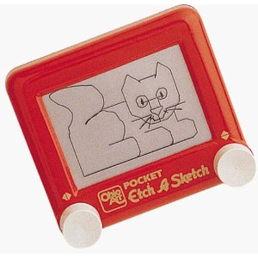

Fig. 2: Etch A Sketch



Fig. 3: Standard 52-deck of playing cards

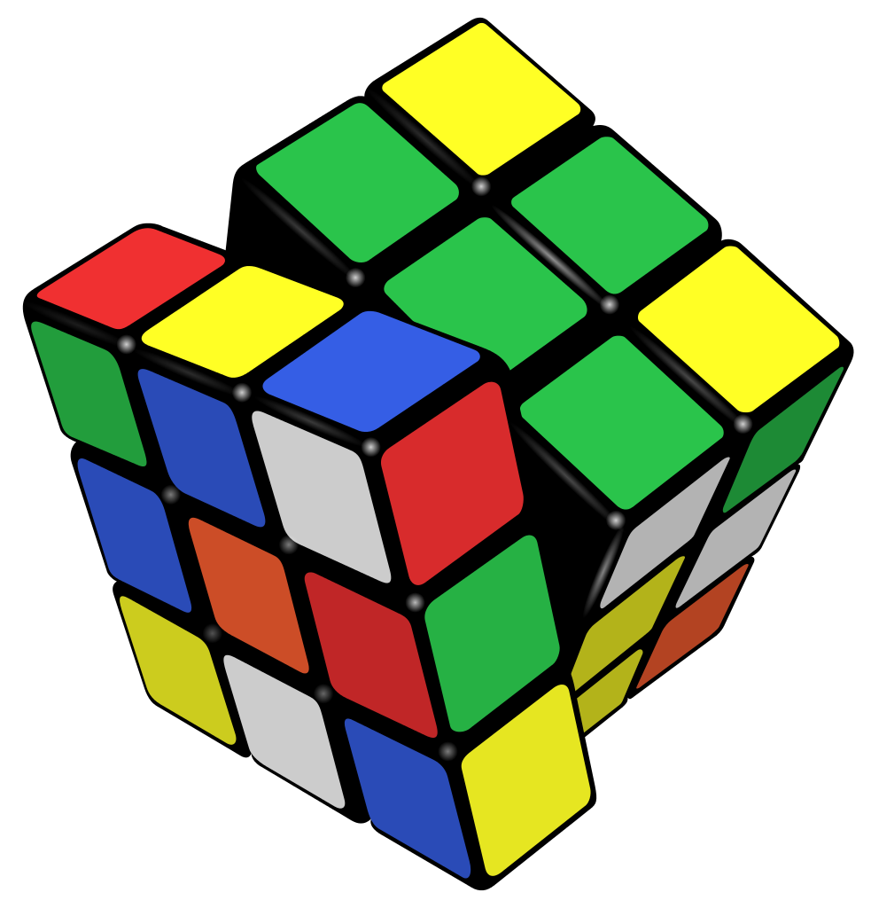

Fig. 4: Rubik's 3x3 Cube



Fig. 5: Simon Carabineer

## Glossary

|  |  |  |
| --- | --- | --- |
| **Entry** | **Definition** | **Aliases** |
| Autonomous |  | Self-sufficient |
| Challenge | One of the four tasks- Simon, Etch A Sketch, Rubik’s Cube, or playing card | Task |
| Course | 5/8 in. x 4 ft. x 8 ft. Sanded Pine Plywood |  |
| Deck of cards | Standard 52-card deck | Deck |
| Emergency |  |  |
| Etch A Sketch | Pocket Etch A Sketch by: Ohio Art (see Appendix A.1, Fig. 2) |  |
| Finish Line | Refer to “FINISH” in Fig. 1 | Finish |
| Line | Scotch Blue 0.94 in. x 60 yd. Painter’s Tape |  |
| Obtain | To have possesion of |  |
| Playing card | A card from the standard 52-card deck (see Appendix A.1, Fig. 3) | Card |
| Print | To draw or produce |  |
| Robot | The platform being built for the 2015 IEEE SoutheastCon Hardware Competition. |  |
| Rubik’s Cube | Rubik’s 3x3 Cube (see Appendix A, Fig. 4) |  |
| Sequence | Simon, Etch A Sketch, Rubik’s Cube, playing card, finish line |  |
| Simon | Simon Carabineer (see Appendix A, Fig. 5) |  |
| Traverse | To move across |  |
|  |  |  |

# Acronyms & Abbreviations