**System Requirements**

**Specifications for Volt & Pepper System (VPS)**

Sponsor

**The Department of Electrical, Computer, Software & Systems Engineering at Embry-Riddle Aeronautical University**

Released September 18, 2014

**Volt & Pepper Development Team**

**Abstract**: The System Requirements Specifications (SyRS) for the Volt & Pepper System are detailed within this document. These requirements serve as a contract between the customer of the Volt & Pepper System and the Volt & Pepper Development Team. All stakeholders are recognized and the extent of each party’s respective involvement is thoroughly detailed. This document is compliant with the Institute of Electrical and Electronics Engineers (IEEE) Std. 1233-1998 [4] and the *IEEE Recommended Practice for Software* *Requirements Specifications* [5].

_______________________

# Revision History

|  |  |  |
| --- | --- | --- |
| **Date** | **Reason for Change** | **Version** |
| Sep. 5, 2014 | Initial draft of document | 0.0.1 |
| Sep. 7, 2014 | Added requirements and user stories | 0.0.2 |
| Sep. 8, 2014 | Revised requirements, definitions added | 0.0.3 |
| Sep. 9, 2014 | Updated Definitions | 0.0.4 |
| Sep. 11, 2014 | Defined document sections | 0.0.5 |
| Sep. 12, 2014 | Compiled components of SyRS together | 0.0.6 |
| Sep. 14, 2014 | Refined document sections and styles | 0.0.7 |
| Sep. 15, 2014 | Abstract, references added | 0.0.8 |
| Sep. 16, 2014 | Use cases added, numbering adjusted | 0.0.9 |
|  |  | 1.0.0 |

**Table of Contents**

Revision History ii

List of Figures iv

List of Tables v

1. Introduction 1

1.1. Purpose 1

1.2. Mission Statement 1

1.3. Scope 1

1.4. Team Roles 1

1.5. Overview 2

2. General Description 2

2.1. Stakeholders 2

2.1.1 Volt & Pepper System Development Team 2

2.1.2 Dr. Barott, Dr. Seker, Jorge Torres 2

2.1.3 Embry-Riddle Aeronautical University 2

2.1.4 Department of Electrical, Computer, Software & Systems Engineering 3

2.1.5 Nova Southeastern University & Broward College 3

2.1.6 Accredation Board of Engineering and Technology, Inc. 3

2.2 Product Perspective 3

2.3 Product Functions 3

2.4 User Characteristics 3

2.5 General Constraints 3

2.6 Assumptions and Dependencies 3

2.7 Use Cases 4

2.7.1 Use Case 1: Startup 5

2.7.2 Use Case 2: Monitor Red LED 5

2.7.3 Use Case 3: Navigation 6

2.7.4 Use Case 4: Simon Carabiner 7

2.7.5 Use Case 5: Etch A Sketch 8

2.7.6 Use Case 6: Rubik’s Cube 9

2.7.7 Use Case 7: Playing Card 9

2.8 Sequence Diagrams 10

3. Requirements 16

3.1 Functional Requirements 16

3.2 Nonfunctional Requirements 16

A. Appendicies 18

A.1. Appendix A 18

Glossary 20

Acronyms & Abbreviations 21

References 22

# List of Figures

# List of Tables

# Introduction

<words>

## Purpose

The purpose of this document is to provide a detailed account of the scope, high-level description, and system requirements of the Volt & Pepper System, henceforth known as VPS. The requirements include functional and nonfunctional requirements and system constraints. This document is aimed toward the customer of the VPS. This document is meant to capture the high-level requirements of the VPS.

## Mission Statement

To create a fully autonomous robot that can traverse over a path marked by a white line, and complete four tasks. These tasks include playing Simon for 15 seconds, drawing IEEE on an Etch A Sketch, rotating one row of a Rubik’s cube 180 degrees, and picking up and carrying a playing card to the end of the course.

## Scope

The VPS is intended to compete in the IEEE SoutheastCon 2015 Hardware [7]. SoutheastCon is the annual IEEE Region 3 Technical, Professional, and Student Conference. It brings together Computer Scientists, Electrical, and Computer Engineering professionals, faculty and students to share the latest information through technical sessions, tutorials, and exhibits [6].

## Team Roles

The following table presents all members of the Volt & Pepper System Development Team (VPSDT) and respective role assignments. Each member is accountable for the overesight and advancement of the positions held.

Table 1—Team roles

|  |  |
| --- | --- |
| **Name** | **Role** |
| Nezar Bahksh | Team Leader  Scrum Master  Development Team |
| Greg Carkin | Software Configuration Manager  Development Team |
| Gary Roach | Development Leader  Development Team |
| Brittany Rompa | Testing Leader  Prodct Owner  Development Team |

## Overview

This document is compliant with the standards established in IEEE Std. 1233, 1998 Edition [4]. The document has been divided into three sections. Section 1 serves as a introduction to the VPS, which describes the scope of the project and the team involved. Section 2 contains the general VPS description which includes the product stakeholders, functions of the VPS, and proposed use cases, and Section 3 contains the VPS functional and nonfunctional requirements.

The glossary contains all ambiguous words and phrases, as well as industry terms used in the document. Appendix A serves as the index for all diagrams, tables, and pictures used in the document.

# General Descriptions

<words>

## Stakeholders

The following is a comprehensive list of individual parties that have a stake in the development, production, and operation of the VPS.

### Volt & Pepper System Development Team

The development team for the VPS will be graded on the adequate completion of the system by customers (see 2.1.2). Grading of the product includes the product itself, along with all artifacts created throughout the 2014-2015 Senior Design process.

### Dr. Barott, Dr. Seker, Jorge Torres

As custumers of the VPS, Dr. Barott, Dr. Seker, and Jorge Torres are interested in the completion of the product and all artifacts created throughout the 2014-2015 Senior Design process. Additionally, Dr. Barott and Dr. Seker are interested in the development team ensuring the product meets the standards set forth in the Capstone Senior Design project for the Department of Electrical, Computer, Software & Systems Engineering (ECSSE) at Embry-Riddle Aeronautical University (ERAU).

### Embry-Riddle Aeronautical University

The VPS will be one of three contending teams from ERAU that is competing to be sent to the IEEE SoutheastCon 2015 Hardware Competition [7]. If chosen, the final product produced by the VPSDT will uphold the prestige of ERAU. In doing so, the VPS must conform to the standards of the University as defined in the 2014-2015 Student Handbook [2]**.**

### Department of Electrical, Computer, Software & Systems Engineering

ERAU’s Department of Electrical, Computer, Software & Systems Engineering (ECSSE) is interested in the product being delivered on time and within budget, as specified by the budget document for this product (TBD as of 9/18/14).

### Nova Southeastern University & Broward College

The hosting University is interested in the product complying with all regulations for the competition. It is essential to maintain a safe environment by assurring no product will cause harm to the University / College, or any persons which may come into contact with the product.

### Accredation Board of Engineering and Technology, Inc.

The product must abide by the standards of ABET in order to receive credit for completion of this two-semester course.

## Product Perspective

The VPS is intended to be a self-propelled, autonomous robot that can complete a series of challenges for the 2015 IEEE SoutheastCon Hardware Competition [7].

## Product Functions

The functionality of the VPS is divided into seven major functions: (1) The VPS startup function, referred to as the setup throughout this document, (2) The VPS navigation function, referred to as navigation throughout this document, (3) The VPS Simon challenge function, referred to as Simon throughout this document, (4) The VPS Etch A Sketch challenge function, referred to as Etch A Sketch throughout this document, (5) The VPS Rubik’s Cube function, referred to as Rubik’s Cube throughout this document, (6) The VPS playing card challenge function, referred to as playing card throughout this document, (7) The VPS shut down function, referred to as shut down throughout this document, These functions do not impose a design constraint on the VPS, but are instead used to facilitate the requirements engineering process.

## User Characteristics

The VPS is proposed by an undergraduate senior team as a graduation project, it is inteneded to show the high standardes asked of all seniors graduating from the Department of Electrical, Computer, Software, and Systems Engineering at Embry-Riddle Aeronautical University. It is also intended to not require higher level of education than undergraduate seniors to develop and operate.

The following user requirments is needed in order to use the VPS. The VPS should not be used by anyone lacking these requirments.

* Basic programming knowledge
* Basic safety precaution with low voltage external power supply
* Basic mathematic knowledge including the following
  + Basic understanding of powers of 10 including
  + Basic understanding of angles and radians
  + Basic computnig knowledge including
    - Addition
    - Substaction
    - Multiplication
    - Division

## General Constraints

The VPS is constrained by the IEEE regulations for the Southeast Con competetion, such regulations includes the following:

* The physical size of the VPS can’t exceed 1ft. x 1 ft. x 1 ft.
* The VPS must remain as one unit while operating
* The VPS can’t have any outside influence while operating
* While operating, the VPS can’t move any object outside its station
* The VPS can’t hold any flammable substances
* While operating, the robot must cover the white line underneath it at all time
* Given the course dimensions the size constrain denies us by default from executing multiple challenges simultaneously
* The VPS is constrained to finish all tasks in a time interval less than five minutes

## Assumptions, Dependencies and Risks

## Dependencies

* The VPS depends on IEEE regulations; as the IEEE regulations change, the VPS requirements will also have to update and change correspondingly.
* Funding from the Department of Electrical, Computer, Software, & Systems Engineering at Embry-Riddle Aeronautical.
* All member of the development team being collaborative

## Assumptions

* The VPSDT assumes the VPS can complete all the requirements without running out of power.
* The VPSDT assumes the VPS can be designed, developed, tested and operated without harming any user.
* The VPSDT assumes the VPS can complete all the requirements without falling apart.

## Risks

* The VPS might deviate from the white line.
* The VPS might fall off the course.
* The VPS might be misaligned with a challenge.
* The VPS might damage an object on the course.
* The VPS might run out of onboard power while operating.
* The VPS might

## Use Cases

The following use cases demonstrate the proper functionality of the autonomous VPS. These use cases represent the required operation in order to receive maximum points for the competition. Deviation from the normal operation of the VPS may result in a loss of points or disqualification

1. Use Case 1: Startup

Scope: VPS

Level: User goal

Primary Actors: Volt and Pepper team member

1. Stakeholders and Interests

<insert stakeholders that apply to this use case>

1. Preconditions

1. The VPS is not on (power to the VPS is disabled)

2. The VPS is not within the 1 ft. x 1 ft. starting square

1. Postconditions

The VPS is on (power to the VPS is enabled)

The VPS is within the 1 ft. x 1 ft. starting square

1. Main Success Scenario
   * + 1. The team member places the VPS within the 1 ft. x 1 ft. starting square, ensuring that the VPS is facing towards the desired path of travel
       2. The team member activates the VPS (enables power to the VPS)
2. Frequency of Occurrence

This use case will occur at the start of each round of the competition. Amount of rounds will vary based on amount of participants, successful completion of the course, as well as the time it takes to achieve successful completion of the course.

1. Use Case 2: Monitor Red LED

Scope: VPS

Level: User goal

Primary Actors: Red LED

1. Stakeholders and Interests

<insert stakeholders that apply to this use case>

1. Preconditions
2. The VPS is on (power to the VPS is enabled) as described in Use Case 1: Startup
3. The VPS is within the 1 ft. x 1 ft. starting square as described in Use Case 1: Startup
4. The Red LED light is on (the light is illuminated)
5. Postconditions
6. The VPS will begin the task of navigation, as described in Use Case 3: Navigation
7. The VPS is within the 1 ft. x 1 ft. starting square, as described in Use Case 1: Startup
8. The red LED light is off (the light is not illuminated)
9. Main Success Scenario
10. The VPS will wait for the red LED light to turn off
11. The red LED light will turn off
12. The VPS will begin the task of navigation, as described in Use Case 3: Navigation

2.7.2.5 Frequency of Occurrence

This use case will occur once during each round of the competition. Amount of rounds will vary based on amount of participants, successful completion of the course, as well as the time it takes to achieve successful completion of the course.

1. Use Case 3: Navigation

Scope: VPS

Level: User goal

Primary Actors: White line

1. Stakeholders and Interests

<insert stakeholders that apply to this use case>

1. Preconditions
2. The VPS is on (power to the VPS is enabled), as described in Use Case 1: Startup
3. The VPS is within the 1 ft. x 1 ft. starting square or in front of one of the 4 challenges, as described in Use Case 1: Startup, Use Case 4: Simon Carabiner, Use Case 5: Etch A Sketch, Use Case 6: Rubik’s Cube, and Use Case 7: Playing Card
4. The Red LED light is off (the light is not illuminated) or the challenge the VPS is currently in front of has been successfully completed, as described in Use Case 2: Monitor Red LED, Use Case 4: Simon Carabiner, Use Case 5: Etch A Sketch, Use Case 6: Rubik’s Cube, and Use Case 7: Playing Card
5. Postconditions
6. The VPS will be halted at the finish line or in front of one of the 4 challenges, as described in Use Case 4: Simon Carabiner, Use Case 5: Etch A Sketch, Use Case 6: Rubik’s Cube, and Use Case 7: Playing Card
7. The VPS will be touching the white line of the finish line or the painted white line which makes up the box that the challenge resides in
8. Main Success Scenario
9. The VPS will follow the white line, as it heads to the finish line or the next challenge
10. The VPS will cover the white line at all times on route to its destination
11. The VPS will visit and complete each challenge, as described in Use Case 4: Simon Carabiner, Use Case 5: Etch A Sketch, Use Case 6: Rubik’s Cube, and Use Case 7: Playing Card
12. The VPS will, after completion of each challenge(as described in Use Case 4: Simon Carabiner, Use Case 5: Etch A Sketch, Use Case 6: Rubik’s Cube, and Use Case 7: Playing Card), will navigate to and halt at the finish line
13. The VPS will remain halted at the finish line
14. Frequency of Occurrence

This use case will occur five times during each round of the competition. The use case will be used each time the VPS must navigate to the next challenge (four challenges in total, described in Use Case 4: Simon Carabiner, Use Case 5: Etch A Sketch, Use Case 6: Rubik’s Cube, and Use Case 7: Playing Card), then once more to navigate to the finish line. Amount of rounds will vary based on amount of participants, successful completion of the course, as well as the time it takes to achieve successful completion of the course

1. Use Case 4: Simon Carabiner

Scope: VPS

Level: User goal

Primary Actors: Simon Carabiner

1. Stakeholders and Interests

<insert stakeholders that apply to this use case>

1. **Preconditions**
2. The VPS is on (power to the VPS is enabled), as described in Use Case 1: Startup
3. The VPS is directly in front of the Simon Carabiner game, touching the painted white square in which the game resides, as described in Use Case 3: Navigation
4. Postconditions
5. The VPS is on (power to the VPS is enabled), as described in Use Case 1: Startup
6. The VPS is directly in front of the Simon Carabiner game, touching the painted white square in which the game resides, as described in Use Case 3: Navigation
7. **Main Success Scenario**
8. The VPS will depress (push) the center button on the game to start Simon Carabiner
9. The VPS will wait for the visual and audible pattern emitted from the game
10. The VPS will then duplicate this pattern by depressing (pushing) the corresponding buttons on the Simon Carabiner game
11. The VPS will then wait for the next visual and audible pattern to be emitted from the game
12. The VPS will once again duplicate this pattern by depressing (pushing) the corresponding buttons on the Simon Carabiner game
13. The VPS, after 15 seconds had passed since depressing (pushing) the center button to start the game, will then depress (push) the center button on the game to stop Simon Carabiner
14. The VPS will then begin navigation, as described in Use Case 3: Navigation
15. **Frequency of Occurrence**

This use case will occur once during each round of the competition. Amount of rounds will vary based on amount of participants, successful completion of the course, as well as the time it takes to achieve successful completion of the course.

1. Use Case 5: Etch A Sketch

Scope: VPS

Level: User goal

Primary Actors: Etch A Sketch

1. Stakeholders and Interests

<insert stakeholders that apply to this use case>

1. Preconditions
2. The VPS is on (power to the VPS is enabled), as described in Use Case 1: Startup
3. The VPS is directly in front of the Etch A Sketch game, touching the painted white square in which the game resides, as described in Use Case 3: Navigation
4. The Etch A Sketch will be blank (nothing has been drawn on the Etch A Sketch display)
5. Postconditions
6. The VPS is on (power to the VPS is enabled), as described in Use Case 1: Startup
7. The VPS is directly in front of the Etch A Sketch game, touching the painted white square in which the game resides, as described in Use Case 3: Navigation
8. The Etch A Sketch will display “IEEE” (the letters “IEEE” have been drawn on the Etch A Sketch display)
9. Main Success Scenario
10. The VPS will begin to turn the knobs of the Etch A Sketch
11. The VPS will continue to turn the knobs in a manner in which the Etch A Sketch will display the letters “IEEE”
12. The VPS will then begin navigation, as described in Use Case 3: Navigation
13. Frequency of Occurrence

This use case will occur once during each round of the competition. Amount of rounds will vary based on amount of participants, successful completion of the course, as well as the time it takes to achieve successful completion of the course.

1. Use Case 6: Rubik’s Cube

Scope: VPS

Level: User goal

Primary Actors: Rubik’s Cube

1. Stakeholders and Interests

<insert stakeholders that apply to this use case>

1. Preconditions
2. The VPS is on (power to the VPS is enabled), as described in Use Case 1: Startup
3. The VPS is directly in front of the Rubik’s Cube game, touching the painted white square in which the game resides, as described in Use Case 3: Navigation
4. The Rubik’s Cube will be solved (no rows are turned from its initial, in package, condition)
5. Postconditions
6. The VPS is on (power to the VPS is enabled), as described in Use Case 1: Startup
7. The VPS is directly in front of the Rubik’s Cube game, touching the painted white square in which the game resides, as described in Use Case 3: Navigation
8. The Rubik’s Cube will have one row turned 180 degrees (from its initial, in package, condition)
9. Main Success Scenario
10. The VPS will begin to turn a row on the Rubik’s Cube
11. The VPS will continue to turn the row on the Rubik’s Cube until it has turned 180 degrees
12. The VPS will then begin navigation, as described in Use Case 3: Navigation
13. Frequency of Occurrence

This use case will occur once during each round of the competition. Amount of rounds will vary based on amount of participants, successful completion of the course, as well as the time it takes to achieve successful completion of the course.

1. Use Case 7: Playing Card

Scope: VPS

Level: User goal

Primary Actors: Deck of Playing Cards

1. Stakeholders and Interests

<insert stakeholders that apply to this use case>

1. Preconditions
2. The VPS is on (power to the VPS is enabled), as described in Use Case 1: Startup
3. The VPS is directly in front of the deck of playing cards, touching the painted white square in which the game resides, as described in Use Case 3: Navigation
4. The deck of cards will contain 52 cards
   * + 1. Postconditions
5. The VPS is on (power to the VPS is enabled), as described in Use Case 1: Startup
6. The VPS is directly in front of the deck of playing cards, touching the painted white square in which the game resides, as described in Use Case 3: Navigation
7. The VPS will have possession of one playing card
8. The deck of cards will contain 51 cards
   * + 1. Main Success Scenario
9. The VPS will pick up the playing card
10. The VPS will maintain possession of the playing card
11. The VPS will then begin navigation, as described in Use Case 3: Navigation
    * + 1. Frequency of Occurrence

This use case will occur once during each round of the competition. Amount of rounds will vary based on amount of participants, successful completion of the course, as well as the time it takes to achieve successful completion of the course.

## Sequence Diagrams

The following diagrams provide a sequence of actions in order to complete a task. The tasks are broken into 6 components based on the potential states of the VPS. Initially, there is the startup state which occurs when the VPS receives the start signal, which has yet to be determined by the competition. The following state is an ongoing state having to do with navigation around the course. Thus it is named the navigation state. The last four states have to do with each of the games; a Simon state, Etch A Sketch state, Rubik’s cube state, and a playing card state. All of the states require preconditions and post conditions in order to enter and exit the state. The specific conditions have yet to be determined, but in general the main task of each state must be completed before the VPS transitions to the following state (i.e. before the VPS can exit the Simon state, it must have completed the task first).

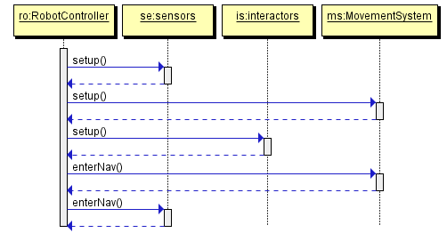

Figure 1—Setup sequence dIagram

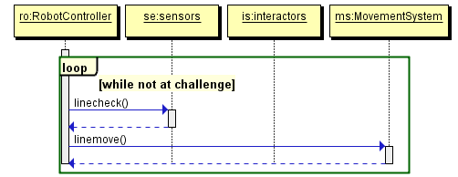

Figure 2—Navigation sequence diagram

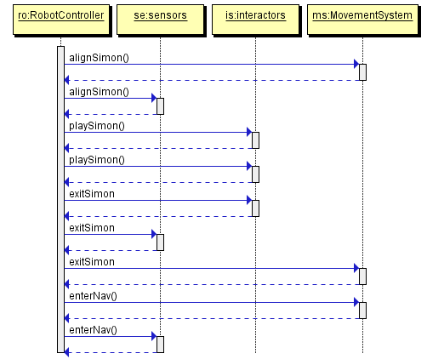

Figure 3—Simon sequence diagram

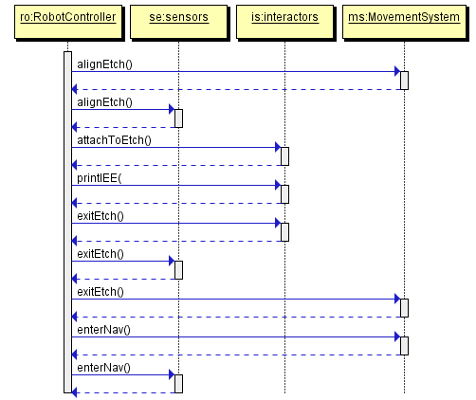

Figure 4—Etch A Sketch sequence diagram

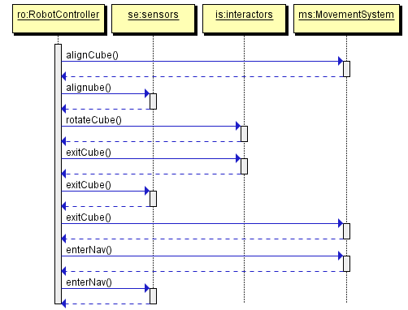

Figure 5-Rubik's Cube sequence diagram

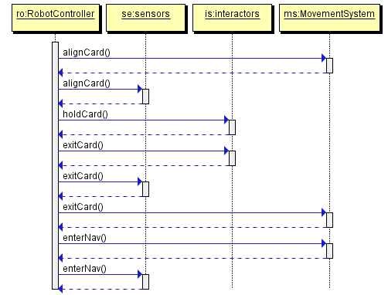

Figure 6—Playing card sequence diagram

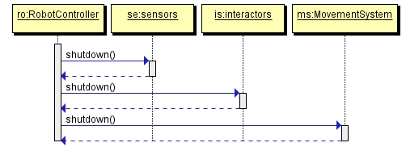

Figure 7-Shutdown sequence diagram

# 3. Requirements

## 3.1 Functional Requirements

* + 1. The VPS shall traverse the course.
       1. The VPS shall remain on the white line, which marks the path of the course, at all times.
       2. The VPS shall move to the next challenge once the current challenge is complete.
       3. The VPS shall move to the finish line once all challenges are complete.
       4. The VPS shall cross the finish line.
    2. The VPS shall complete all four challenges, defined as: Simon, Etch A Sketch, Rubik’s Cube and playing card.
       1. The VPS shall complete each challenge once.
       2. The VPS shall keep track of progress on a challenge.
       3. The VPS shall complete the challenges in a sequential matter.
       4. The VPS shall execute the challenges one at a time.
    3. The VPS shall complete the Simon challenge.
       1. The VPS shall activate the Simon game.
       2. The VPS shall obtain a pattern from Simon.
       3. The VPS shall press the buttons on Simon in a pattern corresponding to the obtained pattern.
    4. The VPS shall complete the Etch A Sketch challenge.
       1. The VPS shall print “IEEE” on an Etch A Sketch.
    5. The VPS shall complete the Rubik’s Cube challenge.
       1. The VPS shall rotate one row of a Rubik’s Cube 180 degrees.
    6. The VPS shall complete the playing card challenge.
       1. The VPS shall obtain one playing card from a deck of cards.
       2. The VPS shall complete the course with the playing card.

## 3.2 Nonfunctional Requirements

1. The VPS shall fit within 1 ft. x 1 ft. x 1 ft.
2. The VPS shall be autonomous.
3. The VPS shall remain on the course for 5 minutes.
4. The VPS shall interact with Simon for 15 seconds.
5. The VPS shall complete the challenges in sequence.
6. The VPS shall execute all requirements within 5 minutes.
7. The VPS shall press the buttons on Simon before Simon outputs an error tone.
8. The VPS shall fulfill the competition safety regulations.
   * + 1. The VPS shall contain nonflammable substances.
       2. The VPS shall not damage the course.
       3. The VPS shall do no harm.
       4. The VPS shall shut off in case of emergency.
     1. The VPS shall operate with an on-board power supply.

# A. Appendicies

## A.1. Appendix A

The following figures are a supplemental visual aid of the IEEE SoutheastCon 2015 Hardware Competition course and challenge components.

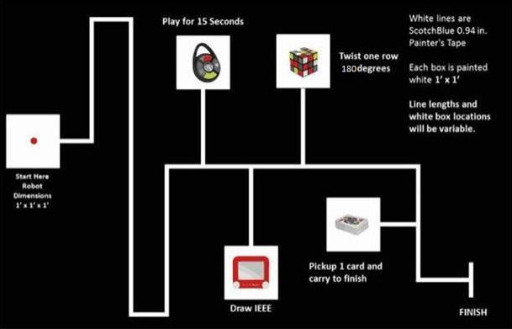

Figure 1—Course for IEEE SoutheastCon 2015 Hardware Competition [7]

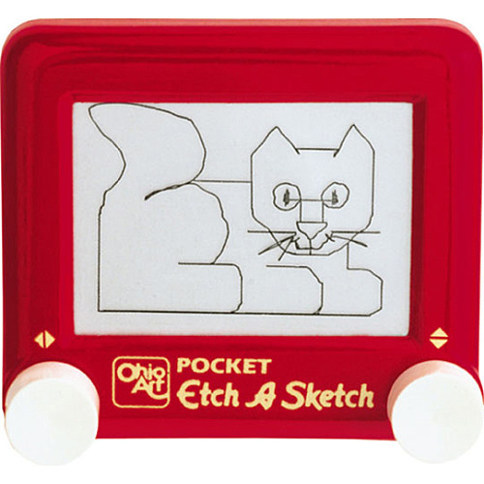

Figure 2—Etch A Sketch [9]

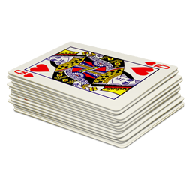

Figure 3—Standard 52-deck of playing cards [10]



Figure 4—Rubik's 3x3 Cube [1]



Figure 5—Simon Carabiner [11]

# Glossary

|  |  |  |
| --- | --- | --- |
| **Entry** | **Definition** | **Alias** |
| autonomous | When activated, it is independent with no outside influence |  |
| challenge | One of the four tasks- Simon, Etch A Sketch, Rubik’s Cube, or playing card | Task |
| course | 5/8 in. x 4 ft. x 8 ft. Sanded Pine Plywood |  |
| deck of cards | Standard 52-card deck (see Appendix A.1, Figure 3) | Deck |
| emergency | Unexpected occurrence requiring human intervention |  |
| Etch A Sketch | Pocket Etch A Sketch by: Ohio Art (see Appendix A.1, Figure 2) |  |
| finish line | Refer to “FINISH” (see Appendix A.1, Figure 1) | Finish |
| interact | Physically affecting by executing the functional requirments |  |
| line | Scotch Blue 0.94 in. x 60 yd. Painter’s Tape |  |
| obtain | To have possesion of |  |
| playing card | A card from the standard 52-card deck (see Appendix A.1, Figure 3) | Card |
| print | To draw or produce |  |
| robot | The platform being built for the IEEE SoutheastCon 2015 Hardware Competition. | VPS |
| Rubik’s Cube | Rubik’s 3x3 Cube (see Appendix A, Figure 4) |  |
| sequence | Simon, Etch A Sketch, Rubik’s Cube, playing card, finish line |  |
| Simon | Simon Carabiner (see Appendix A, Figure 5) |  |
| traverse | To move across |  |

# Acronyms & Abbreviations

|  |  |
| --- | --- |
| **Entry** | **Expanded Phrase** |
| ABET | Accredation Board for Engineering and Technology, Inc. |
| ERAU | Embry-Riddle Aeronautical University |
| ECSSE | Electrical, Computer, Software & Systems Engineering |
| IEEE | Institution of Electrical and Electronics Engineers, Inc. |
| SyRS | System Requirements Specifications |
| VPS | Volt & Pepper System |
| VPSDT | Volt & Pepper System Development Team |

# References

1. Booyabazooka. *Rubik's Cube.* March 5, 2008. http://commons.wikimedia.org/wiki/File:Rubik%27s_cube.svg (accessed September 13, 2014).
2. ERAU. "Student Handbook - Embry-Riddle Aeronautical University." *ERAU - Daytona Beach, FL.* 2014. http://daytonabeach.erau.edu/Assets/daytonabeach/forms/daytonabeach-student-handbook.pdf (accessed September 13, 2014).
3. IEEE. *IEEE Citation Reference.* September 9, 2014. http://www.ieee.org/documents/ieeecitationref.pdf (accessed 2014).
4. IEEE. IEEE Guide for Developing System Requirements Specifications. 1998. New York, NY: IEEE, Decembeer 22, 1998.
5. IEEE. *IEEE Recommended Practice for Software Requirements Specifications.* New York, NY: Institute of Electrical and Electronics Engineers, Inc., 1998.
6. —. *IEEE Region 3.* 2014. http://www.ewh.ieee.org/reg/3/southeastcon/ (accessed 2014).
7. —. "SoutheastCon 2015 Hardware Competition Rules (DRAFT)." *IEEE.* March 19, 2014. http://sites.ieee.org/sb-unfc/files/2014/07/hardwareComp2015.pdf (accessed September 13, 2014).
8. IEEE Standards Association. *2014 IEEE-SA Standards Style Manual.* New York, NY: IEEE, 2014.
9. Ohio Art. *Pocket Etch A Sketch - Red.* Ohio Art. 2014. http://www.toysrus.com/buy/etch-a-sketch-doodle-pro/pocket-etch-a-sketch-red-5163-2395954 (accessed September 13, 2014).
10. Plank Fitness. *Deck of Cards "Anywhere" Workout.* January 3, 2014. http://plankavl.com/wp-content/uploads/2014/01/deck-cards.png (accessed September 13, 2014).
11. The Bridge Direct, Inc. *Simon: Carabiner Edition.* 2012. http://www.thebridgedirect.com/sim_prd_carabiner.php (accessed September 13, 2014).