Chapter 4

A Study on Parsimonious Models in Catchments Generating Saturation Excess Runoff

**Federico Antolini1, Stefany Baron2, Brittany Lopez Barreto3 and Ishrat Jahan Dollan4**

1University of Iowa; *federico-antolini@uiowa.edu*

2Virginia Polytechnic and State University; *stefbaron@vt.edu*

3University of California, Merced; *blopezbarreto@ucmerced.edu*

4George Mason University; *idollan@gmu.edu,*

**Summer Institute Theme Advisors**: Fred Ogden, National Water Center, *fred.ogden@noaa.gov;* Hilary McMillan,San Diego State University, *hmcmillan@sdsu.edu*

**Academic Advisors:** Eric Tate, *University of Iowa;* Randel Dymond *Virginia Polytechnic and State University*; Erin Hestir, *University of California, Merced*; Viviana Maggioni, *George Mason University*

**Abstract:** Conceptual models in hydrology, e.g. TOPMODEL, represent an attractive alternative to distributed models, especially because of their simplicity, parsimony and computational efficiency. However, they often lack physical concepts and are unable to capture relevant hydrologic phenomena in certain areas. This study looks at surface runoff generation in the Northeastern US, namely Hubbard Brook, NH and Sleepers River, VT watersheds, where saturation excess is the dominant mechanism of runoff generation. We compared an established version of TOPMODEL, which uses watershed topography to predict subsurface and overland flow, against an alternate model where characteristics of soil and groundwater are also implemented. Results show that TOPMODEL tends to overpredict peak flows from intense rainfalls and underpredict the others, whereas the alternate model overpredicts peaks, although the latter should be attributed to an imperfect calibration of the delay function for overland flow routing. We used water volume error to assess model performance in correspondence of peak flow events, and we found that errors vary across events, but are in general comparable between the two models. In conclusion, the study shows that conceptual models can reproduce saturation excess runoff with sufficient accuracy and relatively quickly. When applied to small watersheds, model results can be passed down to larger basins, overcoming the reliance of fully distributed models on coarse grids (> 50 m resolution) for hydrologic simulation.

**1. Motivation**

Hydrologic models are used for predicting stream flows in areas of interest during storm events. The ability to do this accurately is of utmost importance for hazard emergency management and watershed planning purposes. Efficiency is also an important characteristic, as models must be able to take advantage of the high quantity and quality of data currently available minimizing the use of computational resources. Conceptual models have the potential to be accurate and efficient at the same time. They are built around a few hydrologic concepts, need a limited amount of input data and are parsimonious, since they use a minimal number of parameters. While parsimony results in easier calibration and fewer uncertainties, their simplicity may not allow to capture all the relevant hydrologic processes and limits their applicability across scales, climates and landscapes.

The National Water Model (NWM) focuses on hydrologic predictions at the continental scale and uses grids of coarse resolution of 1 km for land surface and 250 m for routing. Such resolution is in most cases too high to effectively model headwaters catchments, which represent the majority of modeled catchment.

**2. Objectives and Scope**

This study focuses on saturation excess overland flow (Dunne runoff) and investigates the ability of two parsimonious models of reproducing streamflow values through a rainfall-runoff transformation. This approach can then be adapted and incorporated into NWM to improve the model performance, taking full advantage of high-resolution data available (topographic and geologic) in a computational efficient fashion.

Our work takes TOPMODEL as the conceptual base for the parsimonious models. The next section provides a comprehensive description of TOPMODEL and its applications. We used an R package implementing TOPMODEL as the first parsimonious model. We developed a second parsimonious model (in the following, alternate model) based on the three primary TOPMODEL assumptions, but also using physical equations for subsurface flow and groundwater table oscillations to characterize a watershed. Since the relationship between soil moisture and overland flow is crucial to quantify saturation excess runoff, we explicitly introduced the physics beneath this process in the alternate model.

We applied R package of TOPMODEL and the alternate model in two study areas in the Northeast U.S, which have topographic and geologic characteristics that make saturation excess the main mechanism of runoff generation. The results provide insight into the usefulness and accuracy of modeling saturation excess runoff using few input data and the least number of parameters. An accurate parsimonious model would greatly improve the quality of NWM predictions across different scales, even in small- and medium-sized watersheds, and possibly benefit the NWM infrastructure by minimizing the computational resources required.

Finally, we acknowledge the importance of reproducibility and continuous improvement in the field of hydrology. Hence, all the datasets used, and the code written for this study are available for access through a GitHub repository, whose link is provided at the end of this report.

**3. Background and Previous Studies**

Hydrological processes in a catchment are dynamic and heterogeneous. Because of the lack of measurements of state variables and catchment attributes, a minimal number of parameters representing hydrological connectivity and catchment response are preferred. A detailed modeling of processes would need more calibrated parameters, which would increase model uncertainty.

TOPMODEL simulates hydrological fluxes that rely on topographic information (catchment area, local slope, and topographic wetness index). [1] considers TOPMODEL as a set of conceptual tools to reproduce the dynamics of both surface and subsurface contributing behavior in semi-distributed way. The Topographic Wetness Index (TWI) represents the tendency of developing saturated conditions in the catchment. Areas with higher TWI values represent greater runoff generation. This index is derived from the upstream area above a point that drains through the unit contour at the point and the slope of the local ground surface. A simple approximate relationship between catchment storage deficit and lateral transmissivity is developed within the framework of TOPMODEL. These relationship attributes form the basic physical equations for simulating the response of a catchment. Because of its semi-distributed functional framework, it bridges the gap between the complex distributed process models and simple lumped concepts [2]. R’s TOPMODEL package converts the topographic effects into a distribution of classes while simulating runoff in the outlet.

TOPMODEL relies on three basic assumptions [1]: (1) steady-state condition for a saturated zone, (2) local hydraulic gradient of a saturated zone approximated by the local surface topographic slope, tan β, (3) an exponential decay function of transmissivity with depth (or equivalently deficit). TOPMODEL models three layers of the soil column (root, unsaturated and saturated zones) as three interconnected reservoirs. The parameters TOPMODEL deals with include initial subsurface flow, rate of transmissivity decay in the soil profile, hydraulic conductivity at the surface, and others which are explained fully in [3].

The idea of fractional saturated areas in a catchment and its correlation with soil moisture are key concepts for surface runoff formulation [4]. Conceptually, when precipitation falls over those saturated grids, it converts into surface runoff. In absence of precipitation, the groundwater table naturally lowers, water in the soil flows laterally down to the outlet where subsurface flow discharges to a stream. Lateral flow is only modeled in the saturated part of the soil since unsaturated flow takes more time to drain. More recent implementations address the issue of heterogeneity of soil moisture due to variation in topography. For example [5] use information of sub-grid topography variation and the height of the mean water table to predict low land saturation.

The alternate model in this study proposes a simple relationship between saturated areas and soil water content in the context of saturation excess as dominant type of runoff. While it is based on TOPMODEL assumptions, the alternate formulation can run without the TWI to build a functional relationship. As more rain falls onto the watershed, the relationship generates a simulation of saturation excess runoff. Therefore, a characteristic diagram of saturated areas and volumetric content in soil can replace the topographic index of hydrological similarity in a catchment. This characterization of the watershed best applies to small-scale catchment (less than 10 km2) a scale that most distributed hydrological models have difficulty to capture. Finally, the alternate model replaces the routing scheme by simply calculating the volume of overland flow generated at the hourly time step. This is potentially useful since, for once, a daily time step cannot capture the dynamics of small catchments that has time on the orders of hours, and on the other side flow routing is not computationally efficient at hourly time step for small catchments.

**4. Methodology**

*4.1 Overview*

We ran hydrologic simulations using the established version of TOPMODEL (R package) and an alternate TOPMODEL-based model we developed that incorporates soil parameters. Simulated hydrographs are then compared to the observed to evaluate the performance and the weaknesses of models.

*4.2 Study Sites*

*4.2.1 Hubbard Brook*

The Hubbard Brook watershed in North Woodstock, New Hampshire is a very extensively studied watershed [6]. The availability of a longstanding set of hydrologic data made it an ideal choice for study site. Hubbard Brook forest has nine individual subcatchments, as shown in Figure 1. Subcatchment #7 (HB7) served as our preliminary study site. We chose HB7 because it is a substantially natural area where no artificial practice introduced for research purpose, e.g. clear cut of vegetation, has ever occurred. HB7 extent is about 0.75 km2.

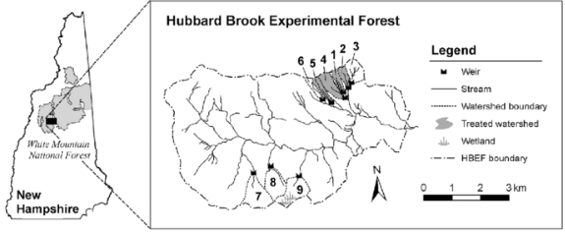

**Figure 1.** Hubbard Brook Watershed [7]

*4.2.2 Sleepers River*

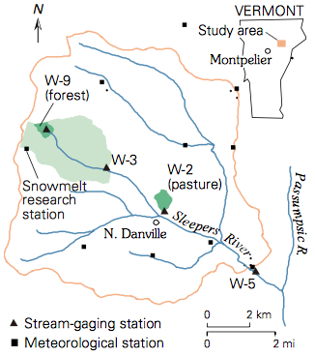The Sleepers River Research Watershed (SRRW) in Vermont has been an active hydrologic research site since 1959 and was the setting where Dunne and Black (1970) determined the controls of saturation-excess overland flow (SOF) on streamflow generation shown in Figure 2. Specifically, the study area is watershed W-3, which covers an area of about 9 km2.

Glaciers that covered New England thousands of years ago have shaped the present landscape and impacted its hydrological patterns. Most of the watershed is covered by 1-4 meters of glacial till which leads to high buffered streamflow due to the weathering of the calcite within the till. The study area has a humid continental climate with an average temperature of 6 degrees Celsius and average annual precipitation of 1.1 meters, of which approximately 20-30% is from snow [8].

**Figure 2.** *Sleepers River Watershed*

*4.3 TOPMODEL (R Package)*

The study areas described in section 4.2 were first modeled using TOPMODEL. The TOPMODEL function in R requires an input of five variables. The first is a set of ten parameters which are described by [3]. The second is a TWI data frame which represents the distribution of TWI values for the Digital Elevation Model (DEM) of the subcatchment. The third variable is a delay data frame which represents channel routing through the watershed. The fourth and fifth variables are precipitation and potential evapotranspiration values respectively. For a more thorough explanation of these five input variables, see [3].

The TOPMODEL package in R comes with functions that can calculate the TWI and delay data frames using only the DEM of the subcatchment. Precipitation values were obtained from the Analysis of Record for Calibration (AORC) [9] and converted to meters of precipitation per hour. Flow data was obtained from USGS and converted to cubic meters per hour per unit area. Evapotranspiration (ET) data was not available and, therefore, it is estimated using the water balance equation. The water balance method was used to find that the average rate of ET for subcatchment W-3 was approximately 3 mm d^(-1). Using this information, an ET vector was created that ranged from 2 to 5 mm/day, with colder months having lower values and hotter months having higher values. For future modeling, it is recommended to use independent measurements or estimates of ET.

Parameters of TOPMODEL were estimated based on the range of values found in the literature for sub-catchments W-3 of Sleepers River and Hubbard Brook. We provided parameter ranges to one of the Hydroinformatics teams of Fellows at the 2019 Summer Institute. They created 22,000 sets of parameters sampled with Saltelli techniques, and performed a Sobol sensitivity analysis. A full explanation of this sensitivity analysis can be found in their report, *A Visualization Workflow for Quantifying Parameter Sensitivities to Uncertainties for Hydrologic Models*. Through the sensitivity analysis, it was learned that the parameters of initial subsurface flow (*qso*), rate of decline of transmissivity in the soil profile (m), and maximum root zone storage deficit (*srmax*) are the most sensitive. Numerous experiments with different values of each of these parameters were performed to evaluate how each would affect simulated flow. One interesting conclusion drawn from this analysis is that different months of the year need to be calibrated with different values of *qso*. Therefore, TOPMODEL is not recommended for modeling a time period of several months. This study focuses on a limited period of 2 weeks for Hubbard Brook (June 24th – July 7th, 2014) and 6 weeks for Sleepers River (April 30th – June 12th, 2017). These date ranges were chosen so that snowmelt process can be considered exhausted and would not interfere with runoff transformation of rainfall.

*4.4 Alternate Model*

Our alternate model applies the assumptions of TOPMODEL to characterize the hydrologic behavior of a watershed and applies a synthetic relationship to the rainfall-runoff transformation. The three main assumptions that are addressed in the alternate model are that in a given watershed a) the soil is highly porous, and thus the contribution of infiltration excess (Hortonian runoff) to overland flow is negligible, b) the thickness of the unconfined aquifer is limited to a few meters (<5) and is spatially uniform across the watershed, c) the groundwater table has the same slope as the ground surface, which implies that groundwater moves in the same direction as surface runoff.

The alternate model is made of two distinct parts, or algorithms. Part 1 of the model consists of characterizing the watershed with a relationship between the proportion of saturated area and the total water content in the soil, or equivalently the soil water deficit. Because saturation excess is generated by those areas of the watershed that are susceptible to becoming completely saturated and hydrologically connected to the outlet, one can quantify the amount of runoff based on the estimated water content in the soil at the watershed level. To accomplish this, the algorithm uses a DEM to identify flow direction based on the prevalent slope in the D8 scheme [10]. The model starts from an ideal condition of complete saturation of the whole watershed and simulates the natural lowering of groundwater and the subsurface flow toward the outlet. At each time step, it identifies the saturated cells, calculates the percentage of the saturated area across the total area of the watershed and records the overall amount of water stored in the aquifer, both in unsaturated and saturated layers. The pseudocode in Algorithm 1 summarizes the steps in Part 1.

**Algorithm 1.** Pseudo code for Part 1 of the alternate model (DrainTheWatershed). The relationship is built at each timestep from recorded values of Saturated Area Ratio and normalized Storage.

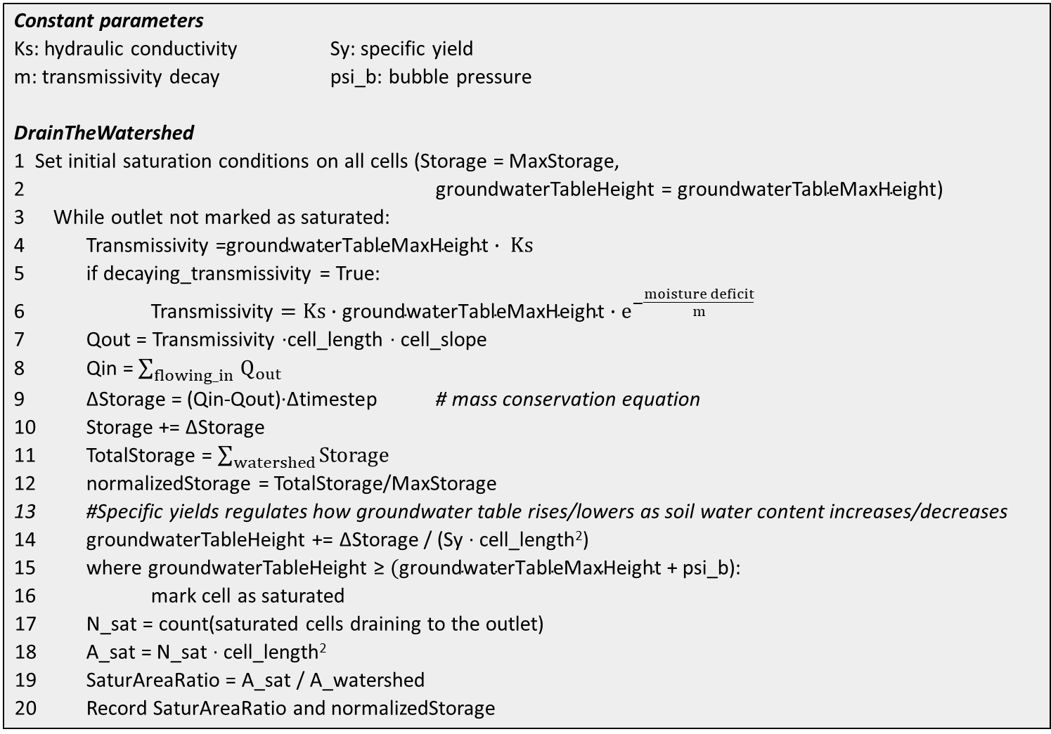

The above relationship characterizes the relevant processes occurring in the watershed. Part 2 of the model is, in fact, a lump type of model. Differently from Part 1, Part 2 moves away from a distributed model and treats the watershed as one reservoir behaving according to the relationship from Part 1. The model takes precipitation and evapotranspiration as input and applies the mass balance equation to determine subsurface storage and overland flow at the outlet of the watershed. Pseudocode in Algorithm 2 summarizes rainfall-runoff transformation algorithm in Part 2. The key concept is that soil water storage and surface runoff, which by hypothesis (c) is generated only from saturation excess, are strictly related and follow the relationship from Part 1.

**Algorithm 2.** Pseudocode for Part 2 of the alternate model (RainfallRunoffSimulation).

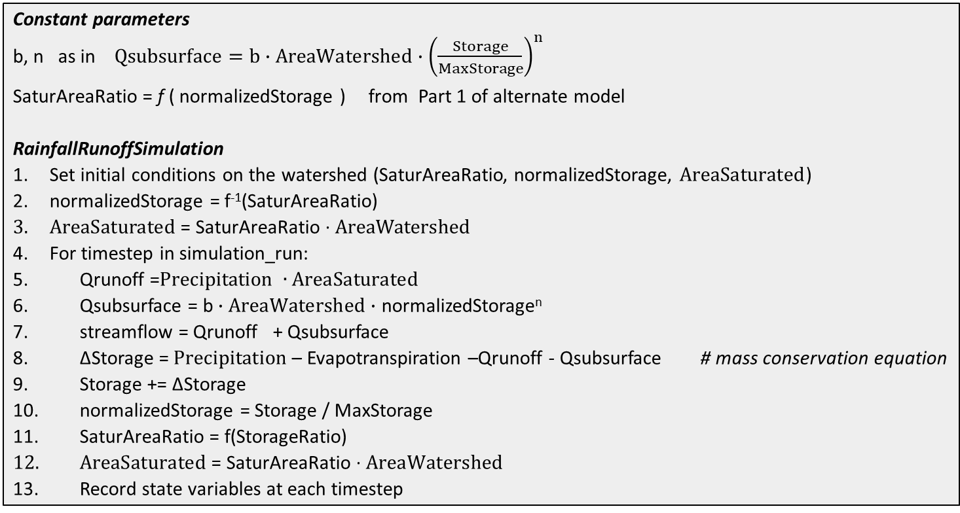

**5. Results**

*5.1 Hubbard Brook subcatchment #7*

4 shows observed and modeled streamflow from June 24th through July 7, 2014 in HB7. Both TOPMODEL and the alternate model reproduced fairly well the size of the peak flow for the main storm event that occurred during this time period. The time to peak for the models, however, is a few hours delayed from the observed. There are minor discharge increases around July 4th that were not observed, despite a 1-hour rain of significant magnitude. Overall, modeled hydrographs are very close to the observed and the models behave quite satisfactorily in this study area. Yet, the problem exists of how reliable precipitation forcing data are in the context of a very small catchment. While in a large watershed errors in precipitation values and/or timing might even out and overall mitigate, similar errors in a small catchment may lead to significant errors in streamflow prediction without the possibility of amendment.

*5.2 Sleepers River*

Figure 5 shows observed and modeled streamflow from April 30th to June 12th, 2017 in W-3 watershed of Sleepers River. Visually from the graphs, neither model performs as well here compared to Hubbard Brook. TOPMODEL overpredicts most of the peak flows and does not do a good job of capturing the duration of peak events. The tendency is to overpredict peak flows from intense rainfall events and underpredict peak flows from weaker rainfalls. The alternate model performs well in terms of recognizing flow peaks, including minor ones. Observed and modeled peaks align, and the alternate model does not generate more peaks than are observed. However, peaks are greatly overestimated at the beginning of the simulation, and are shorter in time. Two weeks in the simulation peaks are better

**Figure 4.** *TOPMODEL and alternate model streamflow simulation in H*ubbard Brook subcatchment *7 for the period from June 24th to July 7th, 2014.* Decay parameter for transmissivity m = 0.015, as estimated from sensitivity analysis.

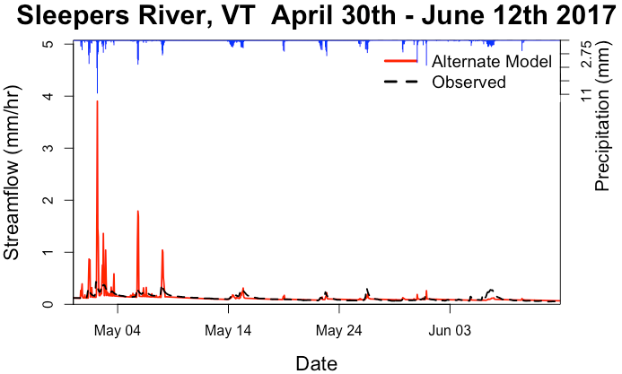

**Figure 5.** TOPMODEL and alternate model streamflow simulation in Sleepers River for the period April 30th to June 12th, 2017. Decay parameter for transmissivity m = 0.0279, as estimated from sensitivity analysis.

reproduced,

reproduced, with the last event around June 6th underestimated. The alternate model responds immediately to precipitation inputs and peaks have a sharp shape, especially on recession limbs. One limitation of the alternate model is the absence of a delay function, which is normally introduced in lumped models to account for travel time of water from the most hydrologically distant areas down to the outlet [11].

The alternate model is qualitatively valid as it can predict when a peak in discharge occurs but is not reliable in the quantification of peak magnitude. Nash-Sutcliffe Efficiency and peak average error are typical ways to assess the performance of a hydrologic model [12]. However, Figures already show systematic high discrepancies at major peaks between modeled and observed streamflow, and we expect that the abovementioned indicators point toward a mediocre performance of the model. Many factors play a role in model overprediction, including the lack of a delay function, the effective correspondence of model hypotheses to reality, an imperfect calibration of the model, the quality of rainfall data, the amount and variability of evapotranspiration along the season.

To compare the performance of TOPMODEL with the alternate model, we computed the outflow per unit area for the top 4 peak events that occurred between May 1st and June 12th, 2017. We defined an event from 3 hours before to 3 hours after the time of the peak. Thus, each of the events considered is of 7-hour duration. Volumes per unit area were computed by integrating the flow per unit area over the 7-hour duration of each peak. Table 1 shows that the alternate model performed better than TOPMODEL in all of the events considered, although in at least two cases the errors are very close. One explanation for the different performance is that TOPMODEL does not explicitly model saturation excess, which is the main way runoff is generated in the study area. Another important difference is the way parameters are used between the two models. TOPMODEL characterizes the watershed hydrologic behavior mainly through TWI, which is determined exclusively by the topographic information from the DEM. Other important hydrologic properties, such as soil hydraulic conductivity and transmissivity decay, are introduced later as additional parameters. On the other side, the alternate model uses topographic and soil information together to characterize the watershed hydrologic behavior. Most of the relevant parameters are introduced at the beginning and concur to determine the fundamental relationship for saturation excess between soil water content and fraction of saturated area. The disadvantage of this approach is that it is currently more difficult to calibrate the model, since it is necessary to build a new relationship at each attempt. However, less parameters are used in the alternate model, and a future development might be a specific calibration function, possibly incorporating sensitivity analysis rationale.

**Table 1.** Volume per unit area of the top five peak events for Sleepers River during April 30 - June 12, 2017

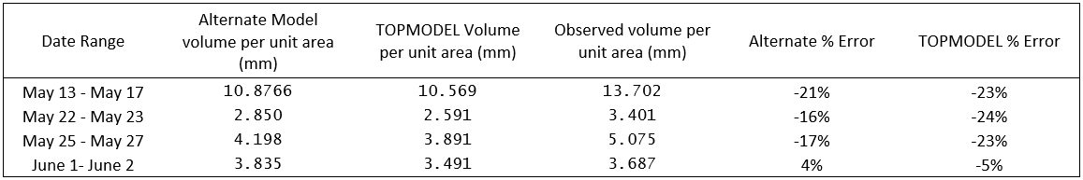

**6. Conclusion**

Motivation for this study arises from the need for a hydrologic model that is accurate and simultaneously computationally efficient. Although conceptual models condense hydrologic concepts in simplified equations to represent water storage in catchments, they often overlook the physics beneath the process. Our study attempts to conjugate these two general trends and presents a model formulation that follows the steps of TOPMODEL as a conceptual and parsimonious model but also takes advantage of high-resolution data and explicitly introduces physics.

We focused our efforts on the saturation excess runoff generation which is dominant in some regions of the United States. The groundwater table rises and declines quickly, and the terrain gets frequently saturated in those regions. The alternate model we created first establishes a relationship between soil moisture and saturated areas, then applies a simple rainfall-runoff routine using that relationship. The results are compared to TOPMODEL simulation and observed data to assess performance of both models, highlight differences between models, weaknesses and potential for application in regions needed.

Given the simplicity of parsimonious models, discrepancies between model results and observations are not surprising. The results indeed represent a satisfactory first step toward a successful application of TOPMODEL-based models. Some improvements and more testing can be made in the future, such as refining model calibration, introducing a delay function based on watershed size and shape, applying the analysis to larger watersheds in the context of scaling and continental climates, and possibly implementing other hydrologic routines, such as snowmelt and infiltration excess. TOPMODEL is known to best work in high precipitation areas with moderate topography and shallow, permeable soils [13], so it would be worthwhile to investigate whether the alternate model can be adapted to areas with different climate, landscape and geology than tested in this report.

The alternate model has considerable potential for being incorporated into the NWM. Effective and fast simulations on headwater watersheds may allow to pass down the results along the stream network and apply the fully distributed model currently in use with coarse grids to just the main stem of major rivers. The results of this work have constantly been improving trend, especially in the last week of the Summer Institute, which has driven our optimism about the capability of the models. The study is worth further investigation and substantial improvements are within reach. The current direction for hydrologic modeling is to integrate multiple approaches that can be applied in different landscapes. The contribution of our study, which emphasizes model simplicity, flexibility and efficiency, becomes absolutely relevant in this context.

**Supplementary Materials:**

Our GitHub repository is found at <https://github.com/brittbarreto/Aquaholics_Anonymous>, where data sets, scripts used from R’s TOPMODEL and our alternate model’s Python scripts are tracked.

**References**

1. Beven, K.; Lamb, R.; Quinn, P.; Romanowicz, R.; Freer, J., TOPMODEL. In *Computer Models of Watershed Hydrology*, 1 ed.; Singh, V., Ed.; Water Resources Publications: Highlands Ranch, CO, USA, 1995.

2. Nourani, V.; Roughani, A.; Gebremichael, M., TOPMODEL capability for rainfall-runoff modeling of the Ammameh watershed at different time scales using different terrain algorithms. *J. Urban Environ. Eng.* **2011,** *5* (1), 1-14, <https://doi.org/10.4090/juee.2011.v5n1.001014>.

3. Buytaert, W., topmodel: Implementation of the hydrological model TOPMODEL in R, R package version 0.7.3, <https://CRAN.R-project.org/package=topmodel>, 2018.

4. Niu, G. Y.; Yang, Z. L.; Dickinson, R. E.; Gulden, L. E., A simple TOPMODEL‐based runoff parameterization (SIMTOP) for use in global climate models. *J. Geophys. Res. Atmos.* **2005,** *110* (D21), <https://doi.org/10.1029/2005JD006111>.

5. Gedney, N.; Cox, P. M., The sensitivity of global climate model simulations to the representation of soil moisture heterogeneity. *J. Hydrometeorol.* **2003,** *4* (6), 1265-1275, <https://doi.org/10.1175/1525-7541(2003)004><1265:TSOGCM>2.0.CO;2.

6. USDA US Forest Service, Hubbard Brook Experimental Forest.

7. Cawley, K. M.; Campbell, J.; Zwilling, M.; Jaffé, R., Evaluation of forest disturbance legacy effects on dissolved organic matter characteristics in streams at the Hubbard Brook Experimental Forest, New Hampshire. *Aquat. Sci.* **2014,** *76* (4), 611-622, <https://doi.org/10.1007/s00027-014-0358-3>.

8. Shanley, J. B. *Sleepers River, Vermont: A water, energy, and biogeochemical budgets program site*; 2327-6932; US Geological Survey Fact Sheet-166-99: 2000, <https://doi.org/10.3133/fs16699>.

9. Kitzmiller, D. H.; Wu, W.; Zhang, Z.; Patrick, N.; Tan, X. The Analysis of Record for Calibration: A High-Resolution Precipitation and Surface Weather Dataset for the United States. AGU Fall Meeting Abstracts, 2018.

10. Jenson, S. K.; Domingue, J. O., Extracting topographic structure from digital elevation data for geographic information system analysis. *Photogramm. Eng. Remote Sensing* **1988,** *54* (11), 1593-1600.

11. Beven, K.; Freer, J., A dynamic topmodel. *Hydrol. Process.* **2001,** *15* (10), 1993-2011, <https://doi.org/10.1002/hyp.252>.

12. McCuen, R. H.; Knight, Z.; Cutter, A. G., Evaluation of the Nash–Sutcliffe efficiency index. *J. Hydrol. Eng.* **2006,** *11* (6), 597-602, <https://doi.org/10.1061/(ASCE)1084-0699(2006)11:6(597>).

13. Sigdel, A.; Jha, R.; Bhatta, D.; Abou-Shanab, R. A.; Sapireddy, V. R.; Jeon, B.-H., Applicability of TOPMODEL in the catchments of Nepal: Bagmati River Basin. *Geosyst. Eng.* **2011,** *14* (4), 181-190, <https://doi.org/10.1080/12269328.2011.10541349>.