|  |
| --- |
| Hogwarts University  Team SAT Project  Created by: Kurtis Caldwell & Brittany Dodd |

Project Brief:

The requirements for this project were to create a Two-Tiered App for a University to be able to utilize for the onboarding students and help them organize their enrollment and help students determine their classes.

Trello board:

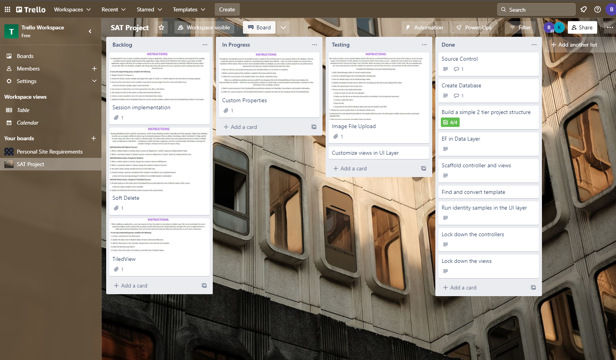

Here we are displaying our process in how we completed our project. This is the best tool to help visualize and optimize our work flow and keeping us on track with our steps to implement code within our application and also our time schedule.

SQL Database schema:

Code Snippet:

Here we are using our Renderbody. We used the styling found in the template’s meeting page to get around the initial problem we had with our floating navbar.

This here is a snippet of our Authorization portion of the project. This helps keep our logins and security levels in order from Administration, to students, and to any user who may come across the website.

Enrollment example:

Here have an example of our enrollment code.

Navigation Bar for different logins:

This navbar is for anonymous users



This navbar is for Administration users



This navbar is for Student users.

Metadata:

