Puzzle Concepts

Reflexes

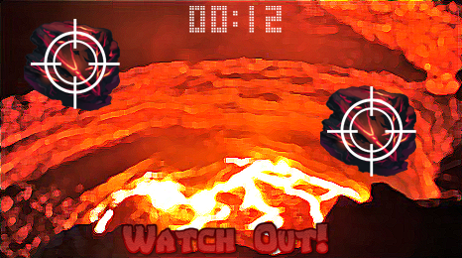

The player will be tasked with climbing out the top of an active volcano near the end of the level. In order to do this, they will have to click/tap on fast-moving falling rocks to deflect them with their sword. Rocks will have various speeds to keep the players on their toes. Some of the rocks will only allow half a second while others will go as slowly as 1 second to 2 seconds. Grading is based on how many rocks they were able to deflect and how quickly they were able to do it with a bonus for not getting hit by any.

Visual Pattern Recognition

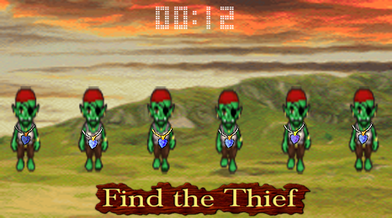
The player's coin pouch will be stolen by a thieving pirate and the player must pursue the pirate. When he catches up the pirate, he's stolen clothes to blend into a crowd of similarly dressed people. The player must go down the line of people and find the
accessory or article of clothing that stands out from the rest to find the thief. The thief will be compared to five to ten other people and the "stand-out" object will be large to obscure depending on the difficulty setting. The player will have to find the thief 5 different times before the puzzle is complete. 3 incorrect guesses and the player fails. Speed and accuracy increase the points with a bonus for never guessing incorrectly.

Audio Pattern Recognition

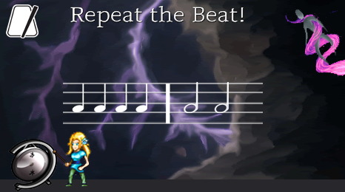
The player encounters a thunder creature that cannot be passed unless the player can convince the creature that he/she is of the Nimbus race. The player accomplishes this by hitting a gong to repeat the thundering sound sequences from the creature. The sequences are comprised of long tones and short tones. The sequence starts with 3-6 tones to start (depending on difficulty) and will gradually increase by one tone for 6 stages. If the player fails, the amount of tones will stay the same and it will play the same sequence again. Failing three times, however, will cause the mini-game to end. Scoring is based on accuracy with a bonus for not missing any tones.

Memory

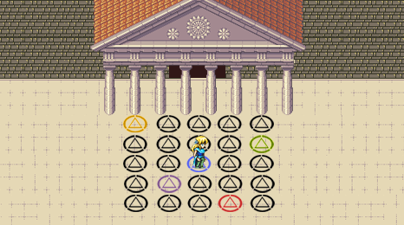

To enter the Temple of Sol, the player must unlock its multiple sealed doors. To do this, the player must step on the proper pattern of sigils on the floor and activate them to open the door. The pattern starts off with 5 randomly placed spaces lit up, and after 2 seconds, they disappear. The correct pattern must be input in order progress, and you get 3 tries. With each progression, an extra space is lit up/filled in. It should be in a “grid” style, and at least 5x5, no more than 10x10. Points are awarded for speed and a bonus for no mistakes.

Multitasking

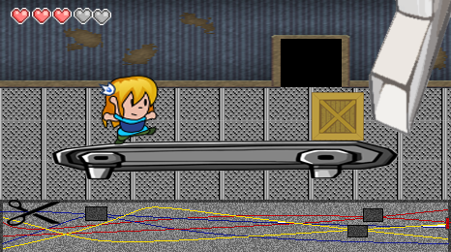

The abandoned factory has been re-activated by accident by a well-meaning but bumbling Cortez and the player is now stuck in the middle of an assembly line. The player must control both their character and Cortez for this puzzle. The player has to either jump over crates or smash through glass panels as they come down a conveyor belt. At the same time, Cortez has to cut three wires in a series of maze-like wires to deactivate the machines. Tracking the wires from the battery to the machine will require a little bit of concentration as they will loop through junction boxes and overlap with other wires. Cutting an incorrect wire will temporarily speed up the conveyor belt objects. The puzzle ends when the player cuts all three of the power wires (success) or if the player's character hits five objects (failure). Scoring is based on speed with deductions for objects hit and incorrect wires cut. A bonus is awarded if the player hits no objects and a separate bonus for no incorrect wires cut.

Attention

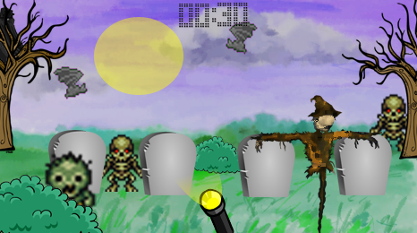

The player enters a graveyard in the Necropolis. A shadowy figure is skulking in the distance. The player's character resolves to confront them, but first, he/she must spot the shadowy figure. The game begins with all sorts of zombies, skeletons, and bats flying in from different directions, popping up from behind tombstones, trees, and bushes. The player has to spot the figure amidst the chaos, clicking/tapping on the figure as they see him. The figure will mimic the poses and locations of the other creatures, attempting to blend in so the player will miss him. Clicking/tapping on the wrong thing three times results in a failure. Finding the figure three times will result in a success, but there is a time limit of 60 seconds. Points are awarded for speed, deducted for clicking/tapping the wrong thing and missing the figure when he does appear, and bonuses are given for not clicking on the wrong thing once as well as a separate bonus for not letting the figure get away once.

Spatial Reasoning

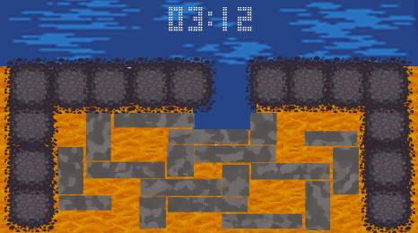

In order to get the power back on in the mine, the player must unclog an underground stream to turn the turbine used to light up the tunnels. Rocks have dammed up the river in various locations. The rocks are too heavy to pick up and are oddly shaped. The player can still slide the rocks, but there's limited room. The player must slide the rocks around in order to create a clear path for the water to run through. This puzzle is similar to how slider puzzles work, but will added larger and oddly-shaped pieces to add complexity. There is no time limit for this puzzle, but the player does receive more points for a faster clear time and less moves. Clearing three of the slider grids means success. Basic difficulty will be a 5x5 grid, increasing to 6x6 and 7x7. Highest difficulty will go to 10x10 then 12x12 and 14x14 respectively.

