Untitled brain adventure Game
(“Brain Game” Placeholder)
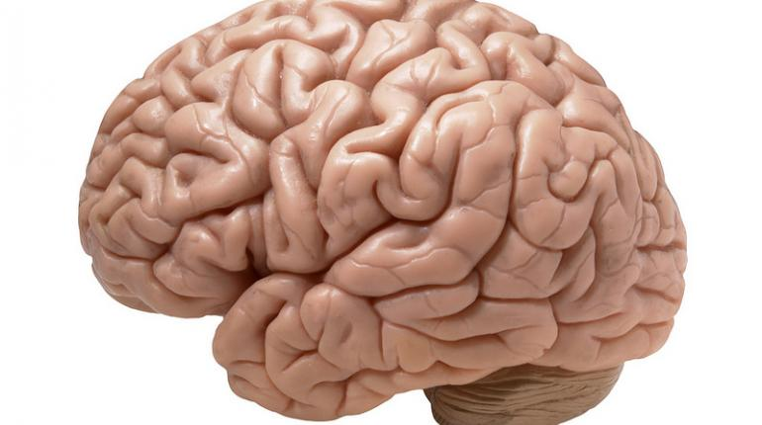
Platform: PC
Genre: Adventure Puzzle

Overview

Brain Game is an adventure game, utilizing puzzles and mini games to give the player a mental workout. There are a few games with a somewhat similar concept on the market, but most are very upfront about their exercising nature. Brain Game sets itself apart by offering similar mental exercises integrated into an adventure with characters, conflict, and an engaging yet charming story. Players will complete various worlds designed around different exercises with the goal of both clearing the story and strengthening their mental agility.

Game Concept

The player starts the story in a hub world, allowed to freely pick from any of the seven open worlds (the eighth is locked until the first seven are completed). Clear worlds by solving various puzzles. Players will have to avoid making too many mistakes or you'll have to start from the last checkpoint. Each world has a certain amount of points the player can earn and they're graded at the end. Continued excellent performance gives out rewards in the form of unlockable bonus stages, costumes, and characters. At the end of each world is a boss fight that incorporates all of the skills tested in that world. Clearing worlds will give the player a medallion which is used towards opening the final world. The game is highly replayable due to its random world compositions and the variable difficulties. Players can revisit worlds after beating them and try each level out at higher difficulties using a slider to change it from 1 (easiest) to 10 (highest). Additionally, there is a free mode where players can test themselves against a gauntlet of anywhere from 10-100 puzzles from the story mode. Players can choose which types of puzzles will be integrated into the gauntlet, as well. Survival and speed are key to getting the high score.

Design Challenges

- Challenging but Fair- Puzzles should be mentally challenging but never frustrating. They should be simple enough for the average player to get through, but allow for higher difficulties if players wish to challenge themselves.
- Unique Worlds- The game must feel interesting and alive. It can't feel like a mini-game compilation with an adventure game skin. It should feel like an adventure game with mini-games strewn about.
- Provide a reason to keep playing- The point is to exercise the mind. Without continuous exercise, the game won't accomplish what it's set out to do. As such, the game has to give a reason for players to come back daily, whether it's high score competitions with friends via social integration or daily tracking of your own grades/scores.
- Lovable, memorable characters- Even though the game isn't heavily relying on story, it's important to have simple but memorable characters. They're essentially the mascots/face of the game. Well-designed visuals for the characters will make them stand out in a sea of competition.

Market Competition

Direct Competition

Games like Brain Age and the online service Lumosity are the direct competition for this title, though it's a very unique spin on the genre. The game will be compared to those games if it's marketed as a “mental exercise” game.

Reference Material

Core Gameplay:
- Mario Bros. Series
- Brain Age

Controls
Adventuring Keyboard & Mouse: WASD keys for Up, Left, Down, Right movements. Space to Jump. Left Mouse Button to Attack. Right Mouse Button to use a Spell. E key to interact. Escape to pause.
Puzzle controls are on a puzzle by puzzle basis.
USB Controller Support

Gameplay
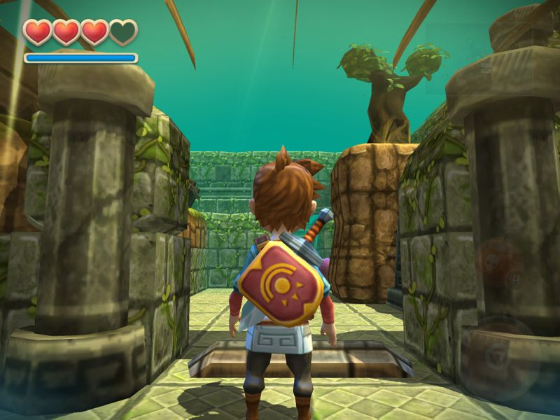
The game will, for the most part, look and feel like a 3D platform adventure game. Exploring worlds will be similar to that of the Zelda series with magic and health bars (vitality bar in place of hearts to accommodate the different levels of armor's effect on damage) except levels will progress in a more linear “point A to point B” fashion. Each zone of a level is dynamically chosen from a “stable” of pre-made rooms for that world, ensuring players will never experience the same experience twice. Checkpoint zones, however, will always be the same to tell the next part of that world's story.
Below is a flow chart for how each world should progress:
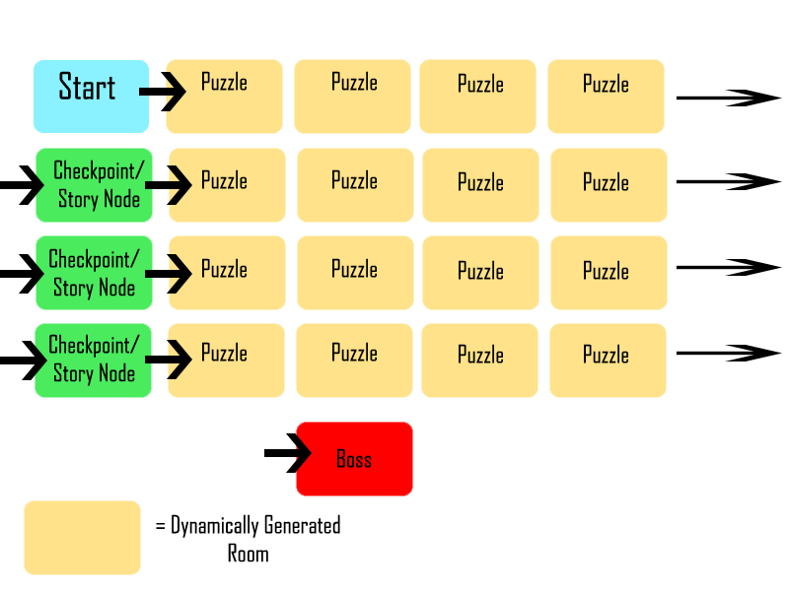
Rooms will vary in size, sometimes being as large as several smaller puzzle rooms with enemies block the path, forcing the player to defeat all of the enemies before progressing to the actual puzzle. Players will encounter a variety of enemies in each level that have a chance of dropping health pickups and mana pickups. Hurting yourself on enemies will lower your vitality for the next puzzle so players have to be careful. Some enemies will drop an essence which can be used to upgrade your equipment from the status screen/pause menu. Equipment upgrades enhance various stats for your hero for adventuring purposes and have no effect on puzzles. Below is a list of equipment upgrades:

Equipment | Level 1 Cost | Level 2 Cost | Level 3 Cost | Level 4 Cost | Level 5 Cost | Level 6 Cost | Level 7 Cost | Level 8 Cost
Head | 10 | 20 | 30 | 40 | 50 | 60 | 70 | 80
Armor | 10 | 20 | 30 | 40 | 50 | 60 | 70 | 80
Weapon | 10 | 20 | 30 | 40 | 50 | 60 | 70 | 80
Boots | 10 | 20 | 30 | 40 | 50 | 60 | 70 | 80

Each level of each piece of equipment enhances a stat specifically tied to that piece of equipment by 12% per level. Leveling up the Head will increase the damage and blast radius of your magic missile. Leveling up armor will reduce the amount of damage enemies will deal to your character. Weapon will increase the damage your weapon deals and your attack speed. Boots improves how quickly your character moves while adventuring. Improving these will be key to survival as clearing each World will increase the difficulty of the enemies in all of the remaining Worlds. Enemies vary in strengths and weaknesses and will test various attributes so it's important that the player keep upgrading. Bosses are a mixture of action-oriented combat and puzzles to either weaken them/expose their weak points so it's important to think AND fight.

Main Story
At the beginning of the game, players can choose their gender and age. Males are named “Mac” and Females are named “Amy” by default, but players may change their names. Mac and Amy are chosen for Paul MacLean, the scientist who first created the idea of the limbic system for the brain and Amygdalae which are groups of nuclei in the limbic system responsible for memory and emotion.

The story opens up showing that Mac/Amy are renowned for their mental acuity. Amy/Mac is loved by her/his village and respected worldwide for the ability to solve any puzzle thrown at her/him, no matter the difficulty or danger. Think of them as the Sherlock Holmes/Indiana Jones of this universe.

Thalamus, a genius criminal, is a constant antagonist to Mac/Amy but is continually outwitted. Frustrated by his continuous failings, he has found out about an artifact that can steal away the strongest abilities of its victims. He acquires the artifact and, in the middle of the night, he steals away Mac/Amy's mental prowess, sealing it inside the artifact. The next morning, even the most common problems confounds Mac/Amy, leading everyone to wonder what has happened to the hero.

An owl by the name Cortez saw everything and trailed Thalamus back to his secret lair. He informs Mac/Amy of what has been done and that the way is sealed. Thalamus plans to tap into the stolen abilities within the artifact to control the world. Mac/Amy decide they must stop Thalamus and head out. Cortez follows, telling them they will need to hone their mental skills once more if they hope to defeat Thalamus. Cortez agrees to help Mac/Amy accomplish this and they set off to figure out how to open the gate to Thalamus' lair. Cortez functions as a bit of a guide/tutorial system from this point on.

Beating any one of the worlds will trigger the next part of the main story where they discover the medallion they found at the end of the completed world is used to open the gate. Cortez mentions seeing empty, disc-shaped slots at the gate so they go to the gate to see if the medallion has any effect. Part of the elaborate gate moves when the medallion is placed in a slot, showing the key to opening the gate is getting the rest of the six remaining medallions.

Once all the medallions are acquired, the gate opens and allows Mac/Amy to pass. Cortez explains that they've regained a good deal of their mental skills back through trials and tribulations, but Thalamus will still be a formidable opponent. Thalamus proves to be a difficult opponent indeed, testing every skill the player has. He seems to have planned for every outcome except for one: Mac/Amy smash the artifact, destroying their sealed away abilities. This makes Thalamus beatable. Once defeated, Cortez congratulates Mac/Amy on their victory, but laments the loss of their world-renowned abilities. Mac/Amy are accepting of the loss as, through hard work, they've regained most if his/her abilities. Cortez jokes about how there's always room for improvement and they return home, victorious.

Worlds
There are seven worlds to start with 10 levels in each then a boss stage. The eighth world is unlocked by beating the original seven. These may be done in any order. The worlds are themed after simple elements drawn from different parts of the world. The themes are of fire, water, earth, wind, light, dark, and metal. Each element will be the overarching theme of individual worlds. For example, Fire will be a Volcano world, Water will be a Pirate's Cove, Earth will be a Mine, Wind will be a floating city in the clouds, Metal will be an abandoned factory, Light will be a temple to the sun goddess, and Dark will be a Graveyard. Each world is also controlled by a specific set of mental tests that tie into its theme. Below is a general layout for the hub world. The different colored segments reflect the changing landscape on the screen. Green should be grassy plains, grey should be more mountainous or rocky, the light blue should be the sky, and the purple should be almost like a swirling darkness in the sky.
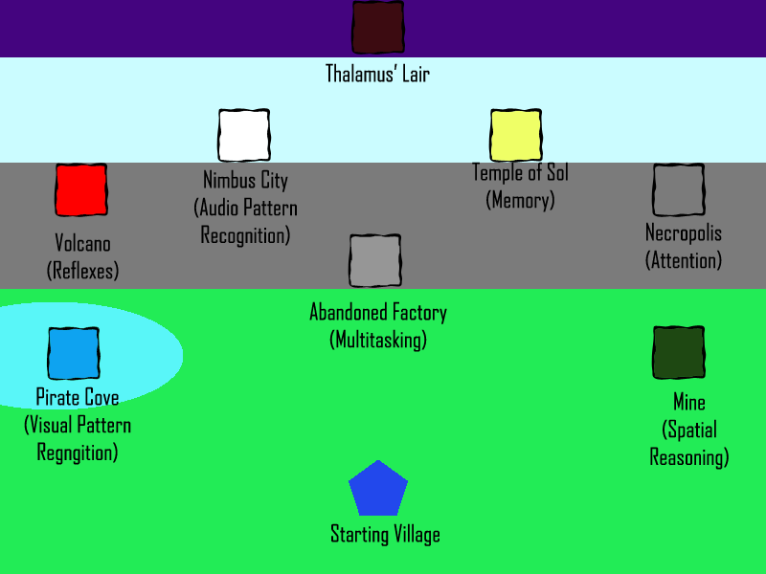

Scoring
Scoring is done on a per exercise basis as they will vary in execution and style. For the most part, however, scoring will be done according to speed with points off for mistakes. As an example of a scoring system, let us take a memory match game. Players have 20 seconds to clear as many matches on a board like this:
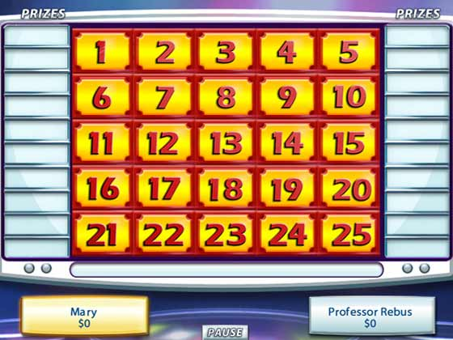
A passing score is 12 matches. This will net the player a C rank. 16 means a B, 20 means an A, and clearing the board means an S rank. Once the player gets to the point of clearing the board, it will record how fast he/she did it on top of the S rank.
Puzzles that require timing will have hidden countdown timers. The closer the player gets to zero, the higher the score. If they pass that timer, it's a miss and counts as a hit to their vitality. Too many misses and they lose a life.
The world itself has a final score that averages out the grades across all of the puzzles and also records your clear time.

Potential Art to Draw From
The following art is just suggestions for designs for the characters. Ultimately, this should be up to the project artist.
Mac/Amy
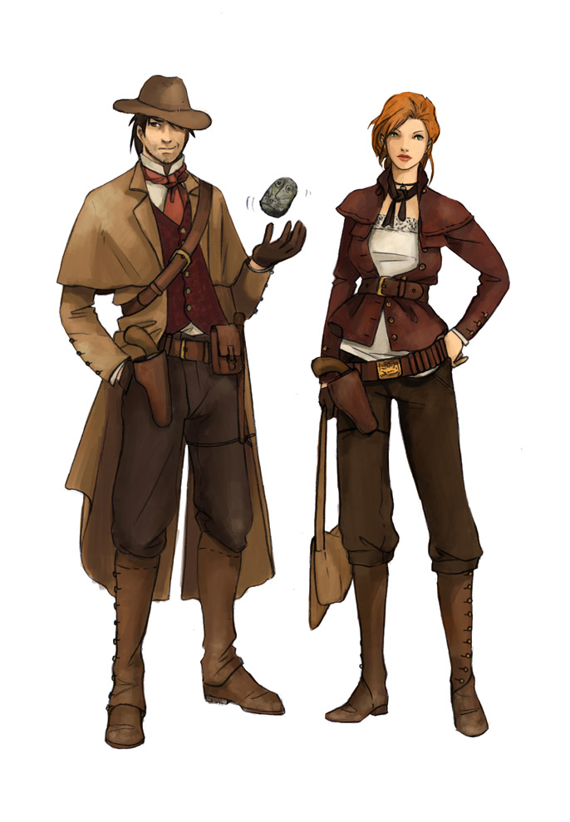

Cortez
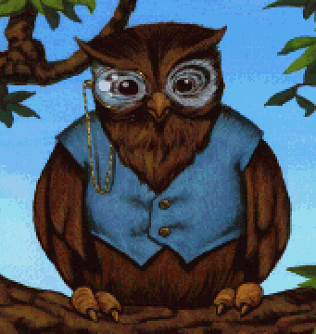

Thalamus (maybe female variant if player chooses to be female?)
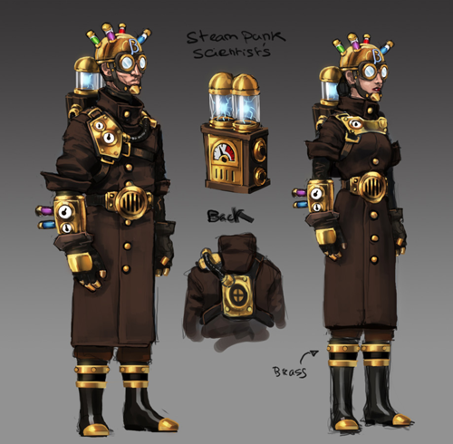

Profit Model

Flat charge for the game is certainly the most basic option. Price should be discussed with everyone involved on the project. It can also be approached from a cheap price point with additional levels and modes as DLC via microtransactions. One other possibility, though one I'd like to avoid, is to allow players to buy their equipment in the game for real money to skip ahead in combat prowess or allow players to buy level skips if they're stuck on a type of puzzle.

