import sys !{sys.executable} -m pip install pandas scikit-learn xgboost boto3

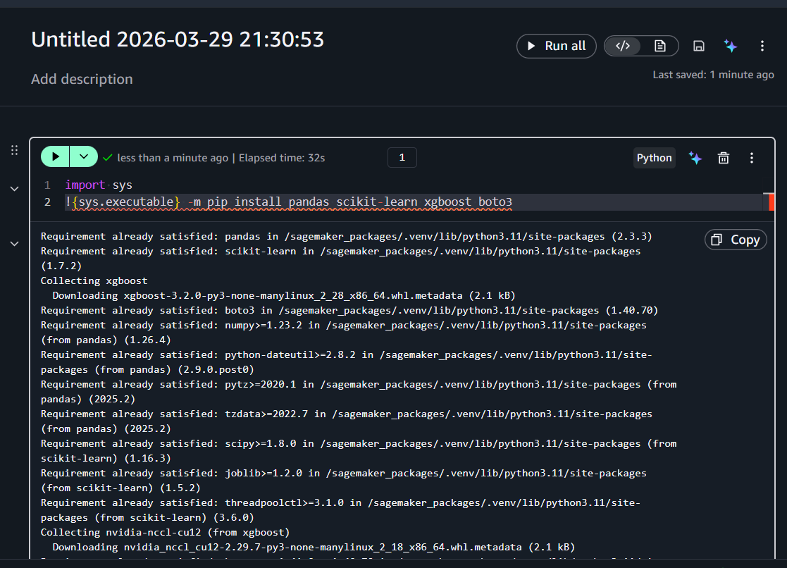

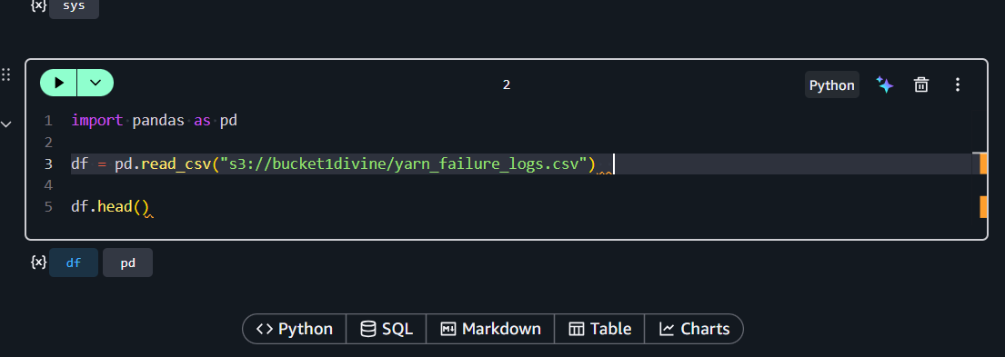

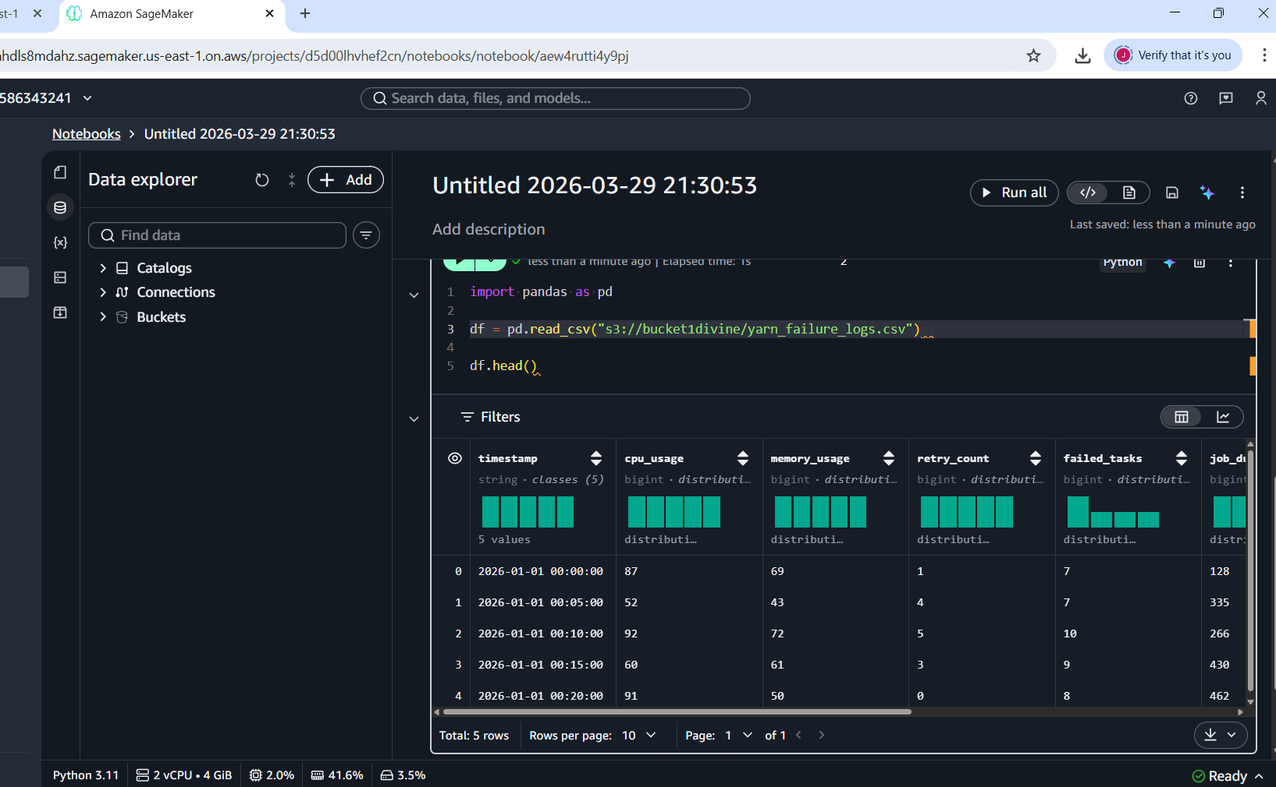

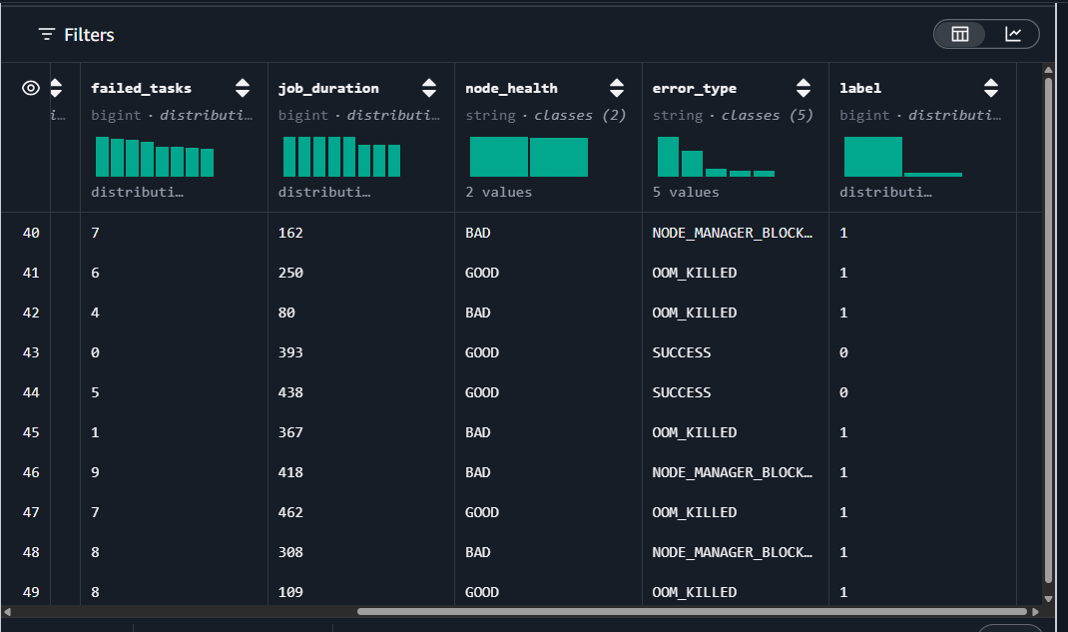

from sklearn.model_selection import train_test_split

X_train, X_test, y_train, y_test = train_test_split(
X, y, test_size=0.2, random_state=42
)
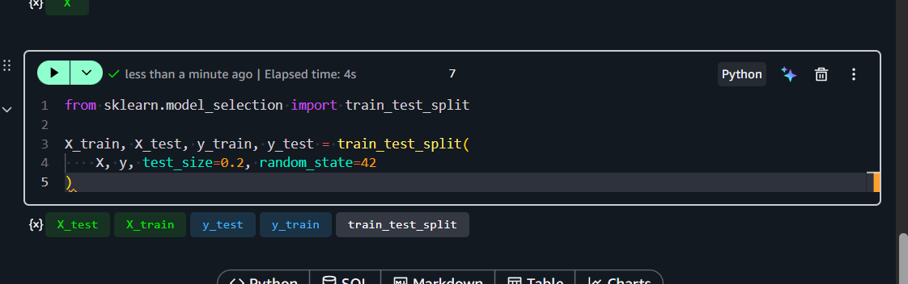

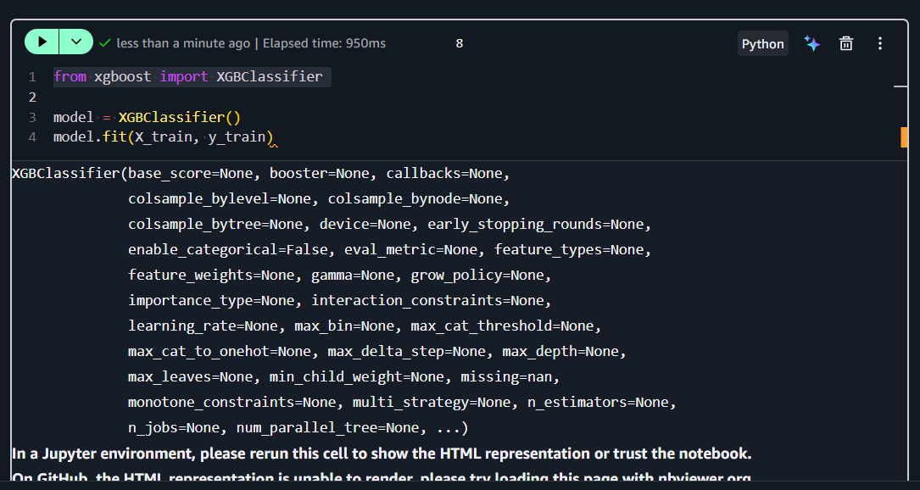

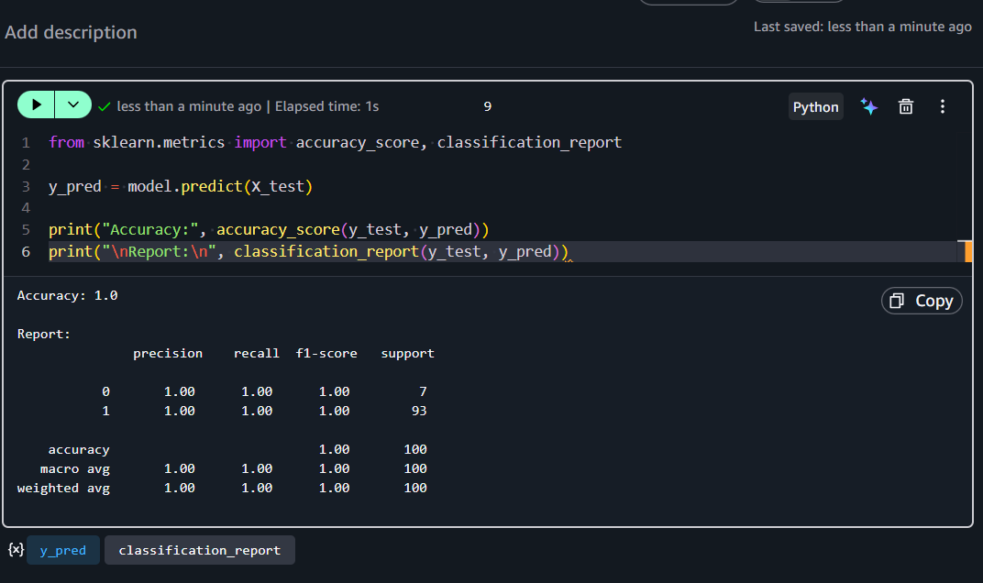

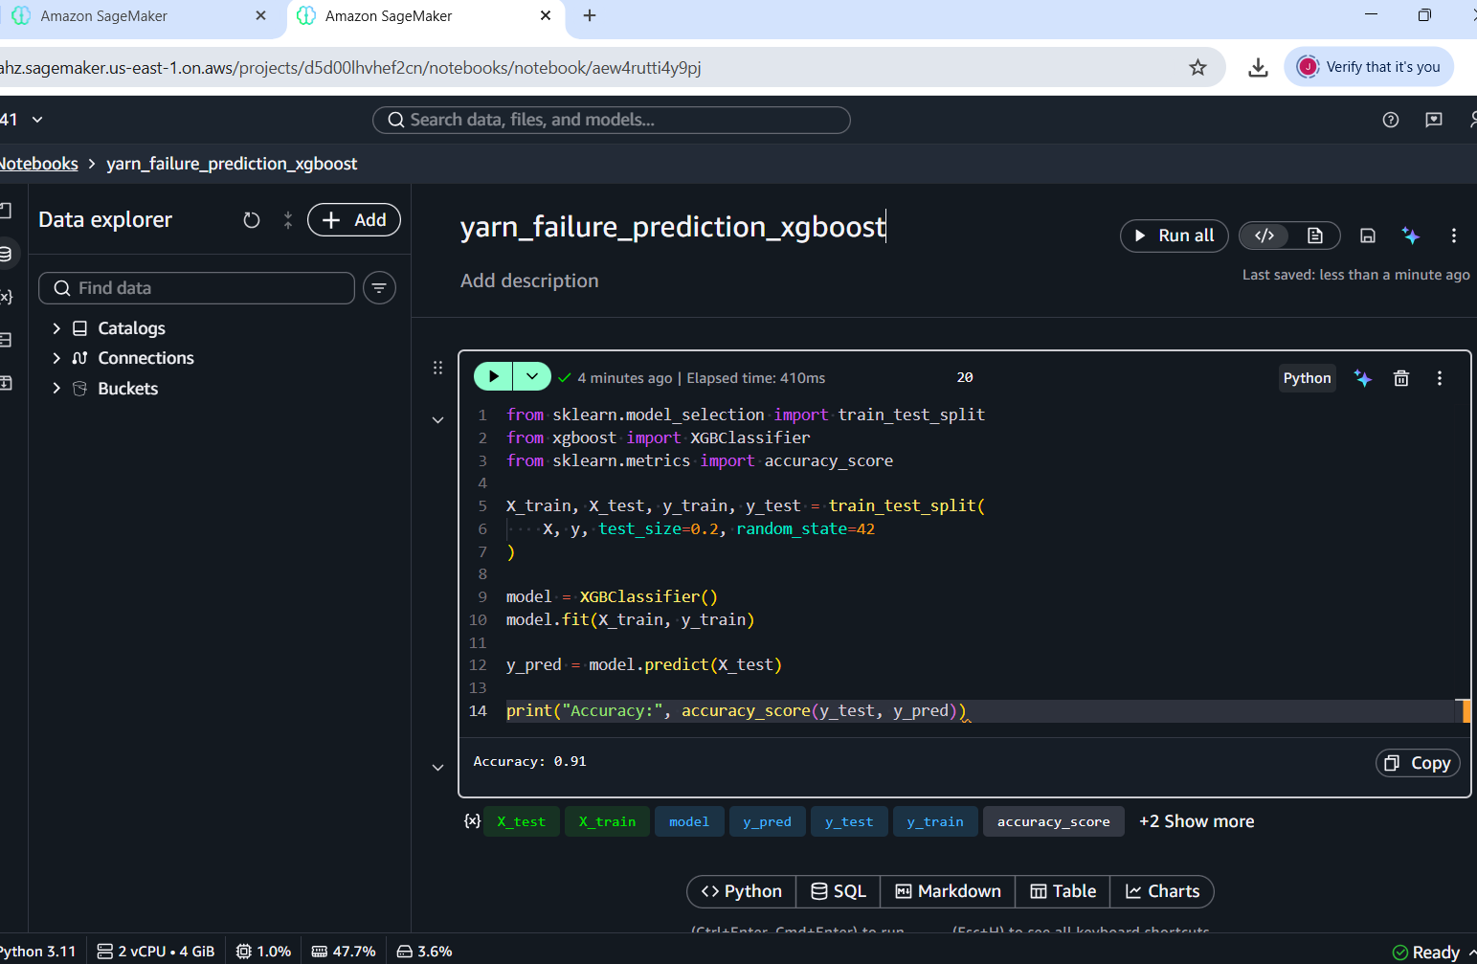

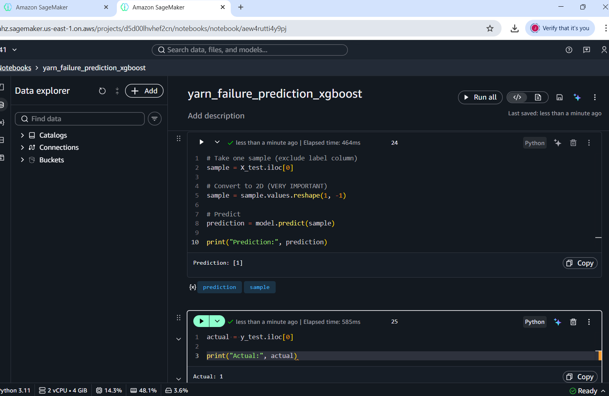

✅ Step 1 — SageMaker Training Job

import sagemaker
from sagemaker import get_execution_role
from sagemaker.inputs import TrainingInput
from sagemaker.estimator import Estimator

role = get_execution_role()
session = sagemaker.Session()

bucket = "bucket1divine"

container = sagemaker.image_uris.retrieve(
framework="xgboost",
region=session.boto_region_name,
version="1.5-1"
)

xgb = Estimator(
image_uri=container,
role=role,
instance_count=1,
instance_type="ml.m5.large",
output_path=f"s3://{bucket}/output",
sagemaker_session=session
)

xgb.set_hyperparameters(
objective='binary:logistic',
num_round=100,
max_depth=5
)

train_input = TrainingInput(
f"s3://{bucket}/yarn/train/",
content_type="csv"
)

xgb.fit({'train': train_input})

