**ELECTION ANALYSIS**

Analysis of data using python

**Overview of Project**

A Colorado board of election has requested some analysis to help with election audit of a recent local congressional election. The high-level request needs to capture the below

* The voter turnout for each county
* The percentage of votes from each county out of the total count
* The county with the highest turnout

**Analysis and Challenges**

The project will be developed using python, our result will be printed in command line and as well saved to a text file. The below information will be provided

* Total number of votes in the congressional election
* Statistics of county who received votes, this will include percentage vote and total number of votes
* Which county had the largest number of votes?
* Breakdown of the number of votes and the percentage of the total votes each candidate received
* Which candidate won the election, what was their vote count, and what was their percentage of the total votes?

**Deliverable 1 Requirements**

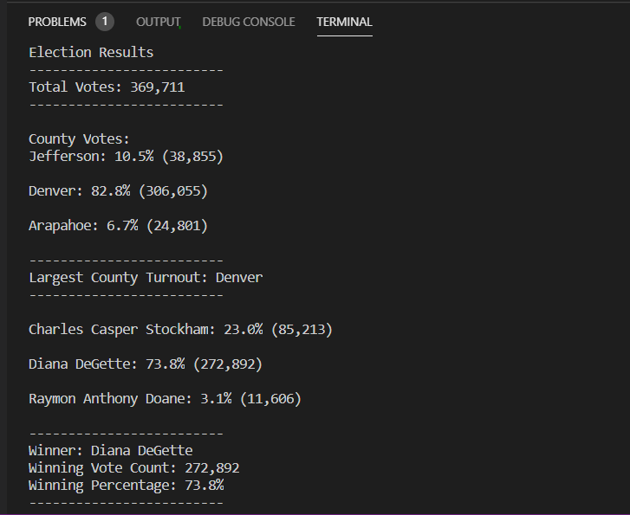

**Candidate Result**

Total Votes in election

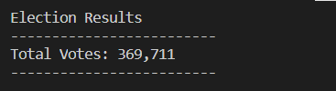

* Candidates total votes and percentage

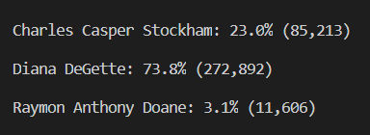

* Winner of election, winning vote count and percentage
* 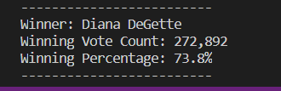

County Results: Below screenshot shows the total vote count by county, the percentage and the county with largest number of voters

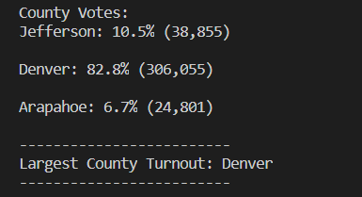

**Deliverable 2: Election Candidate Results Saved to a Text file**

The election result saved in election_results.txt file. The file contains all the expected result which are

* Candidate Results
  + Total votes in election
  + Each candidates' total votes and percentage
  + Winner of Election
* County Results
  + Each county and its total vote count
  + Each county and percentage
  + County with largest number of votes

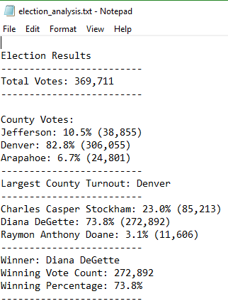

**Election Audit Summary**

The above details statistics of election results. A python script was used for the analysis. The analysis was broken down into steps and every step was commented to facilitate easy understanding. The final output was printed in a command line, we also saved in txt file using the below code sample

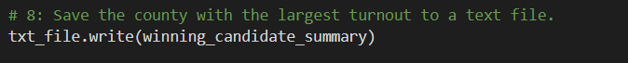

While printing out, we also ensured we capture it in an easy explainable manner. Below shows a snippet code of printing the Winning Candidate summary

